**DAY-2**

**DOCUMENT AND WINDOW OBJECTS**

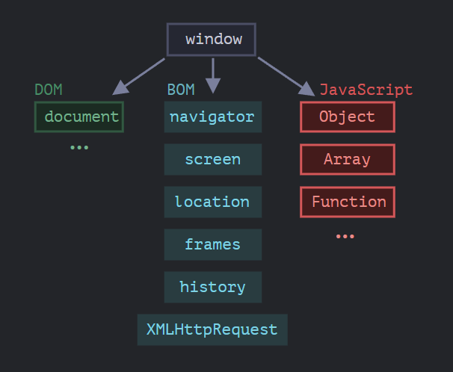

**DOCUMENT OBJECT:**

Document object represents the Document Object Model of the current web page loaded in the browser.

A web page is a document that can be either displayed in the browser window or as HTML source.

DOM is a programming interface for web documents, allowing JavaScript code to access and modify the structure, content, and styles of DOM elements.

DOM is root node of the HTML document, offers methods to select elements, manipulate their attributes, create new elements, and handle events.

It acts as an entry point to the DOM hierarchy, enabling scripts to traverse and manipulate the document's elements and properties.

**WINDOW OBJECT:**

Window object represents the browser window or tab that contains the DOM document.

A global variable, window, representing the window in which the script is running, is exposed to JavaScript code, providing access to various browser-related functionalities and properties.

Each tab is represented by its own Window object in a tabbed browser. The global window seen by JavaScript code running within a given tab always represents the tab in which the code is running.

It encompasses BOM elements such as the location of browser, history, screen dimensions, and methods for interacting with the browser.

It also contains references to other objects like **document**, **navigator**, **console**, **localStorage**.

**SAMPLE CODE:**

const paragraphs = **document.querySelectorAll("p");**

// paragraphs[0] is the first <p> element

// paragraphs[1] is the second <p> element, etc.

**alert(paragraphs[0].nodeName);**

Here,

Document Object - **document.querySelectorAll("p");**

Window Object - **alert(paragraphs[0].nodeName);**