# AGGLOMERATIVE HIERARCHICAL CLUSTERING

* Use hierarchical clustering to cluster the data on all attributes and produce a dendrogram

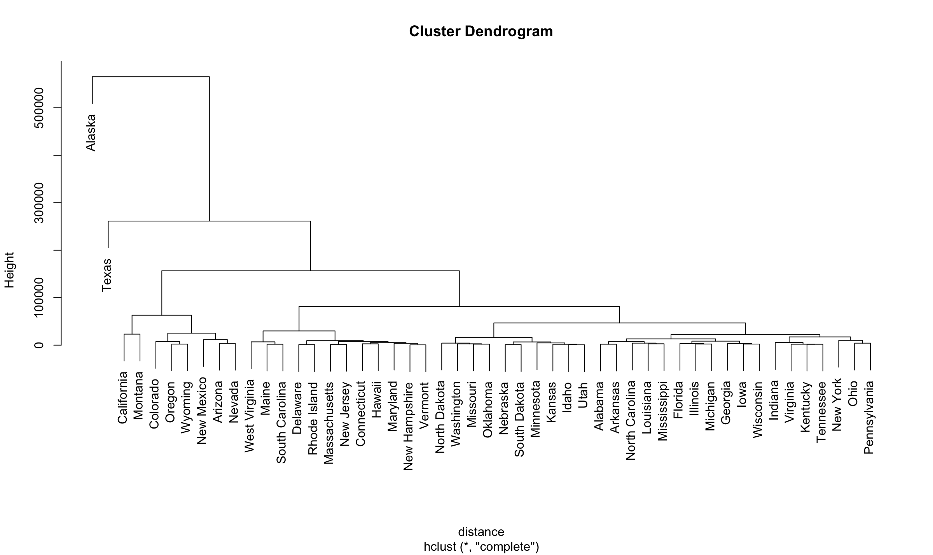

* 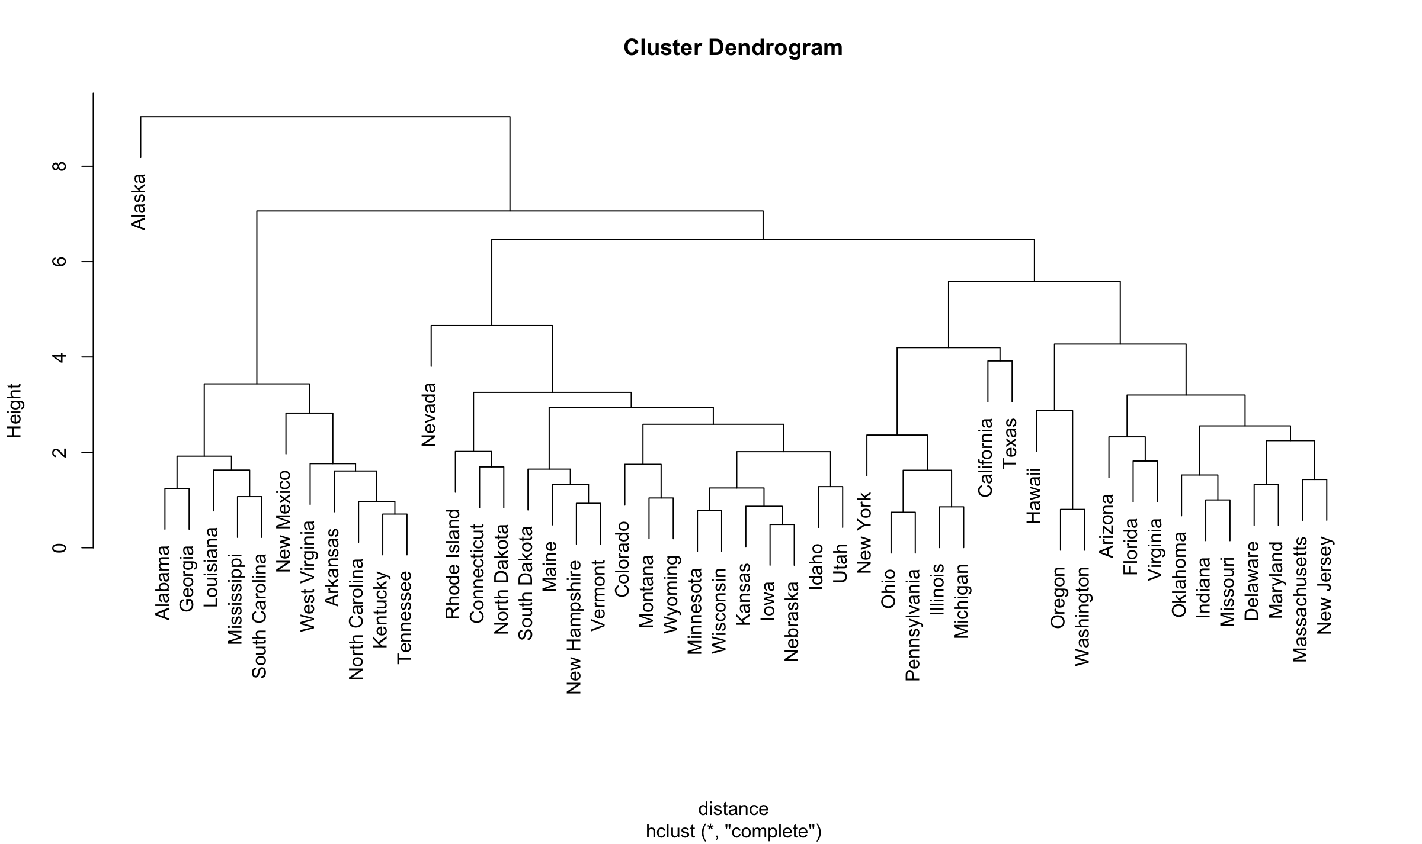Repeat the previous item with a normalized dataset and note any differences

More accurate but Nevada is out of place. Hawaii is also out of place.

* 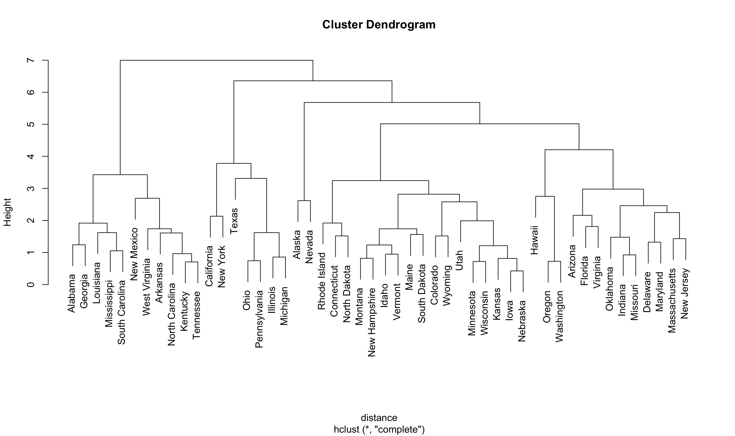Remove "Area" from the attributes and re-cluster (and note any differences)

Area is important because this dendrogram does not make any sense. For example, Alaska isn’t close the Nevada by any mean.

* 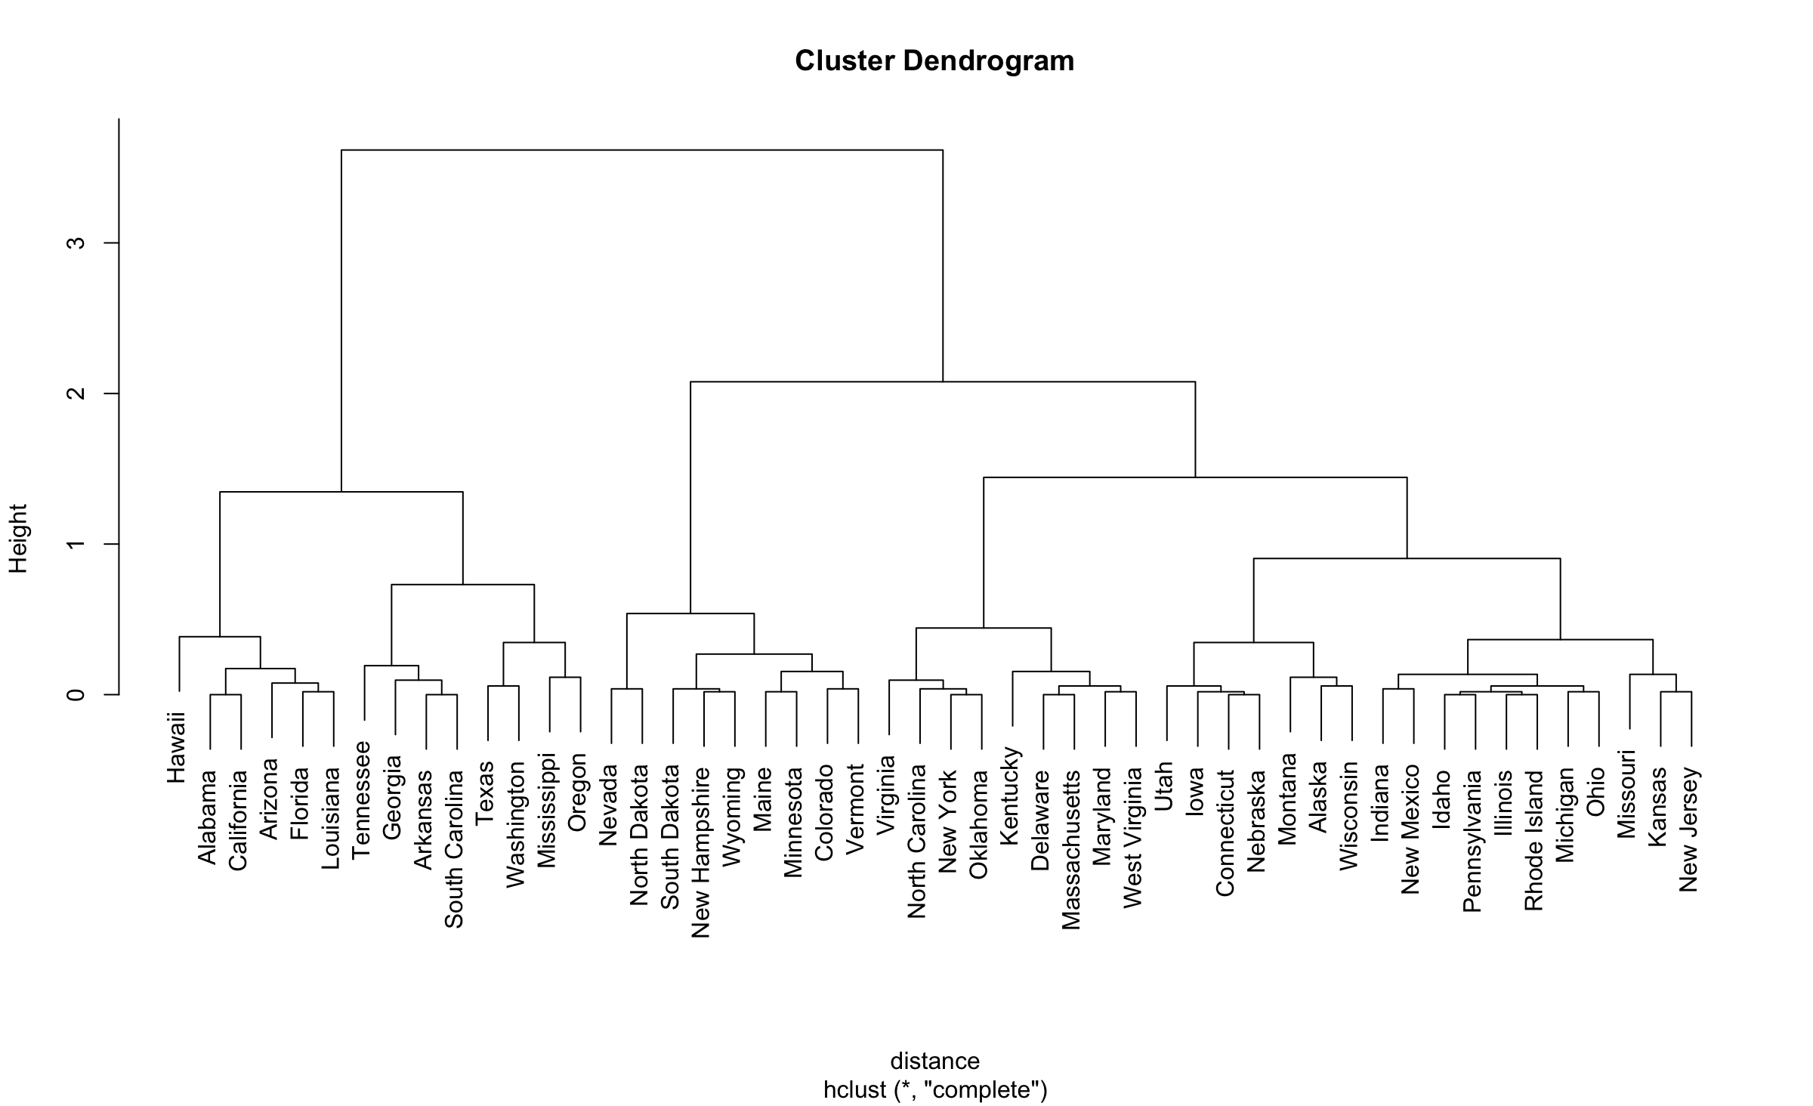Cluster only on the Frost attribute and observe the results

This one is interesting. All the warm state is grouped together. The state with low temperature are also grouped together.

# USING K-MEANS

* Using k-means, cluster the data into 3 clusters. Note the size of each cluster and the mean values. Do you have any insight into why they were divided this way?

[1] 111.66951 67.72742 23.62227

Population Income Illiteracy Life Exp Murder HS Grad Frost Area

1 0.9462026 0.7416690 0.005468667 -0.3242467 0.5676042 0.1558335 -0.1960979 0.4483198

2 -0.4873370 0.1329601 -0.641201154 0.7422562 -0.8552439 0.5515044 0.4528591 -0.1729366

3 -0.2269956 -1.3014617 1.391527063 -1.1773136 1.0919809 -1.4157826 -0.7206500 -0.2340290

It is because of the starting point.

* 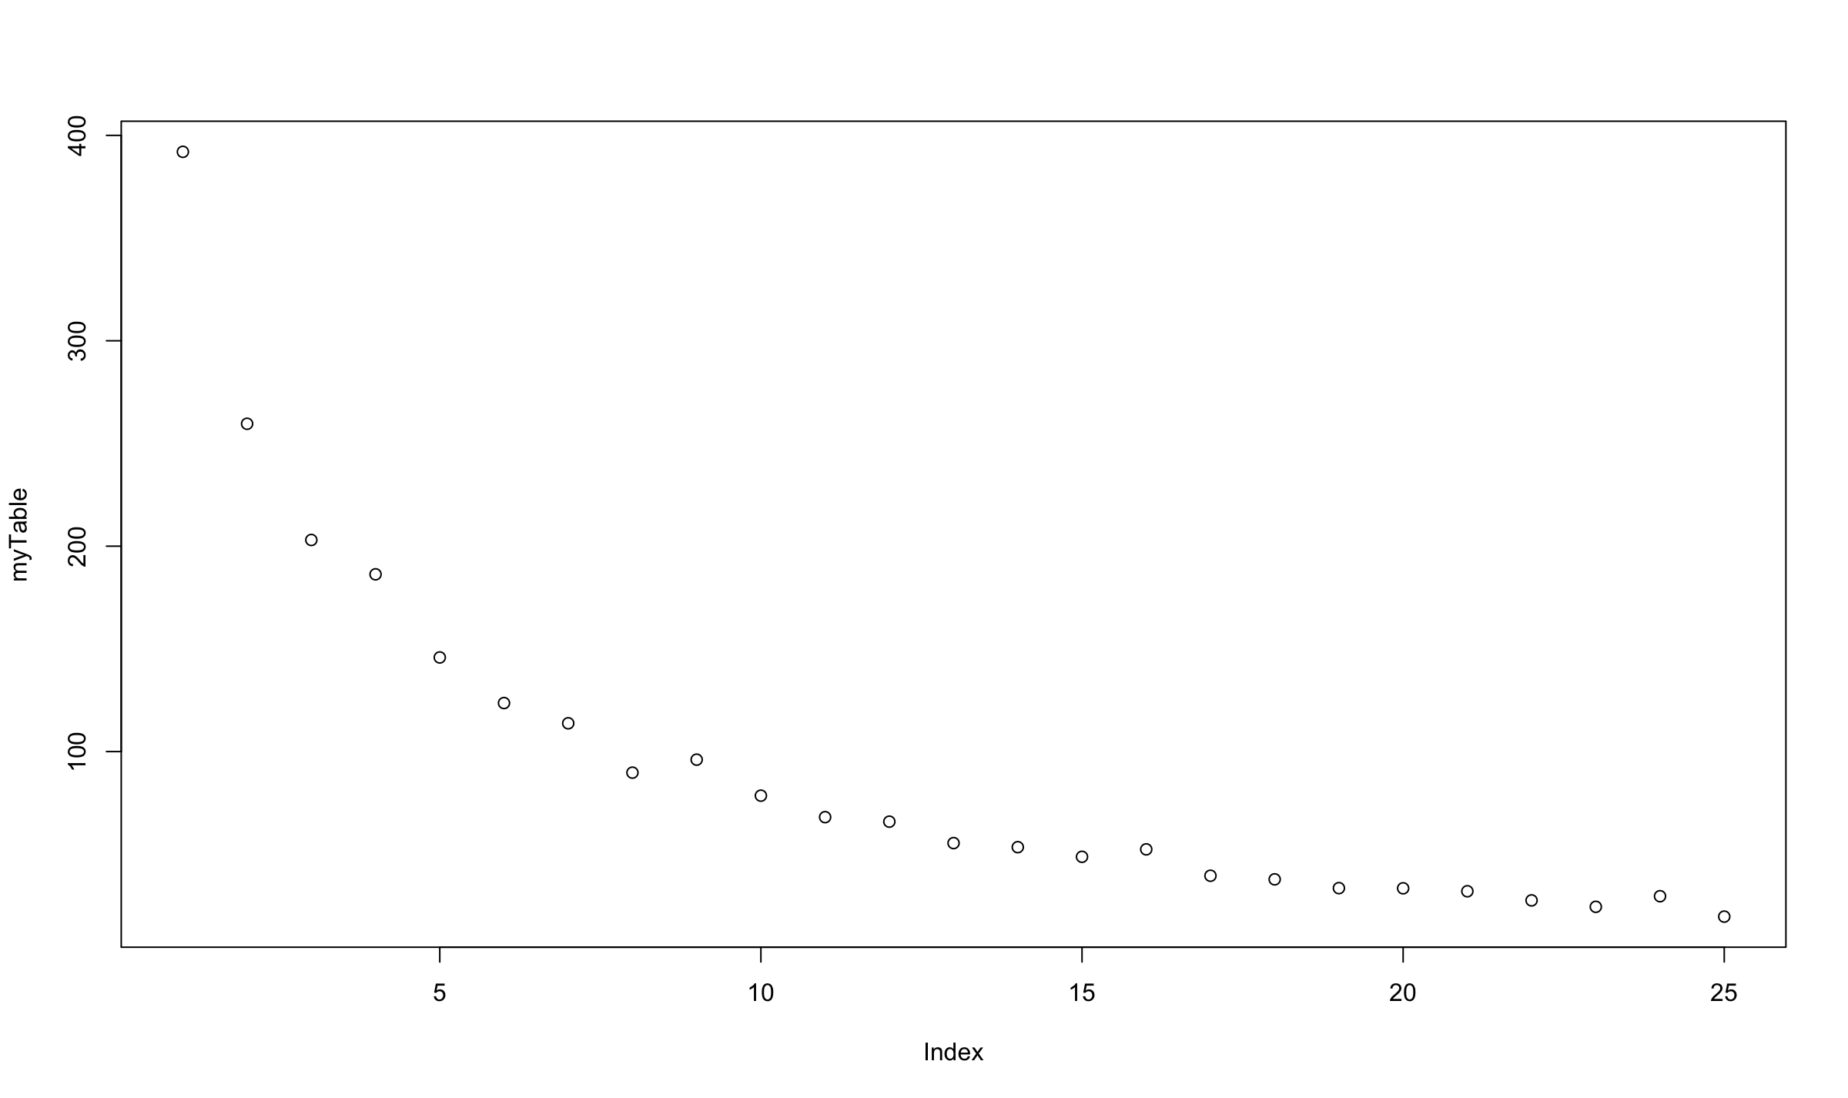Using a for loop, repeat the clustering process for k = 1 to 25, and plot the total within-cluster sum of squares error for each k-value.
* Evaluate the plot from the previous item, and choose an appropriate k-value using the "elbow method" mentioned in your reading. Then re-cluster a single time using that k-value. Use this clustering for the remaining questions.

Using elbow method, I think k = 8 is appropriate

* List the states in each cluster.

myClusters.cluster.o.

Colorado 1

Idaho 1

Iowa 1

Kansas 1

Minnesota 1

Nebraska 1

South Dakota 1

Utah 1

Wisconsin 1

Alaska 2

California 3

New York 3

Texas 3

Connecticut 4

Massachusetts 4

North Dakota 4

Rhode Island 4

Alabama 5

Arkansas 5

Georgia 5

Kentucky 5

Louisiana 5

Mississippi 5

New Mexico 5

North Carolina 5

South Carolina 5

Tennessee 5

West Virginia 5

Delaware 6

Florida 6

Illinois 6

Indiana 6

Maryland 6

Michigan 6

Missouri 6

New Jersey 6

Ohio 6

Oklahoma 6

Pennsylvania 6

Virginia 6

Arizona 7

Hawaii 7

Oregon 7

Washington 7

Maine 8

Montana 8

Nevada 8

New Hampshire 8

Vermont 8

Wyoming 8

* Use "clusplot" to plot a 2D representation of the clustering.

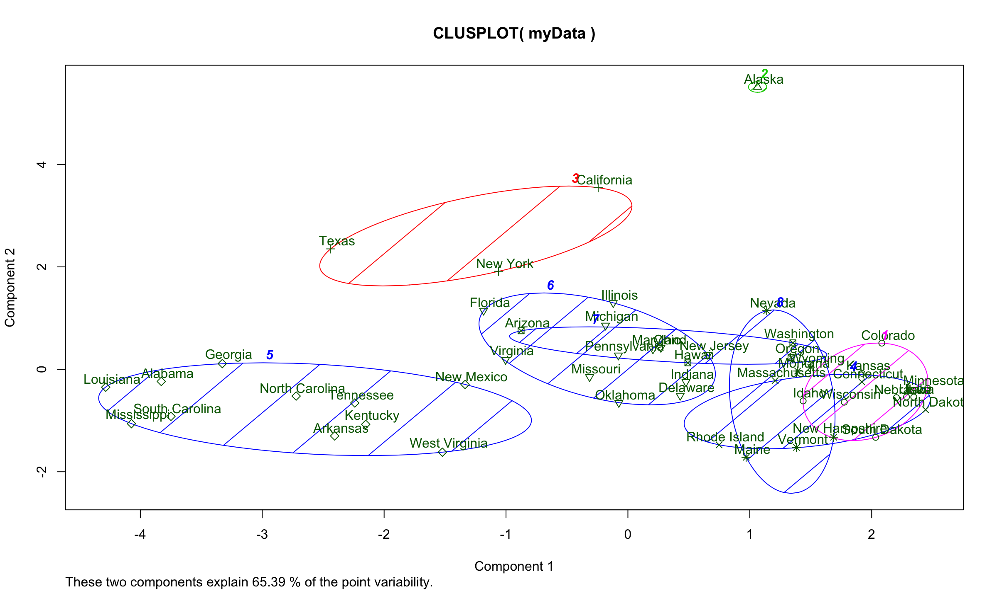

This plot showed Alaska as an outlier, which it is.

* Analyze the centers of each of these clusters. Can you identify any insight into this clustering?

Some center are really close with each other,