Canon LBP6030 Mono Laser Printer

<https://shopee.com.my/Canon-LBP6030-Mono-Laser-Printer-Canon-CART-325-Toner-i.92347945.11809209305?sp_atk=4cf88cd4-471c-453e-8af2-7abc2c5ab3f5>

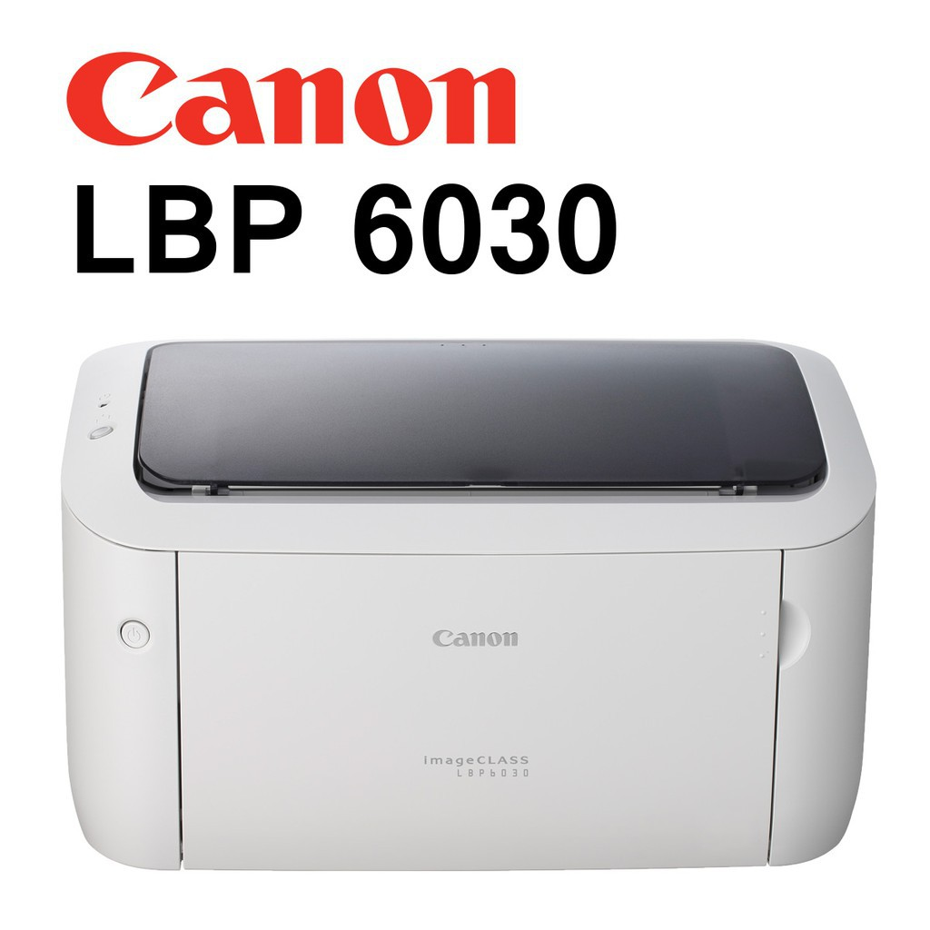

Canon Pixma Ts307 Single Funtion Wireless Printer

<https://shopee.com.my/Canon-Pixma-Ts307-Single-Funtion-Wireless-Printer-With-Smartphone-Copy-Color-Wifi-Printer-i.348812145.8003181256?sp_atk=1bd11994-0801-45e7-bd1a-a3d261117cbf>

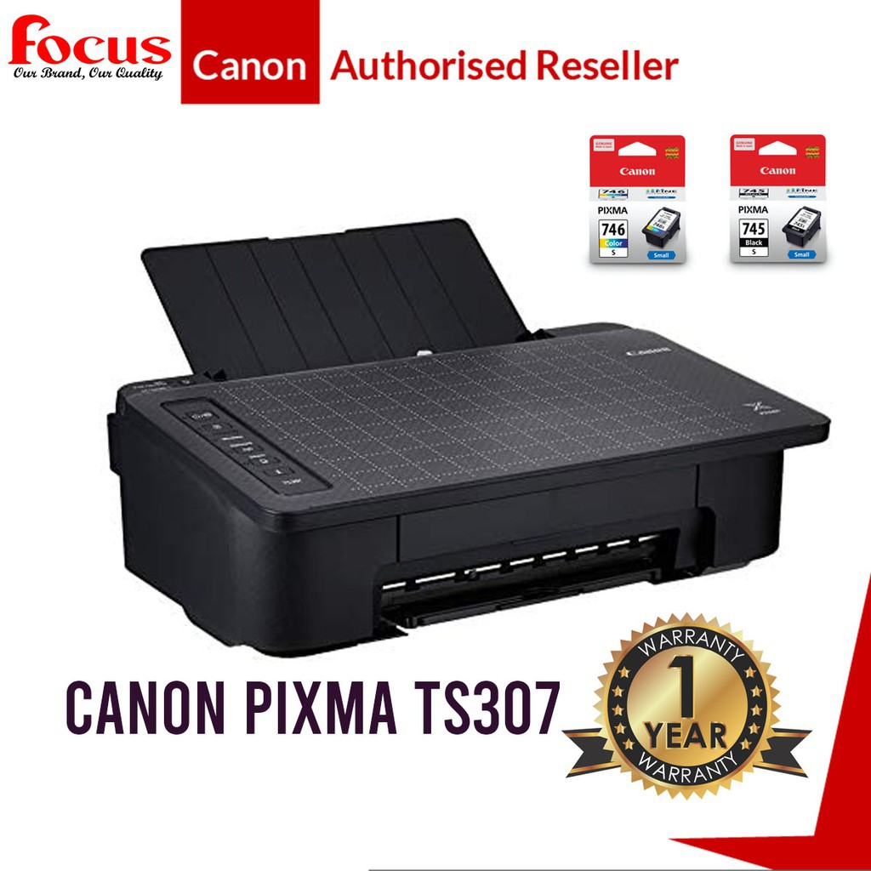

CANON PIXMA MG2577S Compact All-In-One Printer

<https://shopee.com.my/CANON-PIXMA-MG2577S-Compact-All-In-One-Printer-for-Low-Cost-Printing-PRINT-SCAN-COPY-i.215214400.16819006004?sp_atk=f57464cd-8644-4f4d-8941-fb5c3c087fa1>

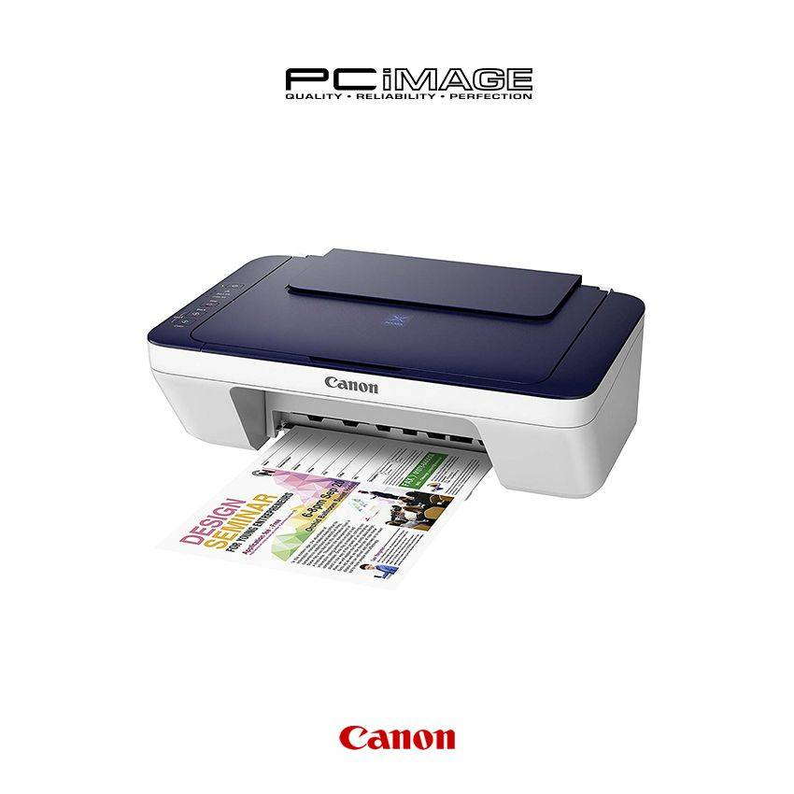

Canon imagePROGRAF PRO-500 Professional A2 Photo Printer

<https://shopee.com.my/Canon-imagePROGRAF-PRO-500-Professional-A2-Photo-Printer-i.69891532.12062884026?sp_atk=340e80dd-1250-40d8-bffc-8a55e34021df>

