ZCAS UNIVERSITY
SCHOOL OF COMPUTING, TECHNOLOGY AND APPLIED SCIENCES
An Artificial Intelligence-Driven Mobile Health Platform for Enhanced Prostate Cancer Diagnosis and Detection within the Zambian Healthcare System
Final-Year Project Report
Bachelor of Science in Computer Science
Course: [COURSE NAME AND CODE]
Student name: [STUDENT NAME]
Student number: [STUDENT NUMBER]
Supervisor: [SUPERVISOR]
Date of submission: [DATE OF SUBMISSION]

Declaration
I, [STUDENT NAME], declare that this report describes the final-year project that I carried out at ZCAS University, and that it has not been submitted for any other award. The work of others has been acknowledged where it is used, and every source is cited in the text and listed in the references. The use of artificial intelligence tools in building the software and in preparing this report is declared in the statement below.
[DECLARATION WORDING: replace this paragraph with the exact declaration that the ZCAS undergraduate project guide requires, if it differs]
[AI USE STATEMENT: to be written by the student in line with ZCAS rules. For accuracy: the project's development log and security review record that much of the code, the tests and the documentation were written by an AI coding assistant (Claude) working under the student's direction, with the design choices recorded as the owner's decisions; this report was drafted with AI assistance from that documentation.]
Signature: [STUDENT SIGNATURE]
Date: [DATE]
Supervisor: [SUPERVISOR NAME, SIGNATURE AND DATE]

Acknowledgements
[ACKNOWLEDGEMENTS: to be written by the student]

Abstract
Prostate cancer is the leading cause of cancer death among men in Zambia. The country records about 65.4 new cases and 37.6 deaths per 100,000 men each year, fewer than one in ten health facilities offer a specialised diagnostic service, and diagnosis took an average of 83.4 days in 2023. The approved research proposal answered this with a design for an artificial intelligence-driven mobile health platform. This project built a working research prototype of that design and evaluated it against the proposal's requirements.
The work followed Design Science Research and an iterative prototyping method. It was carried out in nineteen build phases, and each phase was closed by an automated quality gate. The prototype has four parts. A Flutter phone app lets clinicians register patients and record screenings without internet access, in an AES-256 encrypted database that synchronises safely later. A React website serves administrators. A NestJS backend enforces sign-in, role-based access control, a tamper-evident audit log and a de-identified HL7 FHIR R4 export. A Python service holds the complete AI analysis pipeline and a patient-education assistant. The assistant answers only from a reviewed knowledge base, finds passages by keyword (BM25) and orders them by meaning (MedCPT), and supports voice questions and read-aloud.
On a development laptop with synthetic data, the AI pipeline answered within 545 ms at the 95th percentile under 500 active users (target 3 s), the assistant within 514 ms (target 2 s), and 2,000 offline changes were saved with none lost or duplicated. The FHIR export passed the official validator with no errors, and every package exceeded 80% test coverage.
The limits are stated plainly. The AI models are labelled development mocks, so no clinical accuracy can be claimed. All data is synthetic. The knowledge base awaits clinical sign-off, and Bemba and Nyanja are not yet available. User acceptance testing and the usability score await ethics approval. Push notifications await a Firebase project, and no iOS build was made. The prototype shows that the proposed architecture is feasible; its clinical value remains to be shown.
Keywords: mobile health, prostate cancer, Zambia, offline-first, artificial intelligence, retrieval-augmented generation, HL7 FHIR, design science research.
Table of Contents
Right-click here and choose Update Field (or press F9) to build this list.
List of Figures
Right-click here and choose Update Field (or press F9) to build this list.
List of Tables
Right-click here and choose Update Field (or press F9) to build this list.

List of Abbreviations
Abbreviation | Meaning
ADR | Architecture decision record
AES | Advanced Encryption Standard (AES-256: with a 256-bit key)
AI | Artificial intelligence
ANN | Artificial neural network
API | Application programming interface
AUC-ROC | Area under the receiver operating characteristic curve
BM25 | A standard keyword-ranking function used in search engines
BPH | Benign prostatic hyperplasia
CDH | Cancer Diseases Hospital, Lusaka
CNN | Convolutional neural network
DFD | Data flow diagram
DICOM | Digital Imaging and Communications in Medicine (the file format of medical scans)
DRE | Digital rectal examination
DSR | Design Science Research
ECTA | Electronic Communications and Transactions Act (Zambia)
ERD | Entity-relationship diagram
FCM | Firebase Cloud Messaging
FHIR | Fast Healthcare Interoperability Resources (HL7 standard; R4 is Release 4)
FR | Functional requirement
GCM | Galois/Counter Mode (an authenticated mode of AES)
Grad-CAM | Gradient-weighted Class Activation Mapping
HBM | Health Belief Model
HL7 | Health Level Seven International
HMAC | Keyed-hash message authentication code
ISUP | International Society of Urological Pathology
JWT | JSON Web Token
LOINC | Logical Observation Identifiers Names and Codes
MedCPT | A biomedical text-retrieval model from the US National Center for Biotechnology Information
mHealth | Mobile health
MIL | Multiple-instance learning
mpMRI | Multiparametric magnetic resonance imaging
NFR | Non-functional requirement
NHRA | National Health Research Authority (Zambia)
NRC | National Registration Card (the Zambian identity card)
P95 | 95th percentile (95% of measured times were at or below this value)
PCa | Prostate cancer
PI-RADS | Prostate Imaging Reporting and Data System
PSA | Prostate-specific antigen
RAG | Retrieval-augmented generation
RBAC | Role-based access control
REST | Representational state transfer
SHAP | SHapley Additive exPlanations
SUS | System Usability Scale
TAM | Technology Acceptance Model
TLS | Transport Layer Security
TRUS | Transrectal ultrasound
UAT | User acceptance testing
UC | Use case
UTH | University Teaching Hospital, Lusaka
WCAG | Web Content Accessibility Guidelines
WSI | Whole-slide image
ZAMMDA | The regulator named in the research proposal for AI medical devices [CHECK: the proposal does not expand this abbreviation; confirm the regulator's correct name and abbreviation]

Chapter 1: Introduction

1.1 Background of the Study
More than five hundred and sixty Zambian men die from prostate cancer (PCa) every year. This figure from the World Health Organization's 2020 cancer statistics almost certainly undercounts the toll, because Zambia's health information systems are incomplete (World Health Organization [WHO], 2020). By incidence and mortality, prostate cancer is now the leading male cancer in Zambia.
Zambia records 65.4 new prostate cancer cases per 100,000 men each year, which places it among the highest-burden countries in sub-Saharan Africa (Sung et al., 2021). Mortality stands at 37.6 per 100,000. The gap between incidence and mortality is wide in high-income countries, where early detection is the norm, but narrow in Zambia, where most men are diagnosed after the window for curative treatment has closed. A long delay between the first clinic visit and a confirmed diagnosis is a central driver of late presentation and high mortality (Lombe et al., 2024).
The core problem is one of infrastructure rather than biology. Prostate-specific antigen (PSA) testing, digital rectal examination (DRE), multiparametric magnetic resonance imaging (mpMRI) and biopsy, used together, can find the disease at a stage at which survival approaches 99% (Siegel et al., 2023). Yet fewer than 10% of Zambian health facilities offer any specialised prostate cancer diagnostic service (WHO, 2020). Multiparametric MRI is not available in the Zambian health system, and transrectal biopsy carries an infection rate of about 10% in Zambian facilities, against 1–2% elsewhere (Lombe et al., 2024).
Artificial intelligence (AI) offers one response. Machine learning models have matched or exceeded specialist performance in medical image interpretation, histopathological grading and biomarker-based risk assessment (Topol, 2019), and one server can serve many mobile devices without more specialists. Mobile phone use in Zambia is high, and the national SmartCare Pro electronic health record already links facilities (Ministry of Health Zambia, 2022). The conditions for an AI-supported mobile health (mHealth) intervention therefore exist.
The approved research proposal set out the design of such a platform: a cross-platform mobile application, a multi-modal AI inference engine and a patient-education chatbot, arranged in a six-layer architecture. This report describes the prototype built from that design, how it was implemented and tested, and how far it meets the proposal's objectives.

1.2 Problem Statement
The problem is not a single missing tool but several system failures at once, which make it likely that a man with early, curable prostate cancer stays undiagnosed until the disease is advanced. The proposal identified five.
1. Diagnostic delay. The average time from first presentation to diagnosis was 83.4 days in 2023 (Lombe et al., 2024). Pathway improvements cut it to 23 days in some facilities, but the gains were local.
2. Geographic inaccessibility. With fewer than 10% of facilities offering specialised care, most Zambian men, particularly outside Lusaka, cannot reach specialist evaluation (WHO, 2020).
3. Misclassification at the point of entry. Prostate cancer cases are documented as benign prostatic hyperplasia (BPH) in outpatient registers, which places patients on a benign pathway and distorts national data (Lombe et al., 2024). An AI model trained on such records without correction would repeat the error.
4. The diagnostic modality gap. In the borderline PSA range of 4–10 ng/mL, false-positive rates can reach 75%, which leads to unnecessary biopsies (Djavan et al., 2002). Without mpMRI to guide it, biopsy yields less and carries more risk.
5. Variability between clinicians. Gleason grading shows notable disagreement between and within pathologists, particularly for intermediate grades (Ström et al., 2020), and in Zambia non-specialists often grade biopsies.
A practical system must also work with intermittent connectivity, protect health data under Zambian law, and earn the trust of clinicians and patients. These constraints shaped every design decision.

1.3 Aim and Objectives

1.3.1 Aim
The aim of the project was to design and build a working research prototype of the AI-driven mHealth platform specified in the approved proposal, for the earlier diagnosis and detection of prostate cancer in the Zambian health system, and to evaluate the prototype against the proposal's requirements.

1.3.2 Objectives
The proposal set five objectives. They are reproduced as approved, so that Chapter 5 can evaluate the work against them.
1. To design a cross-platform React Native mobile application implementing AES-256 encrypted offline-first data capture, TLS 1.3 API communication, role-based access control (RBAC), and HL7 FHIR R4 interoperability for secure multi-modal patient data management.
2. To architect a multi-modal AI inference engine comprising a U-Net convolutional neural network (CNN) for lesion segmentation, a ResNet-50 CNN for classification using transfer learning (targeting an AUC-ROC of at least 0.90), an artificial neural network (ANN) for clinical biomarker analysis, and a deep-learning patch-CNN with multiple-instance learning (MIL) for automated Gleason grading, integrated through an XGBoost multi-modal fusion layer.
3. To design a natural language processing (NLP) chatbot based on retrieval-augmented generation (RAG), grounded in a curated medical vector-database knowledge base, delivering evidence-based patient education and diagnostic guidance in English and Zambian indigenous languages within 2-second response times.
4. To develop a data collection, pre-processing, augmentation and AI model training methodology, incorporating transfer learning, fairness-aware training and stratified 5-fold cross-validation, tailored to the data quality and demographic constraints of the Zambian health context.
5. To formulate an ethical, privacy and regulatory compliance framework, encompassing informed consent, AES-256 de-identification, algorithmic bias monitoring, Grad-CAM explainability, SHAP value reporting and alignment with Zambian cyberlaw, embedded as a foundational design requirement.
One change was made to objective 1: the mobile application was built with Flutter rather than React Native, by the owner's decision at the start of the build (ADR-001). Section 3.2.4 explains why every requirement of the objective still applies.

1.4 Research Questions
1. How can a multi-modal AI inference engine be architecturally designed to process heterogeneous prostate cancer data streams within the specific infrastructural, data quality and demographic constraints of the Zambian health system?
2. What data collection, pre-processing and augmentation strategies are most effective for training generalisable AI models, given the documented scarcity, misclassification and non-standardisation of locally available prostate cancer datasets in Zambia?
3. How can an offline-capable mHealth platform architecture reliably deliver AI-augmented diagnostic support both in urban facilities with stable connectivity and in rural facilities with intermittent or absent internet access?
4. What ethical, fairness, explainability and regulatory design measures are required to ensure equitable and trustworthy deployment of AI-driven clinical decision support within Zambia's emerging digital health governance landscape?

1.5 Implementation Plan

1.5.1 The plan in the proposal
The proposal planned a twelve-month project in nine phases (Table 1.1 and Figure 1.1). Phases 4 and 5 were to run in parallel, and ethics and security work (Phase 8) alongside implementation. The plan gives months, not dates.
Table 1.1: The nine phases of the proposal's twelve-month plan
Phase | Activity | Planned months
1 | Planning and requirements analysis | M1–M2
2 | System architecture and design | M2–M4
3 | Data collection and preparation | M3–M6
4 | AI model development and training | M4–M8
5 | Mobile app and chatbot development | M5–M8
6 | System integration and API wiring | M7–M9
7 | User acceptance testing | M8–M10
8 | Ethical compliance and security audit | M3–M10
9 | Evaluation, writing and documentation | M9–M12

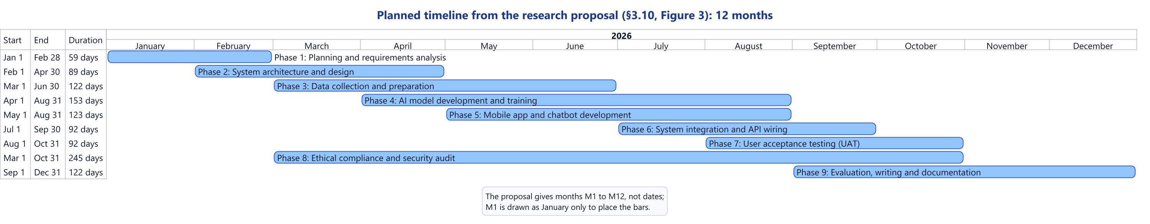
Figure 1.1: Planned timeline (from the research proposal)

1.5.2 The build plan that was followed
At the start of the build, the proposal's phases were divided into nineteen build phases, numbered 0 to 18 (Table 1.2). A phase was finished only when its quality gate passed (formatting, static analysis, tests, build and security checks), the documentation and requirements traceability matrix were updated, and the work was committed.
Table 1.2: The build phases of the development plan
Phase | Name | Main outputs
0 | Project analysis | Architecture, plan, traceability matrix, first decision records
1 | Repository and environment | Repository layout, container services, continuous integration, first tests
2 | Database foundation | Schema and migrations, document collections, file storage, append-only audit log, synthetic seed data
3 | Backend foundation | Validation, security headers, rate limits, errors, health checks, OpenAPI, frozen AI contract
4 | Authentication and authorisation | Sign-in, session tokens, lockout, password reset, RBAC
5 | Patients and clinical data | Registration, screening records, consent, facility scoping
6 | Offline-first synchronisation | Sync endpoint with idempotency and conflicts; encrypted phone database
7 | Flutter foundation | Theme, navigation, sign-in screens, API client, secure storage
8 | Patient workflow | Results, education, messages, consent, sign-up
9 | Clinician and pathologist workflow | Consent, scans and slides, AI request and report, slide review
10 | Imaging and files | Streamed upload, file validation, DICOM checks, object storage
11 | AI service foundation | Model router, labelled mock models, registry, broker with time-outs
12 | Explainable AI | Explanation pipeline, "unavailable" states, evaluation endpoint
13 | Chatbot | Knowledge base, retrieval, safety rules, conversations, chat screens
14 | FHIR R4 export | De-identified bundles and a SmartCare Pro stand-in
15 | Security and compliance review | Access matrix, de-identified AI inputs, separation of duties, TLS check
16 | End-to-end tests | Six workflows on the live system, log review
17 | Performance and reliability | Load, stress and synchronisation tests against the targets
18 | Final quality audit | Traceability review, coverage minimums, accessibility tests

The phases were not completed strictly in number order. After Phase 18, the owner requested further work: a separate administration website, a redesign of the app, voice questions and read-aloud, a move to the database servers installed on the development computer, an operations manual, the report diagrams, the user acceptance testing kit, a biomedical meaning search for the assistant, and push notifications.

1.5.3 The actual timeline
Figure 1.2 shows the actual timeline, drawn from the Git history with one mark per commit. The history records the build from 23 September to 2 October 2026, in 47 commits on the main branch before this report was drafted, far less than the planned twelve months. Two reasons explain most of the difference. Data collection, model training and user acceptance testing could not be carried out, because they need data-sharing agreements, ethics approval and participants (Section 1.6). And the software was written with an AI coding assistant under the student's direction, which probably shortened the implementation. Chapter 5 compares plan and outcome.
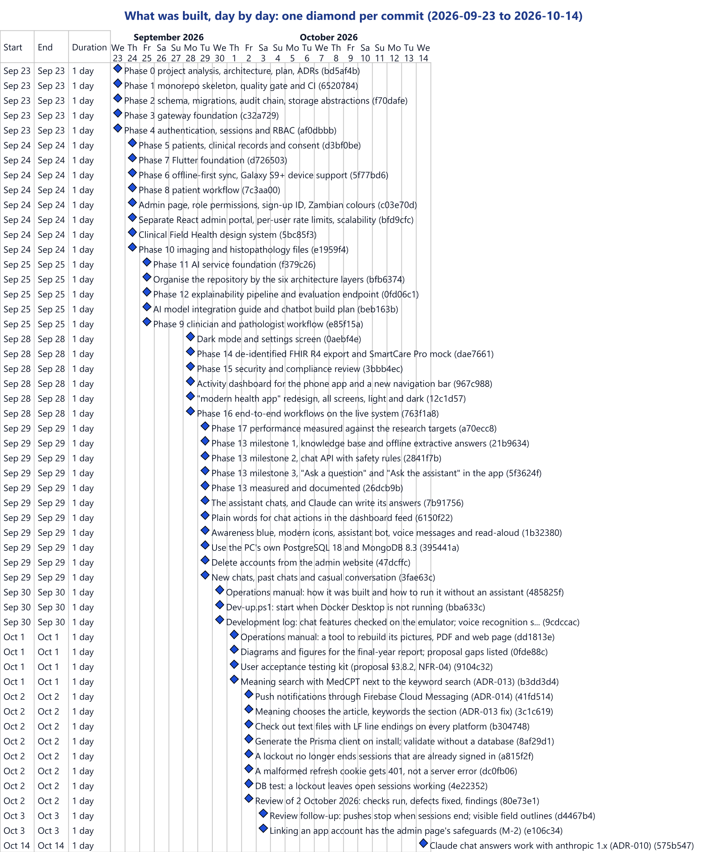
Figure 1.2: Actual build timeline (from the Git history)

1.6 Scope and Delimitations
The proposal scoped the study to design and methodology. This project went further on implementation, but not on clinical work. The prototype has these boundaries:
- Synthetic data only. No real patient data was collected or used anywhere; all records are generated and labelled "SYNTHETIC".
- No trained AI models. The five AI modules are labelled development mocks whose outputs come from a hash of the job identifier, not from patient data, and every result carries the label "DEVELOPMENT MOCK DATA — NOT A CLINICAL RESULT." The pipeline around them is complete; the owner is training the models separately.
- No clinical validation. Without trained models, no diagnostic accuracy figure can be reported.
- English only. Bemba and Nyanja are switched off until human-verified translations exist.
- Android only. No iOS build was made, because building for iOS requires a Mac.
- No user acceptance testing yet. A complete kit was prepared, but sessions require ethics approval.
- A development deployment. The system runs on one laptop; Kubernetes, a web application firewall and measured uptime were documented, not built.
The geographic focus remains the Zambian health system, with the Cancer Diseases Hospital (CDH) and the University Teaching Hospital (UTH) in Lusaka as the intended first sites.

1.7 Significance of the Study
- Clinical. A validated version could shorten the diagnostic pathway, extend decision support to facilities without specialists, and support more consistent grading. The prototype does not yet deliver these benefits, but validated models can be placed into its infrastructure without changing the rest of the system.
- Health system. Offline-first capture lets clinicians without reliable internet still record screenings, and the de-identified FHIR R4 export shows how the tool could feed SmartCare Pro rather than stand alone (Ministry of Health Zambia, 2022).
- Policy and ethics. The prototype shows in working code how consent, de-identification, an append-only audit trail, labelled mock output and fairness checks can be built in from the start.
- Academic. It contributes a tested reference architecture and documented design decisions for AI-supported mHealth in a low-resource setting, including the offline synchronisation design and a retrieval design in which keywords decide whether a question is covered and the section, and meaning chooses the article for a safe patient assistant.

1.8 Definition of Key Terms
Table 1.3: Definition of key terms
Term | Definition
Convolutional neural network (CNN) | A deep learning architecture that learns spatial features from images; U-Net and ResNet-50 are CNN variants.
Multi-modal data fusion | Combining imaging, clinical and histopathological outputs into one prediction, here through an XGBoost meta-learner.
AUC-ROC | The area under the receiver operating characteristic curve: a classifier's ability to separate classes across thresholds (1.0 perfect, 0.5 random).
Retrieval-augmented generation (RAG) | Answering from passages retrieved from a knowledge base, so that answers can be traced to sources.
Gleason score and ISUP grade group | The histopathological grading of prostate cancer; the grade group summarises the Gleason score in five groups.
HL7 FHIR R4 | Release 4 of the Fast Healthcare Interoperability Resources standard for exchanging health records.
Grad-CAM and SHAP | Explanation methods: Grad-CAM highlights the image regions behind a CNN's output; SHAP values show each input's contribution.
Offline-first | Saving data on the device first and sending it to the server when a connection is available.
Idempotency key | A unique key sent with each change, so that a change sent twice is applied only once.
Development mock | A stand-in for a trained model that returns clearly labelled, non-clinical output.
Safe Harbor de-identification | Removal of eighteen classes of identifiers (names, contact details, most dates and others) before sharing.
BM25 and MedCPT | BM25 ranks passages by the words they share with a question; MedCPT is a biomedical model that compares their meaning as 768-number vectors (Jin et al., 2023).
Quality gate | The automated checks (formatting, static analysis, tests, coverage, build, security audits) required before each commit.

1.9 Organisation of the Report
Chapter 2 reviews the literature and states the theoretical framework and research gaps. Chapter 3 presents the system analysis and design: research design, requirements, development method, data and process models, and program, database and interface design. Chapter 4 presents the implementation and testing: system guide, installation manual, testing plan and output, and main function code. Chapter 5 evaluates the work against the objectives and research questions, states its limitations, and gives recommendations and future work. The appendices summarise the requirements traceability, the tests, the user acceptance testing kit and the decision records, and point to the user guide.

Chapter 2: Literature Review

2.1 Introduction
This chapter reviews the knowledge on which the project was built: prostate cancer epidemiology worldwide and in Zambia, the diagnostic pathway and its weaknesses, mHealth in resource-constrained African settings, AI in healthcare, and AI applied to prostate cancer imaging, histopathology and biomarkers. Because the implementation added a patient assistant and a planned usability evaluation, it also reviews clinical reporting standards, conversational agents and retrieval, and usability measurement. It ends with the theoretical framework and the research gaps, and shows how far the prototype addresses each.

2.2 Global Epidemiology of Prostate Cancer
The GLOBOCAN 2020 estimates recorded 1,414,259 new prostate cancer diagnoses and 375,304 deaths worldwide, which makes it the second most frequently diagnosed cancer in men and the fifth leading cause of male cancer death (Sung et al., 2021). In the United States alone, 268,490 new cases and 34,500 deaths were reported in 2022 (National Cancer Institute, 2022).
These totals hide a large disparity in outcomes. Five-year survival is about 98% in the United States but below 50% in many countries of sub-Saharan Africa, mainly because late presentation is the norm (Rebbeck et al., 2013). Age is the strongest risk factor, and ancestry the second: men of African descent show higher incidence, more aggressive disease and worse survival, probably through a combination of genetic susceptibility, unequal access to screening and socio-economic factors (Rebbeck et al., 2013).
This matters for AI. A model trained mainly on European or North American patients risks performing worse in the population that needs it most. Obermeyer et al. (2019) showed that a commercially deployed clinical algorithm systematically under-served Black patients because of bias in its training data. An AI component for Zambia must therefore be evaluated on the population it serves, with performance reported by subgroup.

2.3 Prostate Cancer in Zambia

2.3.1 Epidemiological profile
WHO data for 2020 place Zambia's incidence at 65.4 per 100,000 men per year and mortality at 37.6 per 100,000, which makes prostate cancer the most common cancer and the leading cause of cancer death among Zambian men (WHO, 2020). Award (2022) reports about 561 recorded deaths a year, almost certainly an undercount given the incompleteness of the national registry.

2.3.2 The diagnostic pathway and its failures
The pathway begins at primary or secondary care with DRE and PSA testing, and abnormal findings lead to transrectal ultrasound (TRUS)-guided biopsy. Multiparametric MRI and PSMA PET/CT, the international standards for locating tumours before biopsy and for staging, are absent from the Zambian health system (Lombe et al., 2024). Without imaging guidance, biopsy yield falls and the risk of false negatives and complications rises. The infection rate after transrectal biopsy is about 10% in Zambian facilities, against 1–2% in high-income settings, reflecting constraints on sterile technique and the local prevalence of multi-drug-resistant organisms (Lombe et al., 2024). That risk also deters men from seeking confirmation of a suspected diagnosis.
Lombe et al. (2024) also documented the misclassification of prostate cancer as BPH in outpatient registers. This places patients on a benign pathway and gives the registry inaccurate data. An AI system trained on raw Zambian data without a correction protocol would learn this error.

2.3.3 Zambia's digital health infrastructure
The SmartCare Pro electronic health record, developed through a partnership between the Government of Zambia and IHM Southern Africa's TuSo Business Dynamics, gives patients unique identifiers usable from any connected facility, and the Digital Health Strategy 2022–2026 commits the country to digital technologies for universal health coverage (Ministry of Health Zambia, 2022). A new tool should therefore exchange data with SmartCare Pro through an agreed standard rather than create another isolated record, which is why the prototype includes an HL7 FHIR R4 export.

2.4 Mobile Health in Resource-Constrained African Contexts
Fiordelli et al. (2013) mapped a decade of mHealth research reporting positive outcomes in areas such as antenatal care, HIV treatment adherence, malaria surveillance and chronic disease management, and countries in the region, including Kenya, South Africa and Nigeria, have used mHealth for cancer screening and diagnostic support. Kaplan (2006) identified mobile phone penetration as the critical enabling condition for mHealth in developing countries, a condition that Zambia increasingly meets.
Connectivity is the main constraint. Rural and peri-urban areas face intermittent or absent internet connectivity, which can undermine systems that depend on it (Aranda-Jan et al., 2014). The proposal therefore specified an offline-first design, in which data entry works on the device and data is synchronised when a connection returns. This brings its own problems: a change whose answer was lost may be sent again, two devices may change the same patient during the same gap, and data on a lost phone must be protected. Section 3.4 shows how the prototype deals with each.

2.5 Artificial Intelligence and Machine Learning in Healthcare
Machine learning includes supervised learning from labelled examples, unsupervised learning from unlabelled data, and semi-supervised learning, which combines the two and suits healthcare, where labels are scarce and expensive (Beam & Kohane, 2018). Deep learning, with multi-layered neural networks, dominates medical image analysis because it learns features directly from raw images (LeCun et al., 2015).
Two convolutional architectures matter for this project. U-Net is an encoder–decoder network whose skip connections preserve fine spatial detail, designed for biomedical segmentation with limited training data (Ronneberger et al., 2015), which suits the delineation of prostate lesions. ResNet-50 uses identity skip connections that let gradients flow through many layers, which addresses the vanishing-gradient problem of deep networks (He et al., 2016); its balance of capacity and cost suits classification under the proposal's 3-second target. Transfer learning, which fine-tunes a network pre-trained on a large dataset, has been reported to improve medical imaging models trained on small datasets (Tajbakhsh et al., 2016), which matters where local datasets are small.
The gap between research performance and clinical readiness is well documented. Overfitting is the main risk with small datasets; differences in imaging protocols between sites make models less portable (Woznicki et al., 2020); algorithmic bias produces systematic differences between groups (Obermeyer et al., 2019); and opaque outputs hinder clinician trust and regulatory approval (Rudin, 2019). The proposal answered the last point with Grad-CAM heatmaps for imaging models and SHAP values for the clinical model. The World Health Organization has issued guidance on the ethics and governance of AI for health (WHO, 2021). The prototype applied two principles of its own: AI output is never presented with more authority than its evidence supports, and every output shows where it came from. Every AI result therefore carries its provenance, mock output is always labelled, and no accuracy figure is shown without a stored evaluation.

2.6 AI Applications in Prostate Cancer Diagnosis
MRI. Fehr et al. (2015) combined texture features from apparent diffusion coefficient (ADC) and T2-weighted MRI and reached 93% classification accuracy. Saha et al. (2021) applied 3D CNNs to biparametric MRI from 2,732 patients with strong lesion detection. Woznicki et al. (2020) reported that combining a radiomics model with PI-RADS and clinical parameters raised the AUC from 0.69 (PI-RADS alone) to 0.84. Litjens et al. (2014) evaluated a fully automated computer-aided detection system for prostate cancer in MRI on 347 patients; the proposal cites this work for the public PROSTATEx dataset it planned to use for pre-training. The absence of mpMRI in Zambia defines the gap: the proposal planned TRUS-based analysis in the near term and designed for MRI later.
Histopathology. Automated Gleason grading responds directly to Zambia's shortage of pathologists. Ström et al. (2020) trained a model on biopsy slides from 1,247 men and reached an AUC of 0.997 for separating benign from malignant cores, with grading comparable to an international expert panel. Nagpal et al. (2019) reported a grading accuracy of 0.70 on prostatectomy slides, against a mean of 0.61 for expert pathologists. Pixel-level annotation of whole-slide images needs specialist time that is not available at scale; multiple-instance learning allows training with slide-level labels only (Campanella et al., 2019), and attention-based MIL pooling weights the tiles that matter most, which also highlights the regions behind a grade (Ilse et al., 2018). These works explain the choice of a patch-CNN with MIL.
PSA and biomarkers. Djavan et al. (2002) showed that a neural network applied to borderline PSA values of 4–10 ng/mL achieved better specificity and positive predictive value than conventional thresholds at the same sensitivity. Finne et al. (2000) eliminated 33% of false-positive PSA results at 95% sensitivity, and Remzi et al. (2003) predicted repeat-biopsy outcomes with 68% specificity at 95% sensitivity. Fewer false positives would mean fewer unnecessary biopsies, with their infection risk.
TRUS. Because TRUS-guided biopsy will remain the main confirmatory pathway in Zambia for some time, AI support for TRUS has direct value. Moradi et al. (2009) used support vector machines and random forests to improve cancer detection in TRUS images, and Karimi et al. (2019) developed accurate and robust deep learning segmentation of the prostate in ultrasound images.

2.7 Clinical Reporting Standards Used by the System
A diagnostic support system must record findings in clinicians' terms. The prototype's data model and clinician reference content follow four published standards and measures.
- ISUP grade groups summarise Gleason grading in five groups, from grade group 1 (Gleason score 6 or less) to grade group 5 (Gleason score 9 or 10), as agreed at the 2014 ISUP consensus conference (Epstein et al., 2016). In the prototype, the server computes the grade group from the pathologist's two Gleason patterns.
- PI-RADS version 2.1 reports prostate MRI with an assessment category from 1 (very low likelihood of clinically significant cancer) to 5 (very high) (Turkbey et al., 2019). The prototype records the radiologist's category and sends it to the AI analysis as an input.
- PSA density, PSA divided by prostate volume, adjusts PSA for the size of the gland (Benson et al., 1992).
- The free-to-total PSA ratio: in men with a total PSA of 4–10 ng/mL and a benign-feeling prostate, a lower percentage of free PSA was associated with a higher risk of cancer (Catalona et al., 1998).
The prototype calculates both PSA measures when a record is read and enforces the valid ranges of PSA, PI-RADS, Gleason patterns and grade groups as database constraints.

2.8 Conversational Agents and Retrieval for Patient Education
Patient education influences whether men come for screening and complete the diagnostic pathway. Laranjo et al. (2018) systematically reviewed conversational agents in healthcare and found positive outcomes in delivering health information, supporting adherence and encouraging behaviour change. Safety is central, because a wrong answer can mislead a patient, and open-ended text generation produces fluent but sometimes invented answers. Retrieval-augmented generation conditions the answer on passages retrieved from a knowledge base, which improves factual accuracy in knowledge-intensive tasks (Lewis et al., 2020).
Two retrieval families are relevant. Lexical retrieval, of which BM25 is the standard ranking function, scores passages by the words they share with the question; it needs no model, runs quickly and every match can be explained, but it fails when the question and the right passage use different words, or when an unrelated question shares one word with a passage. Dense retrieval compares meaning through vectors. MedCPT is a dense retriever for biomedical text, based on PubMedBERT and trained on 255 million query–article pairs from PubMed search logs, with separate encoders for questions and articles that produce 768-dimensional vectors (Jin et al., 2023). Dense retrieval alone has its own weakness for a safety-critical assistant: a nearest passage always exists, so there is no natural point at which to say that no reviewed information is available. Section 3.5.7 describes how the prototype combines the two.
Language and literacy also matter. Many older Zambian men read little English, and some cannot read at all. The proposal's answer was a knowledge base in English, Bemba and Nyanja; the prototype added voice input and read-aloud, and kept the two Zambian languages switched off until human-verified translations exist.

2.9 Usability Evaluation
The proposal set a target of a System Usability Scale (SUS) score of at least 75 (NFR-04). The SUS has ten statements answered on a five-point scale and scored to a value between 0 and 100 (Brooke, 1996); it is short, free to use and widely reported. The proposal asked for at least five participants per user group, and Nielsen and Landauer (1993) showed that about five users find most usability problems of a given kind. Think-aloud protocols and thematic analysis of interviews explain why tasks succeed or fail.

2.10 Theoretical Framework
The Technology Acceptance Model (TAM) holds that perceived usefulness and perceived ease of use are the main determinants of technology adoption (Davis, 1989). In the prototype, TAM informed concrete choices that support trust: clinical values in neutral colours, with no suggestion of good or bad that the system cannot justify; a provenance banner at the top of every AI screen; a list of the AI modules that ran and the reasons others were skipped; and offline states always written in words ("Saved on device", "Synced", "Needs attention").
The Health Belief Model (HBM) identifies perceived susceptibility, severity, barriers and benefits as the determinants of health behaviour (Becker, 1974). It explains why awareness alone is not enough: men who see the diagnostic process as burdensome, risky or inaccessible will not seek evaluation. The proposal asked the chatbot's knowledge base to address each construct. The prototype's knowledge base covers some themes (who is at higher risk, and what screening can and cannot tell a person) but not yet the practical barriers of cost, distance and fear of biopsy, a gap returned to in Chapter 5.

2.11 Summary of Research Gaps
Table 2.1 restates the proposal's six research gaps and records how far the prototype addresses each.
Table 2.1: Research gaps and how far the prototype addresses them
# | Gap identified in the proposal | How far the prototype addresses it
1 | No integrated multi-modal AI system for prostate cancer diagnosis in a sub-Saharan African context | Partly: the pipeline for five modules and their fusion is built and tested; the models are labelled mocks
2 | AI models not validated on Black African populations | Not empirically: no model was trained; a fairness check by age, region, stage and equipment is ready for real evaluations
3 | No patient-facing mHealth platform combining AI support with a multilingual chatbot in Zambia | For English: patient app with results, education, messages, consent and an assistant with voice and read-aloud; Bemba and Nyanja await translations
4 | No strategies for Zambia-specific data quality problems (misclassification, incomplete records, non-standard TRUS) | Not empirically: no data was collected; the data model enforces valid ranges, and the correction protocol is future work
5 | No ethical and regulatory framework for AI clinical decision support in Zambia | Partly: consent gating, de-identification, tamper-evident audit, separation of duties and labelled mocks built and tested; legal and ethics approvals outstanding
6 | No offline-first architecture for rural facilities in prostate cancer AI design | Addressed and tested: encrypted offline capture, exactly-once synchronisation and conflict detection, measured under load

2.12 Chapter Summary
The literature shows a strong evidence base for AI in prostate cancer imaging, histopathology and biomarkers, and for mHealth in African settings. It also shows the risks: small and unrepresentative datasets, bias, poor portability and opaque outputs. What did not exist was an integrated system designed for the Zambian context. Chapter 3 describes how the system was analysed and designed to fill that space.

Chapter 3: System Analysis and Design

3.1 Research Design
The project followed Design Science Research (DSR) (Hevner et al., 2004), which suits research whose main output is a purposeful artefact. Its contribution is the artefact and the design knowledge about how and why it works. Here the artefact is the prototype platform; the design knowledge is recorded in fourteen architecture decision records (ADR-001 to ADR-014) and the development log. Table 3.1 shows how each DSR activity was carried out.
Table 3.1: The Design Science Research activities as carried out
DSR activity | How it was carried out
Problem identification and motivation | The research proposal (Chapters 1 and 2)
Definition of objectives | Five objectives, twelve use cases, twelve functional and eleven non-functional requirements, kept in a traceability matrix
Design and development | Nineteen build phases, each closed by an automated quality gate
Demonstration | Live end-to-end workflows, device tests on an Android emulator, and a manual test guide
Evaluation | Automated tests, a security review, performance against the proposal's targets, a retrieval evaluation; user testing prepared but not run
Communication | This report, the operations manual and the decision records

Of the proposal's quantitative methods, only system performance could be measured, because no trained model exists. The qualitative part, stakeholder and usability evidence, is prepared in the user acceptance testing kit but awaits ethics approval.

3.2 Requirements Analysis

3.2.1 Users and roles
Four roles decide what each user may do.
- Patients create an account, see their own results, read or listen to health information, receive messages, manage their consents and ask the assistant.
- Clinicians (urologists, general practitioners, nurses and radiographers) register patients, record screenings with or without internet, record consent, upload scans, request and read AI analyses, and ask the assistant.
- Pathologists upload slides and record their Gleason review.
- Administrators manage accounts, roles and permissions, link patients' sign-ins to clinic records, read the audit log and an activity dashboard, and run the FHIR export. They have no routine access to clinical data.
The research coordinator, AI engineer and IT staff of UC-10 to UC-12 were not given roles, because those use cases were built only in part or left for later.

3.2.2 Use cases
Table 3.2 lists the proposal's twelve use cases with their status (Figure 3.5 shows them as a diagram).
Table 3.2: The twelve use cases and their status
ID | Use case | Primary actor(s) | Status
UC-01 | Registration and authentication | All users | Built and verified
UC-02 | Offline clinical data capture | Clinician | Built and verified
UC-03 | Medical imaging upload and validation | Clinician | Built and verified
UC-04 | Histopathological slide submission | Pathologist | Partly: upload and review verified; slide model is a mock
UC-05 | AI multi-modal diagnostic analysis | System, for a clinician | Built and verified with mock models
UC-06 | Diagnostic report delivery | Clinician, patient | Partly: clinicians only; release to patients awaits trained models and sign-off
UC-07 | Patient chatbot interaction | Patient, clinician | Built and verified in English
UC-08 | National EHR data export | Administrator | Built and verified against a SmartCare Pro stand-in
UC-09 | System administration and RBAC | Administrator | Built and verified
UC-10 | Infrastructure monitoring | Administrator | Partly: health checks and an activity dashboard
UC-11 | Population-level analytics | Research coordinator | Left for later
UC-12 | AI model retraining and deployment | AI engineer | Left for later; the model registry exists

3.2.3 Functional and non-functional requirements
Tables 3.3 and 3.4 summarise the proposal's requirements; Appendix A gives their status, implementation and tests.
Table 3.3: Functional requirements (from the proposal)
ID | Requirement (summary) | Priority
FR-01 | JWT authentication with RBAC for four roles; lockout after five failed sign-ins | Critical
FR-02 | Capture and transmit demographics, PSA, DRE and history, encrypted, over TLS 1.3 | Critical
FR-03 | Full offline entry with an AES-256 local database and conflict-resolving synchronisation | Critical
FR-04 | Accept and validate DICOM MRI, TRUS and CT files, archive and queue them | Critical
FR-05 | PCa probability with a Gleason grade group within 3 s at the 95th percentile | Critical
FR-06 | Grad-CAM for CNN outputs and SHAP values for ANN outputs | High
FR-07 | RAG chatbot answers within 2 s, in English, Bemba or Nyanja | High
FR-08 | AI reports with probability, Gleason prediction, heatmaps, confidence intervals and recommendations | High
FR-09 | De-identified HL7 FHIR R4 JSON export for SmartCare Pro | Medium
FR-10 | Immutable, time-stamped, actor-identified audit log | High
FR-11 | AI performance metrics by age, region and stage | High
FR-12 | Scheduled retraining, versioned model registry and A/B testing | Medium

Table 3.4: Non-functional requirements (from the proposal)
ID | Quality | Measurable target
NFR-01 | Security | AES-256 at rest, TLS 1.3 in transit, RBAC at the gateway
NFR-02 | Performance | AI inference within 3 s at the 95th percentile under load
NFR-03 | Availability | At least 99.5% monthly uptime
NFR-04 | Usability | SUS score of at least 75 in user testing
NFR-05 | Scalability | At least 500 concurrent users
NFR-06 | Interoperability | HL7 FHIR R4
NFR-07 | Maintainability | At least 80% automated test coverage
NFR-08 | Offline capability | Complete data entry without connectivity
NFR-09 | Explainability | Explanations for 100% of AI outputs
NFR-10 | Privacy | Safe Harbor de-identification
NFR-11 | Accessibility | WCAG 2.1 Level AA

3.2.4 Changes from the proposal
Analysis at the start of the build and later reviews led to deliberate changes, each recorded in a decision record (Table 3.5).
Table 3.5: Significant changes from the proposal
Proposal | Prototype | Reason
React Native app | Flutter (Dart) app | The owner's choice; ahead-of-time native code with no JavaScript bridge helps on entry-level Android phones; every requirement unchanged (ADR-001)
Administration in the app | A separate React and TypeScript website | Administration is desk work; same API and permission checks (ADR-005)
Backend language not specified | NestJS backend and a separate Python FastAPI AI service | The language boundary enforces the isolation of the AI layer (ADR-003)
Embeddings, cosine similarity, top 5, a vector database, a fine-tuned generator | BM25 decides coverage, MedCPT orders by meaning; passages are quoted, or Claude writes from them when enabled; 32 passage vectors kept in a file | Answers come only from reviewed text, and the system can say it has no reviewed information (ADR-009, ADR-010, ADR-013)
Cloud hosting, Kubernetes, Prometheus and Grafana | One laptop with Docker Compose; production items documented as plans | Deployment needs resources outside the project
A DICOM archive | Object storage with server-generated keys (local folder or S3-compatible MinIO) | One storage interface for scans, slides and explanation images
A push notification engine | Firebase Cloud Messaging through a database outbox, off until the owner's Firebase project exists | Free, built into Android, no health data in messages (ADR-014)
Reports shown to patients | Patients see values with "Your clinician will explain what this means for you"; AI reports not released | The owner's decision: interpretation belongs to the clinician
(Not in the proposal) | Voice questions, and articles and answers read aloud | Many older men read little or no English (ADR-012)

3.3 System Development Method
The proposal selected iterative prototyping, in which each iteration passes through design refinement, development, internal testing and stakeholder evaluation (Figure 3.1).
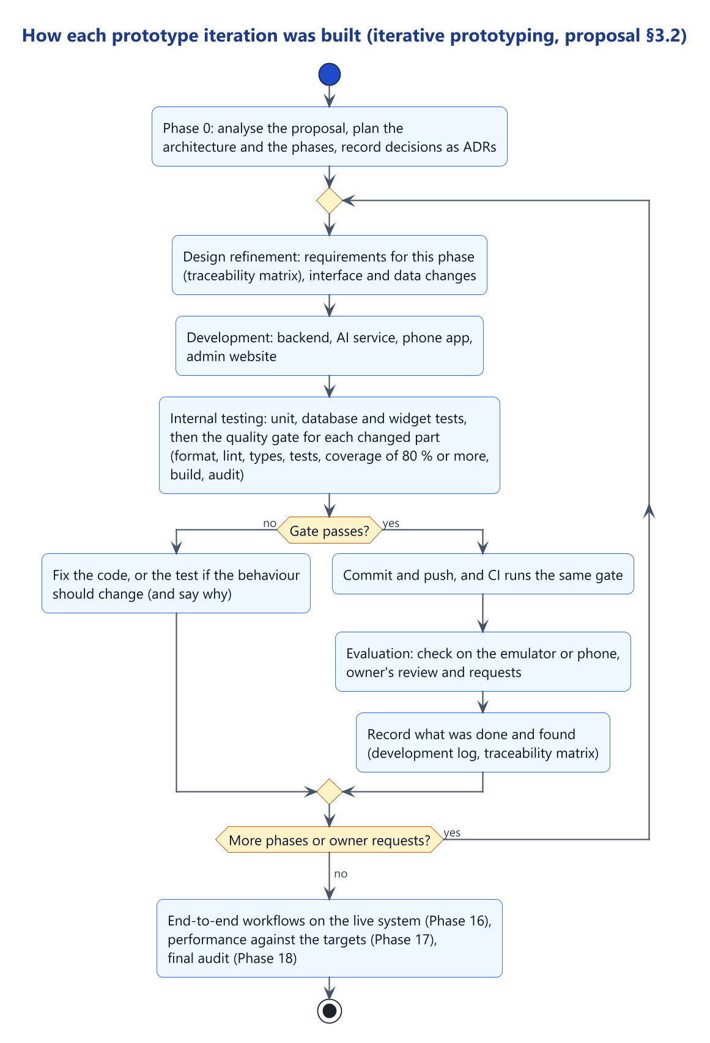
Figure 3.1: The iterative prototyping cycle as followed
- Design refinement. Each phase started from the development plan and the traceability matrix. Lasting decisions were recorded with the options considered and the reasons. When the owner changed the visual design, ADR-004 was superseded and the colours of ADR-006 and ADR-008 replaced; the earlier records were kept as history.
- Development. Code was written test-first where practical, with synthetic data only, in a repository organised by the six architectural layers.
- Internal testing. A quality gate (Section 4.3.2) checked each part, and the same script ran in continuous integration. A phase could not close while the gate failed, and failing tests were fixed, not skipped.
- Evaluation. The owner reviewed each phase on the emulator, in screen renders or through the manual test guide, and the owner's requests fed the next iteration: the separate administration website, the redesign, voice and read-aloud, and the closing of gaps found when the proposal was reread. Evaluation with clinicians and patients is prepared but was not held (Section 4.3.8).
Two departures from the proposal's method should be noted. The iterations were build phases of varying length, not four-week time-boxes. And, as the development log and the security review record, the code, tests and documentation were written with an AI coding assistant (Claude) under the student's direction, with design choices recorded as the owner's decisions. This changed the pace of development but not the method, since every phase passed the same gate.

3.4 Data and Process Modelling

3.4.1 Context and data flow
Figure 3.2 shows the platform as one process, with its users and the outside systems it exchanges data with: SmartCare Pro, the phone's speech services, and the Claude language model, which is optional and off by default.
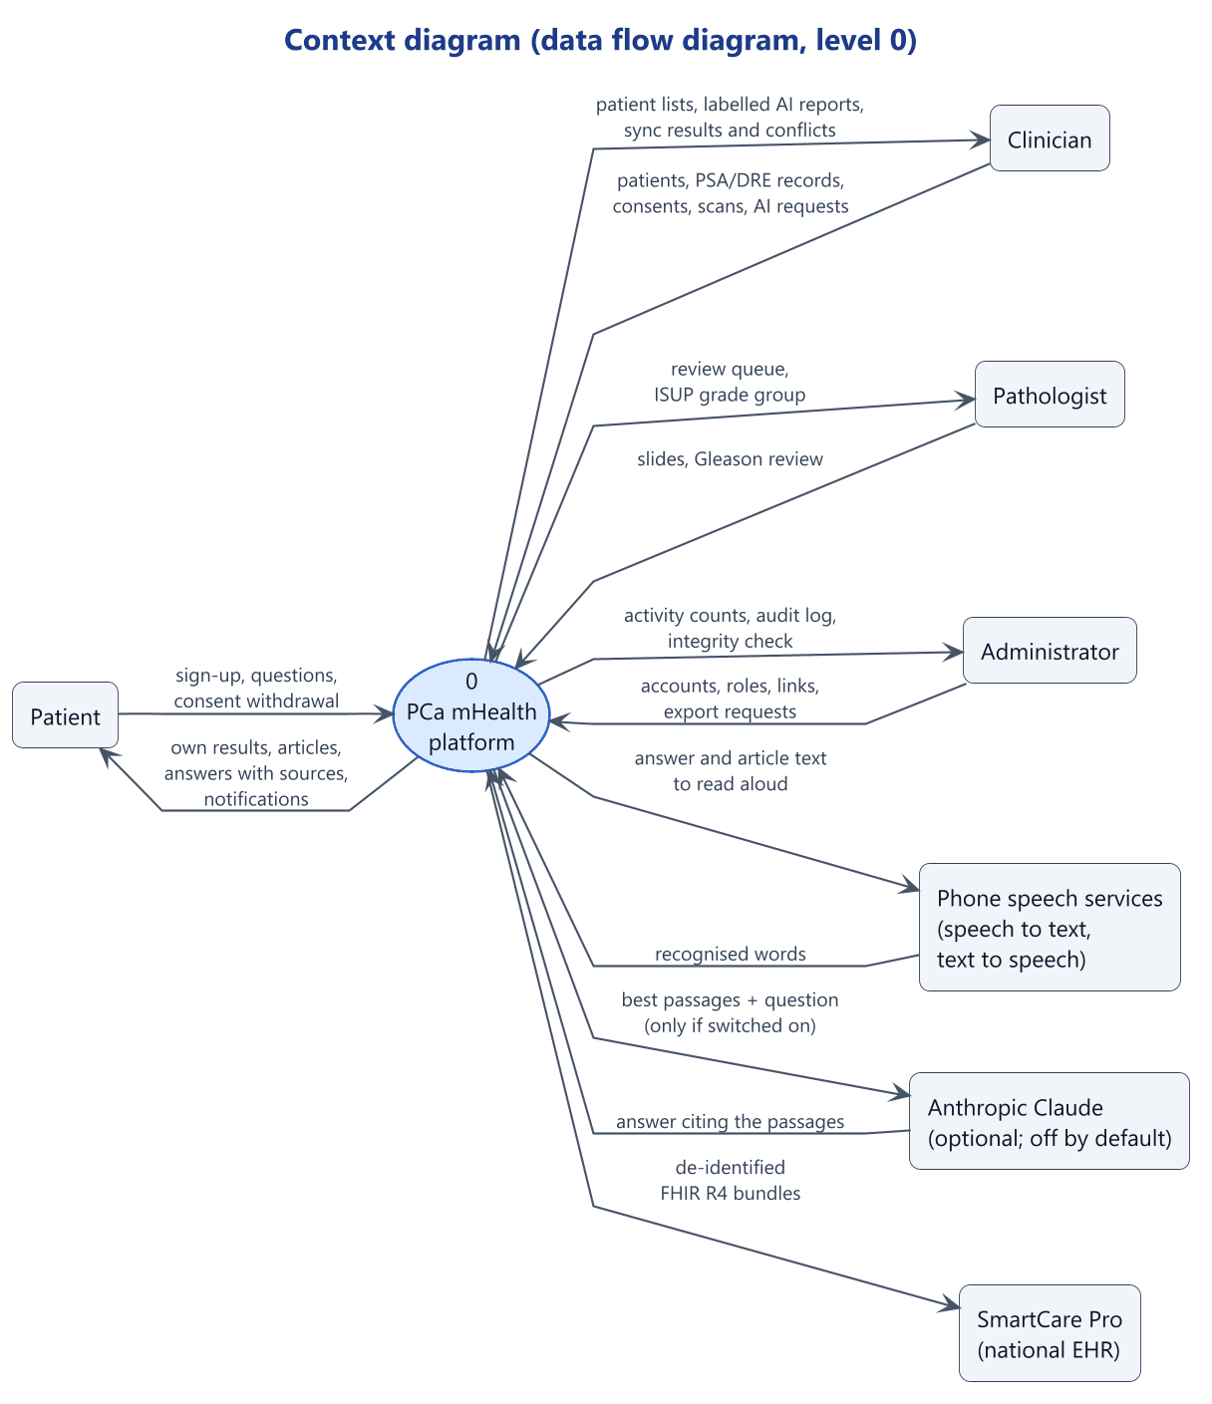
Figure 3.2: Context diagram (DFD level 0)
Figure 3.3 decomposes the platform into eight processes (1.0 authentication, 2.0 account administration, 3.0 patients, screenings and consent, 4.0 scans and slides, 5.0 AI analysis, 6.0 education and questions, 7.0 export to SmartCare Pro, 8.0 audit and monitoring) and eight data stores (D1 to D8, including the hash-chained audit log and the phone's encrypted database and outbox). Two flows are central: process 3.0 writes to the phone first and reaches the server only through the outbox, and process 5.0 reads only consent, clinical values and de-identified copies of scans. Figure 3.4 details process 6.0.
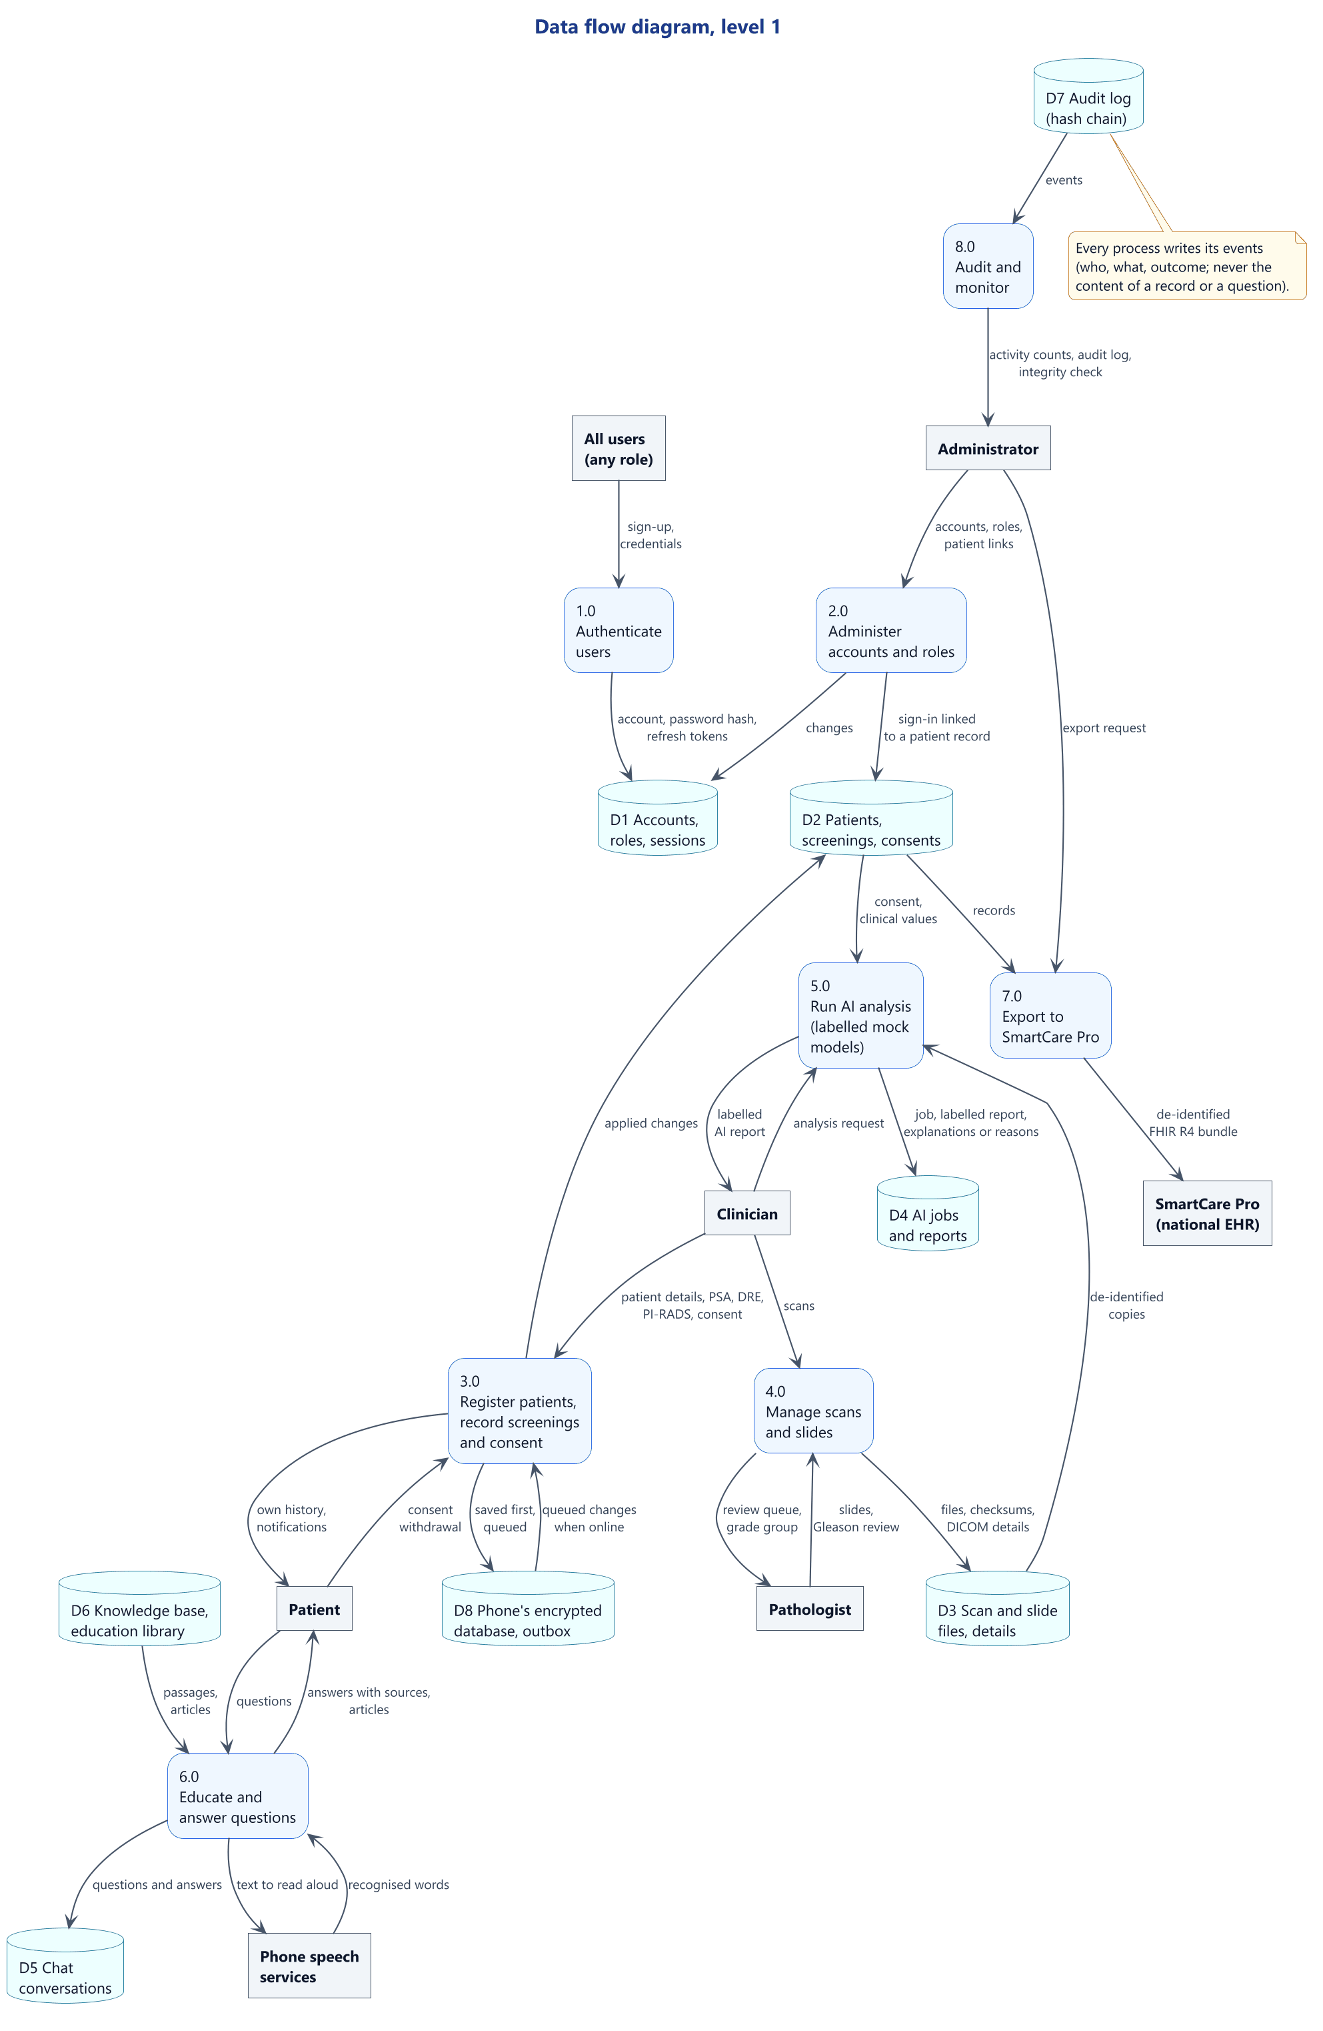
Figure 3.3: Data flow diagram, level 1
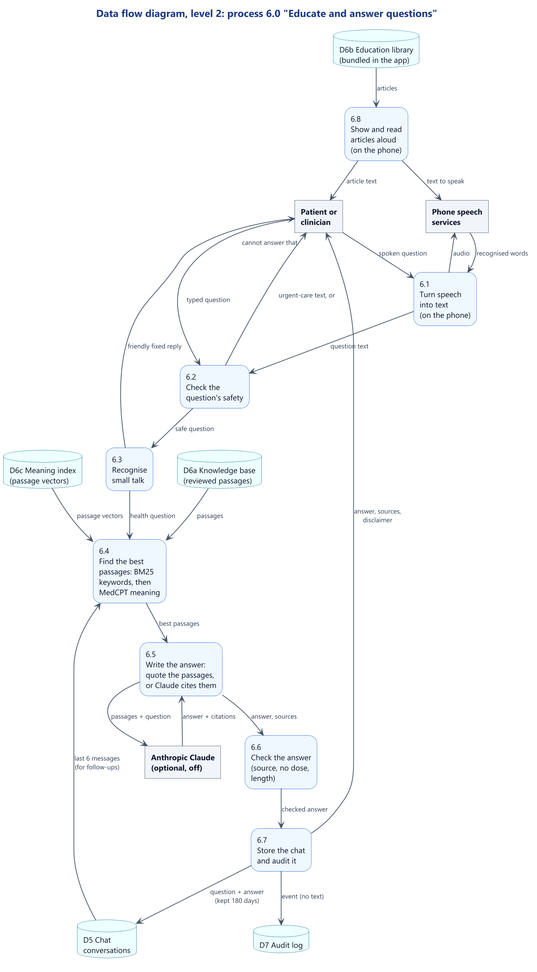
Figure 3.4: Data flow diagram, level 2: the assistant and education

3.4.2 Use case models
Figure 3.5 shows the use cases with their actors; partly built ones are yellow, and those left for later are grey and dashed. Figure 3.6 shows what each role can do in the app, and Figure 3.7 the assistant's use cases.
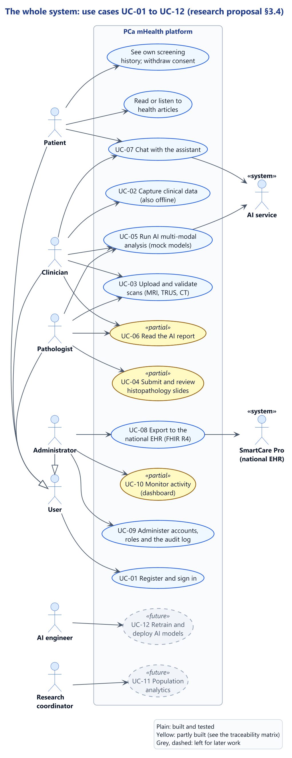
Figure 3.5: Use case diagram: the whole system (UC-01 to UC-12)
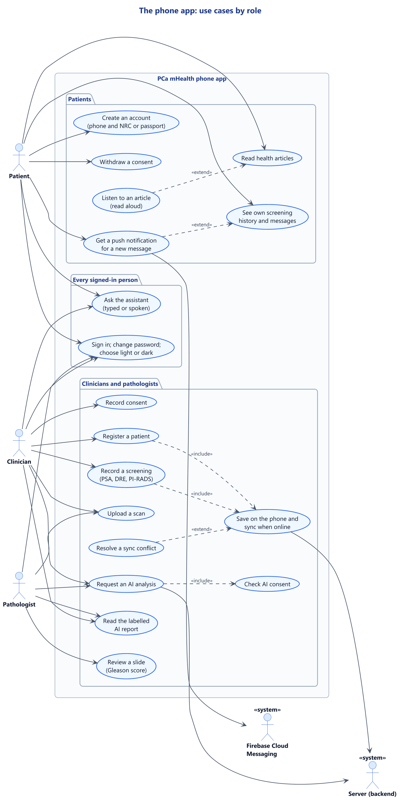
Figure 3.6: Use case diagram: the phone app
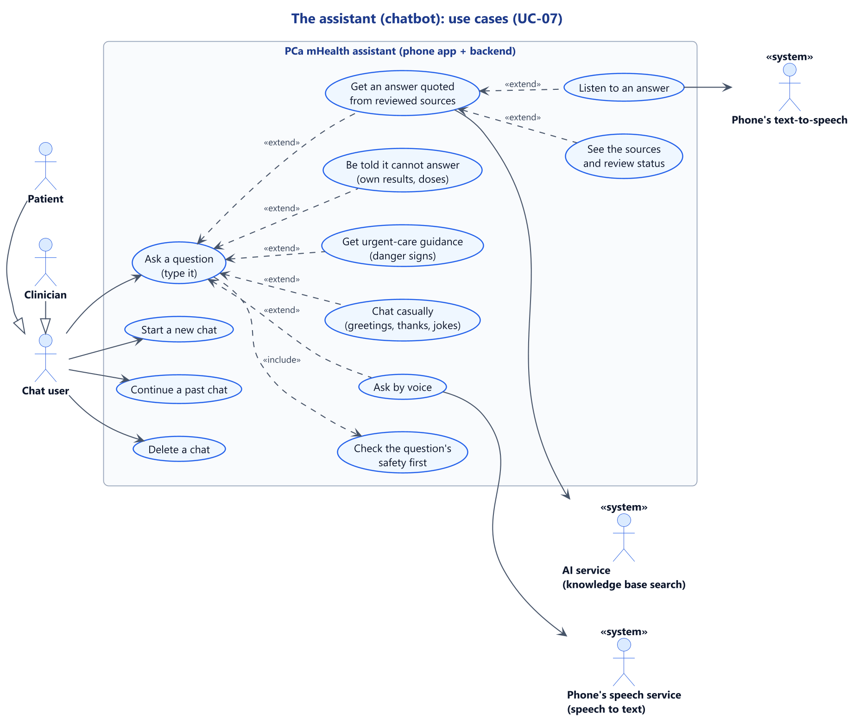
Figure 3.7: Use case diagram: the assistant (UC-07)

3.4.3 Activity models
Figure 3.8 shows each decision in the assistant's answer (Section 3.5.7). Figure 3.9 shows the offline-first design of FR-03: saved on the phone, sent in batches with idempotency keys, and returned as applied, conflict or rejected. Figure 3.10 shows voice input and read-aloud, and Figure 3.11 the AI analysis request, ending in a labelled mock result.
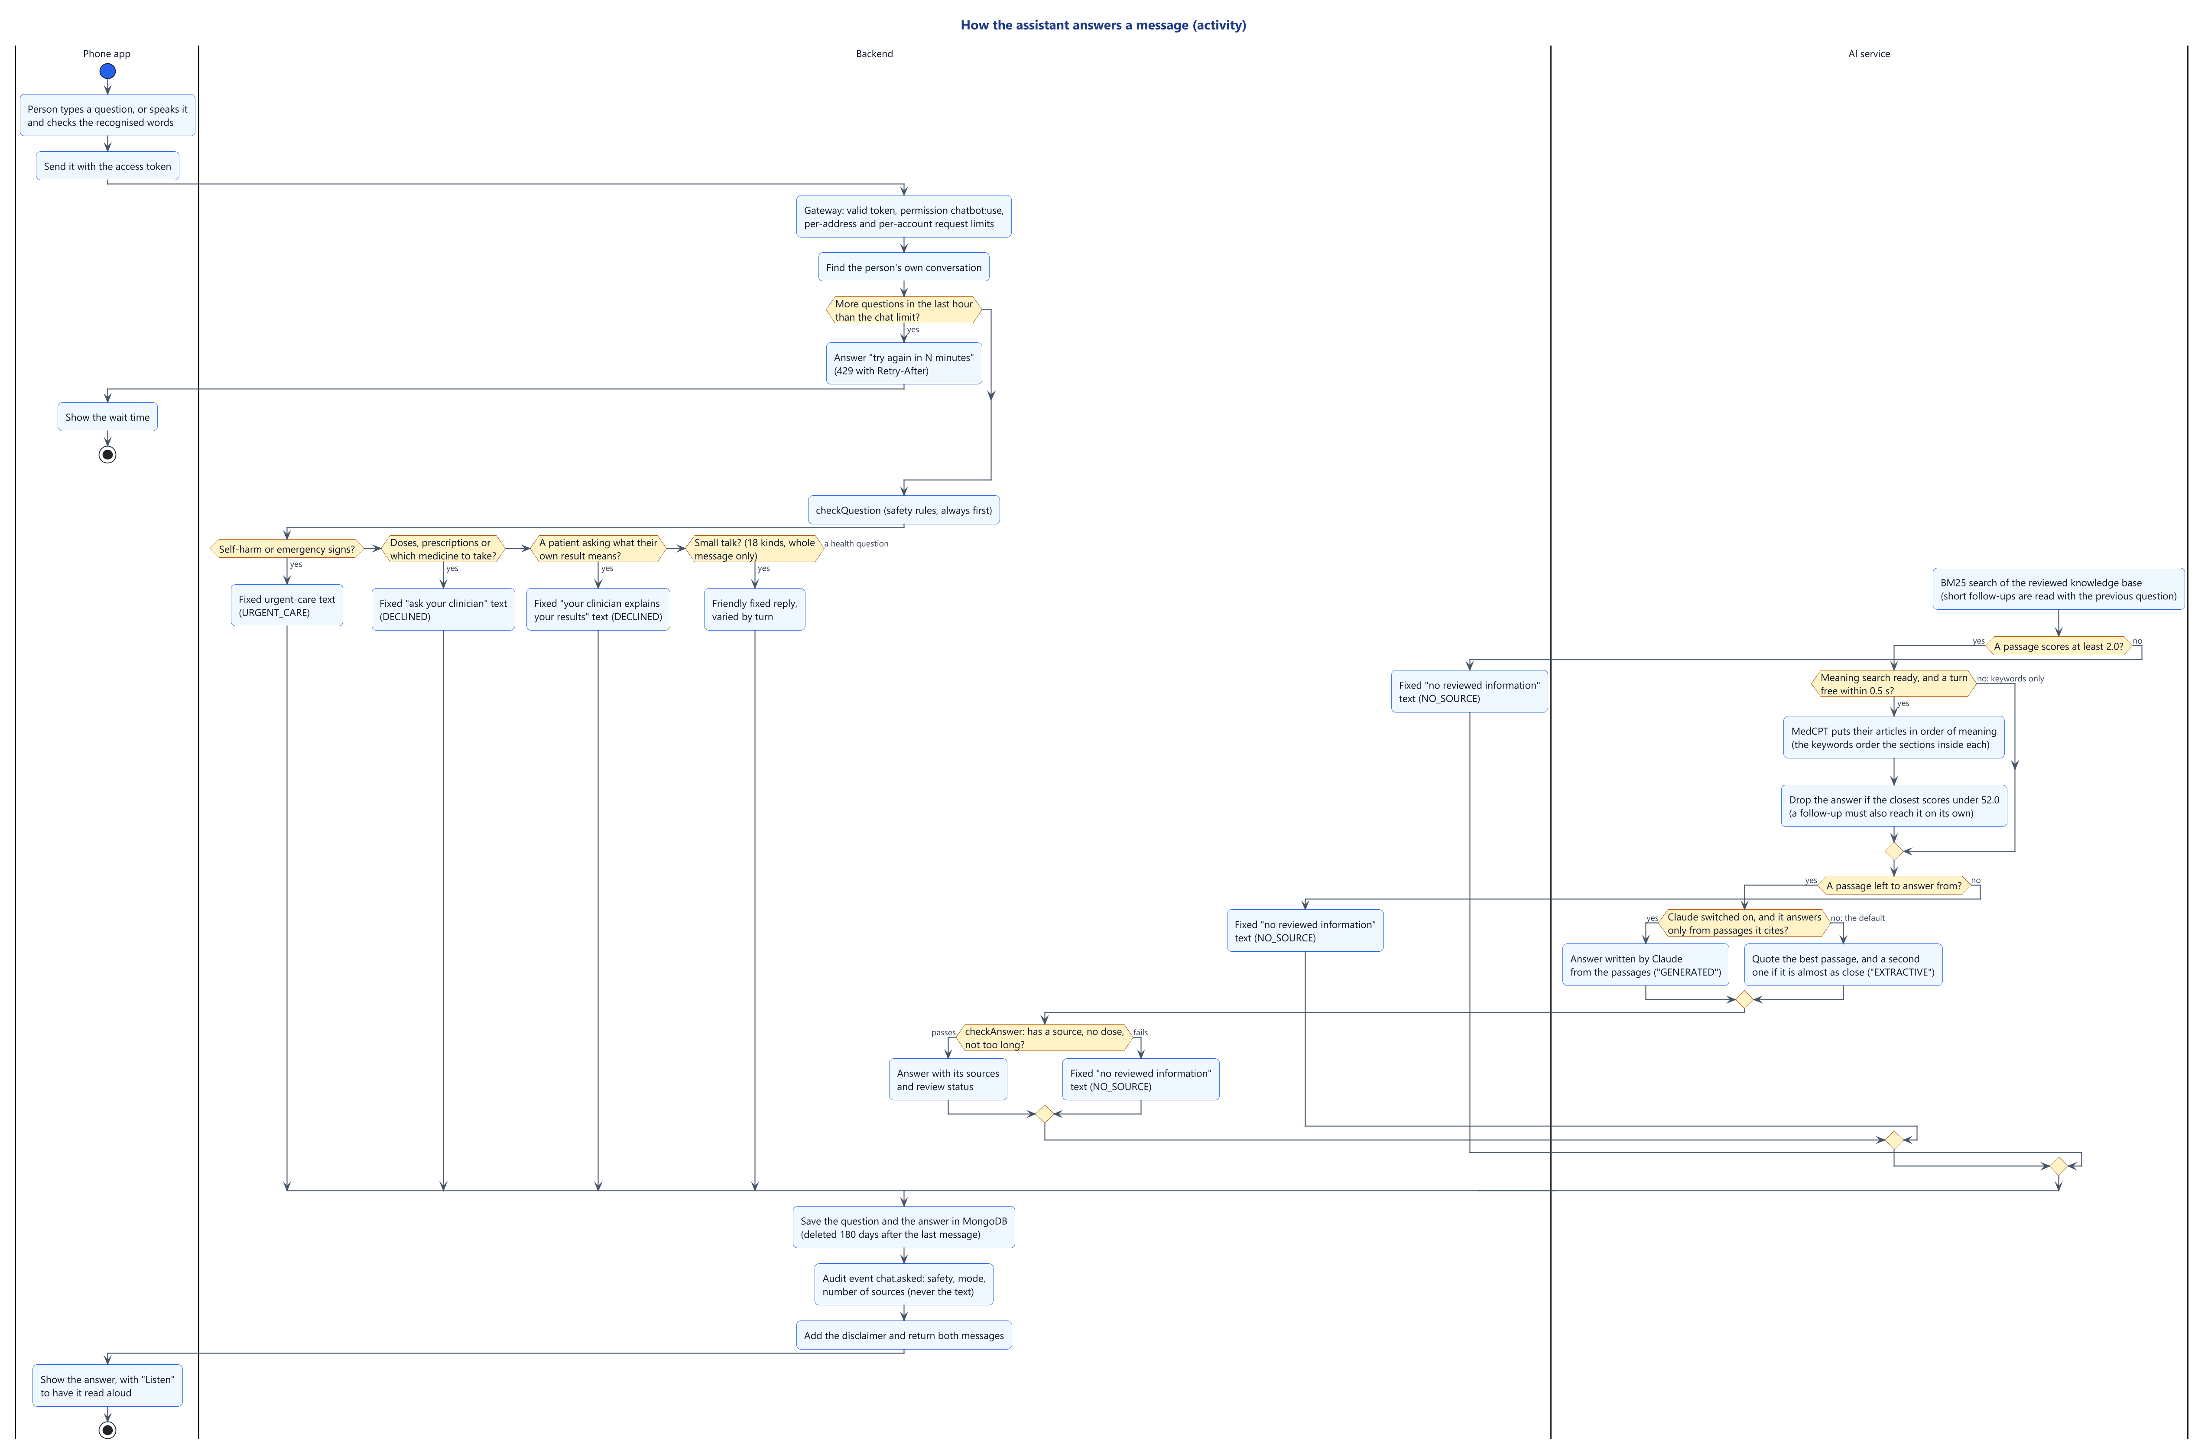
Figure 3.8: Activity diagram: how the assistant answers a message
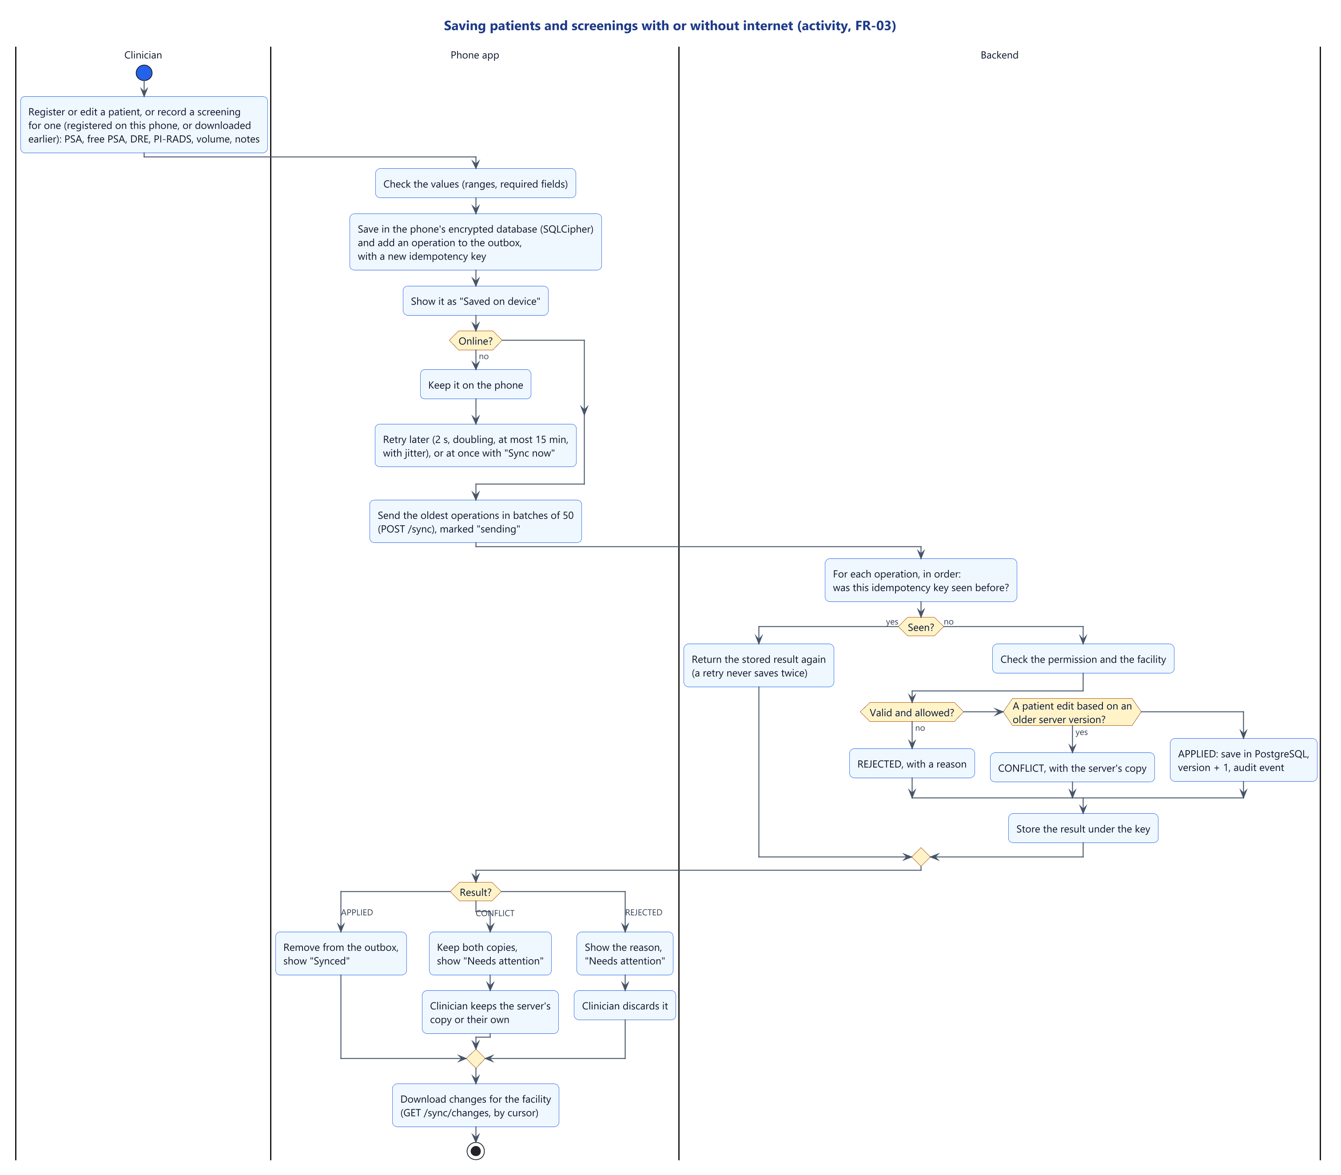
Figure 3.9: Activity diagram: saving patients and screenings with or without internet
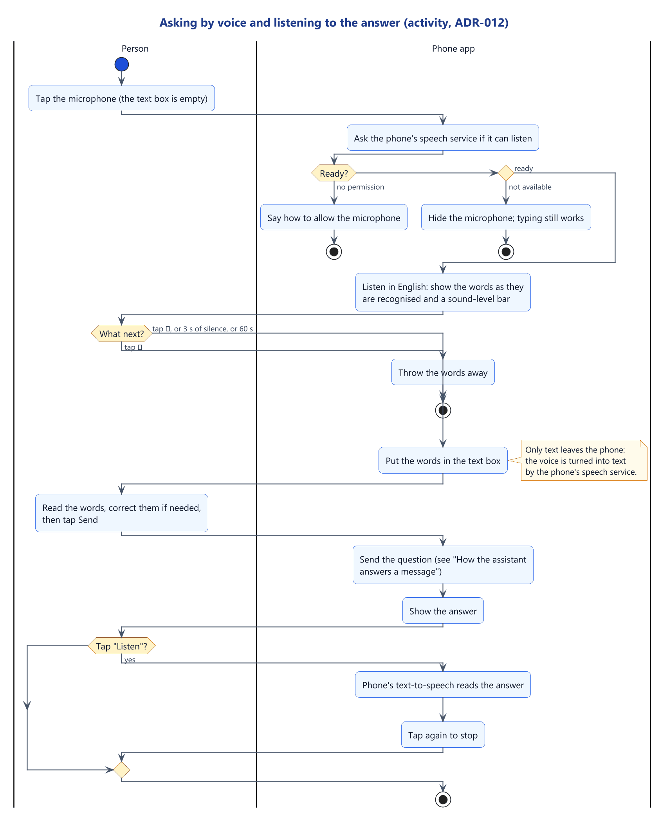
Figure 3.10: Activity diagram: asking by voice and listening to the answer
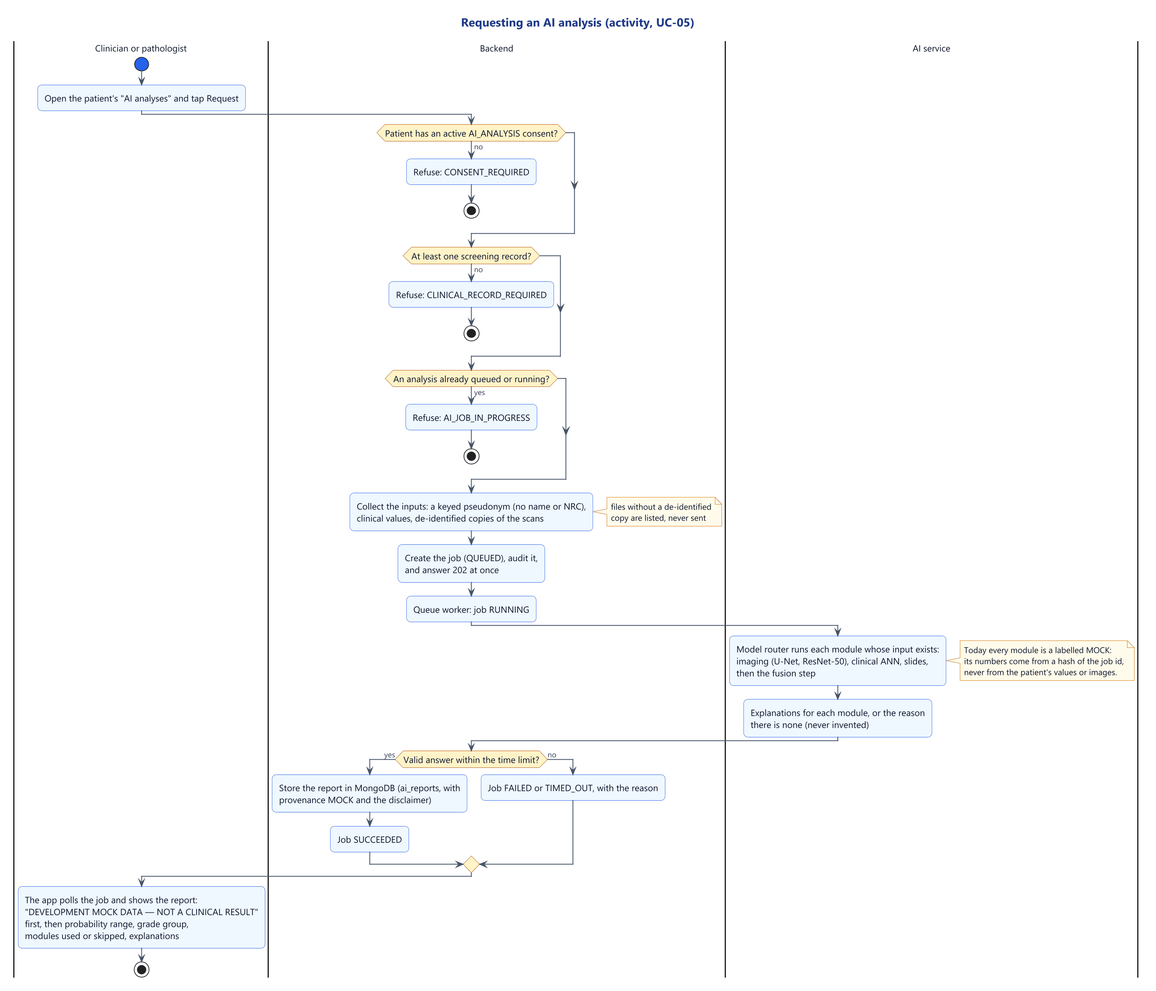
Figure 3.11: Activity diagram: requesting an AI analysis

3.4.4 Sequence models
Figure 3.12 shows sign-in: lockout after five failures, a 15-minute access token, and a refresh token replaced on every use, so that reuse of an old one reveals theft and ends the whole session family (Table 3.7). Figure 3.13 follows a question through the gateway guards, the chatbot service and the AI service to MongoDB and the audit log. Figure 3.14 shows the outbox, the batch and the download of the facility's changes, and Figures 3.15 and 3.16 the AI analysis and the FHIR export with Safe Harbor de-identification. Figure 3.17 shows push notifications: the server's outbox sends each new notification through Firebase as text only, hidden on a locked phone, and sign-out removes the phone.
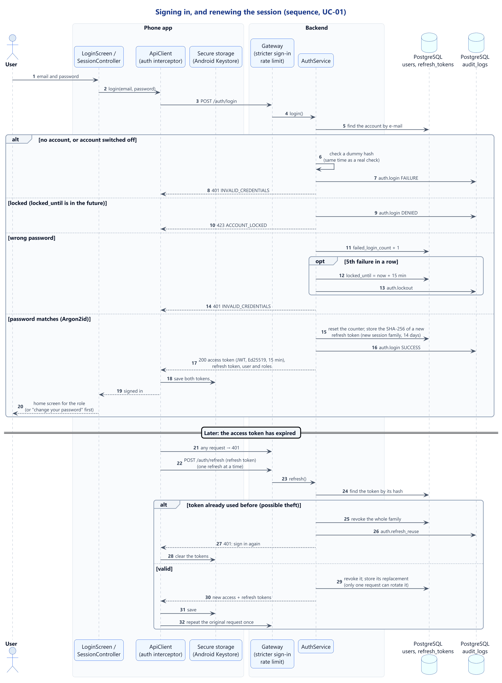
Figure 3.12: Sequence diagram: signing in and renewing the session
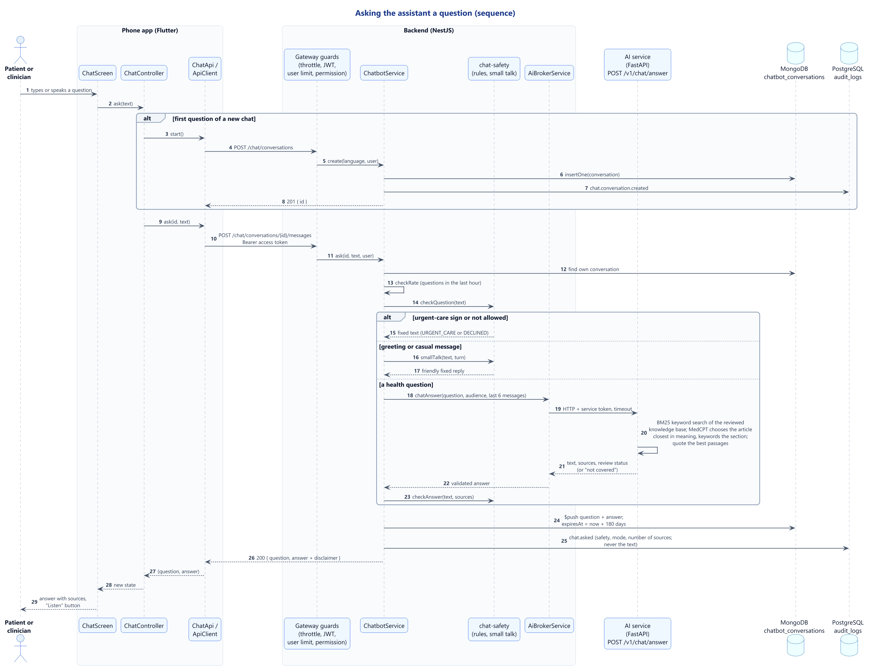
Figure 3.13: Sequence diagram: asking the assistant a question
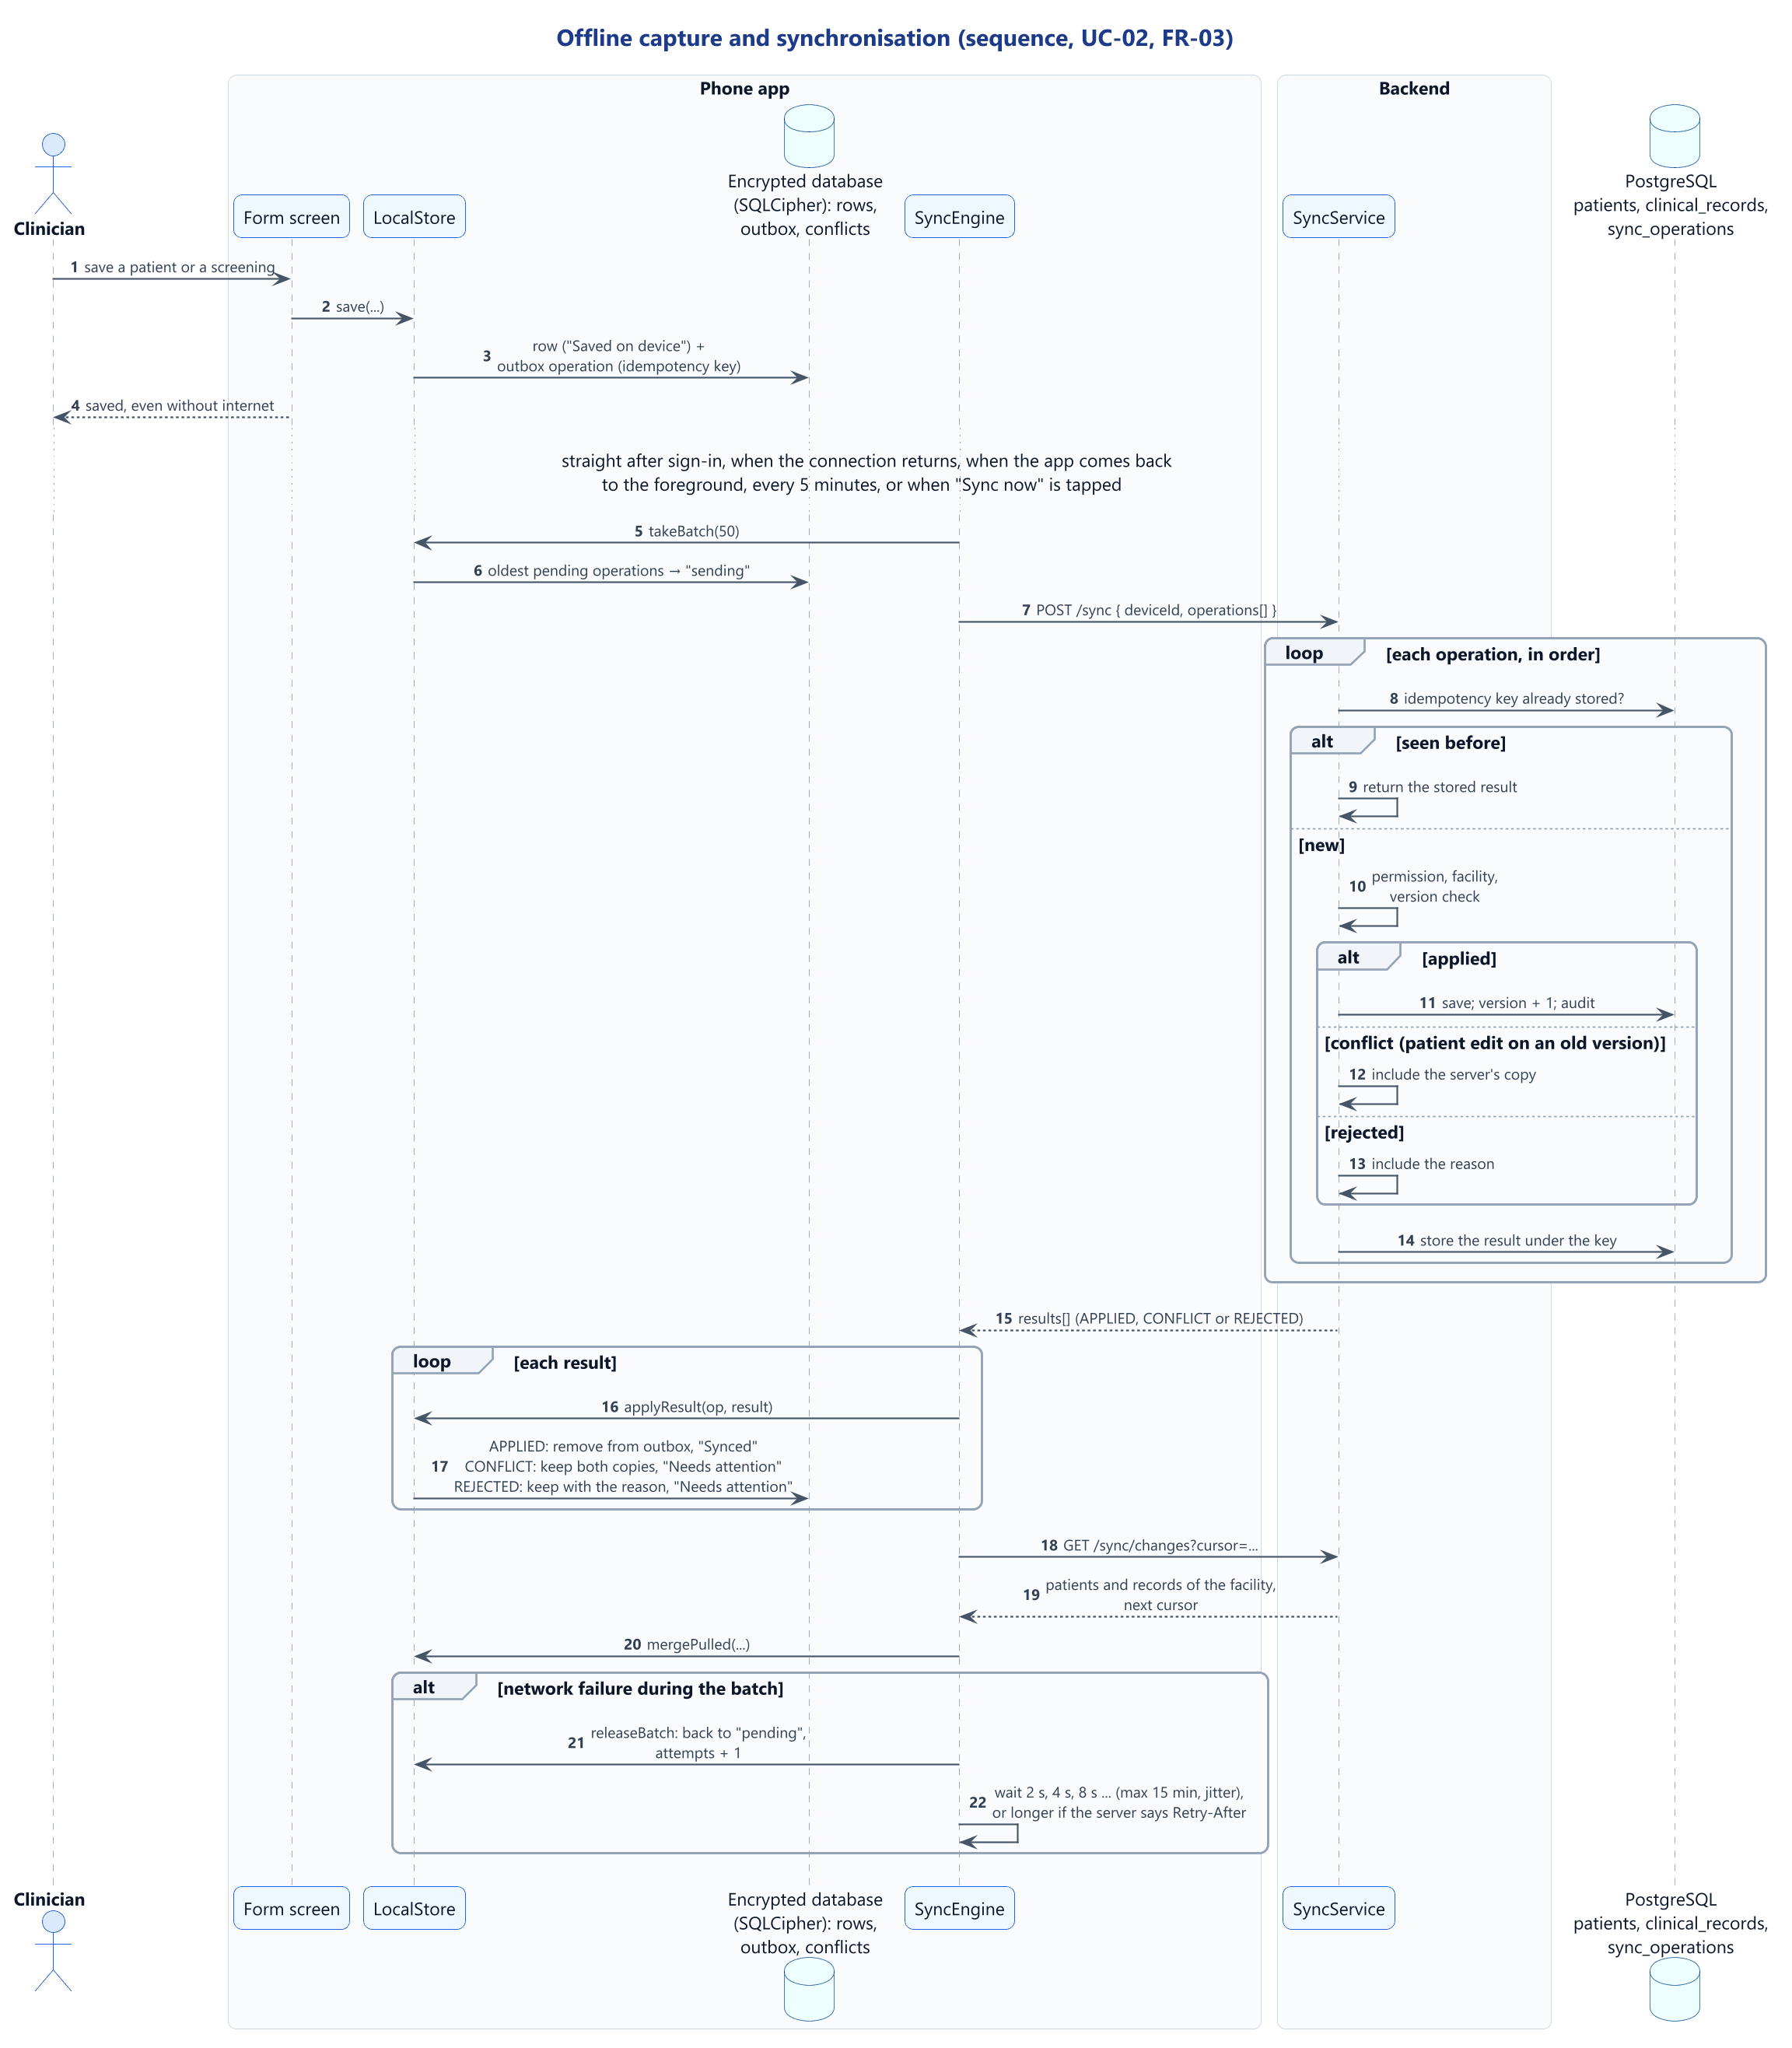
Figure 3.14: Sequence diagram: offline capture and synchronisation
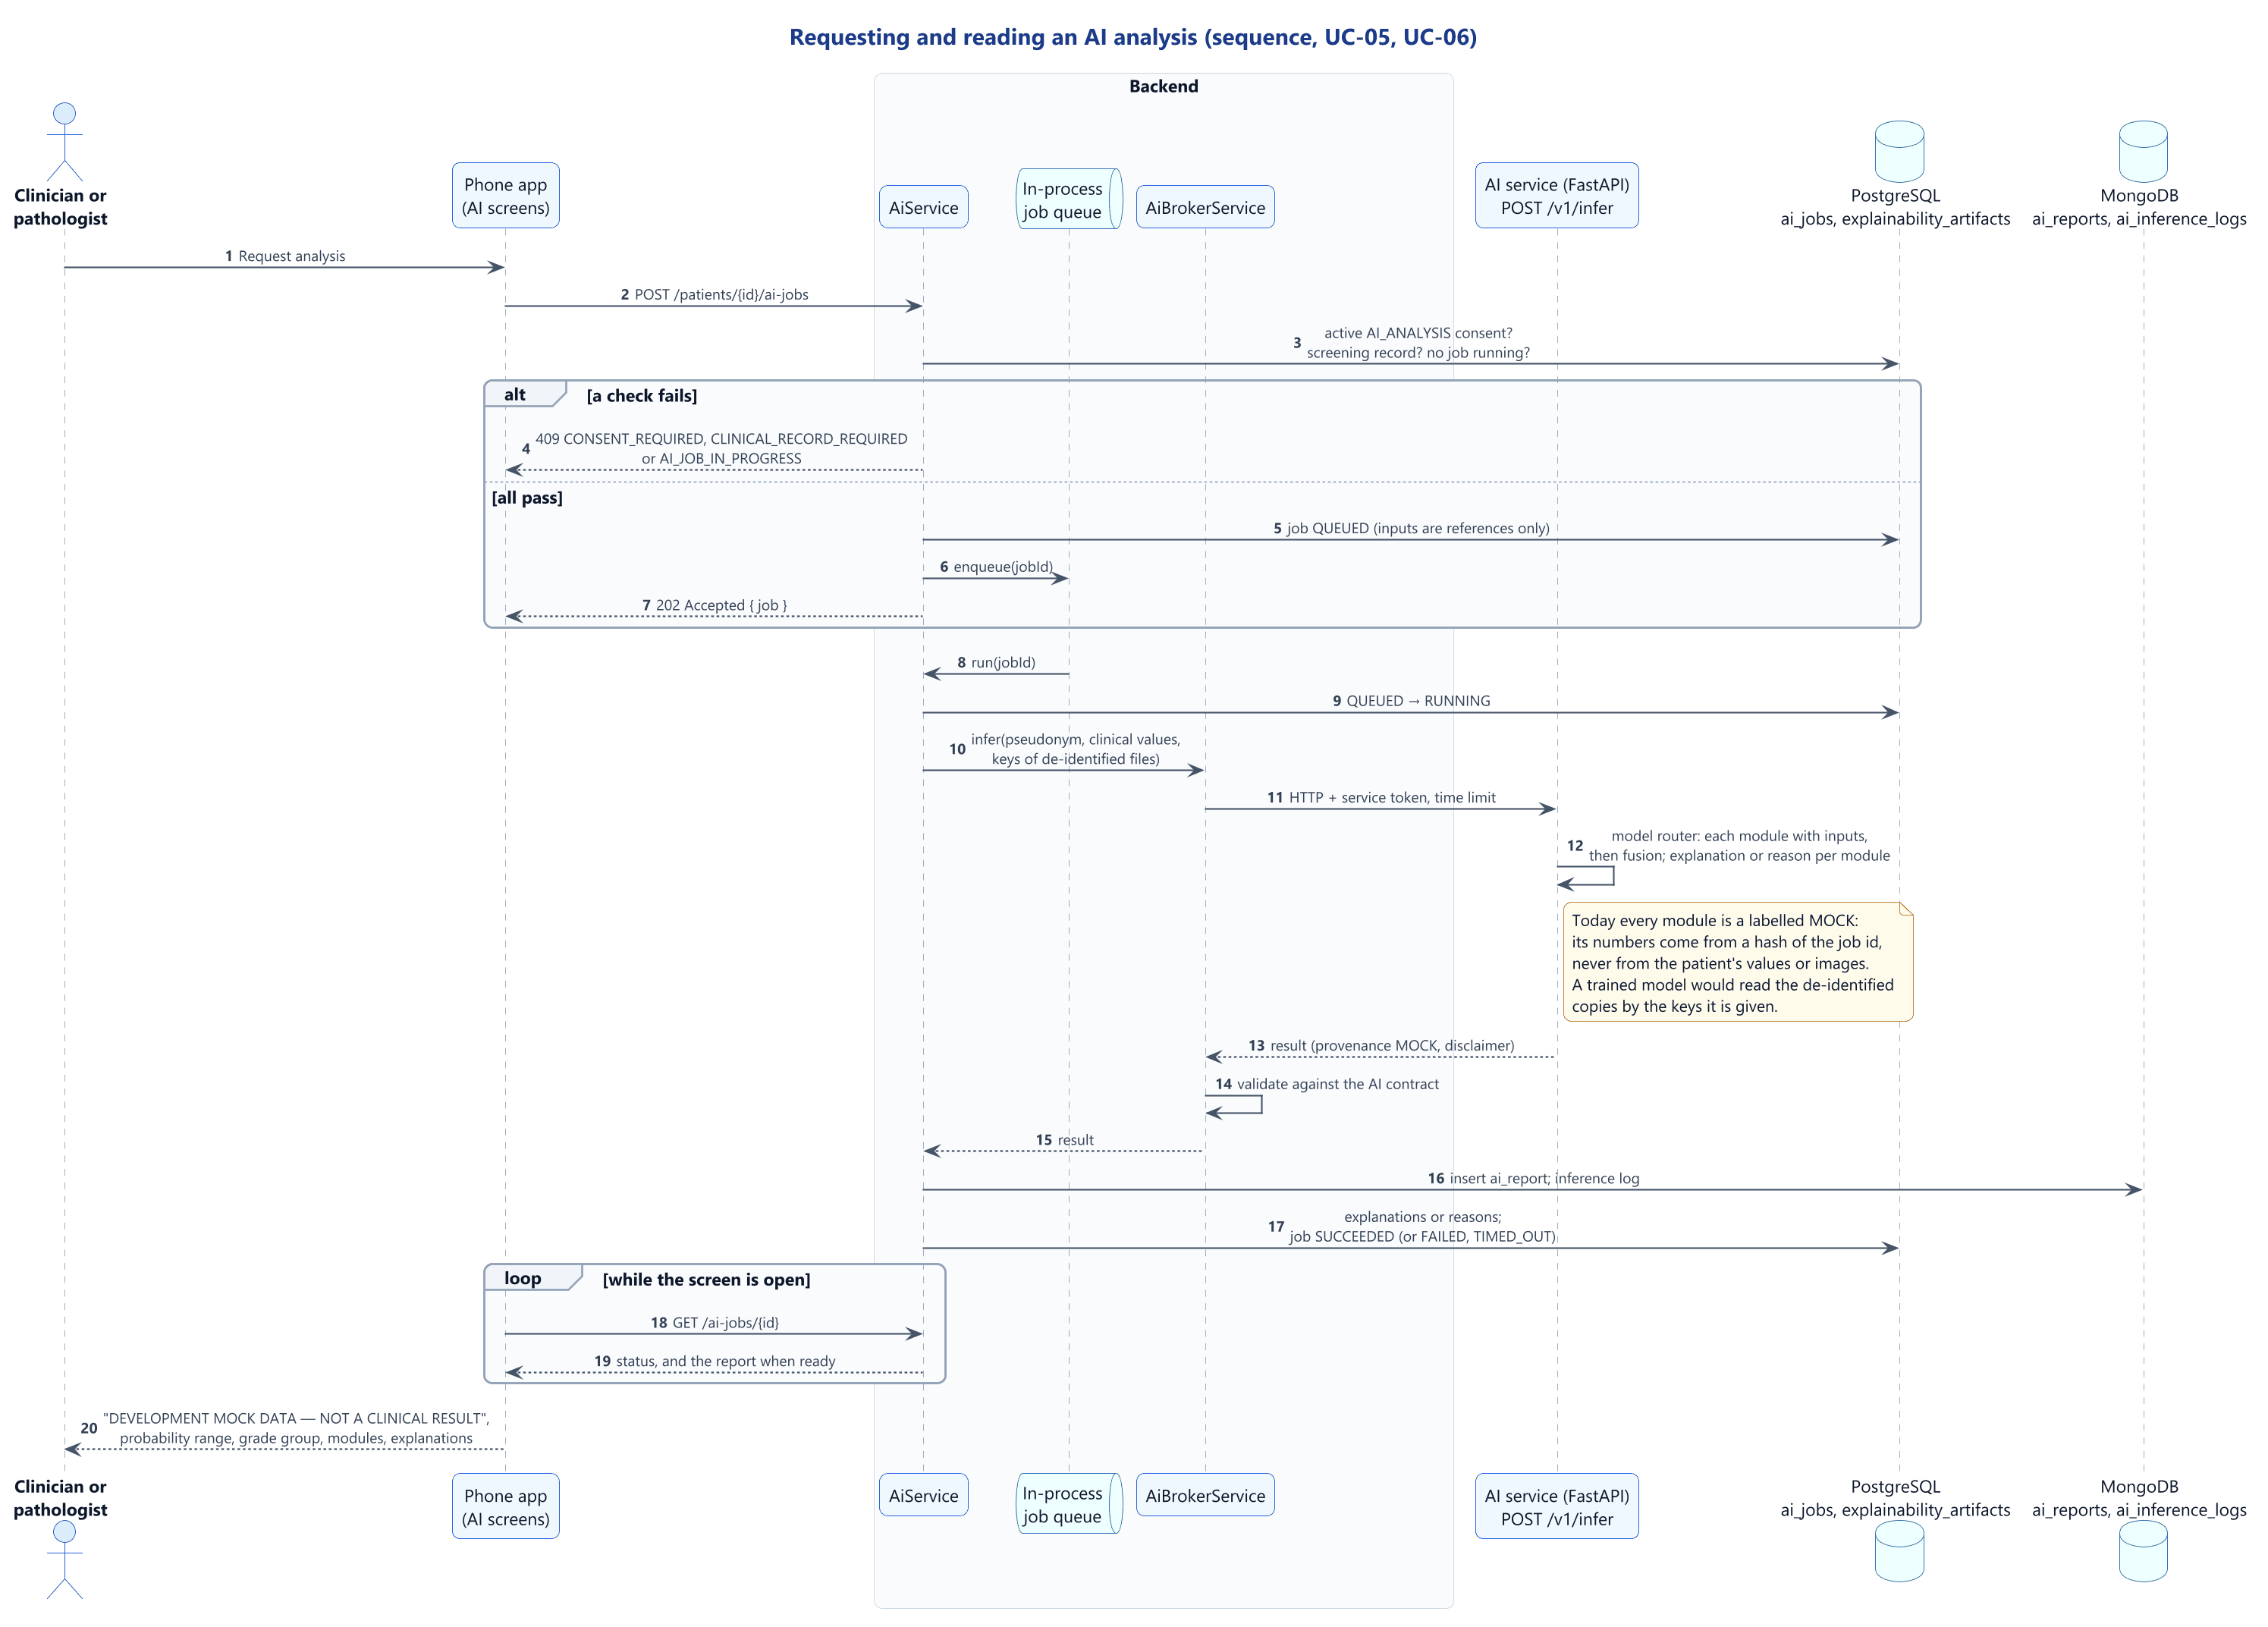
Figure 3.15: Sequence diagram: requesting and reading an AI analysis
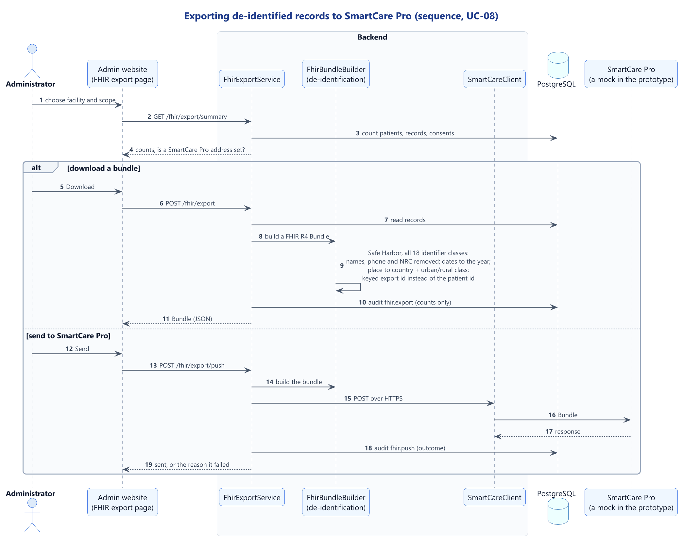
Figure 3.16: Sequence diagram: exporting de-identified records to SmartCare Pro
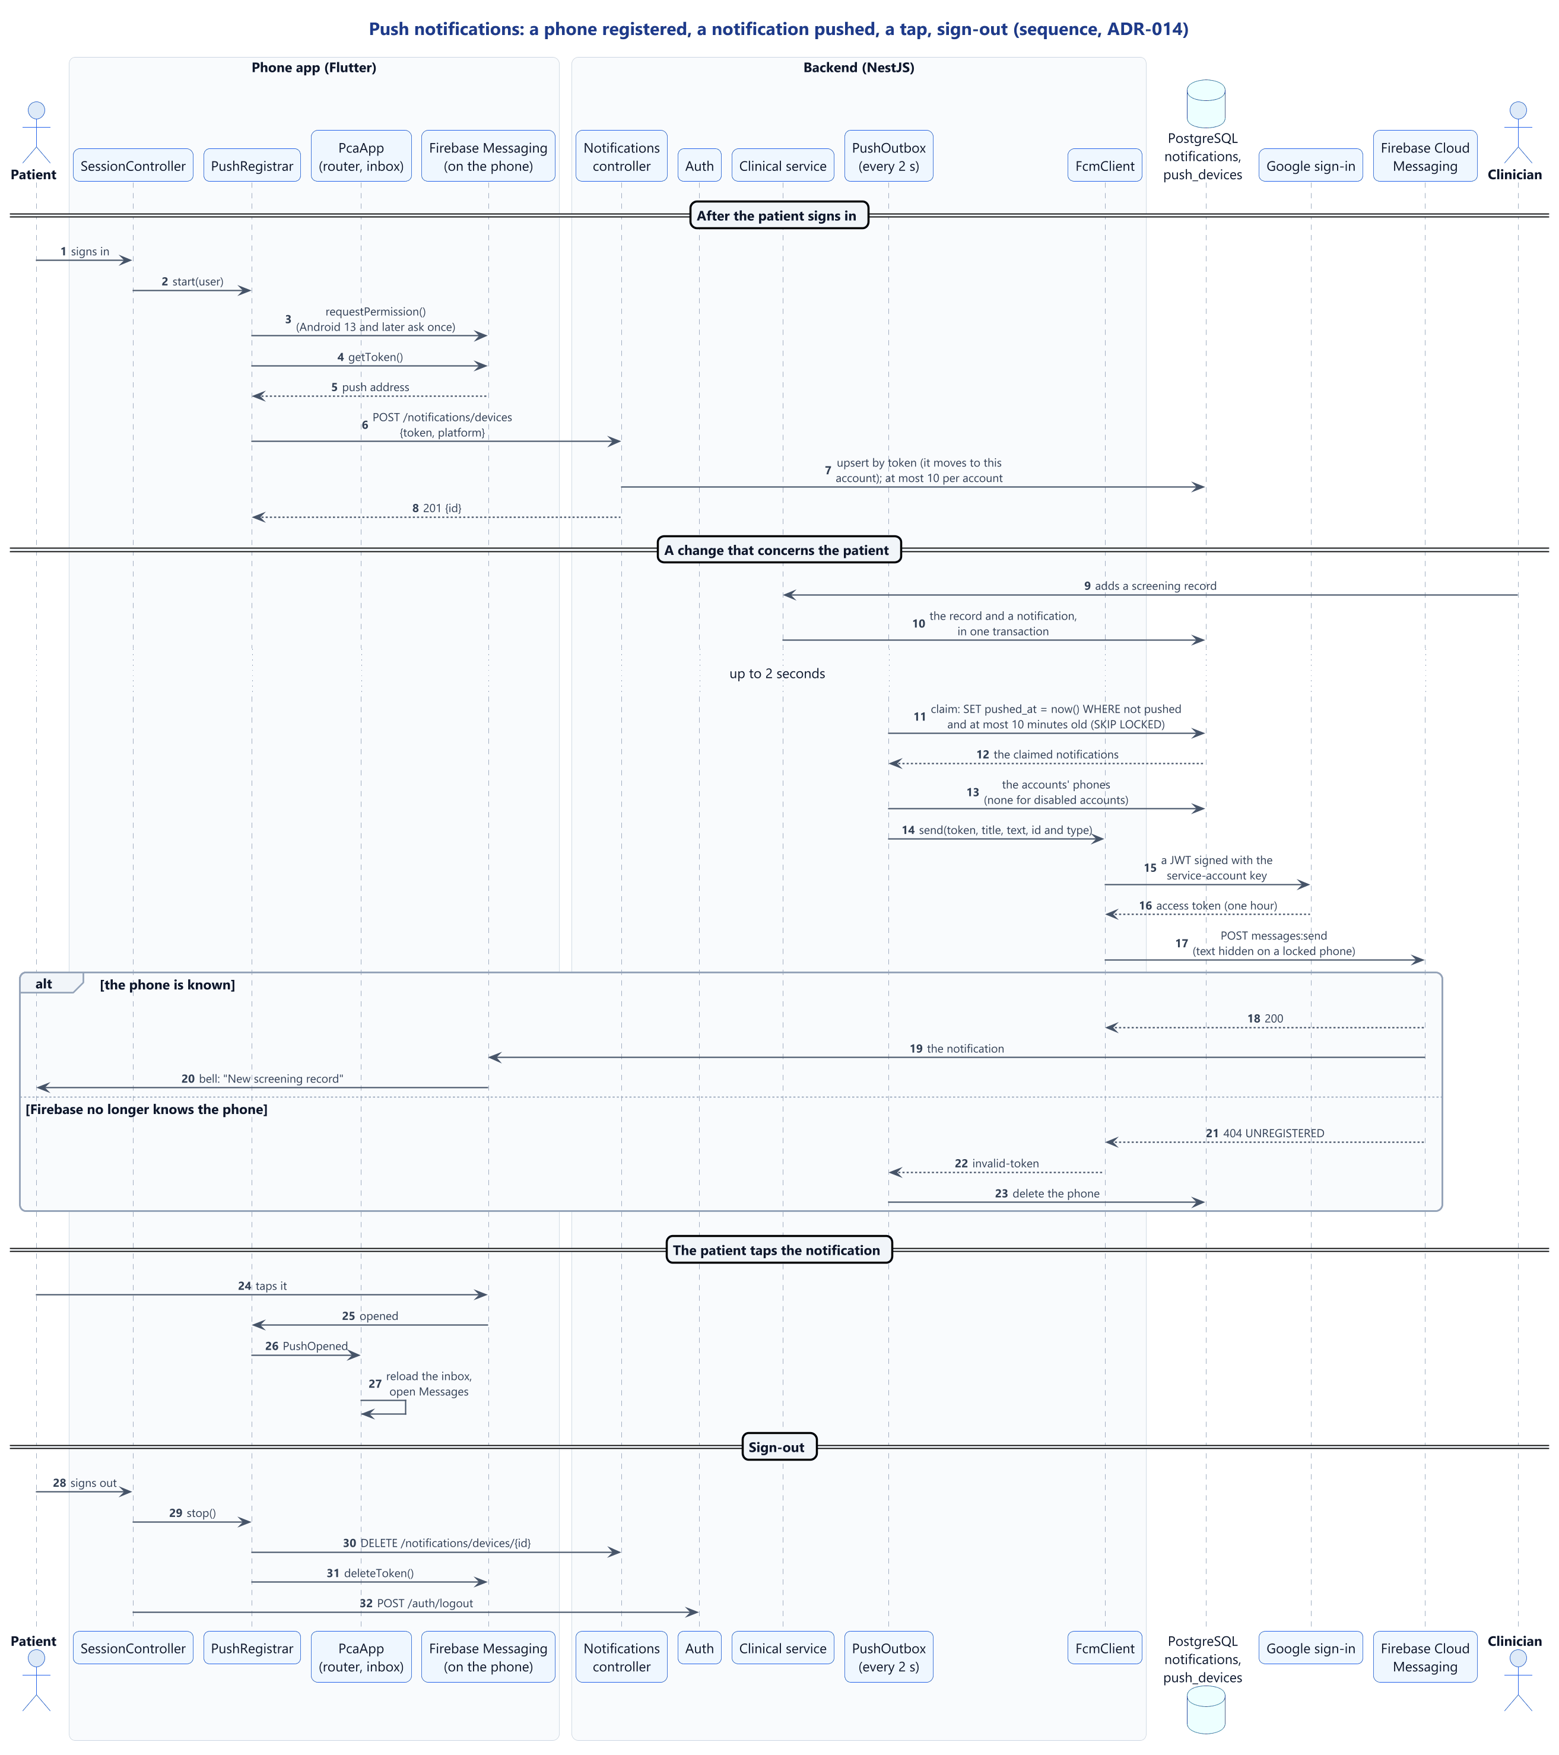
Figure 3.17: Sequence diagram: push notifications

3.4.5 State models
Figure 3.18 shows a change saved on the phone: pending until sent, then synced, or needing attention as a conflict or rejection. Figure 3.19 shows an AI job: queued, running, then succeeded, failed or timed out. Figure 3.20 shows the message box during voice input.
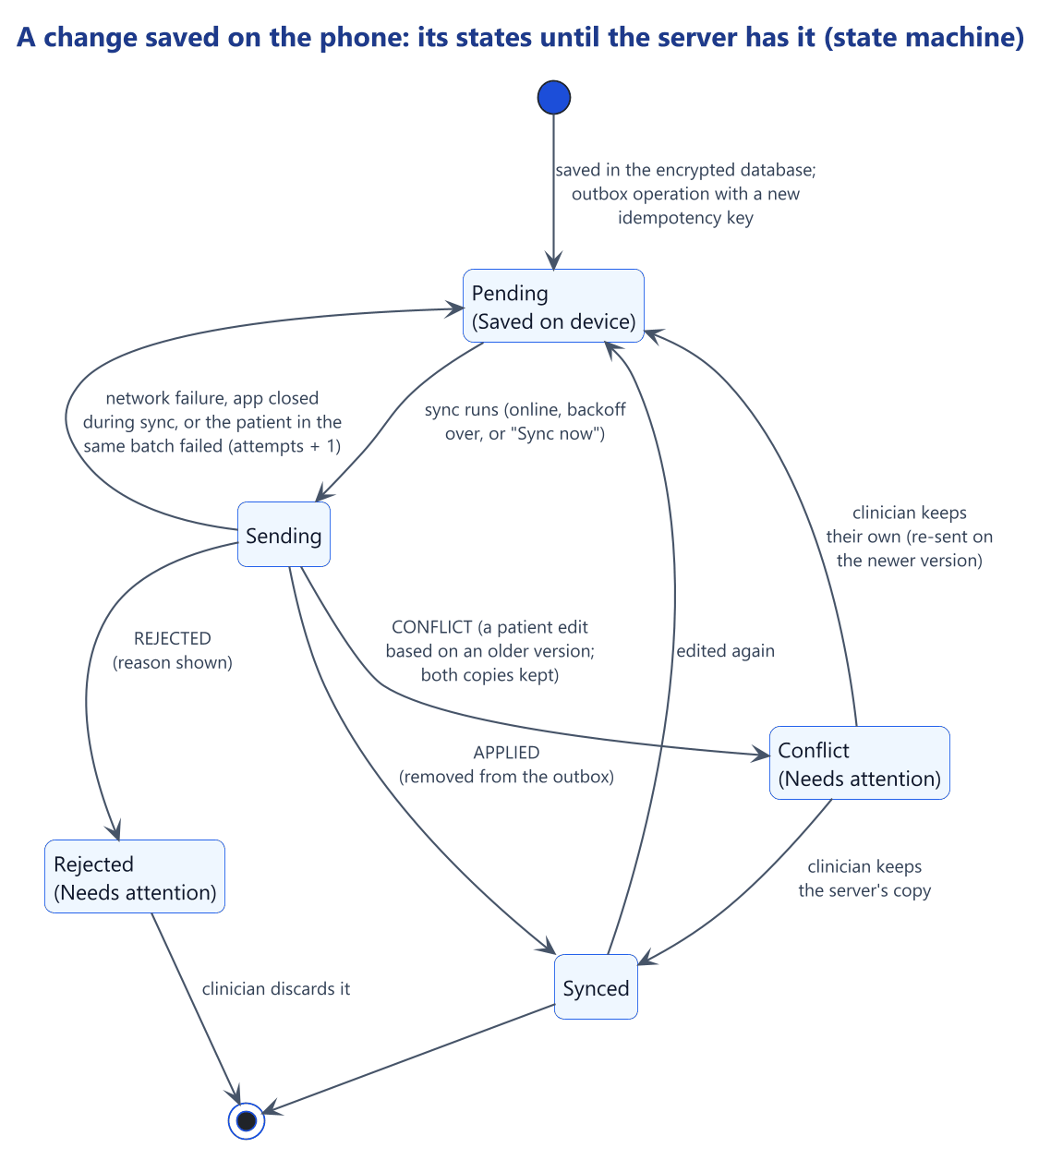
Figure 3.18: State diagram: a change saved on the phone
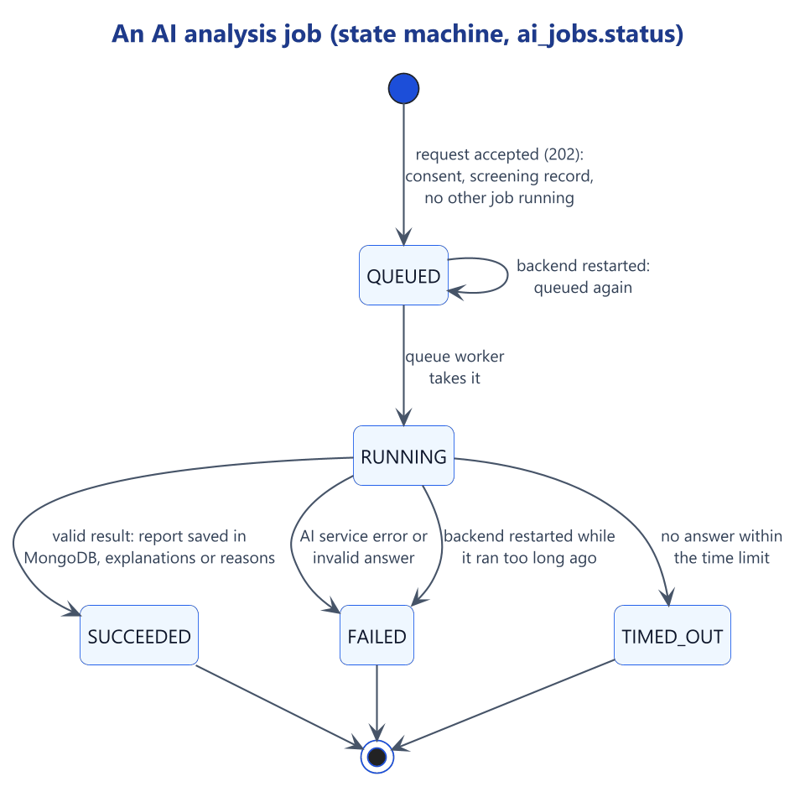
Figure 3.19: State diagram: an AI analysis job
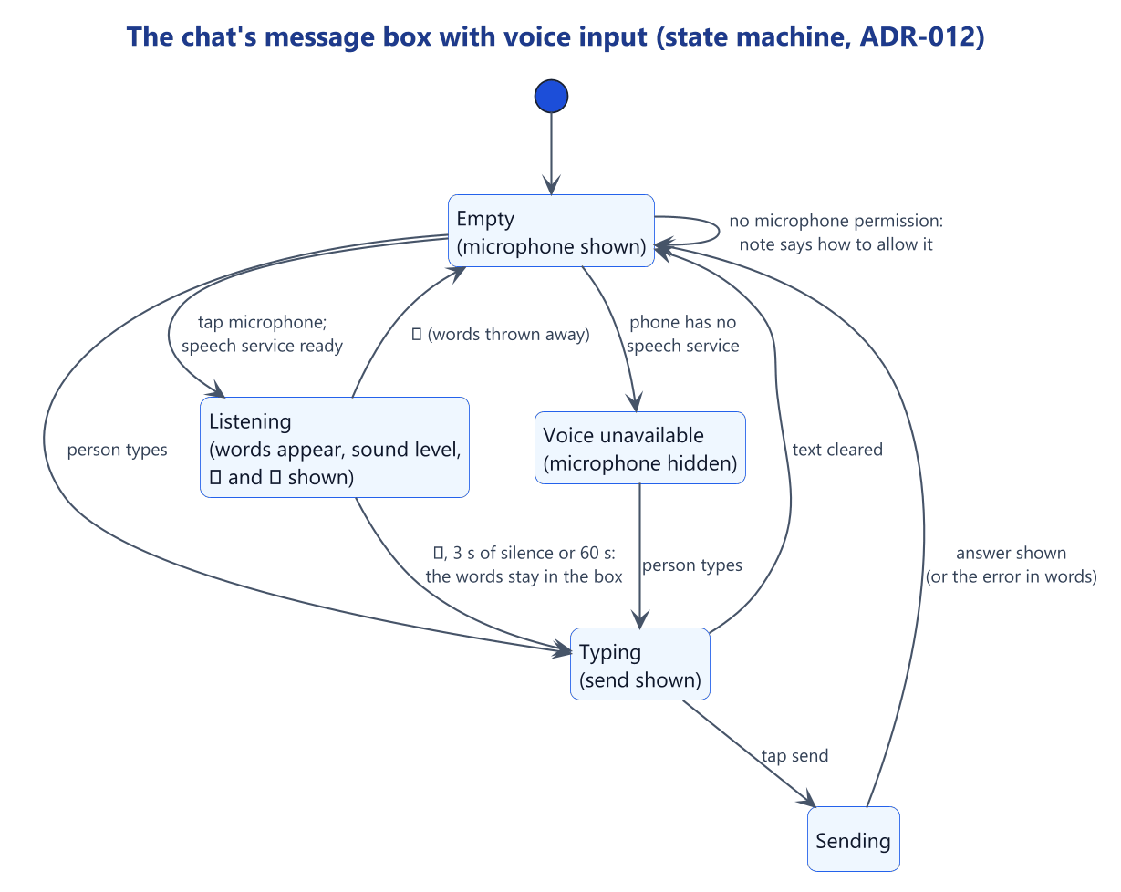
Figure 3.20: State diagram: the chat's message box with voice input

3.5 Program, Database and Interface Design

3.5.1 Architecture
The system keeps the proposal's six layers (Figure 3.21 and Table 3.6), and the repository follows them.
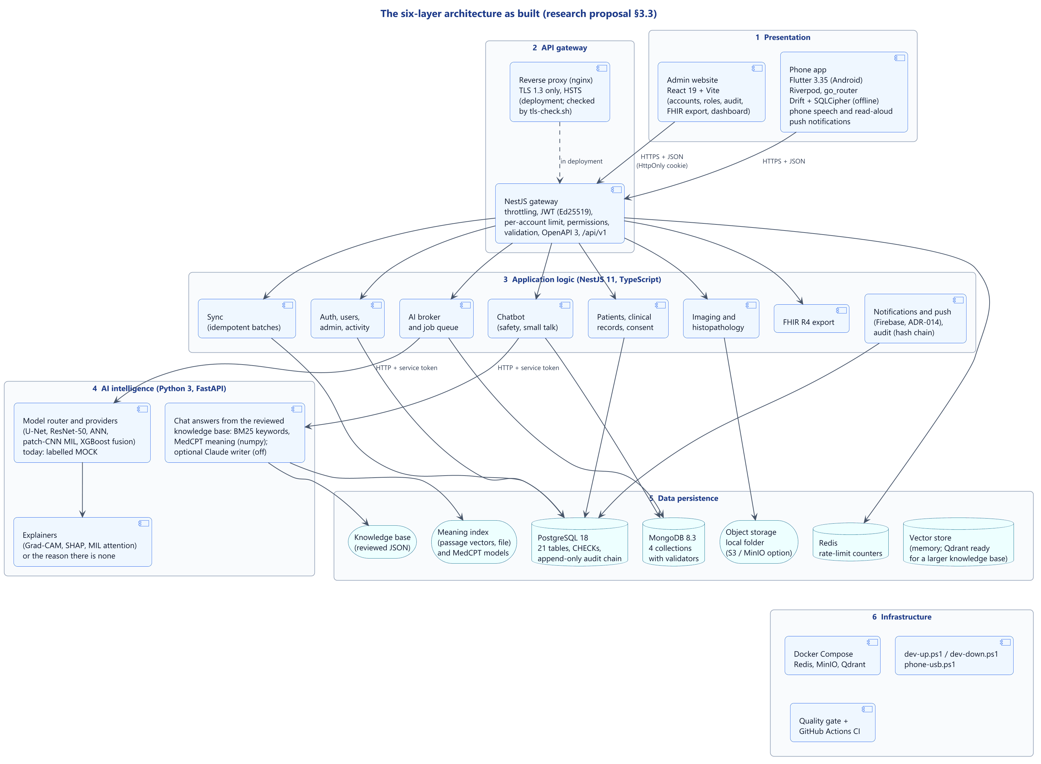
Figure 3.21: The six-layer architecture as built
Table 3.6: Technology of each layer
Layer | Technology in the prototype
1. Presentation | Phone app: Flutter 3.35 (Dart), Riverpod, go_router, Dio, Drift over SQLCipher, secure storage. Admin website: React 19 and TypeScript, built with Vite
2. API gateway | Guards, validation, Redis-shared rate limits, security headers and OpenAPI 3, running first in the backend; an nginx template accepting TLS 1.3 only
3. Application logic | NestJS 11 (TypeScript) on Node.js, Prisma for PostgreSQL, one service module per feature
4. AI intelligence | FastAPI (Python): model router, five model modules (labelled mocks), explanation pipeline, assistant retrieval with a numpy MedCPT encoder
5. Data persistence | PostgreSQL, MongoDB, object storage (local folder or MinIO), Redis; Qdrant available for a larger knowledge base
6. Infrastructure | Docker Compose, PowerShell start and stop scripts, the quality gate, GitHub Actions; Kubernetes and monitoring plans

Contracts separate the layers. The app and the website never reach a database or the AI service directly, so every rule is enforced in one place, the backend. The backend reaches the AI service only through a versioned HTTP contract with a service token, so real models can replace the mocks without changing the backend, database or app. Figure 3.22 shows where each part runs. PostgreSQL 16 and MongoDB 7 ran in Docker until 29 September 2026, when the data was moved, at the owner's request, to the PostgreSQL 18 and MongoDB 8.3 servers installed on the laptop, with identical row counts and an intact audit chain.

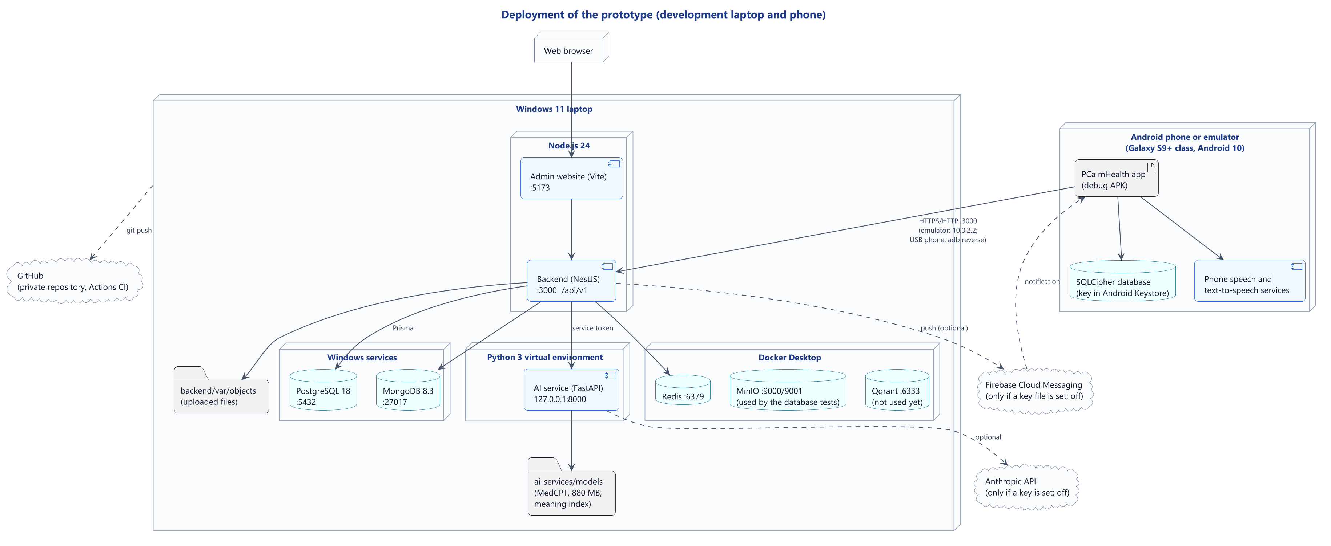
Figure 3.22: Deployment diagram

3.5.2 Program design of the backend
The backend has three folders that mirror the architecture: gateway (which every request passes), services (one module per feature: authentication, users, patients, clinical records, imaging, AI, chatbot, synchronisation, notifications, FHIR, administration and audit) and persistence (database clients, file storage, field encryption, seed data). Each feature has a controller that declares its routes and permissions, data transfer objects that define what may be sent and returned, and a service that holds the rules and writes the audit entry (Figure 3.23).
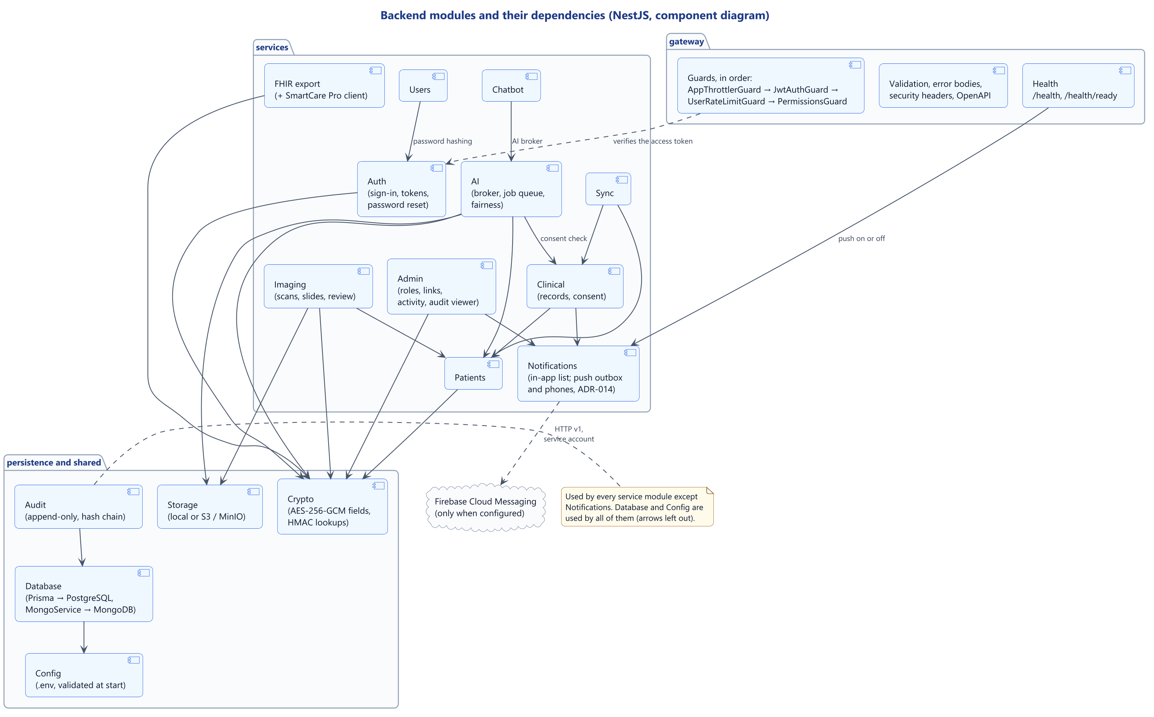
Figure 3.23: Component diagram: the backend modules
Four guards run on every route, in order, and a route is closed unless the code explicitly opens it: a per-address rate limit (600 requests a minute), authentication of the access token, a per-account rate limit (120 requests a minute), and the permission check, which audits every refusal. Services then check each resource's scope: a clinician sees only patients of their own facility, and a request for another facility's patient returns "not found", which hides its existence.

3.5.3 Class design
Figure 3.24 shows the app's assistant, voice input and read-aloud, whose speech services sit behind small interfaces that tests can replace. Figure 3.25 shows the app's offline storage and synchronisation, and Figure 3.26 the server-side assistant.
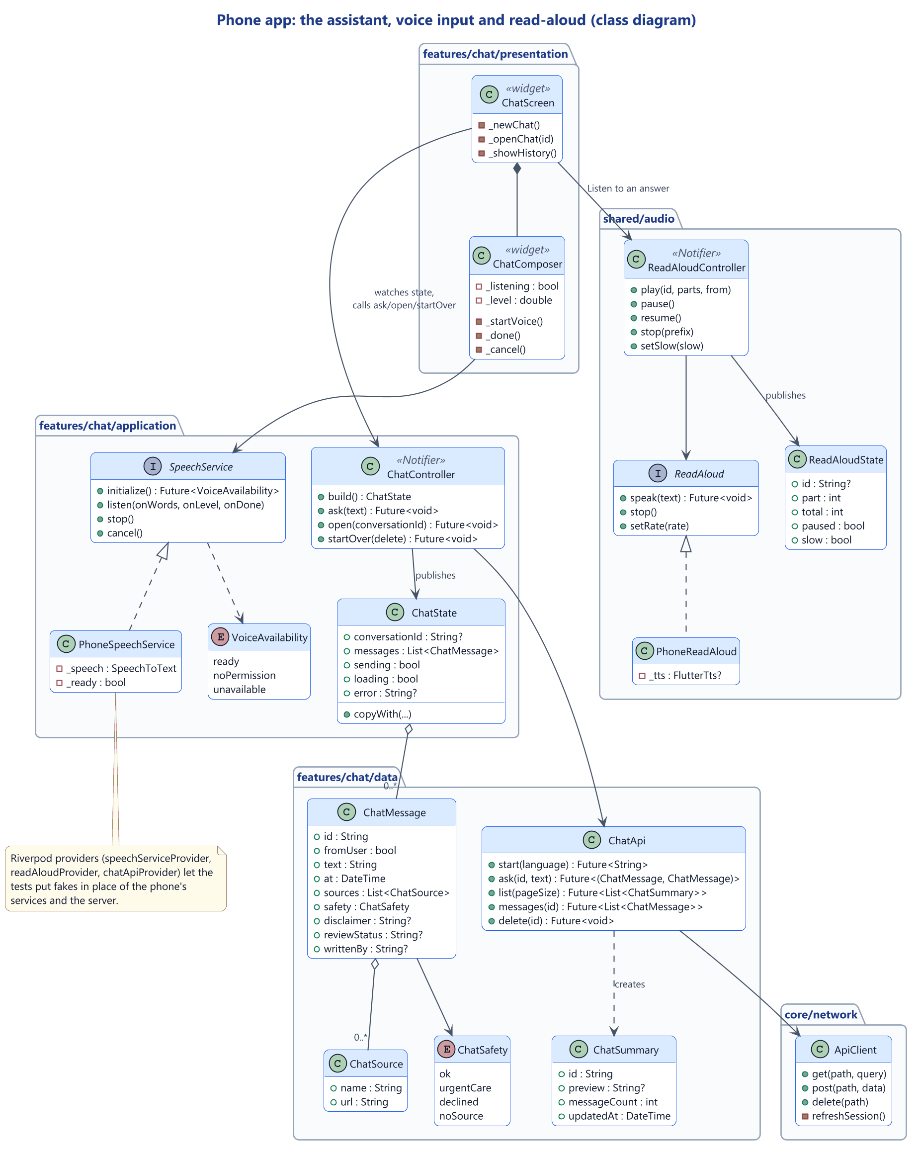
Figure 3.24: Class diagram: the app's assistant, voice input and read-aloud
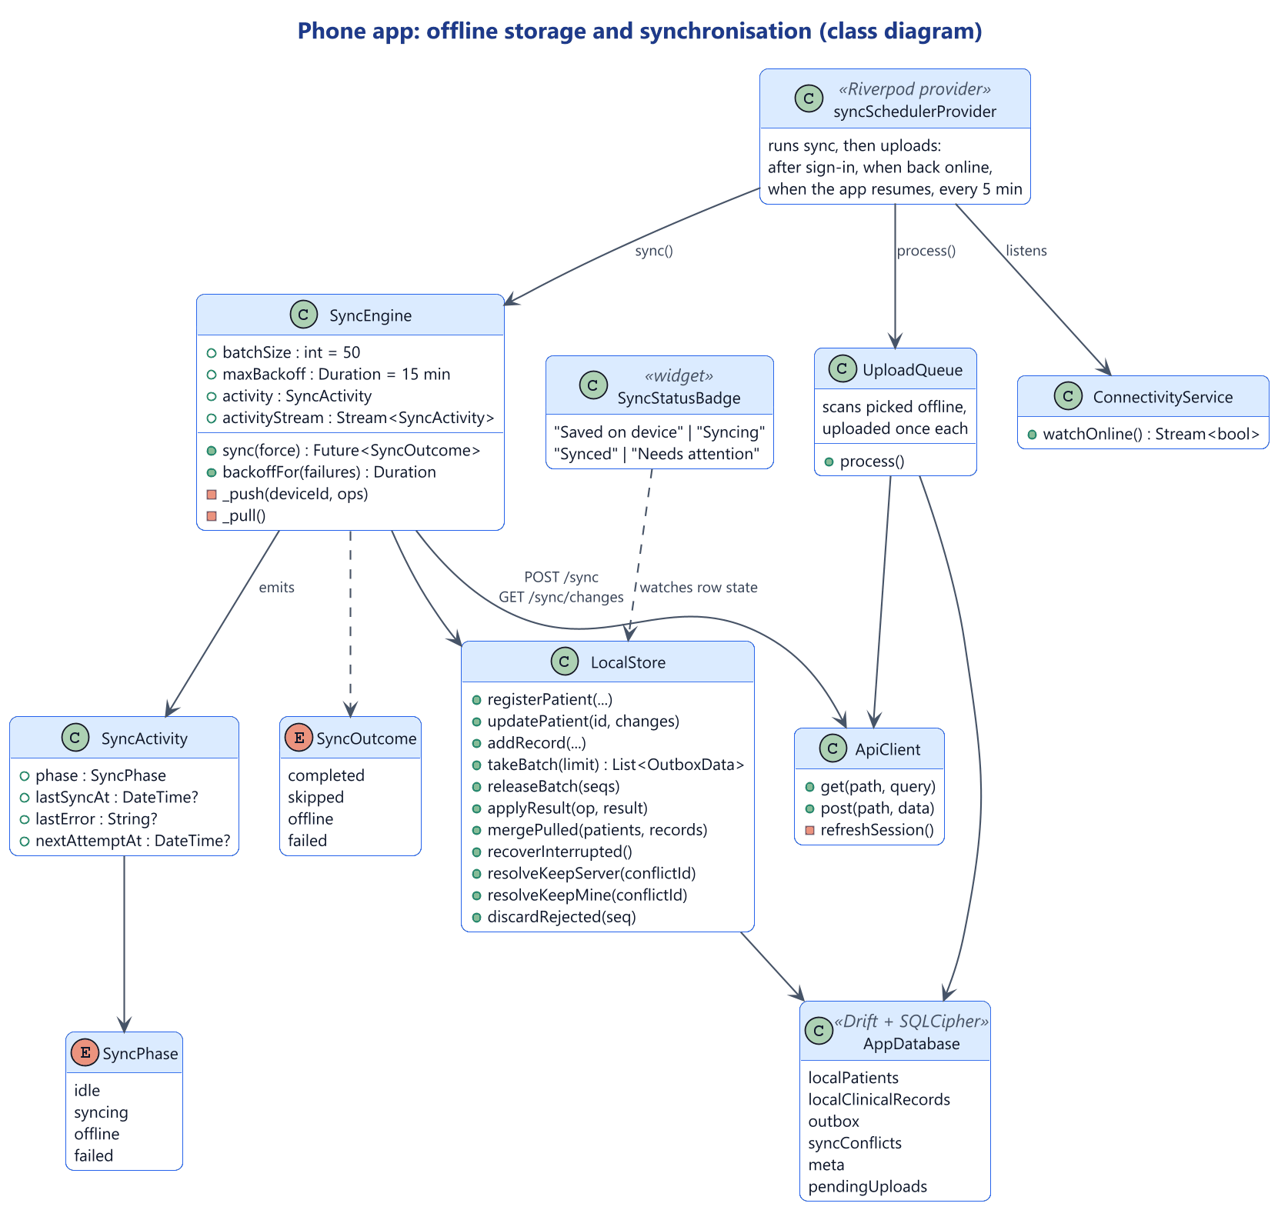
Figure 3.25: Class diagram: the app's offline storage and synchronisation
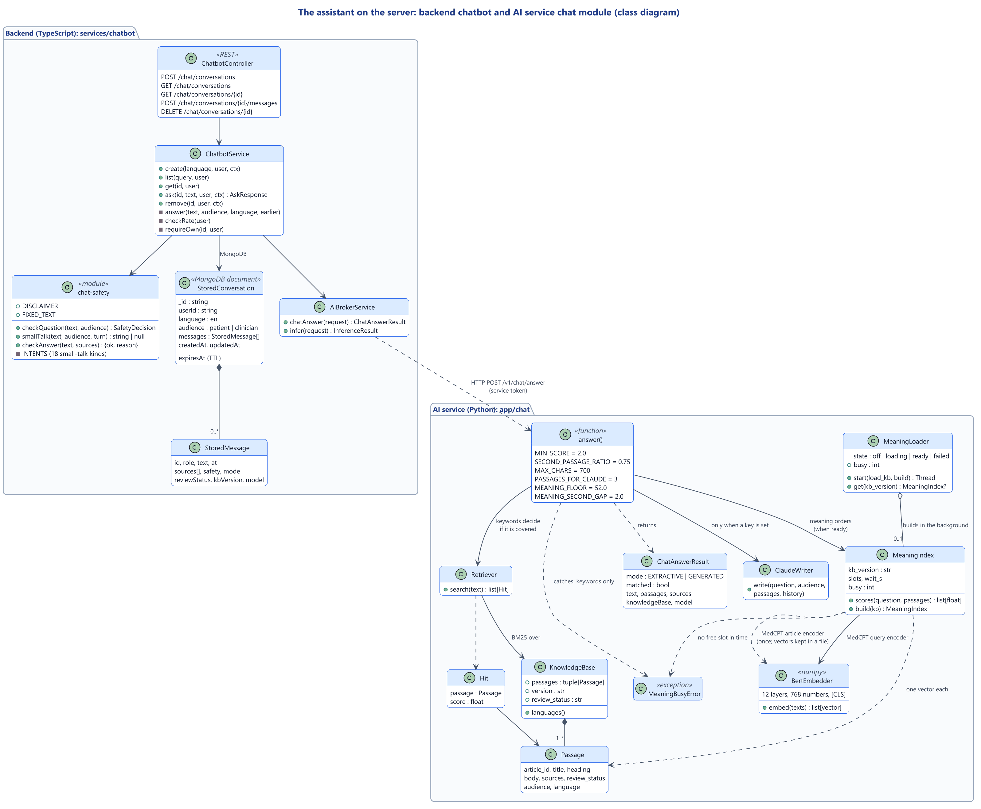
Figure 3.26: Class diagram: the assistant on the server

3.5.4 API design
The API follows REST conventions under /api/v1 and is described in OpenAPI 3. Every error uses one envelope with a stable code and a request identifier, and never contains stack traces or submitted values. Figure 3.27 maps all 75 routes with their permissions and default roles, and the AI service's internal API. The map is generated from the access matrix, itself generated from the code, and the quality gate fails if a route breaks a review rule, such as a clinical route open to administrators. Figure 3.28 shows the API explorer. The AI contract was frozen at version 0 in Phase 3, so that both sides could be built in parallel, and grew additively to version 0.4.
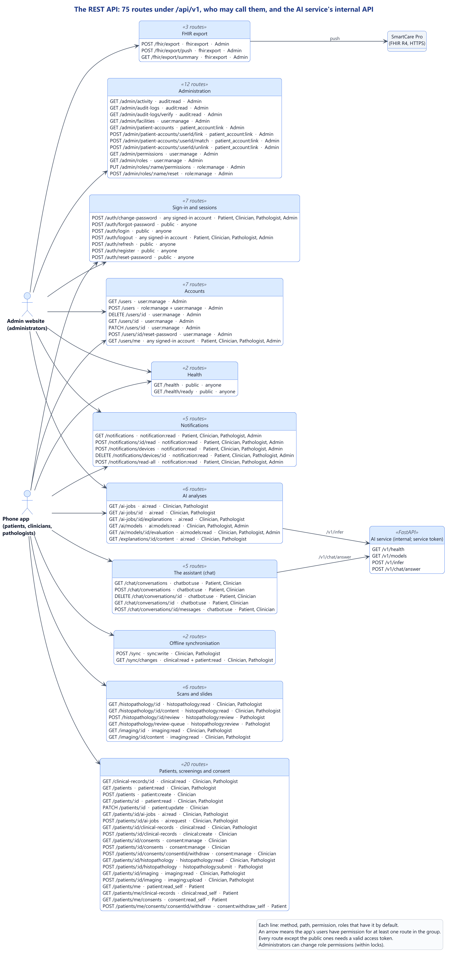
Figure 3.27: API diagram: every route, its permission and its default roles
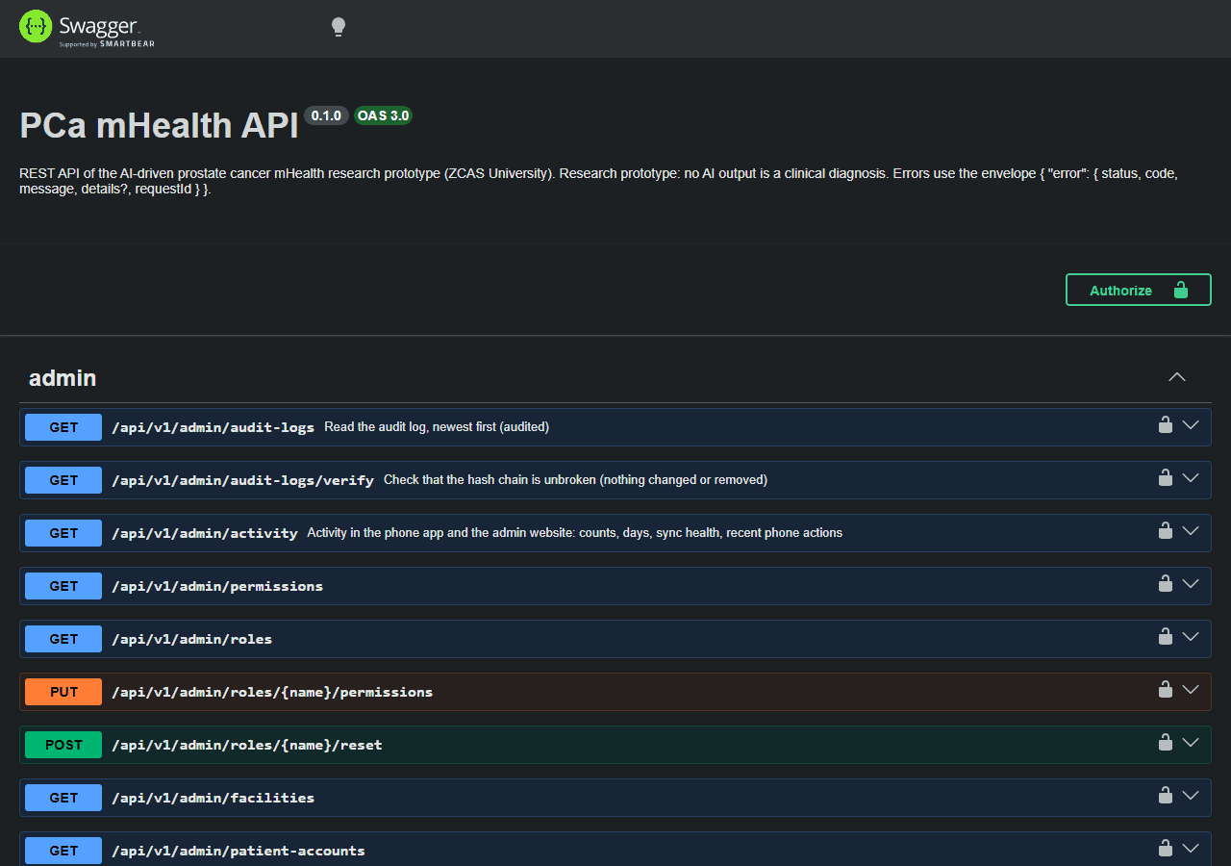
Figure 3.28: The API explorer (OpenAPI 3, Swagger UI)

3.5.5 Database design
Stores. PostgreSQL holds the structured records: accounts, roles, permissions, sessions, facilities, patients, screenings, consents, scan and slide records, AI jobs and explanation records, notifications and push phones, synchronisation results and the audit log. MongoDB holds documents whose shape varies: AI reports, inference logs, scan details and chat conversations. Large files never enter a database; a row keeps a server-generated storage key and the file's SHA-256 checksum, size and type.
Relational design. Figure 3.29 shows all twenty PostgreSQL tables and their keys, and Figures 3.30 to 3.32 three groups in detail. The diagrams are generated from the Prisma schema, so they cannot drift from the code.

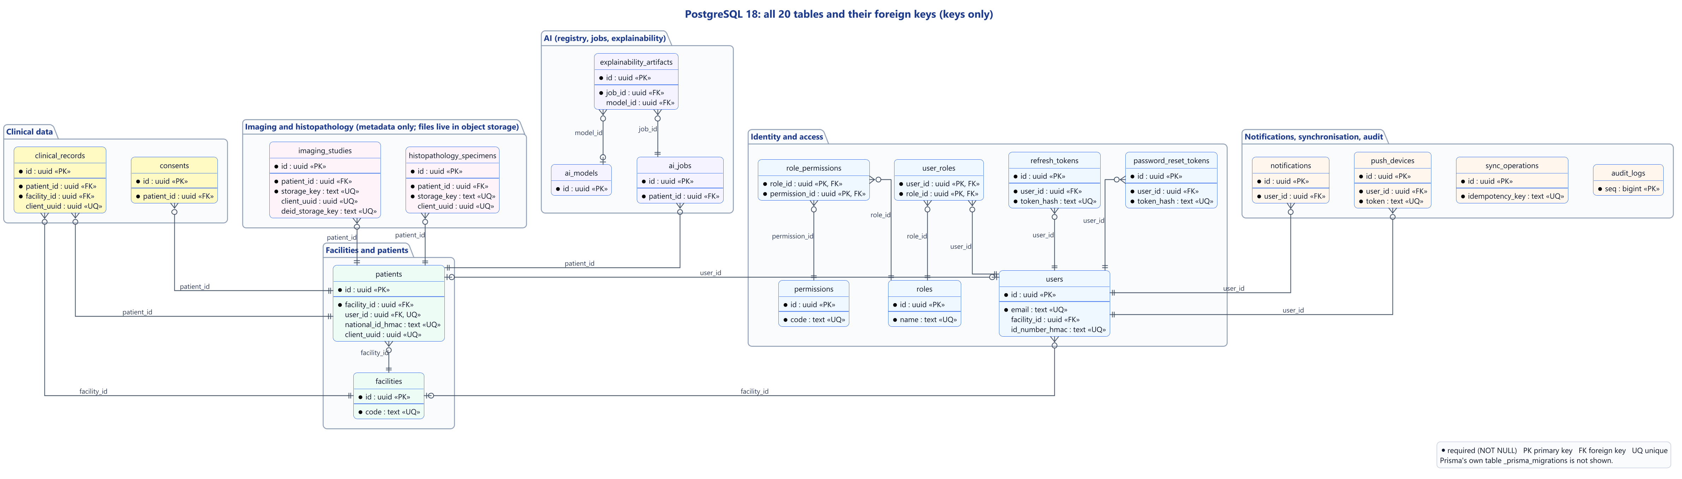
Figure 3.29: Entity-relationship diagram: all PostgreSQL tables and their keys

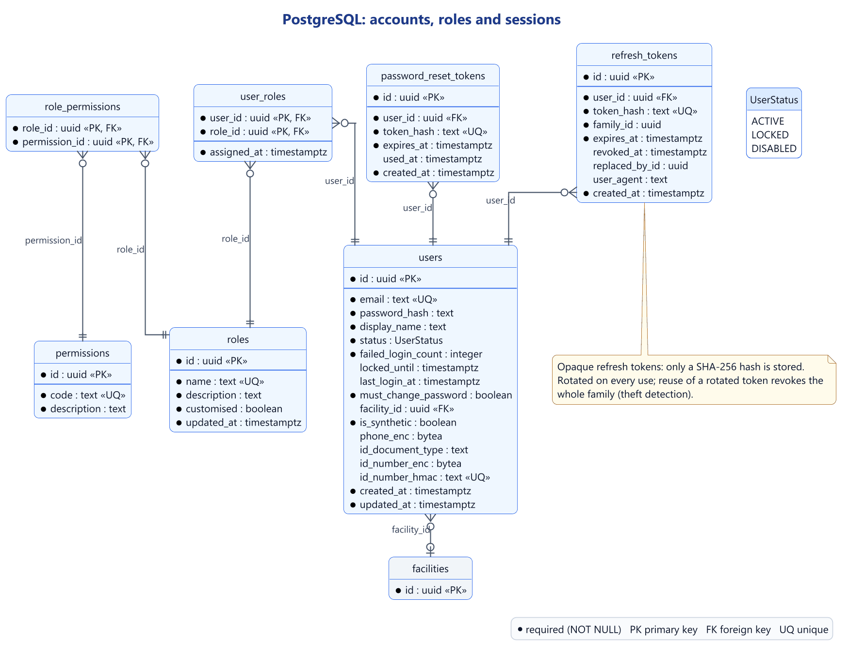
Figure 3.30: ERD: accounts, roles and sessions
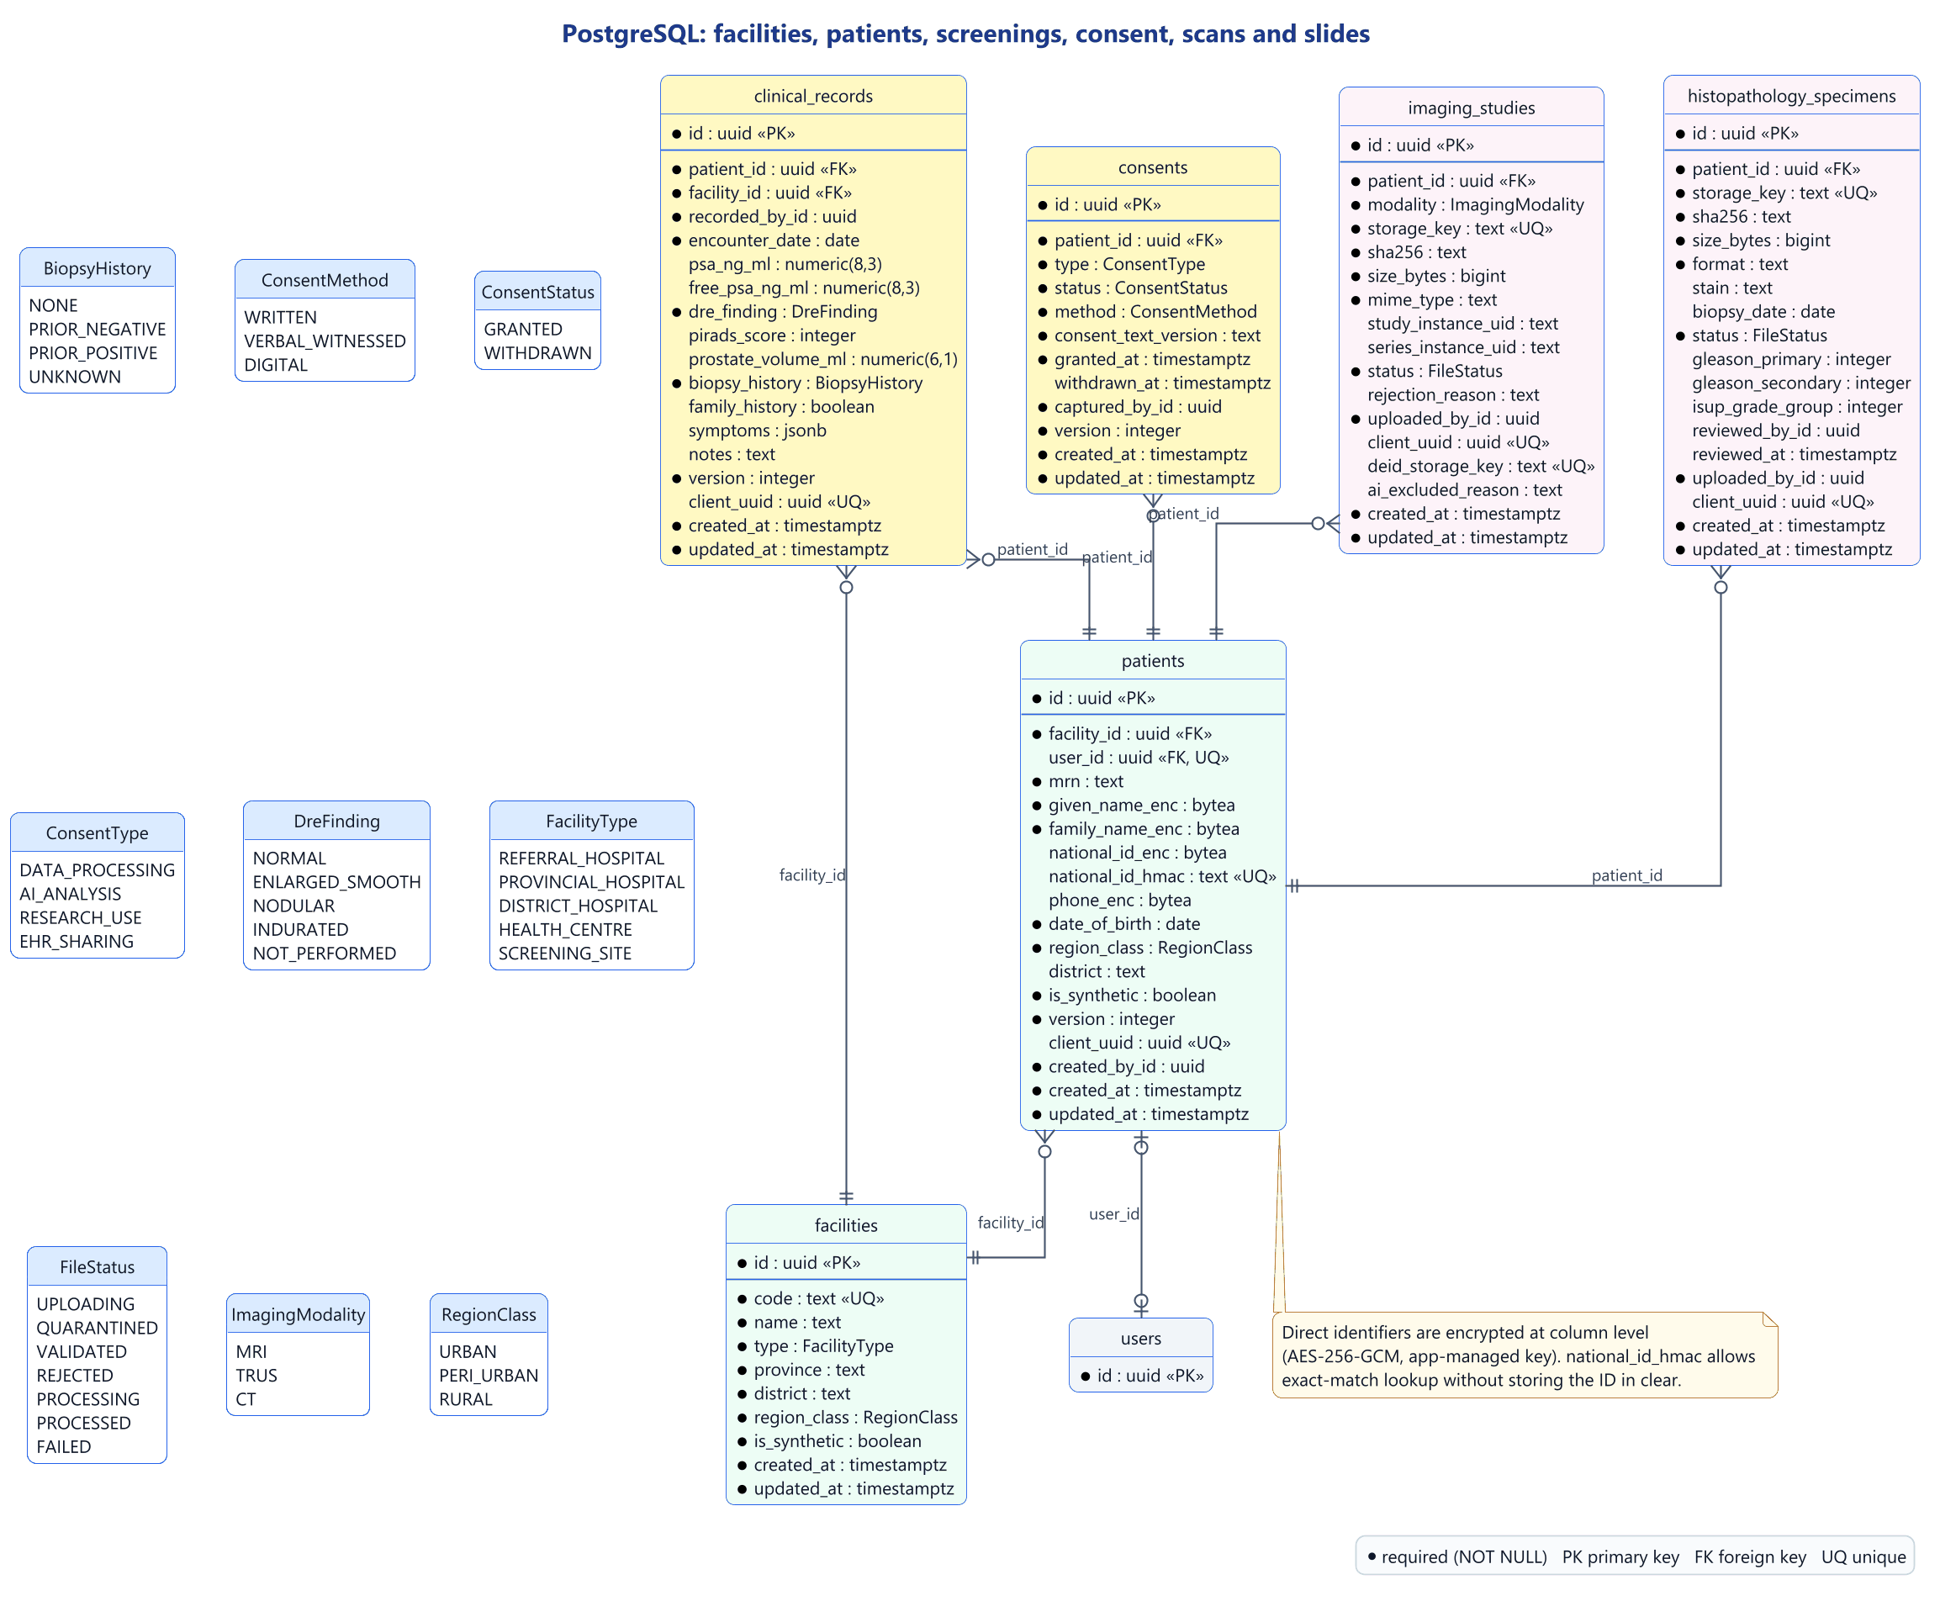
Figure 3.31: ERD: facilities, patients, screenings, consent, scans and slides

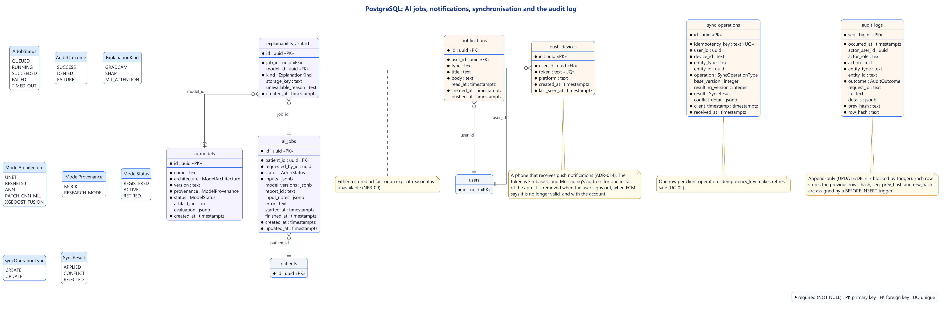
Figure 3.32: ERD: AI jobs, notifications, synchronisation and the audit log

Normalisation. The schema follows third normal form, with exceptions.
- Keys. Every table has a primary key, mostly a UUID id. The link tables user_roles (user_id, role_id) and role_permissions (role_id, permission_id) have composite keys, and audit_logs is keyed by a sequence number, seq. Unique constraints enforce alternate keys such as users.email and push_devices.token, so one phone is registered only once.
- First and second normal form. Columns hold single values; repeating groups, such as a patient's screening records, are child tables, and the many-to-many relations are resolved by the two link tables. The only composite keys are those of the link tables, and user_roles.assigned_at depends on the whole key.
- Third normal form. Facility details and role names are stored once. PSA density and the free-to-total ratio are calculated when a record is read, not stored.
- Exceptions. Some columns hold JSON whose content varies and is read as a whole: clinical_records.symptoms, ai_jobs.inputs, model_versions and input_notes, ai_models.evaluation, sync_operations.conflict_detail and audit_logs.details. The ISUP grade group of a slide review is computed by the server and stored with the review, so that the review is a fixed record. AI reports, chats and scan details live in MongoDB, linked by identifier.
Integrity rules. The database itself enforces 19 foreign keys (18 from the first migration and one added with the push phones), unique keys, and CHECK constraints on clinical values (non-negative PSA, free PSA not above total PSA, PI-RADS, Gleason patterns and grade groups between 1 and 5, positive prostate volume). A withdrawn consent must have a withdrawal time; every explanation record has either a stored file or a stated reason (NFR-09); every synchronisation result has a unique idempotency key.
Encryption and audit. Names, national identity numbers and phone numbers are stored encrypted with AES-256-GCM, and the national identity number also as a keyed HMAC-SHA-256 hash, so that a patient can be found by exact match without the number being in clear. The audit log is append-only: triggers refuse updates, deletes and truncation, and a trigger before each insert takes an advisory lock, assigns the next sequence number and stores a SHA-256 hash that covers the previous row's hash. A database function walks the chain and reports the first broken row, so tampering is detected even if the triggers are disabled. The cost, measured in Section 4.3.5, is that audited writes take turns.
MongoDB and the phone. Each MongoDB collection has a server-side validator (Figure 3.33): every AI report must state its provenance, MOCK or RESEARCH_MODEL, and carry a disclaimer, and chats are deleted 180 days after the last message. The app keeps six tables on the phone for offline work: patients, screening records, the outbox, conflicts, files waiting to upload, and metadata such as the device identifier and synchronisation cursor (Figure 3.34). The database is encrypted with SQLCipher (AES-256), with a random 256-bit key held only in the Android Keystore, and is wiped when a different user signs in.
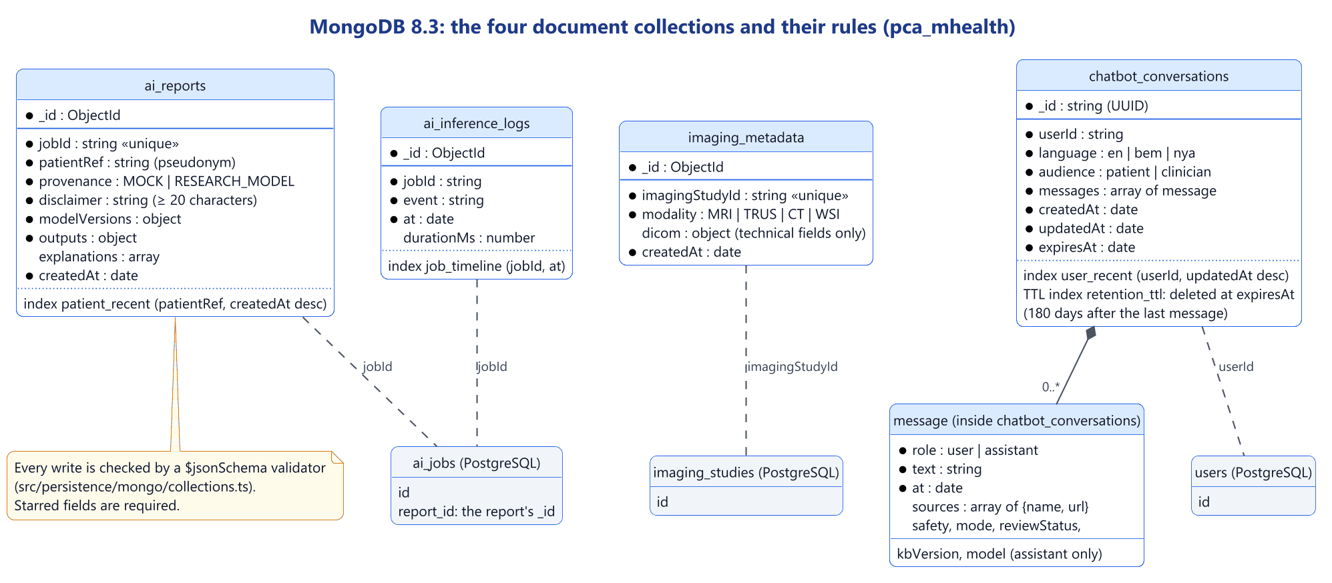
Figure 3.33: MongoDB: the four document collections and their rules
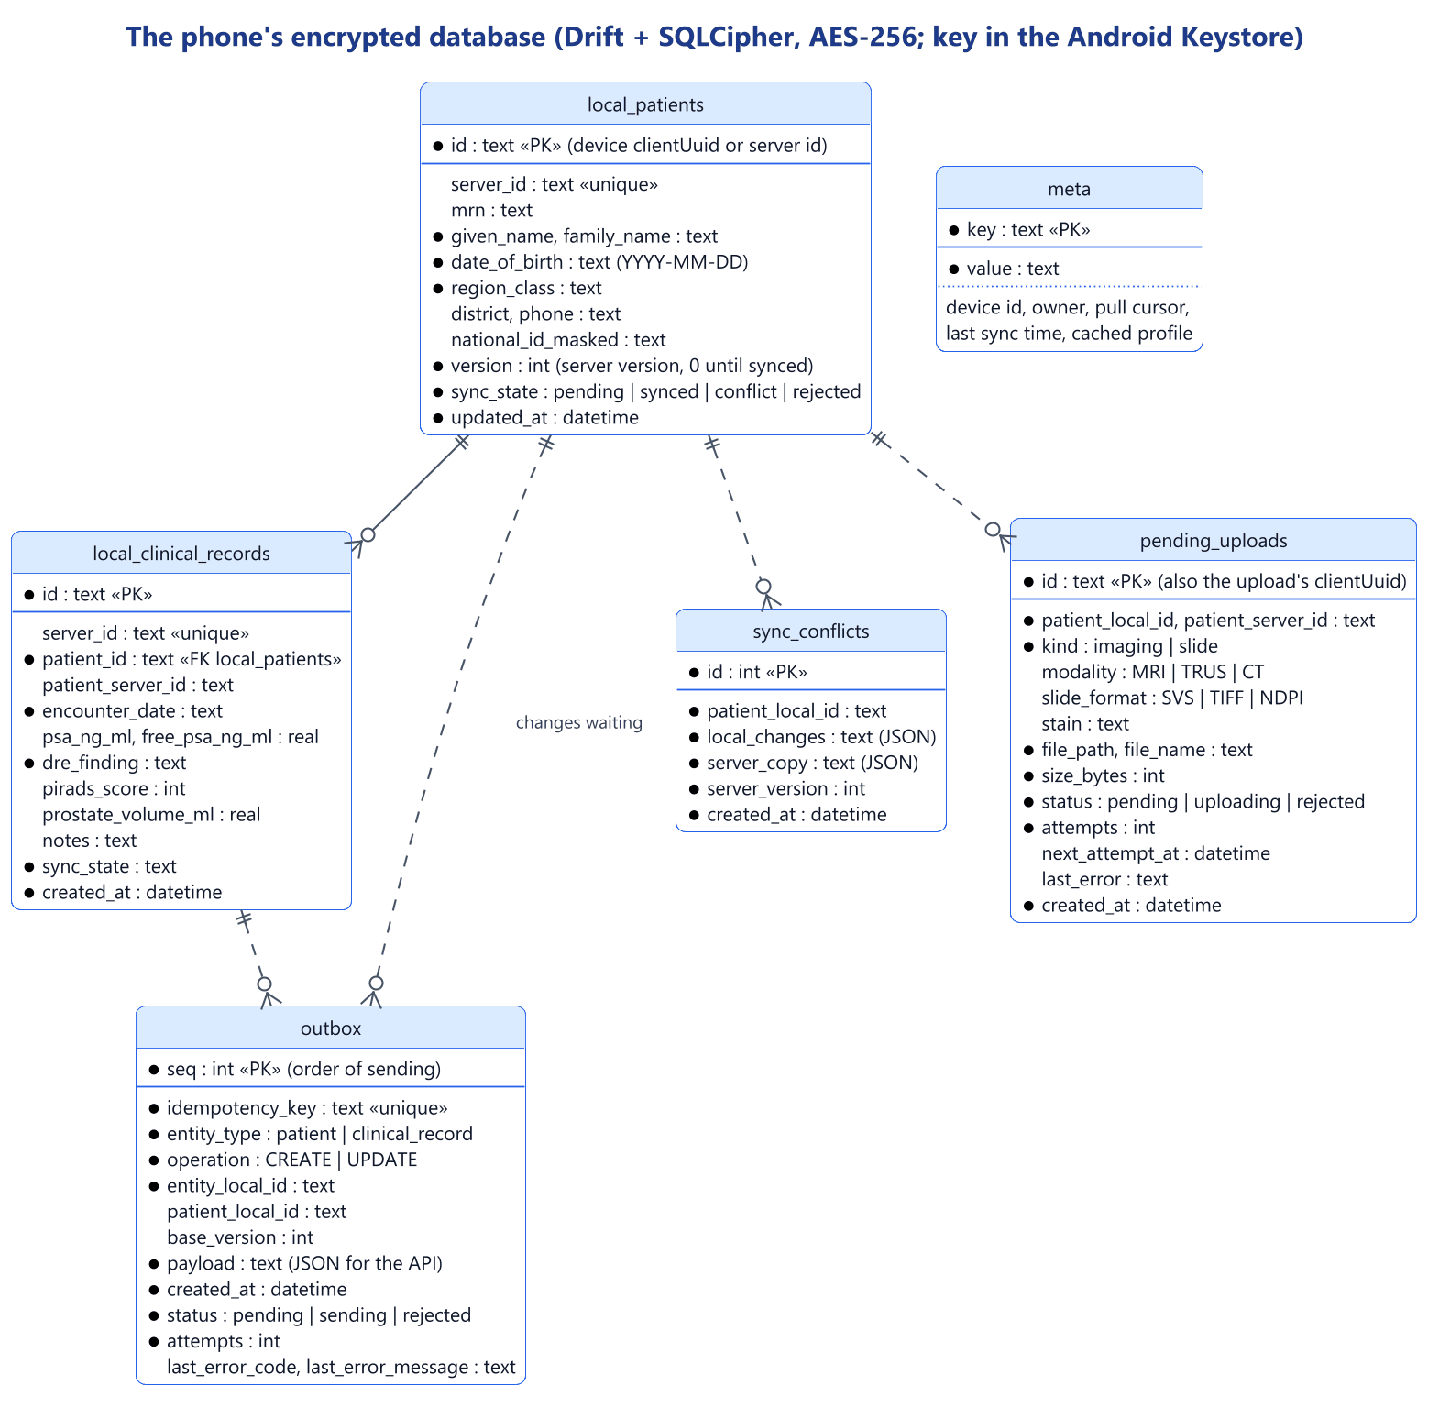
Figure 3.34: The phone's encrypted database

3.5.6 Design of the AI inference engine
A model router in the AI service runs every module that the available inputs allow, lists the modules it skipped with reasons, and fuses the results. The five modules of the proposal (U-Net, ResNet-50, the clinical ANN, the patch-CNN with MIL and the XGBoost fusion) sit behind one provider interface. In the prototype, each provider is a labelled mock whose numbers come from a hash of the job identifier, never from the patient's values; a test changes the PSA and checks that the number does not change. Each module maps to its kind of explanation (Grad-CAM for ResNet-50, SHAP for the ANN and fusion, MIL attention for slides); with mocks, every explanation is an explicit "unavailable" reason, and no heatmap or SHAP value is invented. Images from a future real model are accepted only as genuine PNG files of at most 2 MB.
The backend's broker sends only a keyed pseudonym, the clinical values and de-identified copies of scans, never names, identity numbers or record identifiers. A request needs the patient's active AI consent, a screening record, and no other analysis running for that patient. Performance and fairness figures come only from a stored evaluation; otherwise the system says "Evaluation data not yet available." The fairness check compares stored per-group AUC values by age (under 50, 50–64, 65 and over), region, stage and equipment, and flags a gap above 0.05; groups with fewer than 30 test cases are listed rather than compared.

3.5.7 Design of the patient-education assistant
The assistant follows one rule: it must never invent medical content. Every question passes through these steps:
1. Limits: up to 30 questions an hour per account.
2. Safety rules, before anything is looked up: emergency and self-harm wording receives fixed urgent-care text; questions about medicines and doses are declined; a patient's questions about their own results or a diagnosis are declined with a referral to their clinician.
3. Small talk: eighteen kinds of casual message, including Bemba and Nyanja greetings, receive fixed friendly replies, but only if the message is nothing else; "hello, is my PSA bad?" still meets the safety rules.
4. Retrieval (ADR-013): keywords decide, because BM25 must find a passage scoring at least 2.0; meaning chooses the article, because MedCPT scores those passages and the article with the closest passage comes first; inside an article the keywords choose the section, because MedCPT scores sections of one article too closely to tell them apart, and if the best scores below a floor of 52.0 the answer is "no reviewed information". A short follow-up is read with the previous question but must also reach the floor on its own, so a new topic is not answered from the old one.
5. Writing: by default, the best passages are quoted word for word. If Claude is enabled, which it is not in the prototype, it writes from the three best passages as structured output (JSON held to a fixed schema), and its answers are labelled "Written by AI (Claude) from the sources below".
6. Output check and storage: an answer without a source, or with a dose in it, is never shown; questions and answers are stored for their owner only, and the audit log records that a question was asked, never its words.
The knowledge base holds the six Learn articles, each citing public sources (NHS, the US National Cancer Institute and WHO), and five clinician cards (ISUP grade groups, PI-RADS v2.1, PSA density and the free-to-total ratio, DRE findings, and how to read the AI report): 32 passages in all. Everything is marked "Draft for review by a qualified clinician" until a clinician signs it off, and patients never receive clinician content. The MedCPT encoders run inside the AI service, written with numpy and matching the reference implementation to within 0.0001, so questions leave the system only if Claude is enabled. Under load, questions are encoded side by side, with a keyword-only fallback (Section 4.3.5).

3.5.8 Interface design
Figure 3.35 shows every screen and how each role moves between them. Administrators who sign in on a phone are told that administration is on the website.

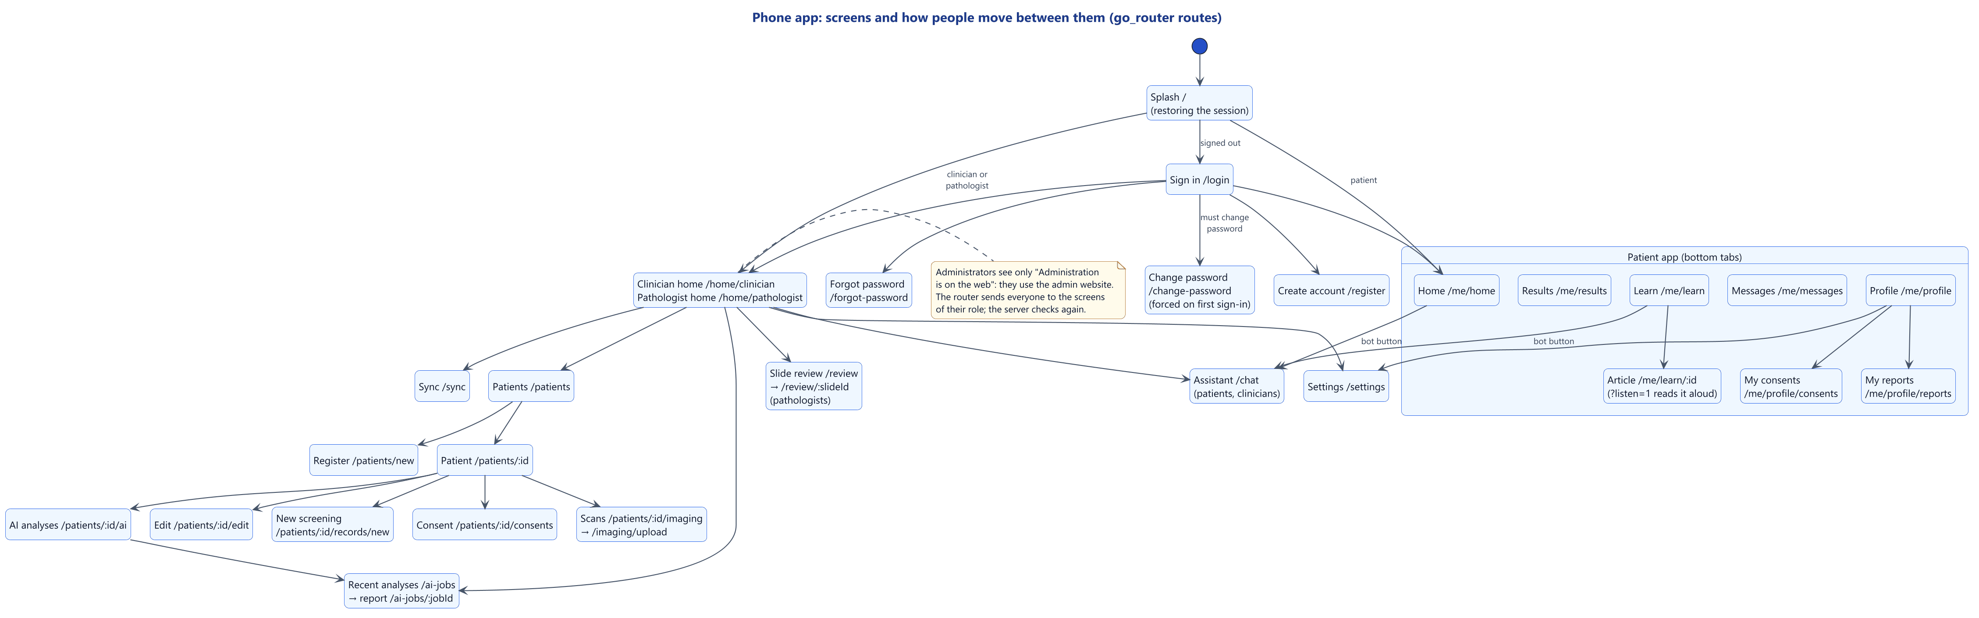
Figure 3.35: The app's screens and navigation

The visual design went through three iterations at the owner's request: the "Clinical Trust" option with stronger legibility rules (ADR-002), a "modern health app" style (ADR-008), and finally awareness blue with modern rounded icons and a drawn assistant figure (ADR-011). Rules held throughout: body text of at least 15 px, touch targets of at least 48 dp and 52 px inputs; every text pair at a WCAG AA contrast of at least 4.5:1, tested in light and dark mode; states written in words, never by colour alone; clinical values in neutral colours with nothing that suggests good or bad; the AI provenance banner first on every AI screen; and a notice on every sign-in screen that the app is not an official government service. Figures 3.36 to 3.39 show the main screens with synthetic data.
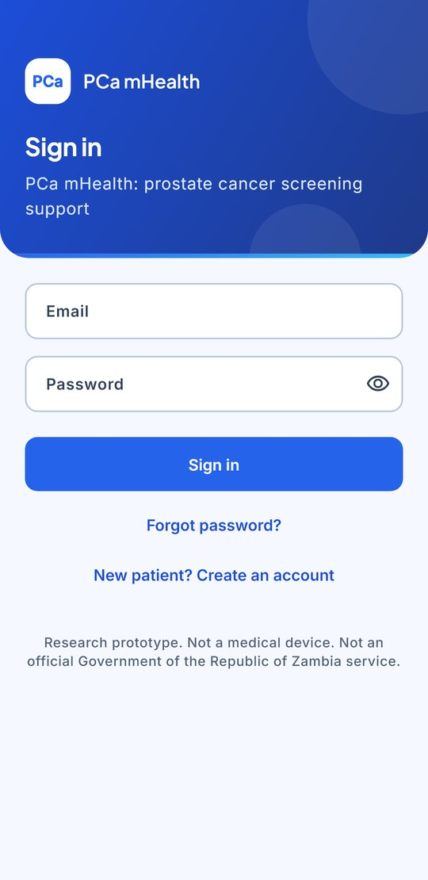  Sign-in | 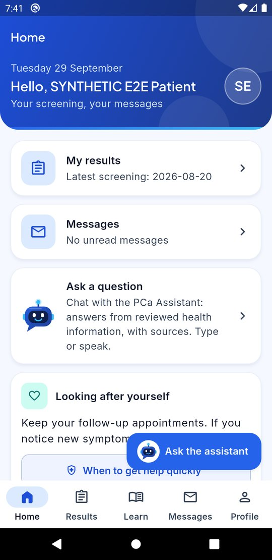  Patient home (emulator) | 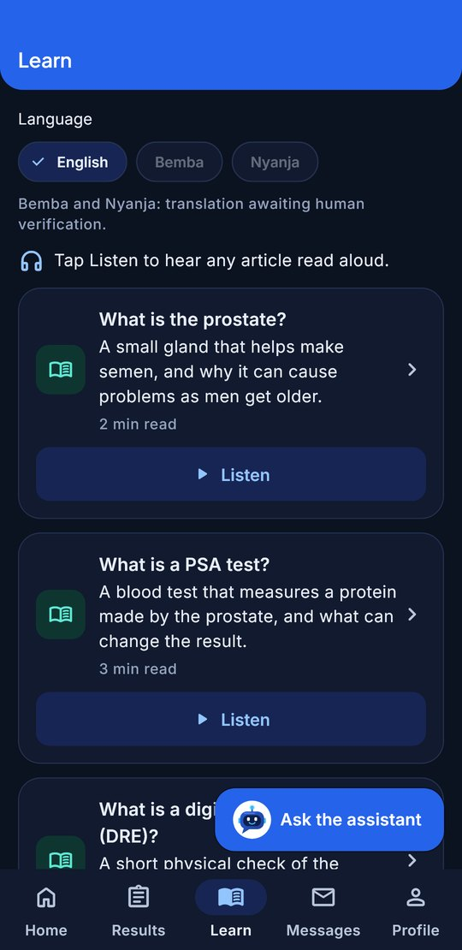  Learn, dark mode | 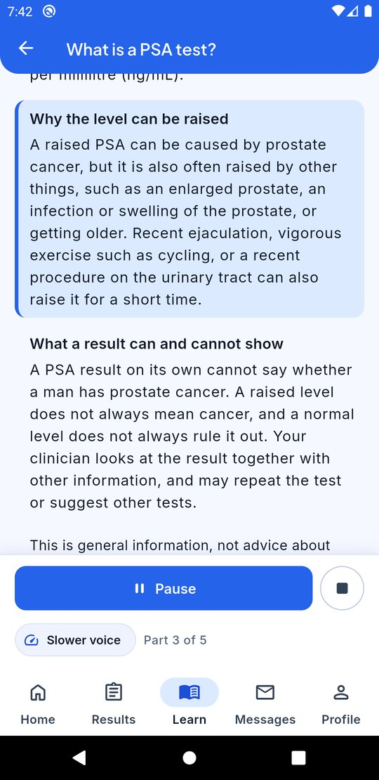  An article read aloud (emulator)
Figure 3.36: Interface design: patient screens (sign-in; patient home on the emulator; Learn in dark mode; an article read aloud on the emulator)
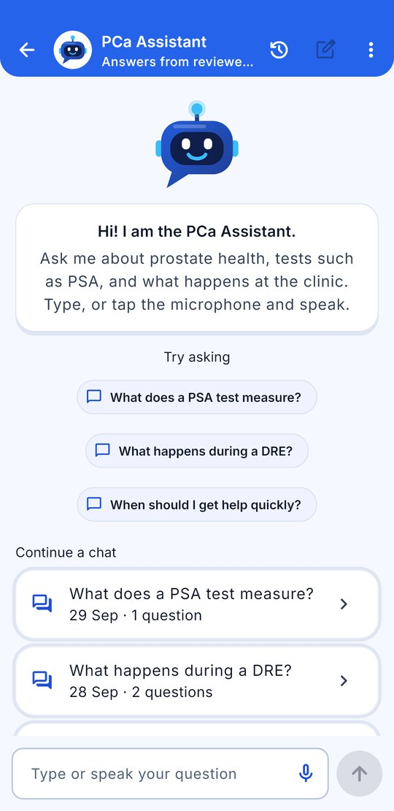  Empty chat | 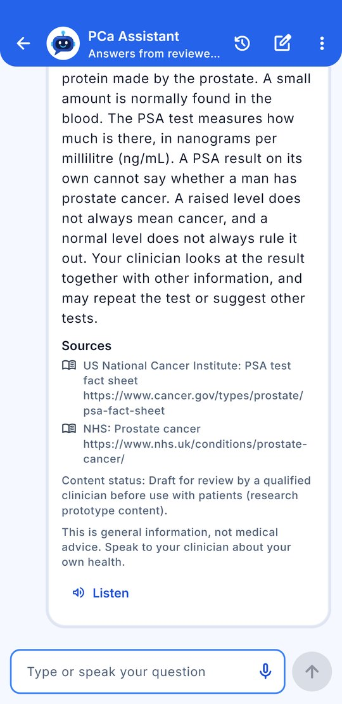  An answer with its sources | 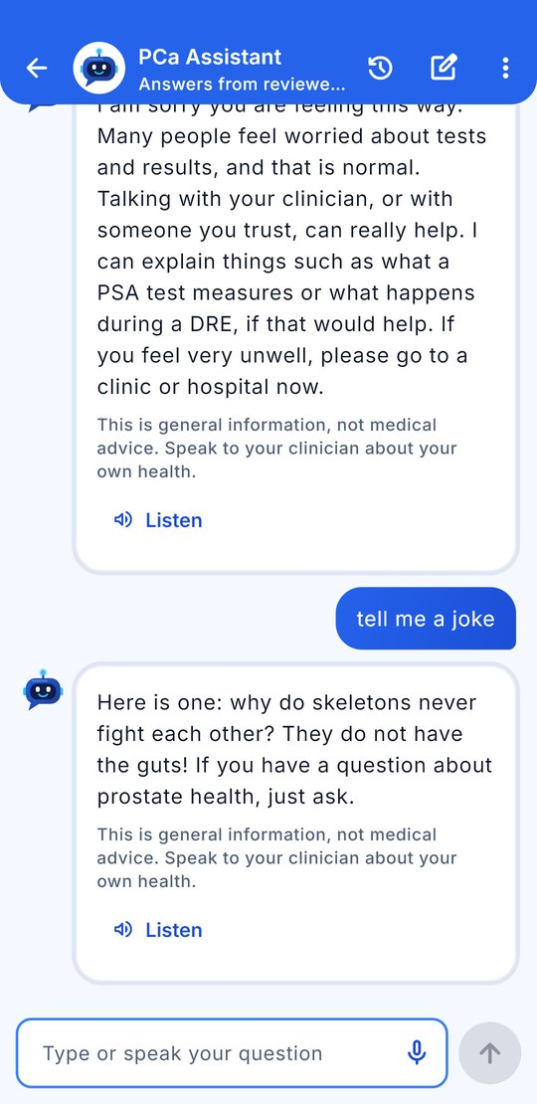  Casual chat
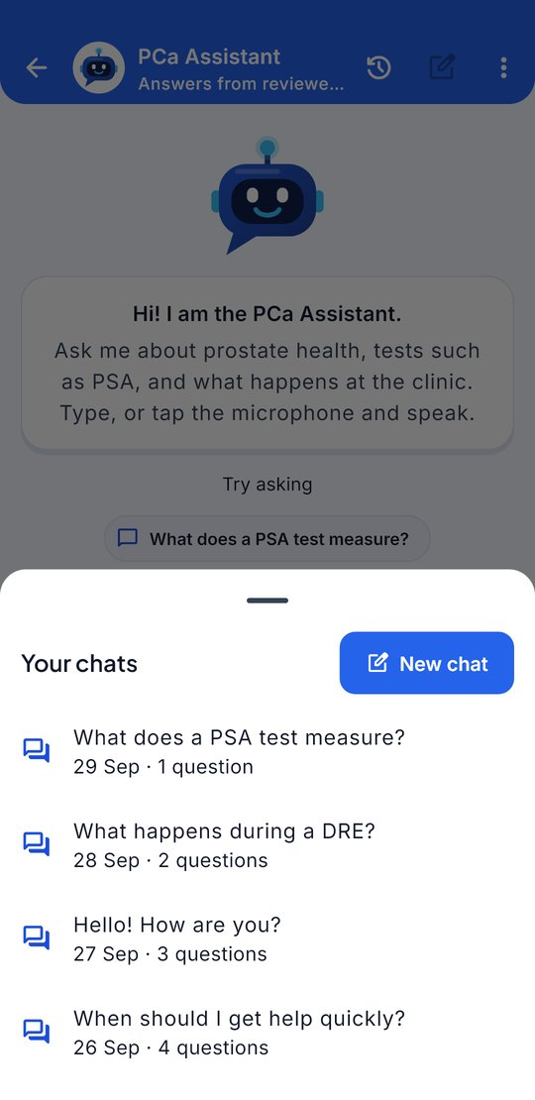  Past chats | 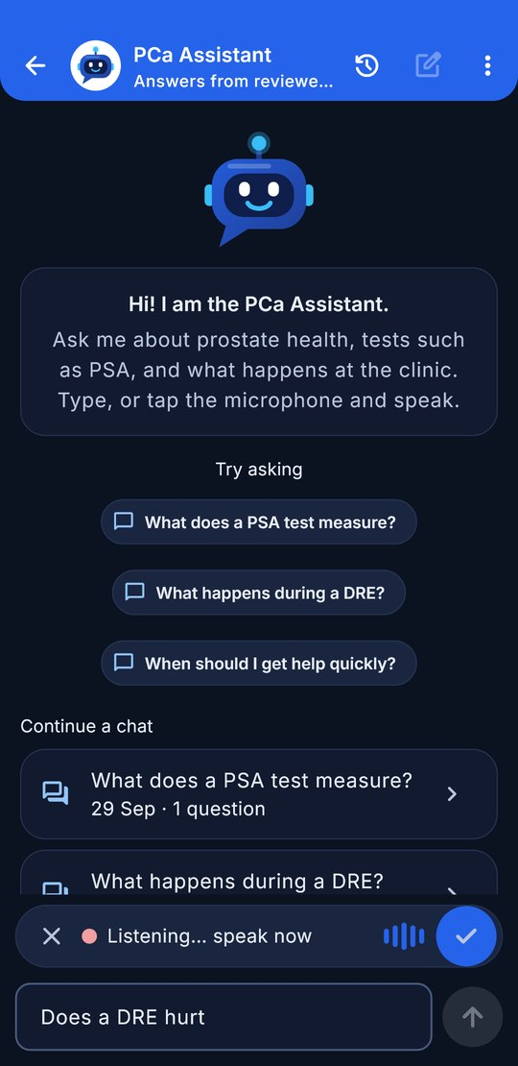  Speaking a question
Figure 3.37: Interface design: the assistant (empty chat; an answer with its sources; casual chat; past chats; speaking a question)
The answer in Figure 3.37 is the AI service's real answer from the draft knowledge base; in the recording picture, a stand-in plays the phone's speech service.
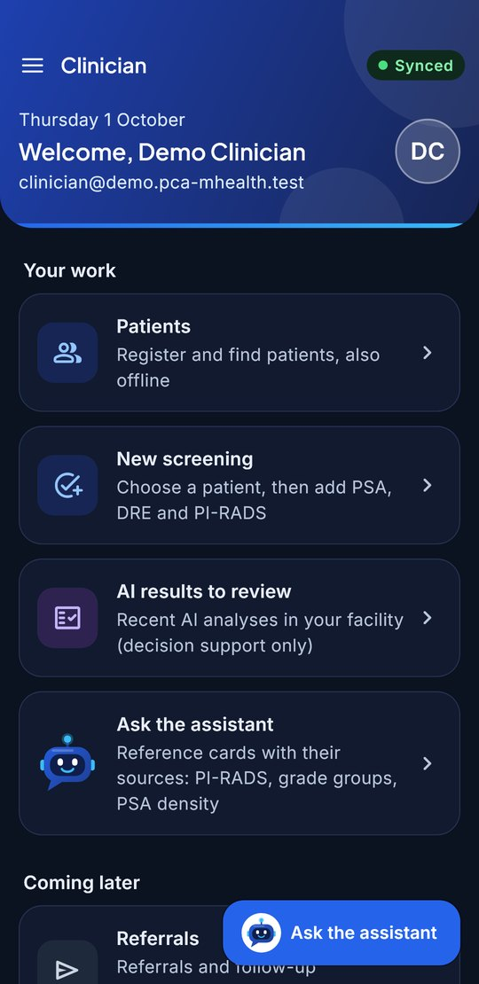
Figure 3.38: Interface design: clinician home
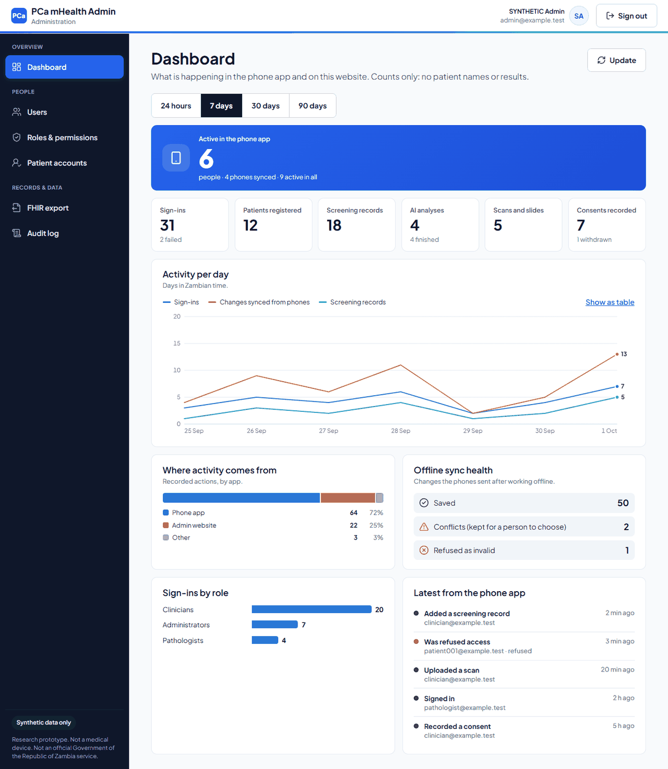
Dashboard
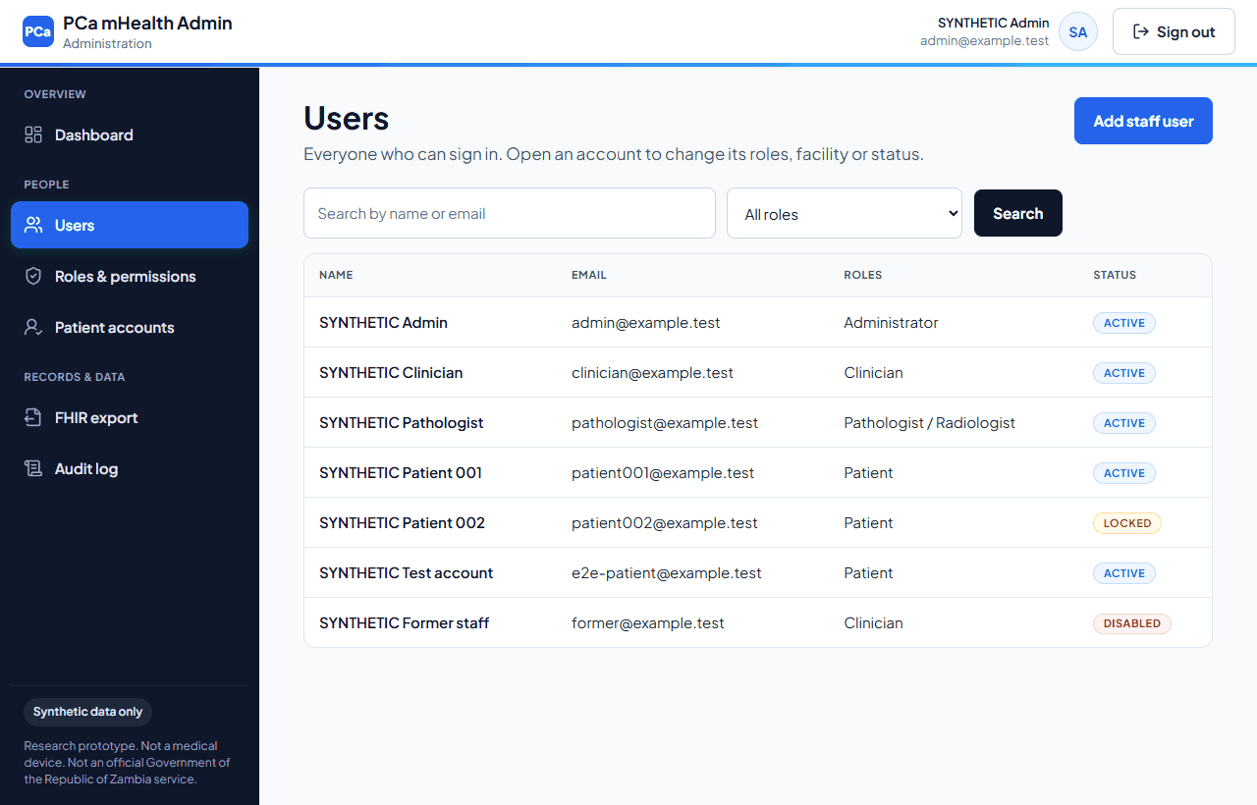
Users
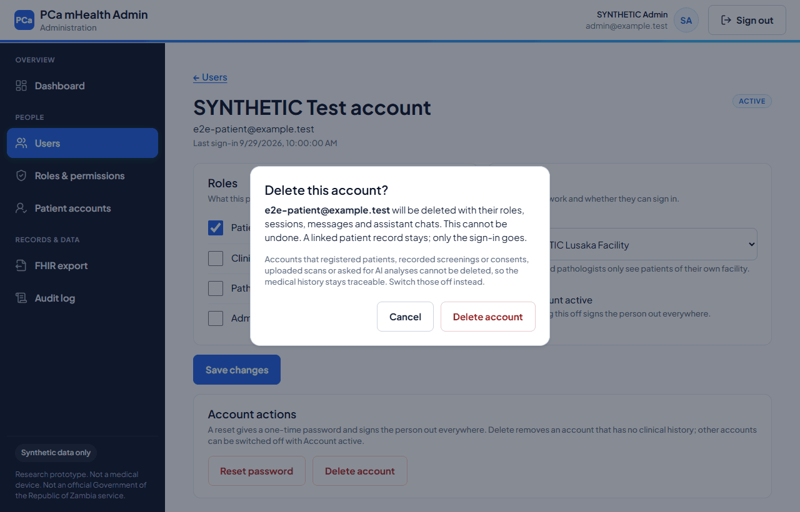
Delete this account?
Figure 3.39: Interface design: the admin website (dashboard, accounts list and delete dialog; synthetic API answers, and the dashboard's numbers were made up for the picture)
Accessibility was designed in. An automated test (Section 4.3.7) found and fixed a real overflow in the sign-in header at 200% text size. Field and button outlines were later raised to at least 3:1 against their background, as WCAG 2.1 criterion 1.4.11 asks.

3.5.9 Security design
Table 3.7 summarises the main security controls; Section 4.3.4 describes their testing.
Table 3.7: Main security controls
Concern | Control
Passwords | Argon2id hashes (64 MiB, three passes); at least 12 characters, with a common-password denylist
Sessions | EdDSA-signed 15-minute access tokens; hashed refresh tokens replaced on every use, reuse revoking the whole family; account and session re-checked on every request
Brute force and enumeration | Lockout for 15 minutes after five failures; stricter limits on sign-in routes; identical answers for unknown and wrong accounts
Authorisation | Deny by default; role permissions; facility scoping; separation of duties (no clinical-data permissions for administrators, no administration permissions for clinical roles, no adding roles to one's own account)
Transport and storage | TLS 1.3 only at the reverse proxy, with HSTS; AES-256-GCM identifiers on the server; SQLCipher on the phone
De-identification | Safe Harbor rules for the FHIR export; pseudonym and de-identified scan copies for the AI
Uploads | Streamed and size-capped; file type decided by content; DICOM headers checked; file names never stored
Accountability and secrets | Hash-chained audit log with an integrity check; secrets only in a git-ignored file, with a full-history secret scan

3.6 Chapter Summary
The project followed Design Science Research and an iterative prototyping method, adapted to build phases closed by a quality gate. The requirements came from the proposal, and changes were recorded with their reasons. The models describe the system's context, processes, stores, use cases, activities, interactions and object life cycles. The design kept the proposal's six layers, separated by contracts, with security, safety and accessibility rules built in. Chapter 4 describes the implementation and testing.

Chapter 4: System Implementation and Testing
Sections 4.1 and 4.2 condense the system guide and installation manual; the full versions are the project's operations manual and a step-by-step manual test guide (Appendix D). Section 4.3 presents the testing plan and its output, and Section 4.4 the main function code for each objective.

4.1 System Guide

4.1.1 The parts of the system
Table 4.1: The parts of the system on the development computer
Part | What it does | Built with | Address
Phone app | Screens for patients, clinicians and pathologists; works offline | Flutter 3.35 (Dart) | Android emulator or phone
Admin website | Accounts, roles, patient links, audit log, dashboard, FHIR export | React 19 and Vite (TypeScript) | http://localhost:5173
Backend (API) | Every rule: sign-in, permissions, patients, consent, uploads, synchronisation, chat, audit | NestJS 11 on Node.js 24 | http://localhost:3000
AI service | The AI modules (labelled mocks) and the assistant's search | FastAPI (Python 3.14) | http://127.0.0.1:8000
PostgreSQL | Accounts, patients, screenings, consents, audit log | PostgreSQL 18 | localhost:5432
MongoDB | AI reports, chats, scan details | MongoDB 8.3 | localhost:27017
Redis, MinIO, Qdrant | Shared rate limits; S3-style file storage; vector search (for later) | Docker containers | ports 6379; 9000–9001; 6333

Every request passes through the backend's guards in a fixed order (Section 3.5.2), then validation and the service, which does the work and writes an audit entry. Only the backend talks to the databases and the AI service.

4.1.2 Using the system
Clinicians sign in on the phone and register patients and add screening records (PSA, free PSA, DRE finding, PI-RADS, prostate volume, earlier biopsy, family history of a father or brother, and seven yes/no symptoms), with or without a connection. Answers left out stay "not known" and are not sent to the AI analysis. These three items were added on 14 October 2026 (phone database schema v3, AI contract v0.6, an additive change), because the form had not captured what the contract already had room for. Each item shows its state in words ("Saved on device", "Synced" or "Needs attention"); the Sync screen shows any conflict side by side for the clinician to resolve. A synchronised patient's page offers Consent, Images and slides (files wait in an upload queue until they can be sent) and AI analysis, which is disabled, with the reason shown, when the phone is offline, AI consent is missing or no screening has been synchronised. The report begins with the banner "DEVELOPMENT MOCK DATA — NOT A CLINICAL RESULT." and then shows the values, the modules used and skipped, and each explanation or the reason there is none.
Pathologists open the review queue, enter the primary and secondary Gleason patterns (3 to 5) for a slide and save; the server computes the ISUP grade group and allows one review per slide.
Patients create an account with their name, e-mail, phone, NRC or passport number and a password; it shows "Almost ready" until an administrator links it to their clinic record. The patient app has five tabs: Home; Results, which shows values only, always with "Your clinician will explain what this means for you"; Learn, six short articles that can be read aloud; Messages; and Profile, with consents that can be withdrawn at any time, the reports area (empty until reports are released), settings and sign-out. The assistant accepts typed or spoken questions and can read its answers aloud.
Administrators use six website pages: the Dashboard (app activity as counts only); Users (create staff with a one-time password, change roles and facility, disable, unlock, reset a password, or delete an account that has no clinical history); Roles and permissions (within safety locks); Patient accounts (match by exact NRC and link); FHIR export; and the Audit log, with a "Check integrity" button that recomputes the hash chain.

4.2 Installation Manual

4.2.1 Requirements
The system was developed on a Windows 11 laptop (11th-generation Intel Core i5, 4 cores, 8 threads, 32 GB of memory). Table 4.2 lists the software versions in use on 30 September 2026.
Table 4.2: Software required
Tool | Version | Used for
Node.js and npm | 24.15.0 and 11.12.1 | Backend, admin website, scripts
Python | 3.14.5 | AI service
Flutter and Dart SDK | 3.35.2 and 3.9 | Phone app
Android Studio and SDK | Emulator Galaxy_S9_Plus_API_29 (Android 10) | Running the app
PostgreSQL | 18.6, with pgAdmin 4 | Main database
MongoDB | 8.3.2, with Compass | Document database
Docker Desktop | 29.8.0 | Redis, MinIO, Qdrant
Git | 2.51 | Version control

4.2.2 Installation steps
1. Install the tools in Table 4.2.
2. Clone the private repository: git clone https://github.com/deedeestephen/final-year-project.git.
3. Create the settings file with random secrets: node 6-infrastructure\scripts\gen-keys.mjs --init-env. The file, .env, is never committed and must be backed up safely: without its keys, the encrypted fields cannot be read again.
4. Create the database login and database on PostgreSQL and MongoDB as described in docs/local-databases.md, and put the passwords in .env.
5. Install the AI service in 4-ai-intelligence-layer\ai-services: py -3 -m venv .venv, then .venv\Scripts\python -m pip install -e ".[dev]".
6. Optionally download the MedCPT models for the meaning search (about 880 MB, checked against pinned SHA-256 sums): .venv\Scripts\python -m app.chat.embeddings download. Without them, the assistant uses keyword search only.
7. Start everything with one command from the project folder:
powershell -ExecutionPolicy Bypass -File 6-infrastructure\scripts\dev-up.ps1
The script checks the settings, starts the databases and containers, applies migrations, adds the synthetic demonstration data, and starts the backend, website and AI service. It ends with READY. dev-down.ps1 stops everything without losing data.

4.2.3 Checking, signing in and running the app
Table 4.3: Checks after starting
Open this | Expected result
http://localhost:3000/api/v1/health | "status":"ok"
http://127.0.0.1:8000/v1/health | "status":"ok", models reported as development mocks, and chat_retrieval showing keywords+meaning (MedCPT) when the models are installed
http://localhost:5173 | The admin sign-in page
http://localhost:3000/api/docs | The API explorer

The seed creates four synthetic accounts, admin@, clinician@, pathologist@ and patient@demo.pca-mhealth.test, with the password set in SEED_DEMO_PASSWORD; five wrong passwords lock an account for 15 minutes, and dev-up.ps1 -ResetDemoPasswords resets them. The app is started on the emulator from 1-presentation-layer\mobile-app:
flutter emulators --launch Galaxy_S9_Plus_API_29
flutter run -d emulator-5554 --dart-define=API_BASE_URL=http://10.0.2.2:3000
On a USB-connected phone, phone-usb.ps1 lets it reach the computer, and the app uses API_BASE_URL=http://localhost:3000. Debug builds allow plain HTTP only to these local addresses; release builds allow HTTPS only.

4.2.4 Switching on push notifications
Push notifications are built but off, because they need a Firebase project in the owner's Google account. The owner creates a free project, adds an Android app (zm.ac.zcas.pca_mhealth) and generates a service-account key, a secret kept outside the project folder; its path goes in FCM_SERVICE_ACCOUNT_FILE. Four public identifiers go into a git-ignored firebase-app.json that the app reads at build time. After a restart, http://localhost:3000/api/v1/health/ready reports "push":"on". Until then, the same messages remain in the app's Messages tab.

4.3 Testing Plan and Test Output

4.3.1 Testing plan
Testing ran in every phase. The proposal required at least 80% coverage (NFR-07), integration testing of the gateway, AI broker, chatbot and synchronisation, and automated regression testing. Table 4.4 shows the levels used.
Table 4.4: Levels of testing
Level | What it covers | Tools
Unit | Encryption, permissions, safety rules, mappers, the sync engine with a fake clock | Jest, pytest, flutter test, Vitest
Integration | Services against real PostgreSQL, MongoDB, MinIO and Qdrant, in a fresh database for each run | Jest and Supertest
API end-to-end | Routing, validation, errors, rate limits, headers, OpenAPI | Jest and Supertest
Live workflows | The built backend in production mode, the real AI service and an HTTPS SmartCare Pro stand-in | npm run test:workflows
Device | The app on the Galaxy S9+ emulator against the running system | Flutter integration tests
Performance | Load, stress, AI and synchronisation stages | npm run perf
Security | Route rules, TLS, secrets, dependencies, de-identification, audit tampering, log contents | Gate scripts and tests
Interoperability and accessibility | HL7 FHIR validator; accessibility guidelines and contrast | Validator, flutter test, Vitest
Retrieval quality | The assistant's answers on fixed question sets | python -m app.chat.evaluate
User acceptance | Task success, time, SUS and interviews | UAT kit (not yet run)

The strategy made these categories mandatory: invalid, unauthenticated, forbidden, malformed and oversized API requests; tampered, expired and alg:none tokens, refresh-token reuse, privilege escalation, injection and path traversal; repeated submissions, version conflicts, partial batches and an app killed mid-sync; provenance on every AI response and a label on every mock; and refusals, referrals and citations for the chatbot. All test data was synthetic.

4.3.2 The quality gate and test output
The quality gate (Figure 4.1) runs formatting, static analysis, type checking, tests with at least 80% coverage, the build and the security audits for each part, plus the live workflows, a documentation link check, the HL7 validator, the access-matrix rules, the TLS check and a full-history secret scan. It ran in continuous integration on every push, and no commit was made unless the gate for the changed part passed.
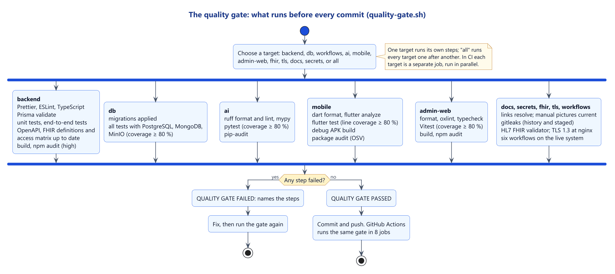
Figure 4.1: The quality gate
Table 4.5 gives the test counts from the development log: those of 2 October 2026 (after the meaning search, push notifications and the review fixes of Section 4.3.4) and, for the backend and the AI service, those of 14 October 2026 (after the screening form gained biopsy history, family history and symptoms). All tests passed. The log records the phone app's 14 October gate as passed but gives no new count, so the figure of 2 October is kept.
Table 4.5: Automated tests and coverage (14 October 2026 for the backend and the AI service)
Part | Tests | Coverage
Backend unit tests | 331 | Coverage recorded on 1 October 2026 (all backend tests together): 94.7% of statements, 81.4% of branches
Backend end-to-end tests (in process) | 20 | (included above)
Full database run (46 suites, with Docker) | 592 | (included above)
AI service | 104 passed; 1 skipped (it would call the real Claude API); 3 more skipped when the MedCPT models are absent, as in CI | 98%
Phone app | 290 (2 October) | 91.1% of lines (recorded on 1 October 2026)
Admin website | 82 | Coverage recorded on 1 October 2026: 87.8%

At the final quality audit (Phase 18), every package was given an 80% minimum that fails the gate. The admin website was below it (78.6% of statements, 73.4% of branches) until eleven tests were added. Figure 4.2 shows the backend gate's output.
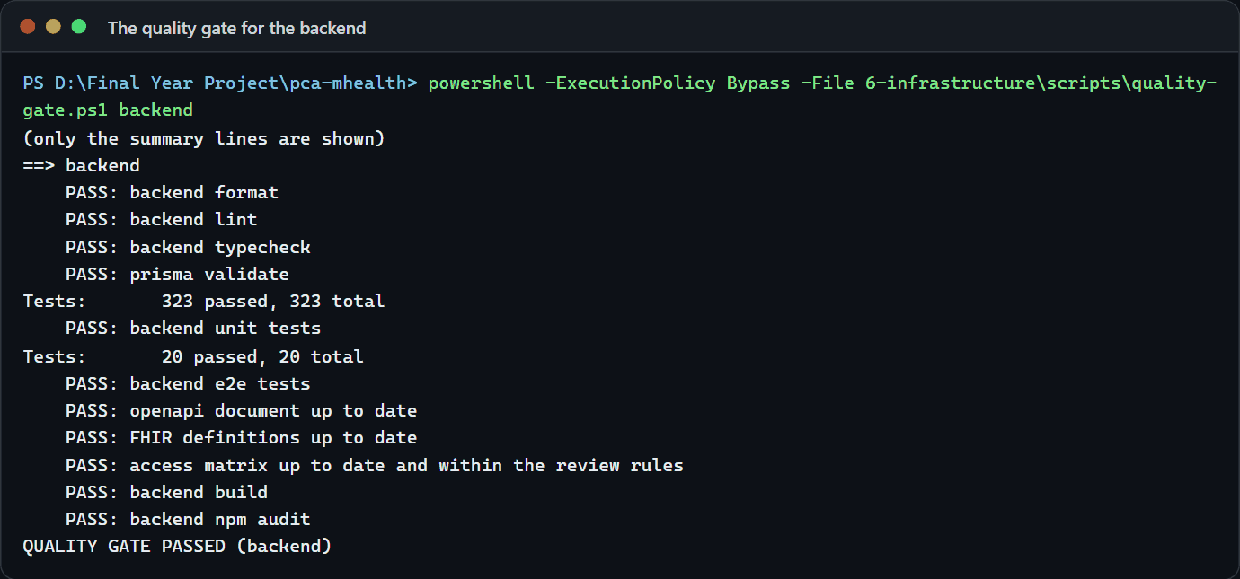
Figure 4.2: Test output: the backend gate

4.3.3 End-to-end workflows and device tests
The live workflow suite starts the real system for each run, with its own database and temporary folder. In Phase 16 it ran 13 tests in six workflows, each with failure paths (Table 4.6); a seventh, for the assistant, was added in Phase 13.
Table 4.6: End-to-end workflows on the live system
Workflow | What it proves
1. Sign-up and linking | A patient signs up, the clinic registers the same NRC, the administrator links them, and the patient sees only their own record; a taken e-mail and other areas are refused; five wrong passwords lock the account
2. Offline synchronisation | A repeated batch changes nothing; a stale edit returns a conflict; the valid part of a partly invalid batch is kept; changes stay within the facility
3. Imaging and AI | Consent is required; wrong files and modalities are refused; the de-identified copy has no DICOM identifiers; the report is labelled mock, with no invented explanations or metrics; other facilities cannot see it
4. Slide review | Clinicians cannot review; the server computes the grade group; a second review is refused; the slide is held back from the AI
5. Consent withdrawal | After withdrawal in the app, AI requests are refused and the research export excludes the patient
6. SmartCare Pro export | Only consented, de-identified data is sent over HTTPS; no name, NRC or record identifier reaches the receiver; the audit chain is intact
7. The assistant | Questions are answered from the real knowledge base through the whole system

The last test stops the system and searches both logs for every value used in the run: passwords, tokens, names, NRC numbers, phone numbers, clinical notes and chat questions. None appeared. On the Galaxy S9+ emulator (Android 10), the device test passed four flows against the running system (clinician, patient, administrator and pathologist) and confirmed that the phone's database is encrypted by SQLCipher.

4.3.4 Security testing
Phase 15 was an internal security and compliance review whose checks were automated into the gate. The access matrix then listed 66 routes (75 today) with no rule breaks. The TLS check against the real nginx configuration accepted only TLS 1.3. The full-history secret scan found four matches, all false positives; no real settings value appeared in any commit. Dependency audits of every package, including 130 Dart and Flutter packages, found no known vulnerabilities. A tamper test changed an audit entry inside a rolled-back transaction, and the chain check caught it. Table 4.7 lists the review's findings, all fixed.
Table 4.7: Findings of the security review (Phase 15)
ID | Severity | Finding | Resolution
F-1 | High | Files sent to the AI were the original uploads, with identifying DICOM headers | Only a de-identified copy is sent; slides held back until slide de-identification exists
F-2 | Medium | Role editing could break separation of duties | Administration and clinical-data permissions locked to their roles
F-3 | Medium | An administrator could add a clinical role to their own account | Nobody can add roles to their own account
F-4 | Low | The secret scan was not running locally | Now runs locally; earlier summaries corrected
F-5 | Low | The audit log could not be read without database access | Audit-log page with an integrity check
F-6 | Low | TLS 1.3 was configured but never tested | TLS check added to the gate
F-7 | Low | A vulnerable pip came with a rebuilt Python environment | Upgraded

A second review on 2 October 2026 (of code, security and design) found and fixed further defects. A lockout after five wrong passwords had ended the person's open sessions, so anyone who knew an email address could repeatedly sign a clinician out. Now a lockout only stops new sign-ins, and a disabled account is still refused at once. A malformed refresh cookie caused a server error; it now receives a 401 answer. Push devices are now removed whenever all of an account's sessions end (password reset, disabling, a role change or unlinking a patient account). Text-field and button outlines were 1.5 to 2.6:1 against their background, failing WCAG 2.1 AA criterion 1.4.11; they now reach at least 3:1, and tests check this. Clinicians linking a patient account from the patient record now have the same safeguards as the administrator's page: an account registered with an NRC links only to the record with the same NRC, a record already linked to another account is never taken over, and a new link is audited and announced to the patient. Passport holders are still linked by their clinic, which checks the passport in person. Some findings remain open for the owner, among them the lockout answer that shows an account exists. The report's screen pictures taken before the fix still show the fainter outlines.
Eight residual risks (R-1 to R-8) must be closed before real data is used; they are listed with the recommendations in Section 5.7.

4.3.5 Performance testing
Phase 17 measured the whole system against the proposal's targets. A load generator written for the project starts the real system, creates 10 synthetic facilities, 500 clinician accounts and 300 patients, and runs a sequence of stages. Each virtual user waits 2–8 seconds between requests and follows a clinician's traffic mix. Latency is measured on the client, to the last byte. The run fails only on wrong answers (server errors, failed AI jobs, or a change lost or saved twice); speed is reported, not asserted.
Table 4.8: Measured performance against the targets (development laptop, synthetic data)
Target | Measured | Result
NFR-02: AI result within 3 s at P95 under load | 545 ms P95 end to end with 500 users active and one analysis a second; 1,027 ms P95 for 20 at once | Met for the pipeline with mock models
NFR-05: at least 500 concurrent users | 500 users at about 98 requests a second: 0 errors, P95 156 ms, P99 269 ms (25 users: P95 41 ms) | Met in practice
NFR-08: offline changes never lost or saved twice | 100 phones × 20 changes at once: all 2,000 saved, 0 errors; resent, all 2,000 recognised as already saved | Met
FR-07: assistant within 2 s | 100 clinicians (about 18 questions a second): 0 errors, P50 260 ms, P95 514 ms with the meaning search; P95 43 ms with keywords only | Met
Start-up (no target) | Backend 3.8 s, AI service 1.4 s; app cold start 1.7 s median on the emulator | Reported

A stress stage found the saturation point of one API instance on the laptop at about 133 requests a second, with no errors but a P95 of 5,146 ms. Sign-in is deliberately slow because of Argon2id: 500 sign-ins, 25 at a time, took 39.5 seconds.
The measurements exposed two problems, both fixed. Bulk synchronisation was slow, each phone taking 14–18 seconds and all finishing together; sampling showed that 79% of the busy database time was spent waiting for the audit chain's lock, held until commit. Writing the audit row last in screening transactions shortened the lock and cut the time per phone from 14.4 seconds to 11.3 and 12.2 seconds; the remaining capacity of about 160–180 audited changes a second is far above a clinic's load. The first version of the meaning search failed the 2-second target with a P95 of 8,440 ms, because questions were encoded one at a time on all threads; encoding each on one thread, six side by side with a keyword fallback after half a second, brought the P95 to 514 ms with no fallbacks.
These numbers have limits. One laptop ran everything at once, including the load generator, both databases, the emulator and the development tools, so the numbers are a floor, not a ceiling. The mock models take almost no time, so the AI timings say nothing about real models. "Concurrent users" means users active at the same time, each acting every few seconds. The main runs, on 28–29 September 2026, used PostgreSQL 16 and MongoDB 7 in Docker, before the move to the installed servers, and were not repeated afterwards.

4.3.6 Evaluation of the assistant's retrieval
The assistant was measured on fixed question sets written by the developer: 18 quality questions, 24 everyday-word questions, 12 off-topic questions, and 11 follow-ups and new topics. An answer is right when its first quoted passage comes from a correct article, and an off-topic question is right when it is refused (Table 4.9).
Table 4.9: Retrieval evaluation of the assistant (1 October 2026)
Retrieval | Quality set (18) | Everyday words (24) | Off-topic refused (12) | Follow-ups right (7) | New topic refused (4)
Keywords only | 18 | 18 | 9 | 6 | 0
Keywords and meaning (MedCPT) | 18 | 20 | 11 | 7 | 3

The first quoted passage should also come from the right section, which was checked on 10 questions whose right section was found by reading the passages (ADR-013, added 2 October 2026). Keywords alone chose the right section for 8 of the 10. The first version, which ordered every passage by meaning, chose it for 5, putting a PI-RADS question under the wrong section. The version as shipped, where meaning chooses the article and keywords the section, chose it for 9. One question is still wrong: "What else apart from cancer can push the level up?" receives What a result can and cannot show instead of Why the level can be raised. Known failures remain: "Tell me about breast cancer screening" receives the prostate screening passage, and "Will it rain tomorrow?" after a PSA question is answered. A general sentence-embedding model was tried first and dropped, because it did worse than keywords alone. The sets are small and developer-written, so they guard against regressions rather than prove quality. The safety rules passed a 34-prompt red-team set in full, small talk was tested with 40 phrases, and a test checks that every quoted answer equals the reviewed passages word for word.

4.3.7 Interoperability and accessibility testing
The FHIR export was checked with the official HL7 validator (version 6.10.4). After the project's local definitions were published, the sample export passed with 0 errors and 46 best-practice warnings (no narrative text, and no performer, because staff are deliberately not exported). Every LOINC and HL7 code was checked on the HL7 terminology server; for PI-RADS, the rectal examination and prostate volume, no standard code could be verified, so project code systems are used instead of a guess. A test for each of the eighteen Safe Harbor identifier classes runs against a synthetic patient carrying every identifier the system can hold.
For accessibility, the theme test checks 30 text pairs per mode against the WCAG AA ratio of 4.5:1; the accessibility suite applies Flutter's guidelines (tap-target size, labels and contrast) to twelve screens in both modes and at 200% text; and the website's contrast test fails the build if any text pair falls below 4.5:1. A test with screen-reader users remains for the user acceptance test.

4.3.8 User acceptance testing
The proposal's user acceptance test has not been carried out. It requires written approval from the ZCAS University Ethics Review Board and the National Health Research Authority, which has not been obtained. No participant has used the system, and no SUS score exists.
A kit was prepared: a plan; an information sheet and consent form with a witness line for participants who cannot read; task sheets with success criteria for patients (14 tasks), clinicians (11), pathologists (6) and administrators (7, optional); the SUS questionnaire with reading-aloud instructions and a scoring example; and a results template designed for this section. The plan asks for at least five participants per group from CDH, UTH and a rural or peri-urban facility, using synthetic data only, in 45-minute sessions of think-aloud, timed tasks with recorded help levels, the SUS and an interview. The analysis covers success rates, time on task, SUS statistics per group, problems rated on Nielsen's severity scale and a thematic analysis. Appendix C summarises the kit.
[UAT RESULTS: to be added after the sessions, from the results template in docs/uat/results-template.md: task success and time per task, the SUS score per group against the target of 75, the problems found with their severity, the themes from think-aloud and interviews, and the read-aloud and voice results for participants with limited reading skills. Report failed tasks as they happened.]
Table 4.10: System Usability Scale results (to be completed after the sessions)
Group | Participants | Mean SUS | Standard deviation | Range | Target (≥ 75) met?
Patients | [UAT RESULTS] | [UAT RESULTS] | [UAT RESULTS] | [UAT RESULTS] | [UAT RESULTS]
Clinicians | [UAT RESULTS] | [UAT RESULTS] | [UAT RESULTS] | [UAT RESULTS] | [UAT RESULTS]
Pathologists | [UAT RESULTS] | [UAT RESULTS] | [UAT RESULTS] | [UAT RESULTS] | [UAT RESULTS]
All | [UAT RESULTS] | [UAT RESULTS] | [UAT RESULTS] | [UAT RESULTS] | [UAT RESULTS]

4.4 Main Function Codes
Each picture shows the real file, with its name and line numbers, as it stood when the picture was taken.

4.4.1 Objective 1: a secure, offline-first mobile application
The phone's database is opened with SQLCipher and a key held in the Android Keystore, and opening refuses to continue without SQLCipher (Figure 4.3). The sync engine runs one sync at a time, sends the outbox in batches and pulls the facility's changes (Figure 4.4), and the server applies each change once, returning the stored result for a repeated idempotency key (Figure 4.5).
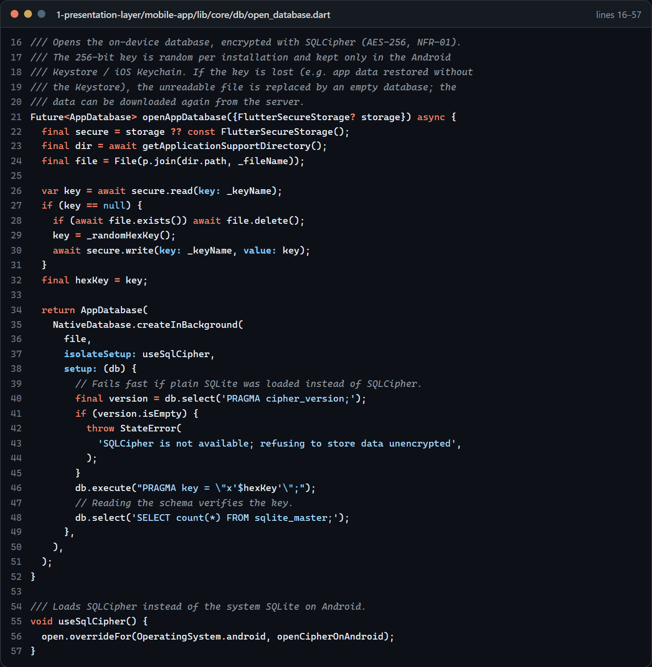
Figure 4.3: The phone's encrypted database (SQLCipher key in the Keystore)
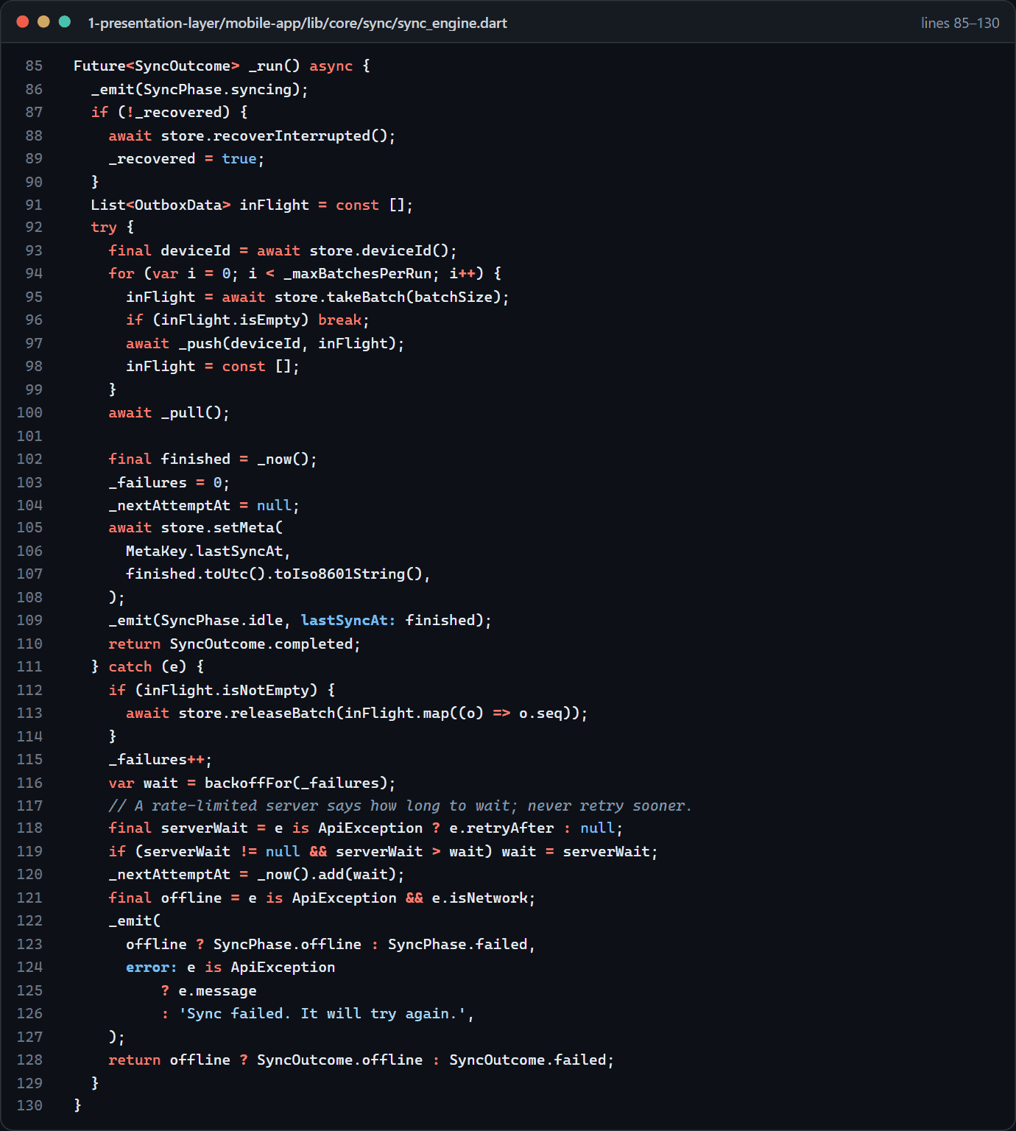
Figure 4.4: The phone's sync engine
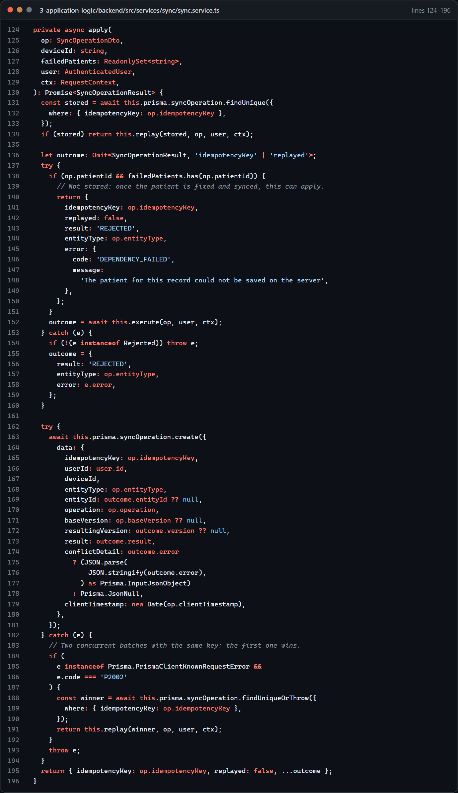
Figure 4.5: The server applies each synced change once (idempotency)
Identifiers are encrypted with AES-256-GCM, with HMAC look-ups (Figure 4.6). Sign-in applies the lockout and issues the tokens (Figure 4.7), and the permissions guard enforces RBAC and audits refusals (Figure 4.8). The reverse proxy accepts TLS 1.3 only (Figure 4.9), the FHIR export applies the Safe Harbor rules (Figure 4.10), and the push outbox sends each new notification once (Figure 4.11).
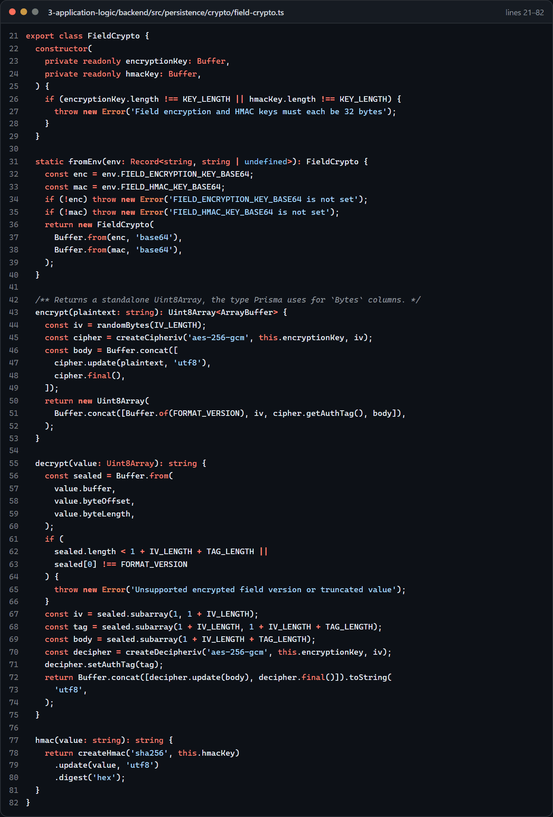
Figure 4.6: AES-256-GCM encryption of identifiers, and HMAC look-ups
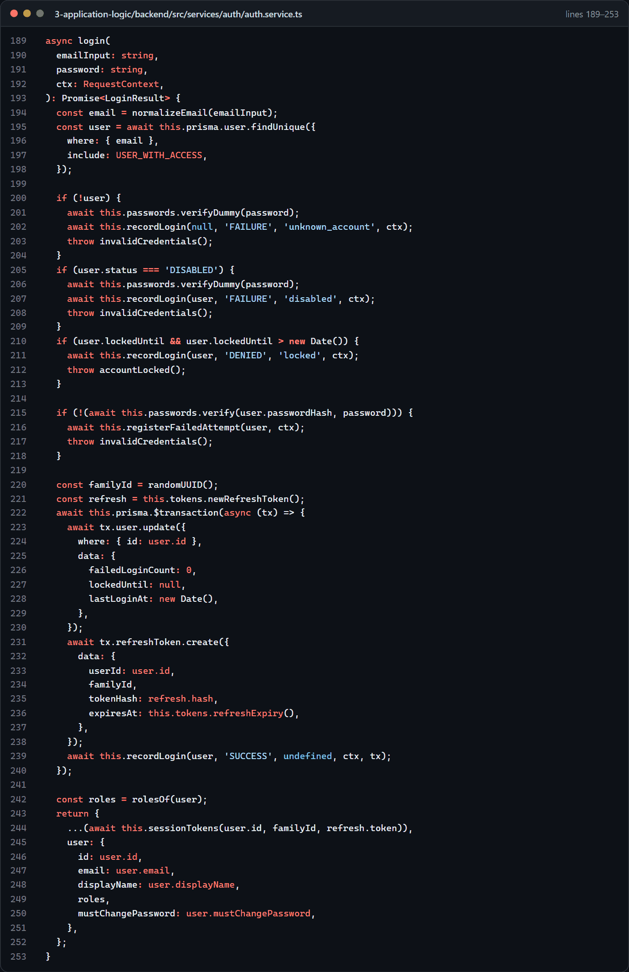
Figure 4.7: Sign-in with lockout and session tokens
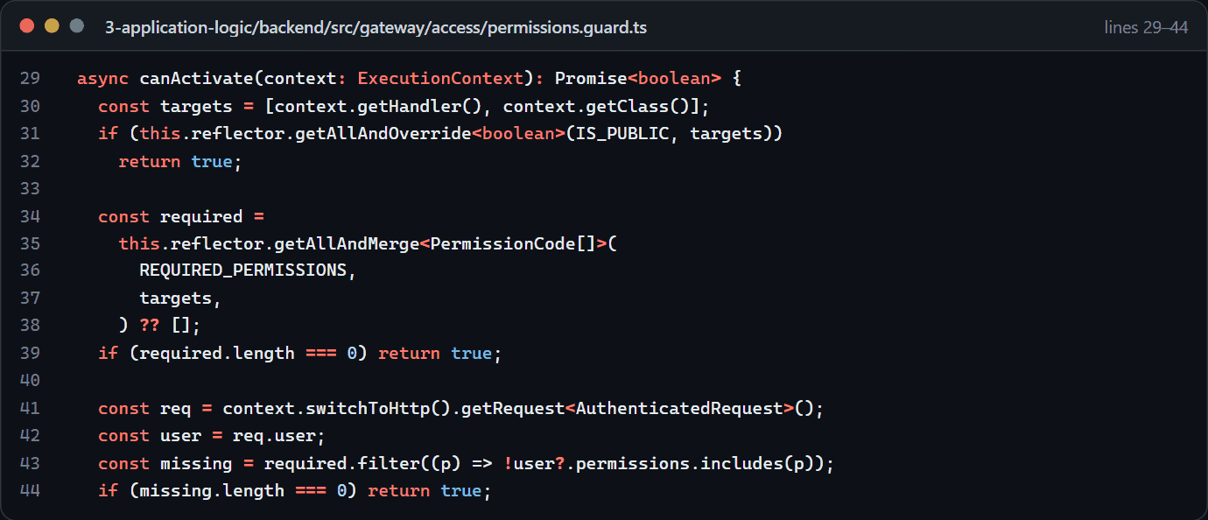
Figure 4.8: Role-based access control: the permissions guard
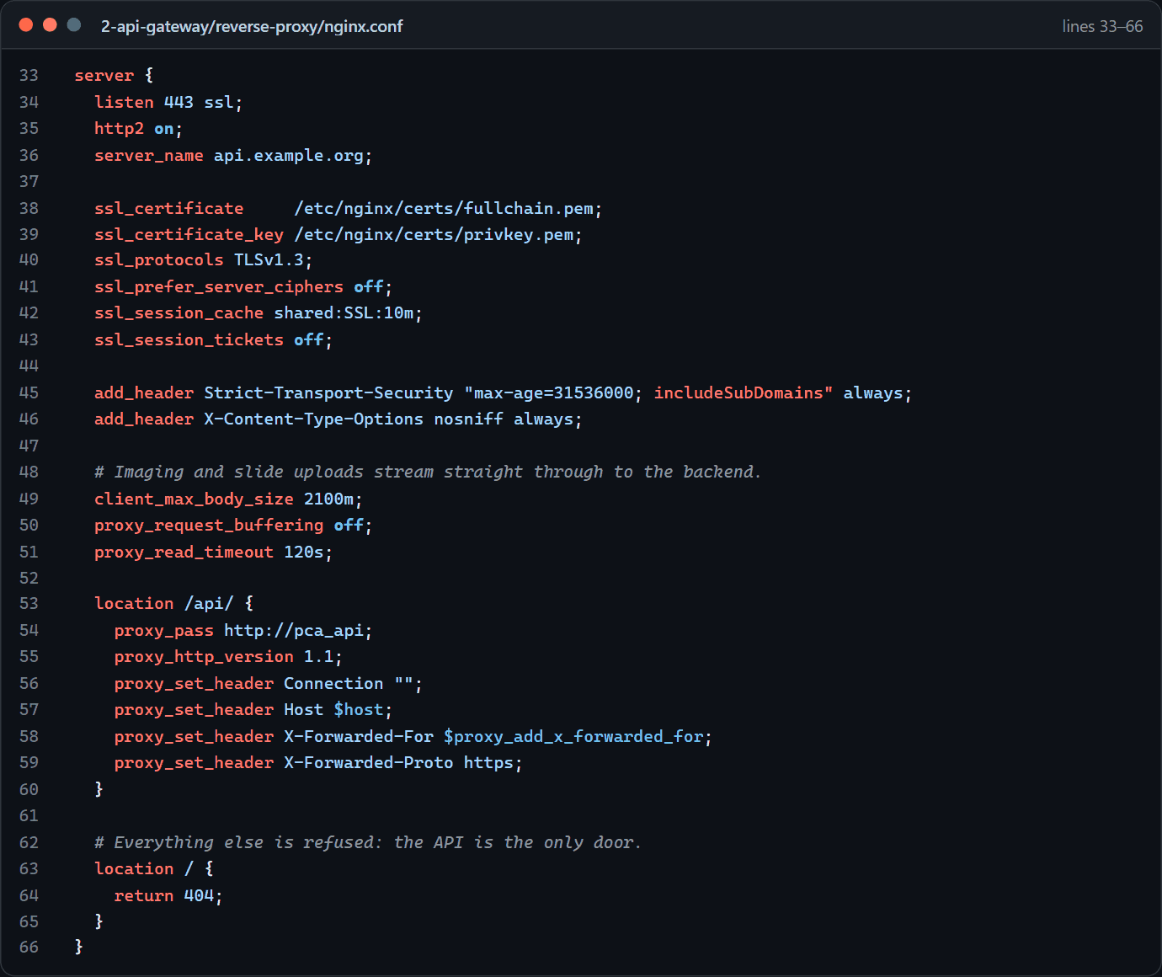
Figure 4.9: TLS 1.3 only at the reverse proxy
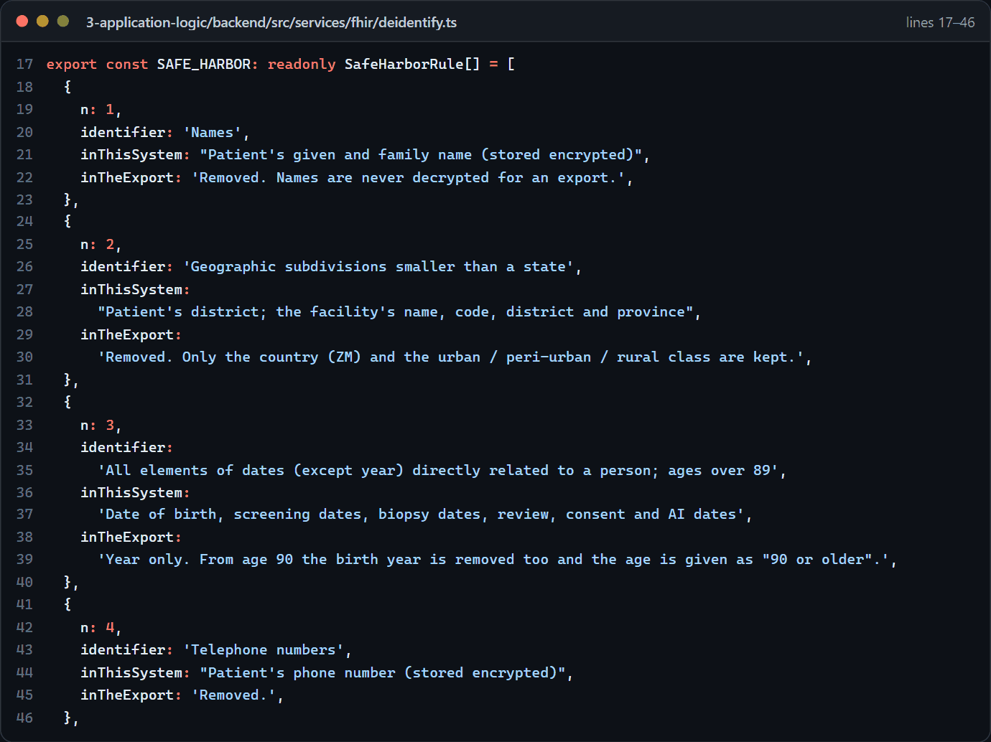
Figure 4.10: Safe Harbor de-identification rules for the FHIR export
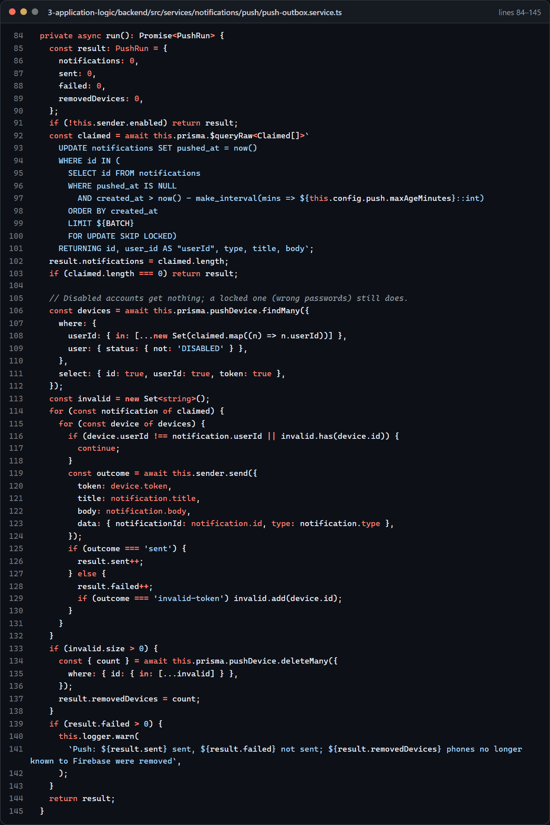
Figure 4.11: Push notifications: the outbox sends each new notification once (ADR-014)

4.4.2 Objective 2: the multi-modal AI inference engine
The pipeline is built but the trained models are not, so the modules are labelled mocks. A request checks consent first (Figure 4.12); the model router runs the modules the inputs allow and fuses their results (Figure 4.13); and the fairness check flags an AUC gap above 0.05 between groups (Figure 4.14), so far tested on test figures only.
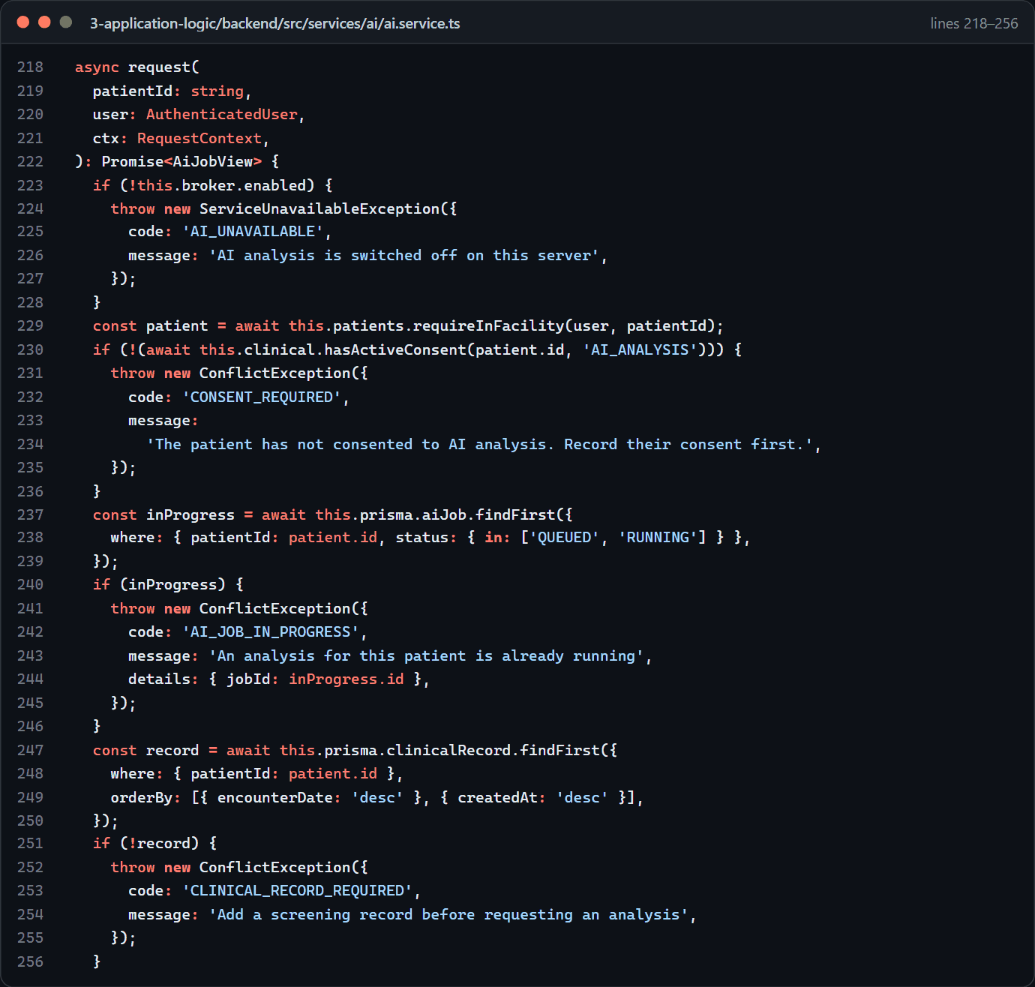
Figure 4.12: Requesting an analysis: consent first
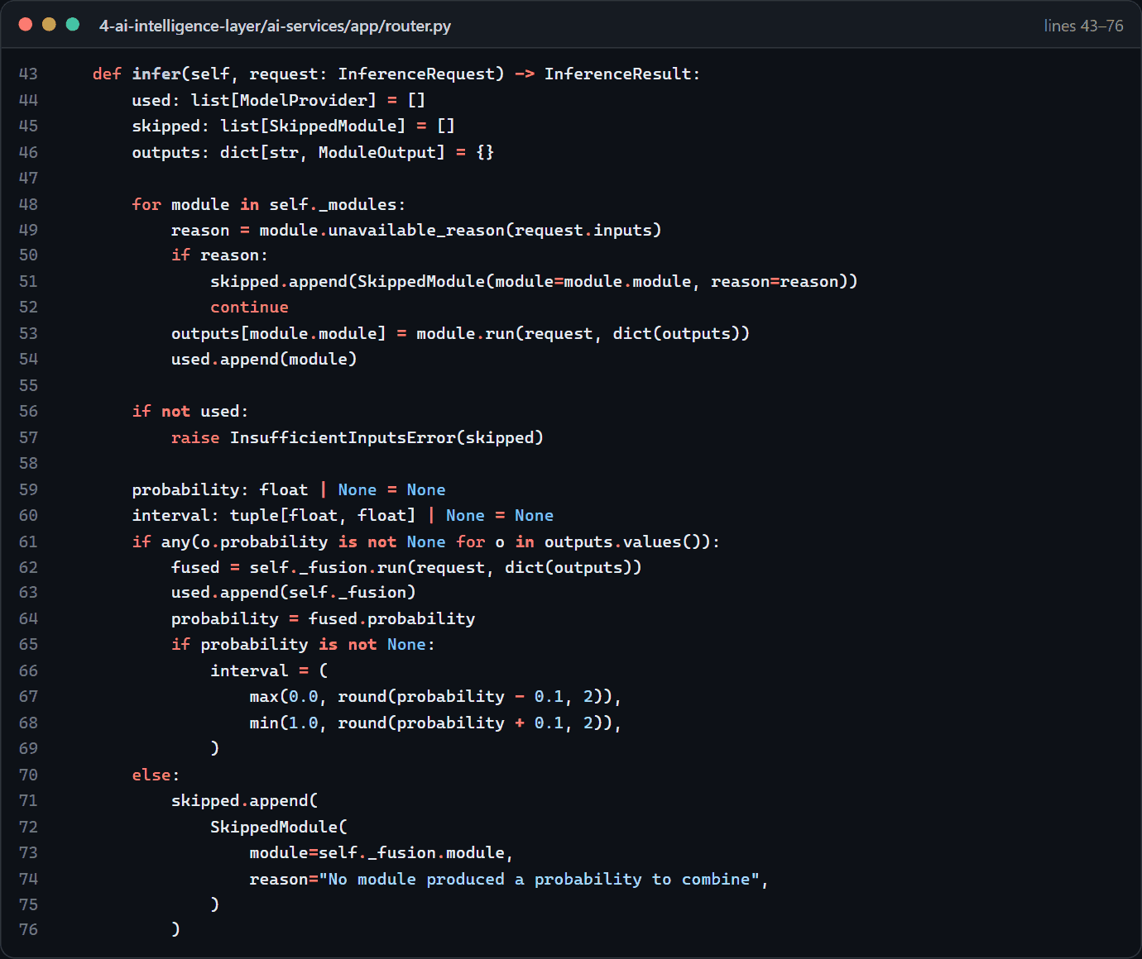
Figure 4.13: The model router and the fusion step
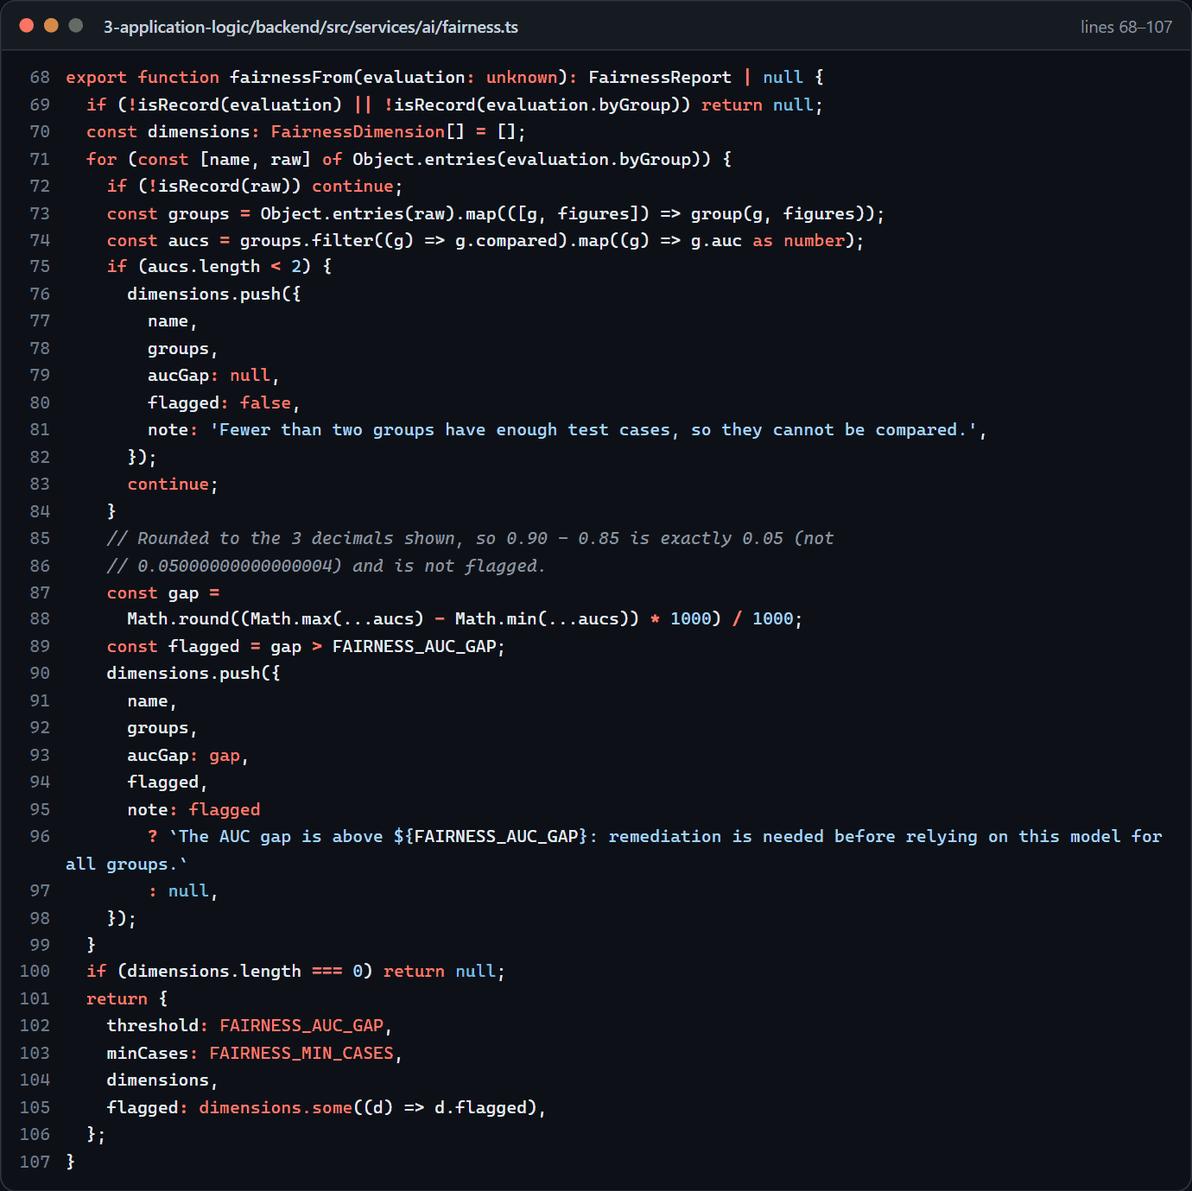
Figure 4.14: Fairness check across groups (AUC gap above 0.05 flagged)

4.4.3 Objective 3: the patient-education chatbot
The safety rules are checked before every answer (Figure 4.15), and the chatbot service applies safety, then small talk, then the knowledge base (Figure 4.16). Retrieval uses BM25 keyword search (Figure 4.17) and then MedCPT: the keywords decide whether a question is covered, MedCPT chooses the article and the keywords choose the section (Figure 4.18). The MedCPT encoder, a 12-layer PubMedBERT model, is written with numpy (Figure 4.19), and the answer is written from the passages (Figure 4.20). In the app, the chat controller holds the conversation (Figure 4.21); voice input uses the phone's speech service, so the app receives only text (Figure 4.22); and read-aloud reads articles part by part for people who cannot read (Figure 4.23).
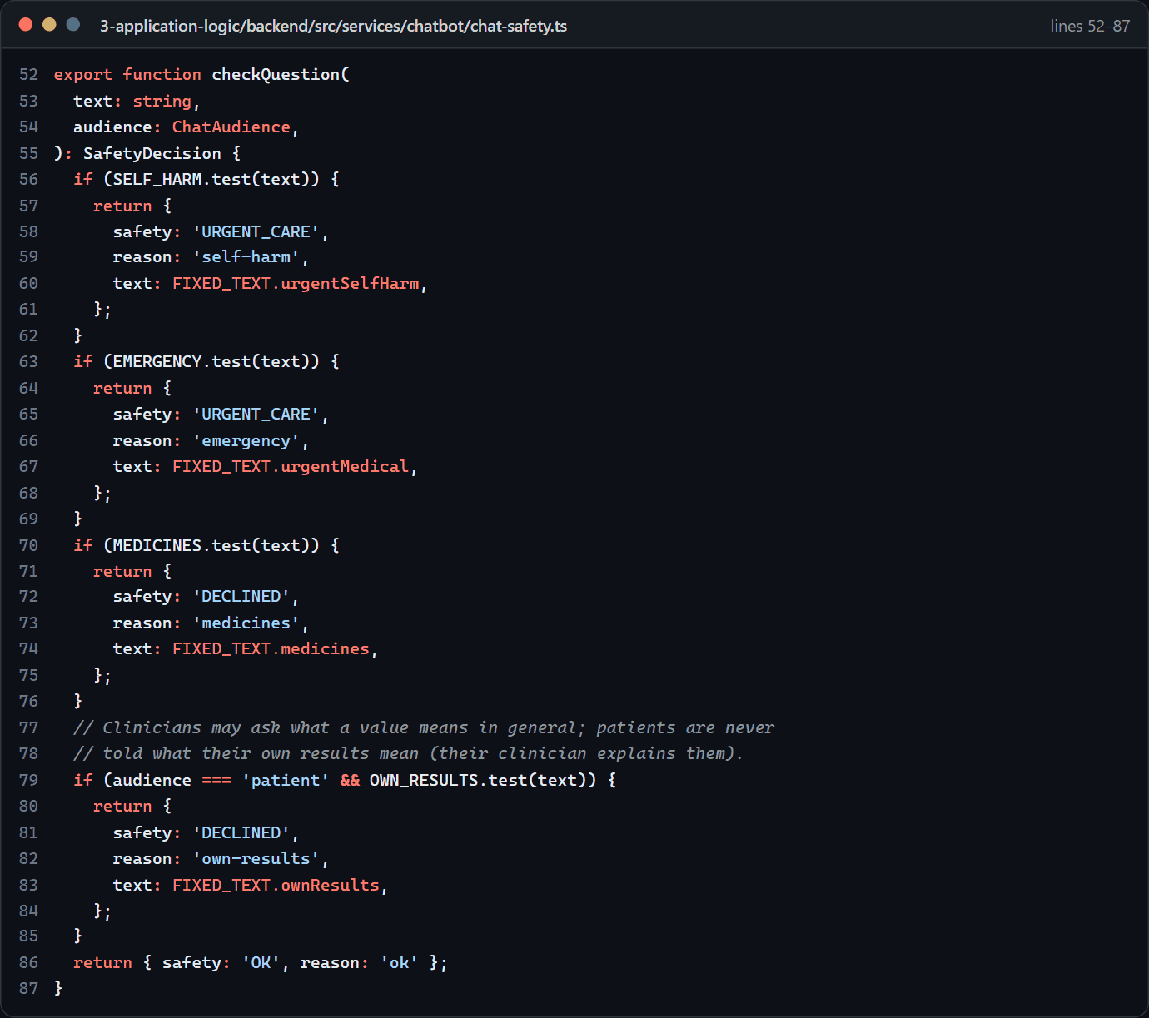
Figure 4.15: Safety rules, checked before every answer
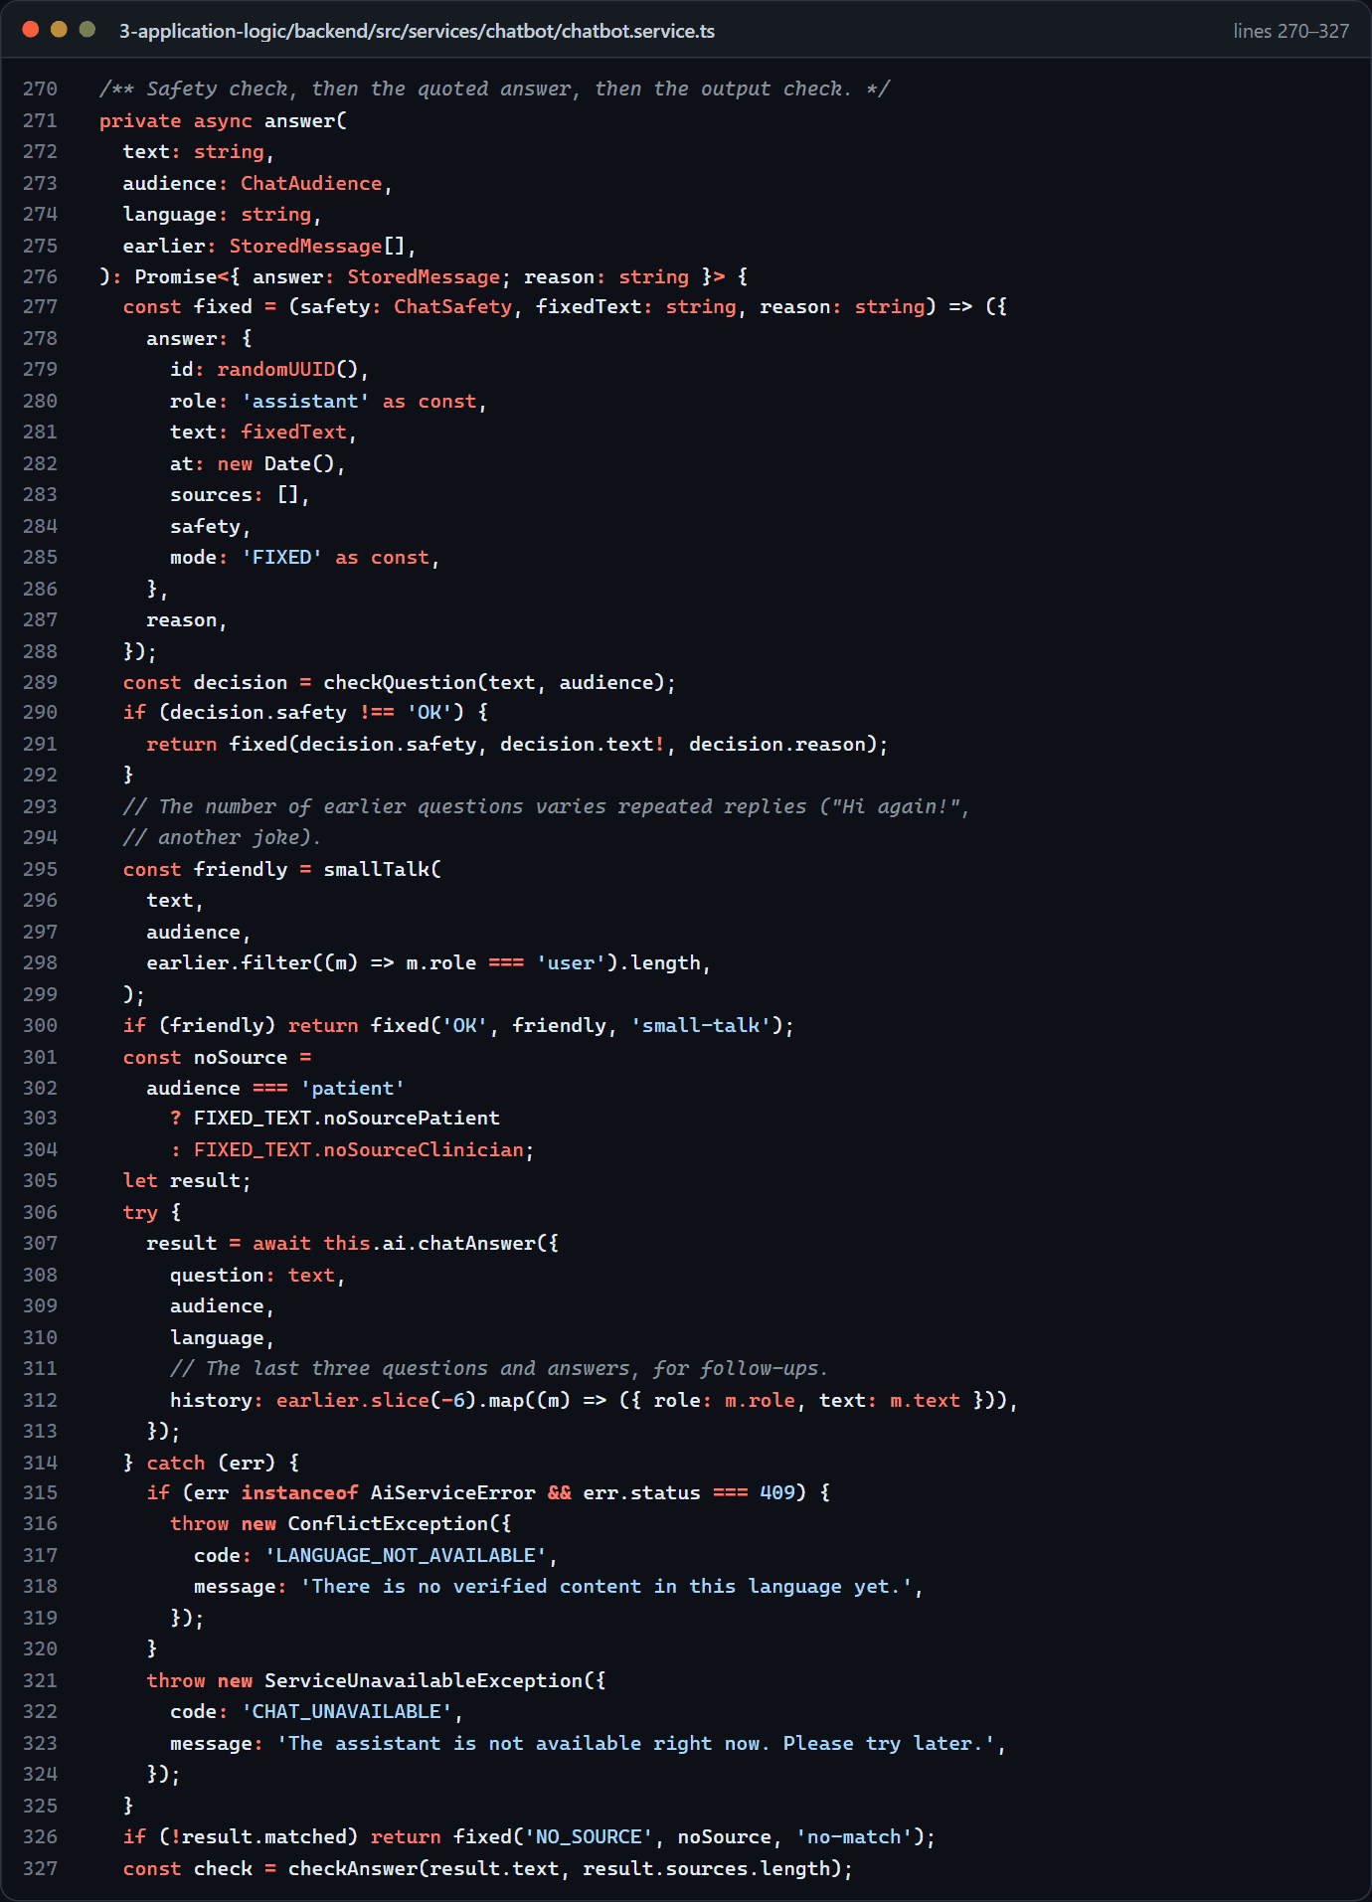
Figure 4.16: The chatbot service: safety, small talk, then the knowledge base
Figure 4.17: Retrieval, step 1: BM25 keyword search of the reviewed knowledge base
Figure 4.18: Retrieval, step 2: the keywords decide, MedCPT chooses the article (ADR-013)
Figure 4.19: The MedCPT encoder (PubMedBERT, 12 layers) written with numpy
Figure 4.20: Writing the answer from the passages
Figure 4.21: The app's chat controller
Figure 4.22: Voice input with the phone's speech service
Figure 4.23: Reading aloud for people who cannot read

4.4.4 Objective 5: ethics, privacy and compliance
The audit log's hash chain is enforced by a database trigger, independent of the application code (Figure 4.24); Figures 4.6, 4.10 and 4.14 also serve this objective.
Figure 4.24: The audit log's hash chain (database trigger)
Objective 4, data collection and model training, has no code in the prototype, because no training data or trained model exists. Its preparation is an integration guide specifying what each trained model must provide: portable weights, a model card, the exact input and output specification, and an evaluation file with held-out results and per-group figures for the fairness check.

4.5 Chapter Summary
The system was implemented as six layers of working software, installed with a settings script and started with one command. Testing ran at every level, and every package passed its 80% coverage minimum. The targets for AI response time, concurrent users, offline synchronisation and assistant response time were met on a development laptop, within the stated limits. The user acceptance test is prepared but awaits ethics approval. Chapter 5 evaluates these results.

Chapter 5: Conclusion and Recommendations

5.1 Introduction
This chapter evaluates the project against the proposal's five objectives and four research questions, compares the plan with the outcome, states the limitations, and gives recommendations and future work. It uses only what was built and measured, and says where an objective depends on work that could not be done.

5.2 Summary of the Work
The project built a working prototype of every layer of the proposed architecture. A Flutter app lets clinicians register patients and record screenings with or without internet, in an encrypted database on the phone, with each change applied exactly once and conflicting edits never silently overwritten. It also gives patients their results, health information that can be read aloud, messages, consent management and an assistant that accepts typed or spoken questions, and lets pathologists review slides. A React website serves administrators. A NestJS backend enforces authentication, role-based access, facility scoping, separation of duties and a hash-chained audit log, and exports de-identified HL7 FHIR R4 records. A Python service holds the AI pipeline, with labelled mock models in place of the five trained models, and the assistant's retrieval over a reviewed knowledge base. Each of the nineteen phases closed with an automated quality gate; every package met the 80% coverage minimum, and measured response times met the proposal's targets on a development laptop.

5.3 Evaluation Against the Objectives
Table 5.1 summarises the evaluation; the sections that follow explain each judgement.
Table 5.1: Evaluation of the objectives
Objective | Judgement | Main evidence | Main shortfall
1. Secure, offline-first app (AES-256, TLS 1.3, RBAC, FHIR R4) | Largely met | Encrypted phone database confirmed on the device; exactly-once synchronisation under load; TLS 1.3 only; 75 routes under checked rules; FHIR export with 0 validator errors | Flutter, not React Native; Android only; push off until a Firebase project exists; SmartCare Pro reached only through a stand-in
2. Multi-modal AI engine (AUC-ROC ≥ 0.90) | Partly met | Router, contract, queue, explanations, registry and fairness check built and tested; 545 ms P95 with mock models | No trained model; no accuracy figure; no real Grad-CAM or SHAP output
3. RAG chatbot, English and Zambian languages, within 2 s | Met for English retrieval and speed; partly met overall | 514 ms P95 under 100 users; MedCPT (768 dimensions) choosing the article from reviewed passages; measured retrieval gains; safety rules; voice and read-aloud | No Bemba or Nyanja; knowledge base not signed off; no usability test
4. Data collection and training methodology | Not met in the prototype | An integration guide for trained models and their evaluations | No data collected; methodology not applied
5. Ethics, privacy and compliance framework | Partly met | Consent per purpose, Safe Harbor tests per identifier class, de-identified AI inputs, tamper-evident audit, separation of duties, labelled mocks, evaluation-gated metrics | No ethics approval, data-protection review or legal review; no real explainability or bias figures

5.3.1 Objective 1: the mobile application
The objective is largely met. The phone's database is encrypted with SQLCipher (AES-256), and the on-device test confirms the cipher is in use. Offline capture was verified in unit tests, a live workflow, on the emulator and under load (Section 4.3.5). TLS 1.3 was proved against the real nginx configuration, RBAC is checked on every route, and the FHIR R4 export passed the official validator with no errors.
Four shortfalls remain. The app uses Flutter rather than React Native, which changes the framework but not the requirements (ADR-001). Only Android was built and tested, because an iOS build needs a Mac. Push notifications are built and tested with stand-ins but stay off until the owner creates a Firebase project, so real delivery is untested. Interoperability is one-way and simulated: the export works against a SmartCare Pro stand-in, while receiving data needs identified data and a data-sharing agreement. On the development computer the system runs over plain HTTP locally; TLS 1.3 applies at the reverse proxy that a deployment would place in front of the backend.

5.3.2 Objective 2: the AI inference engine
This is the largest gap between proposal and prototype. The architecture is built and tested: broker, queue with time-outs, contract, router, fusion step, registry, explanation pipeline and fairness check. The pipeline met the 3-second target with 545 ms at the 95th percentile under load. However, no trained model exists. Every module is a labelled mock whose numbers come from a hash of the job identifier, so the prototype produces no probability, Gleason prediction or heatmap, the AUC-ROC target cannot be assessed, and no accuracy figure can be claimed. The latency result also says nothing about real inference. The models are being trained separately, and an integration guide describes how each replaces its mock by changing only the AI service.

5.3.3 Objective 3: the chatbot
The objective is met for English retrieval and response time, and partly met overall. The proposal asked for biomedical embeddings of 768 dimensions; the prototype uses MedCPT, a PubMedBERT retriever with 768-dimensional vectors (Jin et al., 2023), combined with BM25. On the developer's question sets the hybrid answered 20 of 24 everyday-word questions correctly (18 with keywords alone) and refused 11 of 12 off-topic questions (9 before), within 514 ms at the 95th percentile under load (Section 4.3.6). The safety rules passed a 34-prompt red-team set.
Some departures are deliberate and documented: the assistant never interprets a patient's own results; it scores by MedCPT's dot product rather than cosine similarity, ranks every keyword match rather than the top five, and keeps its 32 vectors in a file rather than a vector database; and it quotes reviewed passages rather than using a fine-tuned generator, with Claude available to write from them if enabled. The genuine shortfalls are that Bemba and Nyanja are unavailable until human-verified translations exist, that the small knowledge base has not been signed off by a clinician and does not yet cover the practical barriers of the Health Belief Model, and that the think-aloud test with users of limited literacy has not been held.

5.3.4 Objective 4: data collection and model training
This objective is not met in the prototype. Collecting clinical data requires data-sharing agreements and ethics approval from the ZCAS Ethics Review Board and the NHRA, and neither was available. None of the methodology could therefore be applied: specialist-led correction of PCa and BPH misclassification, normalisation, registration, augmentation, transfer learning, stratified 5-fold cross-validation and external validation. The project produced only the receiving end: an integration guide specifying the weights, model card, input and output specification and evaluation file (with held-out results and per-group figures) that each trained model must bring, plus a fairness check, evaluation endpoint and report screens to use them.

5.3.5 Objective 5: the ethics, privacy and compliance framework
The technical part of this objective is met and tested; the formal part is not. Built and tested are the measures listed under research question 4, together with a Safe Harbor test for each of the eighteen identifier classes, de-identified scan copies and a keyed pseudonym for the AI, and a log review that found no secrets or patient details. Outstanding are ethics approval; a data-protection review under Zambia's Data Protection Act (2021) covering the third parties some features involve (the phone's speech service, Firebase and, if enabled, Anthropic); a legal review of data residency, which is documented but not implemented; and real data for the explainability and bias mechanisms.

5.4 Answers to the Research Questions
Research question 1: how can a multi-modal AI engine be designed for Zambia's constraints? The prototype's answer is architectural. Isolate the engine in its own service behind a versioned contract, so that models can change without touching the rest of the system. Let a router run whatever modules the inputs allow, which suits a setting without mpMRI and with incomplete inputs. Run jobs through a queue with time-outs and one job per patient. De-identify inputs before they leave the backend, label every output with its provenance, and show no metric without a stored evaluation. Whether trained models would meet the clinical and latency targets on Zambian data remains open (Section 5.3.2).
Research question 2: which data strategies work best for scarce, misclassified and non-standard Zambian data? The prototype cannot answer this empirically, because no data was collected and no model trained. The proposal's strategies remain the plan. The project contributes the specification of what a trained model must report, including per-group figures, so that the effect on subgroups will be visible.
Research question 3: how can an offline-capable architecture serve both connected and disconnected facilities? This is answered most fully. Work is saved first in an encrypted database on the phone and queued in an outbox. Each change carries an idempotency key, so a change sent twice is applied once. Batches are retried with exponential back-off, stale edits return as conflicts for the clinician to resolve, and files wait in an upload queue that survives lost connections and restarts. Tests, a live workflow and a load run verified this. Two limits remain: AI analysis and the assistant still need a connection, as the proposal acknowledged, and offline behaviour was tested on an emulator, not in a rural facility.
Research question 4: which ethical, fairness, explainability and regulatory measures are needed? The prototype implements consent per purpose with withdrawal at any time; minimum necessary access; de-identification before data leaves the core system; a hash-chained audit trail; provenance and a mock label on every AI output; evaluation-gated metrics with fairness gaps above 0.05 flagged; an explanation or stated reason for every AI output; no interpretation of results for patients; safety rules before any assistant answer; and a data-protection review for every outside processor. Only ethics and legal review, user testing and real data can show whether these suffice.

5.5 Plan Versus Outcome
Comparing Figure 1.1 with Figure 1.2: of the proposal's nine phases, planning (1), design (2), app and chatbot development (5), integration (6), the security audit (8, as an internal review) and documentation (9) were completed. Data collection (3), model training (4) and user acceptance testing (7) were not, because each depends on approvals, agreements or participants outside the project's control. The implementation took far less time than planned (23 September to 2 October 2026, by the Git history), probably largely because of the AI coding assistant recorded in the development log and security review. The order of the work also changed at the owner's request, and several features not in the plan were added in response to the owner's evaluation of each iteration.

5.6 Limitations
1. The AI models are development mocks. No diagnostic result is produced, and no accuracy, sensitivity, specificity or AUC figure can be reported.
2. All data is synthetic. Behaviour with real clinical data, including incomplete and misclassified records, is untested.
3. The knowledge base is a draft of 32 passages that awaits a clinician's sign-off and does not yet address all Health Belief Model constructs.
4. English only. Bemba and Nyanja are switched off until human-verified translations exist.
5. No user acceptance testing. No participant has used the system, there is no SUS score against the target of 75, and no screen-reader user has tested it.
6. One laptop. All measurements were taken on one laptop running every component, and the main performance runs predate the move to the installed database servers.
7. Android only, mostly on an emulator. No iOS build exists; speech recognition was not confirmed with a real voice; push was not tested with real Firebase.
8. Simulated integration. SmartCare Pro was reached only through a stand-in, and receiving data was not built.
9. Small evaluation sets. The assistant's thresholds were tuned on 65 developer-written questions and 10 section checks, which guard against regressions but do not prove quality. One section check is still wrong (9 of 10).
10. An internal security review, not an independent penetration test, with eight residual risks open and some findings of the 2 October review (for example the lockout answer that shows an account exists) still open for the owner.

5.7 Recommendations
Before any use with real patients, the following are recommended.
1. Obtain ethics approval from the ZCAS Ethics Review Board and the NHRA, then run the user acceptance test with the prepared kit and report the SUS score per group against the target of 75.
2. Train and evaluate the models with the proposal's methodology, integrate them through the integration guide with per-group evaluation figures, and re-run the performance tests with real inference.
3. Have a qualified clinician sign off the knowledge base, and extend it to the practical barriers of cost, distance and fear of biopsy.
4. Commission human-verified Bemba and Nyanja translations before enabling those languages.
5. Carry out a data-protection review under the Data Protection Act (2021) covering the speech service, Firebase and Claude, and a legal review of data residency.
6. Close the residual security risks: remove label and macro images from slides before slides reach the AI (R-1); choose an SMS or e-mail provider for password resets (R-2); add a second factor for administrators (R-3); provision managed keys, encrypted object storage and backups, and database TLS (R-4); detect burned-in text in DICOM pixels (R-5); share exports only under a data-sharing agreement, since de-identified data is not anonymous (R-6); commission an independent penetration test to OWASP ASVS level 2 (R-7); and never run the demonstration seed against production (R-8). Also switch on MongoDB access control, which is off in the development installation.
7. Create the Firebase project and test push delivery on a real phone, and confirm speech recognition with a real voice.

5.8 Future Work
- A controlled clinical pilot at CDH and UTH, measuring turnaround time, AI-versus-clinician performance, adoption and outcomes.
- Federated learning across Zambian institutions, without centralising patient records.
- On-device inference with compressed models, so that basic AI support works without a connection.
- New imaging modalities, mpMRI and later PSMA PET/MRI, as they become available.
- Longitudinal outcome tracking, and AI-literacy training for clinicians.
- Two-way SmartCare Pro integration, and FHIR Bulk Data export at national scale.
- National-scale audit logging, chaining rows in batches or per facility to remove the single-lock bottleneck measured in Section 4.3.5.
- Production deployment with Kubernetes, monitoring and alerts (UC-10), and measured uptime against the 99.5% target.
- Population analytics (UC-11) and model retraining with A/B testing (UC-12).
- An iOS build, resumable uploads for large files, Bemba and Nyanja voices, and real user questions added to the retrieval evaluation sets.

5.9 Conclusion
The project set out to build a working prototype of an AI-driven mHealth platform for prostate cancer diagnosis in Zambia and to evaluate it honestly against the approved proposal. It built every layer of the proposed architecture and showed, in tested software, that the hard engineering problems of the setting can be solved: safe offline capture where connectivity fails, strict protection and de-identification of health data, a traceable audit trail, an AI pipeline that never presents mock output as real, and a patient assistant that answers only from reviewed content, quickly, by text or voice.
The prototype does not yet show that the platform improves diagnosis. That depends on work outside a software project: trained and validated models, real data under ethical approval, clinical review of the content, verified translations, and testing with the people the system is meant to serve. The proposal ended with the men who die each year from a disease that could be found earlier. This project does not yet change that number, but it provides a tested foundation for validated models and clinical evaluation.

References
Aranda-Jan, C. B., Mohutsiwa-Dibe, N., & Loukanova, S. (2014). Systematic review on what works, what does not work and why of implementation of mobile health (mHealth) projects in Africa. BMC Public Health, 14(1), 188. https://doi.org/10.1186/1471-2458-14-188
Award, N. (2022). Prostate cancer mortality in Zambia: Annual epidemiological statistics 2020. Zambia National Cancer Registry, Ministry of Health.
Beam, A. L., & Kohane, I. S. (2018). Big data and machine learning in health care. Journal of the American Medical Association, 319(13), 1317–1318. https://doi.org/10.1001/jama.2017.18391
Becker, M. H. (1974). The health belief model and personal health behavior. Health Education Monographs, 2(4), 324–508. https://doi.org/10.1177/109019817400200407
Benson, M. C., Whang, I. S., Pantuck, A., Ring, K., Kaplan, S. A., Olsson, C. A., & Cooner, W. H. (1992). Prostate specific antigen density: A means of distinguishing benign prostatic hypertrophy and prostate cancer. The Journal of Urology, 147(3 Pt 2), 815–816. https://doi.org/10.1016/s0022-5347(17)37393-7
Brooke, J. (1996). SUS: A "quick and dirty" usability scale. In P. W. Jordan, B. Thomas, B. A. Weerdmeester, & I. L. McClelland (Eds.), Usability evaluation in industry (pp. 207–212). CRC Press. https://doi.org/10.1201/9781498710411-35
Campanella, G., Hanna, M. G., Geneslaw, L., Miraflor, A., Werneck Krauss Silva, V., Busam, K. J., Brogi, E., Reuter, V. E., Klimstra, D. S., & Fuchs, T. J. (2019). Clinical-grade computational pathology using weakly supervised deep learning on whole slide images. Nature Medicine, 25(8), 1301–1309. https://doi.org/10.1038/s41591-019-0508-1
Catalona, W. J., Partin, A. W., Slawin, K. M., Brawer, M. K., Flanigan, R. C., Patel, A., Richie, J. P., deKernion, J. B., Walsh, P. C., Scardino, P. T., Lange, P. H., Subong, E. N., Parson, R. E., Gasior, G. H., Loveland, K. G., & Southwick, P. C. (1998). Use of the percentage of free prostate-specific antigen to enhance differentiation of prostate cancer from benign prostatic disease: A prospective multicenter clinical trial. JAMA, 279(19), 1542–1547. https://doi.org/10.1001/jama.279.19.1542
Davis, F. D. (1989). Perceived usefulness, perceived ease of use, and user acceptance of information technology. MIS Quarterly, 13(3), 319–340. https://doi.org/10.2307/249008
Djavan, B., Remzi, M., Zlotta, A., Seitz, C., Snow, P., & Marberger, M. (2002). Novel artificial neural network for early detection of prostate cancer. Journal of Clinical Oncology, 20(4), 921–929. https://doi.org/10.1200/JCO.2002.20.4.921
Epstein, J. I., Egevad, L., Amin, M. B., Delahunt, B., Srigley, J. R., Humphrey, P. A., & Grading Committee. (2016). The 2014 International Society of Urological Pathology (ISUP) consensus conference on Gleason grading of prostatic carcinoma: Definition of grading patterns and proposal for a new grading system. The American Journal of Surgical Pathology, 40(2), 244–252. https://doi.org/10.1097/PAS.0000000000000530
Fehr, D., Veeraraghavan, H., Wibmer, A., Gondo, T., Matsumoto, K., Vargas, H. A., Sala, E., Hricak, H., & Deasy, J. O. (2015). Automatic classification of prostate cancer Gleason scores from multiparametric magnetic resonance images. Proceedings of the National Academy of Sciences, 112(46), E6265–E6273. https://doi.org/10.1073/pnas.1505935112
Finne, P., Finne, R., Auvinen, A., Juusela, H., Aro, J., Maattanen, L., Hakama, M., Rannikko, S., & Stenman, U.-H. (2000). Predicting the outcome of prostate biopsy in screen-positive men by a multilayer perceptron network. Urology, 56(3), 418–422. https://doi.org/10.1016/S0090-4297(00)00672-9
Fiordelli, M., Diviani, N., & Schulz, P. J. (2013). Mapping mHealth research: A decade of evolution. Journal of Medical Internet Research, 15(5), e95. https://doi.org/10.2196/jmir.2430
He, K., Zhang, X., Ren, S., & Sun, J. (2016). Deep residual learning for image recognition. Proceedings of the IEEE Conference on Computer Vision and Pattern Recognition (CVPR), 770–778. https://doi.org/10.1109/CVPR.2016.90
Hevner, A. R., March, S. T., Park, J., & Ram, S. (2004). Design science in information systems research. MIS Quarterly, 28(1), 75–105. https://doi.org/10.2307/25148625
Ilse, M., Tomczak, J. M., & Welling, M. (2018). Attention-based deep multiple instance learning. Proceedings of the 35th International Conference on Machine Learning (ICML), 2127–2136.
Jin, Q., Kim, W., Chen, Q., Comeau, D. C., Yeganova, L., Wilbur, W. J., & Lu, Z. (2023). MedCPT: Contrastive pre-trained transformers with large-scale PubMed search logs for zero-shot biomedical information retrieval. Bioinformatics, 39(11), btad651. https://doi.org/10.1093/bioinformatics/btad651
Kaplan, W. A. (2006). Can the ubiquitous power of mobile phones be used to improve health outcomes in developing countries? Globalization and Health, 2(9). https://doi.org/10.1186/1744-8603-2-9
Karimi, D., Zeng, Q., Antony, P., Zunair, A., Rondeau, B., Bhalla, M., & Salcudean, S. E. (2019). Accurate and robust deep learning-based segmentation of the prostate clinical target volume in ultrasound images. Medical Image Analysis, 57, 186–196. https://doi.org/10.1016/j.media.2019.07.005
Laranjo, L., Dunn, A. G., Tong, H. L., Kocaballi, A. B., Chen, J., Bashir, R., Surian, D., Gallego, B., Magrabi, F., Lau, A. Y. S., & Coiera, E. (2018). Conversational agents in healthcare: A systematic review. Journal of the American Medical Informatics Association, 25(9), 1248–1258. https://doi.org/10.1093/jamia/ocy072
LeCun, Y., Bengio, Y., & Hinton, G. (2015). Deep learning. Nature, 521(7553), 436–444. https://doi.org/10.1038/nature14539
Lewis, P., Perez, E., Piktus, A., Petroni, F., Karpukhin, V., Goyal, N., Küttler, H., Lewis, M., Yih, W., Rocktäschel, T., Riedel, S., & Kiela, D. (2020). Retrieval-augmented generation for knowledge-intensive NLP tasks. Advances in Neural Information Processing Systems, 33, 9459–9474.
Litjens, G., Debats, O., Barentsz, J., Karssemeijer, N., & Huisman, H. (2014). Computer-aided detection of prostate cancer in MRI. IEEE Transactions on Medical Imaging, 33(5), 1083–1092. https://doi.org/10.1109/TMI.2014.2303821
Lombe, D. C., Manda, S. O., & Mwaba, C. K. (2024). Prostate cancer diagnostic delays and outcomes in Zambian healthcare facilities: A prospective cohort analysis. African Journal of Urology, 30(1), 14–22. https://doi.org/10.1186/s12301-024-00414-3
Ministry of Health Zambia. (2022). Digital Health Strategy 2022–2026: Leveraging digital technologies for universal health coverage. Government of the Republic of Zambia.
Moradi, M., Abolmaesumi, P., & Mousavi, P. (2009). Augmenting detection of prostate cancer in transrectal ultrasound images using SVM and random forest machine learning approaches. IEEE Transactions on Biomedical Engineering, 56(3), 664–668. https://doi.org/10.1109/TBME.2008.2009936
Nagpal, K., Foote, D., Liu, Y., Chen, P.-H. C., Wulczyn, E., Tan, F., Olson, N., Smith, J. L., Mohtashamian, A., Wren, J. H., Corrado, G. S., Peng, L. H., MacDonald, R., Bui, M. M., Mermel, C. H., Hipp, J. D., Jain, A., & Stumpe, M. C. (2019). Development and validation of a deep learning algorithm for improving Gleason scoring of prostate cancer. npj Digital Medicine, 2(1), 48. https://doi.org/10.1038/s41746-019-0112-2
National Cancer Institute. (2022). SEER cancer statistics review 1975–2022. National Institutes of Health.
Nielsen, J., & Landauer, T. K. (1993). A mathematical model of the finding of usability problems. In Proceedings of the SIGCHI Conference on Human Factors in Computing Systems (CHI '93) (pp. 206–213). ACM. https://doi.org/10.1145/169059.169166
Obermeyer, Z., Powers, B., Vogeli, C., & Mullainathan, S. (2019). Dissecting racial bias in an algorithm used to manage the health of populations. Science, 366(6464), 447–453. https://doi.org/10.1126/science.aax2342
Rebbeck, T. R., Devesa, S. S., Chang, B. L., Bunker, C. H., Cheng, I., Cooney, K., Eeles, R., Fernandez, P., & Giri, V. N. (2013). Global patterns of prostate cancer incidence, aggressiveness, and mortality in men of African descent. Prostate Cancer, 2013, 560857. https://doi.org/10.1155/2013/560857
Remzi, M., Anagnostou, T., Ravery, V., Zlotta, A., Stephan, C., Marberger, M., & Djavan, B. (2003). An artificial neural network to predict the outcome of repeat prostate biopsies. Urology, 62(3), 456–461. https://doi.org/10.1016/S0090-4297(03)00409-6
Ronneberger, O., Fischer, P., & Brox, T. (2015). U-Net: Convolutional networks for biomedical image segmentation. Lecture Notes in Computer Science, 9351, 234–241. https://doi.org/10.1007/978-3-319-24574-4_28
Rudin, C. (2019). Stop explaining black box machine learning models for high stakes decisions and use interpretable models instead. Nature Machine Intelligence, 1(5), 206–215. https://doi.org/10.1038/s42256-019-0048-x
Saha, A., Hosseinzadeh, M., & Huisman, H. (2021). End-to-end prostate cancer detection in bpMRI via 3D CNNs: Effects of attention mechanisms, clinical priori and decoupled false positive reduction. Medical Image Analysis, 73, 102155. https://doi.org/10.1016/j.media.2021.102155
Siegel, R. L., Miller, K. D., Wagle, N. S., & Jemal, A. (2023). Cancer statistics, 2023. CA: A Cancer Journal for Clinicians, 73(1), 17–48. https://doi.org/10.3322/caac.21763
Ström, P., Kalinichenko, K., Hagmar, M., Mathiesen, T., Bengtsson, E., Wählby, C., & Kullberg, J. (2020). Artificial intelligence for diagnosis and grading of prostate cancer in biopsies: A population-based, diagnostic study. The Lancet Oncology, 21(2), 222–232. https://doi.org/10.1016/S1470-2045(19)30738-7
Sung, H., Ferlay, J., Siegel, R. L., Laversanne, M., Soerjomataram, I., Jemal, A., & Bray, F. (2021). Global cancer statistics 2020: GLOBOCAN estimates of incidence and mortality worldwide for 36 cancers in 185 countries. CA: A Cancer Journal for Clinicians, 71(3), 209–249. https://doi.org/10.3322/caac.21660
Tajbakhsh, N., Shin, J. Y., Gurudu, S. R., Hurst, R. T., Kendall, C. B., Gotway, M. B., & Liang, J. (2016). Convolutional neural networks for medical image analysis: Full training or fine tuning? IEEE Transactions on Medical Imaging, 35(5), 1299–1312. https://doi.org/10.1109/TMI.2016.2535302
Topol, E. J. (2019). High-performance medicine: The convergence of human and artificial intelligence. Nature Medicine, 25(1), 44–56. https://doi.org/10.1038/s41591-018-0300-7
Turkbey, B., Rosenkrantz, A. B., Haider, M. A., Padhani, A. R., Villeirs, G., Macura, K. J., Tempany, C. M., Choyke, P. L., Cornud, F., Margolis, D. J., Thoeny, H. C., Verma, S., Barentsz, J., & Weinreb, J. C. (2019). Prostate Imaging Reporting and Data System version 2.1: 2019 update of Prostate Imaging Reporting and Data System version 2. European Urology, 76(3), 340–351. https://doi.org/10.1016/j.eururo.2019.02.033
Woznicki, P., Weiss, N., & Penzkofer, T. (2020). Multiparametric MRI for prostate cancer characterization: Combined use of radiomics model with PI-RADS and clinical parameters. Cancers, 12(7), 1767. https://doi.org/10.3390/cancers12071767
World Health Organization. (2020). Global cancer observatory: Cancer today. International Agency for Research on Cancer. https://gco.iarc.fr
World Health Organization. (2021). Ethics and governance of artificial intelligence for health: WHO guidance. World Health Organization.

Appendix A: Requirements Traceability Summary
This appendix summarises the project's requirements traceability matrix (docs/requirements-traceability.md), which records for every requirement the component, the implementation, the tests and the phase. In the matrix, "Verified" means that a passing automated test demonstrates the requirement; nothing is marked Verified without one.
Table A.1: Functional requirements
ID | Requirement (summary) | Status | Notes
FR-01 | JWT authentication, RBAC for four roles, lockout after five failures | Verified | 25 integration tests for authentication, plus token and password unit tests
FR-02 | Capture and transmit clinical data, encrypted, over TLS 1.3 | Verified | Backend, app forms, TLS 1.3 at the reverse proxy, end to end
FR-03 | Offline entry, AES-256 local database, conflict-resolving synchronisation | Verified | Server, app and on-device tests
FR-04 | Accept and validate DICOM scans, archive and queue them | Verified | Upload, validation and archive; AI receives de-identified copies only
FR-05 | PCa probability and grade group within 3 s at P95 | Pipeline verified with mock models only | 545 ms P95 under load; no trained model, so no real probability or grade
FR-06 | Grad-CAM and SHAP explanations | Pipeline verified | With mock models every explanation is an honest "unavailable" reason
FR-07 | RAG chatbot within 2 s, English, Bemba and Nyanja | Verified for English | P95 514 ms; Bemba and Nyanja answer "not available"; knowledge base awaits clinician sign-off
FR-08 | Render AI reports | Verified with mock output | Banner first, values, modules used and skipped, explanations or reasons; heatmaps when a trained model supplies them
FR-09 | De-identified FHIR R4 export for SmartCare Pro | Verified | HL7 validator 0 errors; sent to a SmartCare Pro stand-in
FR-10 | Immutable, time-stamped audit log | Verified | Append-only triggers, hash chain, viewer with integrity check
FR-11 | Disaggregated AI metrics by age, region and stage | Verified on test figures | "Evaluation data not yet available" until a trained model is evaluated
FR-12 | Retraining, model registry, A/B testing | Partial | Registry and versions verified; retraining and A/B testing are future work

Table A.2: Non-functional requirements
ID | Target | Status | Notes
NFR-01 | AES-256 at rest, TLS 1.3, RBAC | Verified for the prototype | Deployment items (managed keys, encrypted object storage, database TLS) remain, risk R-4
NFR-02 | AI ≤ 3 s at P95 | Met for the pipeline with mock models | 545 ms under load; 1,027 ms for a burst of 20; to be re-measured with trained models
NFR-03 | ≥ 99.5% uptime | Not measurable in the prototype | Health checks and restart policies only
NFR-04 | SUS ≥ 75 | Not done | Kit prepared; sessions need ethics approval
NFR-05 | ≥ 500 concurrent users | Met in practice | 500 users, 0 errors, P95 156 ms
NFR-06 | HL7 FHIR R4 | Verified | Official validator, 0 errors
NFR-07 | ≥ 80% test coverage | Verified | Every package has a minimum of 80% that fails the gate
NFR-08 | Complete offline data entry | Verified for registration and screening records | 100 phones × 20 changes, none lost or saved twice
NFR-09 | 100% explainability coverage | Verified | Every module that ran has an explanation or an explicit reason, enforced by the contract and a database constraint
NFR-10 | Safe Harbor de-identification | Verified | FHIR export, AI requests and scan copies; slides held back until slide de-identification exists (R-1)
NFR-11 | WCAG 2.1 AA | Partial | Contrast, target size, labels and 200% text tested on twelve screens; a test with screen-reader users remains

Table A.3: Ethics and compliance items (proposal §3.7)
Requirement | Status
Informed consent tracking and withdrawal | Verified; AI analysis requires active consent
Data minimisation and role-limited access | Verified
Fairness monitoring (AUC gap above 0.05 flagged) | Verified on test figures; needs real evaluations
Data residency | Documented as a deployment constraint
No fabricated results | Verified: provenance required by the database, mock label on every result and screen, no invented explanations or metrics

Table A.4: Gaps against the proposal for the phone app and the assistant (review of 1 October 2026)
Proposal | Prototype | What closing the gap needs
React Native app | Flutter app (ADR-001) | Nothing to build; explained in Section 3.2.4
Android and iOS | Android only | A Mac with Xcode to build and test
Push notification engine | Built (ADR-014), tested with stand-ins | The owner's Firebase project
Patients see their AI report | "My reports" is empty | Trained models and a clinician's sign-off
Grad-CAM and SHAP on the report | The screen shows why each is unavailable | Trained models
UAT with SUS ≥ 75 and a screen-reader test | Not done; kit prepared | Ethics approval and participants
Speech to text with a real voice | Works with a stand-in; not confirmed with a real voice | A person speaking to the phone
Semantic retrieval with 768-dimension biomedical embeddings | Closed for retrieval with MedCPT (ADR-013) | A fine-tuned generator is not planned; quoting or Claude writes from reviewed passages
English, Bemba and Nyanja | English only | Human-verified translations
Clinician-validated, HBM-structured knowledge base | Draft content; some HBM themes; no practical barriers | Content written or reviewed by a clinician
Chatbot think-aloud test | Not done | Participants

Appendix B: Test Summary
Table B.1 lists the main test suites by area, with the counts recorded in the development log when each was last reported. The total counts on 1 October 2026 are in Table 4.5.
Table B.1: Main test suites
Area | Suite (file) | What it checks
Authentication | auth.int-spec.ts (25) | Sign-in, lockout, tokens, rotation and reuse, password reset, RBAC, escalation attempts
Patients and consent | patients.int-spec.ts | Registration, encryption of identifiers, facility scoping, audit of access
Offline synchronisation | sync.int-spec.ts (14 when added); app sync_test.dart | Replay, conflicts, partial batches, per-operation permissions, pull with cursor, back-off and Retry-After
Imaging | imaging.int-spec.ts (11) | Streamed upload, size cap, file type by content, DICOM checks, MinIO path, de-identified copies
AI pipeline | ai.int-spec.ts (11), AI service tests | Consent gate, pseudonymised inputs, contract validation, mock labels, explanations, evaluation and fairness
Fairness | fairness.spec.ts (5) | AUC gaps above 0.05 flagged; small groups listed, not compared
FHIR export | fhir.int-spec.ts (33), fhir-mappers.spec.ts, smartcare.client.spec.ts | One test per Safe Harbor class, consent selection, mock exclusion, time-outs, refused redirects
Audit log | audit-log.int-spec.ts (7) | Viewer, integrity check, tamper detection inside a rolled-back transaction
Administration | admin.int-spec.ts, users-and-edges.int-spec.ts, activity.int-spec.ts (5) | Roles and locks, separation of duties, linking, deletion rules, dashboard counts without patient details
Rate limits | rate-limit.int-spec.ts | Per-account limit, Redis-shared counters across two instances, fail-open, web session cookie
Assistant | chat-safety.spec.ts, chatbot.int-spec.ts (11), AI service test_chat.py, test_meaning.py, test_embeddings.py, test_chat_claude.py | 34-prompt red-team set, 40 small-talk phrases, retrieval quality set (at least 90% right at the first passage), meaning search, quoted answers, Claude with a fake client
Push notifications | fcm.client.spec.ts (14), push.int-spec.ts (8), app push_test.dart | Google sign-in, message content, at-most-once outbox, phone registration and removal
Live workflows | system.workflow-spec.ts (13 in Phase 16) and workflow 7 | Six workflows and the assistant on the live system; log review
Phone app | accessibility_test.dart (18), theme_test.dart, chat_test.dart, chat_history_test.dart (6), read_aloud_test.dart (6), patient_app_test.dart, icon_style_test.dart | Accessibility guidelines, contrast in both modes, chat, voice, read-aloud, patient app, icon style
Device | integration_test/app_flow_test.dart | Clinician, patient, administrator and pathologist flows on the emulator, SQLCipher in use
Admin website | App.test.tsx (17), DashboardPage.test.tsx (11), FhirExportPage.test.tsx (6), UsersPages.test.tsx, contrast.test.ts | Session, permissions, dashboard, export, deletion, contrast of every token pair
Performance | system.perf-spec.ts (npm run perf) | Baseline, 500 users, stress, AI under load and in a burst, synchronisation stress, start-up

Table B.2: Performance results in brief (development laptop, synthetic data)
Stage | Result
Baseline, 25 users | About 4.9 requests a second; P95 41 ms; 0 errors
Main run, 500 users | About 98 requests a second; P95 156 ms; P99 269 ms; 0 errors
Stress, 500 users acting about once a second | About 133 requests a second (saturation of one instance); P95 5,146 ms; 0 errors
AI analyses, one a second during the main run | 60 jobs, 0 failed; P95 545 ms end to end
AI analyses, 20 at once | 20 jobs, 0 failed; P95 1,027 ms
Synchronisation, 100 phones × 20 changes | 2,000 changes saved, 0 errors; all 2,000 recognised when sent again
Assistant, 100 clinicians | P95 514 ms with the meaning search; P95 43 ms with keywords only; 0 errors
Sign-in, 500 accounts, 25 at a time | All done in 39.5 s (Argon2id)
Start-up | Backend 3.8 s; AI service 1.4 s; phone app 1.7 s median on the emulator

Appendix C: User Acceptance Testing Kit Summary
The kit is in docs/uat/, with a printable version in docs/uat/PCa-mHealth-UAT-kit.pdf. It may only be used after ethics approval.
Table C.1: Documents in the kit
Document | Purpose
Plan (README.md) | Aims, ethics, participants, preparation, how a session runs, analysis, and what the test cannot show
Information sheet and consent form | Given to every participant before the session; a witness line for people who cannot read
Task sheets for patients, clinicians, pathologists and administrators | Tasks read aloud, success criteria, and columns for time, help level and notes; interview questions
SUS questionnaire | The ten statements, how to give them (including reading aloud), and how to score them
Results template | Tables for task success and time, SUS by group, problems by severity, themes, and read-aloud and voice results

Table C.2: Participants and tasks
Group in the proposal | Account used | Tasks
Patients (men aged 40 and over, including some with limited reading skills) | Patient | 14 (P-1 to P-14): create an account, sign in, find the last screening and PSA result, read and listen to an article, ask the assistant by typing and by voice, find an answer's source, listen to an answer, small talk, start and reopen a chat, read a message, find where to withdraw consent
Urologists, general practitioners, nursing staff, radiographers | Clinician | 11 (C-1 to C-11): sign in, register a patient and record a screening offline, a timed registration under pressure (target under 3 minutes), synchronise, record consent, add a scan offline, request and read an AI analysis and say how far they would rely on it, ask the assistant, find the facility's AI results
Pathologists | Pathologist | 6 (H-1 to H-6): sign in, add a slide, find the review queue, review a slide, read the grade group, read an AI report
Administrators (optional) | Admin website | 7 (A-1 to A-7): create an account, reset a password, link a patient account, delete an account, check the audit log's integrity, export FHIR data, read the dashboard

Session. About 45 minutes for one participant: welcome and consent (5 minutes), background questions (3), a practice task (2), the tasks with think-aloud (20–25), the SUS (5), an interview (5–10) and the close (1). Help is recorded per task at four levels: none, a hint, shown by the facilitator, or gave up. A task succeeds when its criterion is met with no help or a hint.
Analysis. Task success rate per task and group; median time on task; the SUS score of each form (statements 1, 3, 5, 7 and 9 score the answer minus 1; statements 2, 4, 6, 8 and 10 score 5 minus the answer; the sum is multiplied by 2.5), reported as mean, standard deviation and range per group against the target of 75; the problems found, rated on Nielsen's severity scale from 0 (not a problem) to 4 (catastrophic); and a thematic analysis of the think-aloud notes and interviews.
What the test cannot show. The AI results are labelled mock output, so the test can show whether people understand and trust the report's layout and labels, not whether the AI is right. The knowledge base is a draft. The app is in English, so patients who prefer Bemba or Nyanja may need an interpreter, which the session notes should record.
[UAT RESULTS: to be added after the sessions, from the completed results template.]

Appendix D: User Guide
The complete user guide, system guide and installation manual for the prototype are in the project repository. They are not reproduced here because of their length.
Table D.1: Where to find the user documentation
Document | Location | Contents
Operations manual | docs/operations-manual.md; PDF in docs/report/PCa-mHealth-operations-manual.pdf; web page in docs/report/operations-manual.html | The system on one page; installed tools; starting and stopping; the settings file; the backend, databases, Docker and AI service; the chatbot end to end; the phone app; the admin website; tests and the quality gate; Git; troubleshooting; what is needed before real patients; updating the manual; switching on push notifications
Manual test guide | docs/how-to-test.md | Plain step-by-step checks of every phase and feature, on the computer, the emulator and a real Android phone
Report figures | docs/report-figures.md; PDF in docs/report/PCa-mHealth-report-figures.pdf | Every figure of this report, with its caption and its source files (PNG for Word, SVG for editing)
Architecture and decisions | docs/architecture.md; docs/decisions/ | The six layers, the data flows, and the fourteen decision records
Requirements traceability | docs/requirements-traceability.md | Every requirement, use case and ethics item, with its implementation, tests and status
Security | docs/security.md, docs/security-review.md, docs/access-matrix.md | Security design, the Phase 15 review, and every API route with its rule
Performance | docs/performance.md, docs/scalability.md | Measurements against the research targets, and the rate limits
AI model integration | docs/ai-model-integration-guide.md | What each trained model must provide and how it replaces its mock
User acceptance testing | docs/uat/ | The kit summarised in Appendix C

Appendix E: Architecture Decision Records
Table E.1: The fourteen architecture decision records
Record | Decision | Status
ADR-001 | Flutter and Dart for the presentation layer, instead of React Native | Accepted
ADR-002 | Mobile design system: "Clinical Trust" with stronger legibility rules | Accepted; its legibility rules still apply
ADR-003 | NestJS (TypeScript) backend and a Python FastAPI AI service | Marked "Proposed" in the record; implemented as described
ADR-004 | Zambian national colours for the app theme | Superseded by ADR-011
ADR-005 | Administration as a separate React and TypeScript website | Accepted
ADR-006 | "Clinical Field Health" design for the admin website | Accepted; its colours superseded by ADR-011
ADR-007 | De-identified FHIR R4 export and the SmartCare Pro stand-in | Accepted
ADR-008 | "Modern health app" look for the phone app | Accepted; its colours superseded by ADR-011
ADR-009 | An offline, extractive chatbot over a reviewed knowledge base | Accepted; retrieval extended by ADR-013
ADR-010 | Claude may write chat answers from the reviewed passages | Accepted; off unless an API key is set
ADR-011 | Awareness blue, modern icons and a visible assistant | Accepted
ADR-012 | Voice questions to the assistant, and articles read aloud | Accepted
ADR-013 | Hybrid retrieval: keywords decide, MedCPT orders by meaning | Accepted
ADR-014 | Push notifications through Firebase Cloud Messaging | Accepted; switched on with the owner's Firebase project

