23CSE452 Business Analytics - Individual Case Study
PREDICTING OPTIMAL BOOKING TIMING FOR INTERCITY BUS TRAVEL USING WEB-SCRAPED FARE DATA
Deepak S | CB.SC.U4CSE23267 | CSE-C
Amrita School of Computing, Amrita Vishwa Vidyapeetham, Coimbatore

1. PROBLEM STATEMENT AND OBJECTIVES
Intercity bus operators in India price seats dynamically, so the fare for the same route, operator, bus type and departure time depends on when the ticket is bought. Travellers, corporate travel desks and bulk bookers decide when to book on instinct: some book weeks ahead assuming fares only rise, others wait for a last-minute deal. Neither habit is based on evidence, so buyers overpay on some trips and miss cheaper windows on others. The stakes are high because a travel desk books hundreds of such trips a month and festival fares are unregulated. The objectives are to: (1) identify what drives quoted fares (days to departure, occupancy, operator, bus class, departure slot, travel day, festivals); (2) build a regression model that predicts a listing's fare; (3) build a classifier that labels a quoted fare Book Now or Wait; and (4) measure how the booking-window effect differs across operators and corridors.

2. DATA COLLECTION AND DATASET DESCRIPTION
The data was collected by web scraping public search pages of redBus (www.redbus.in), India's largest online bus-ticketing platform; no ready-made dataset was used. Eight corridors were covered (Bengaluru-Chennai, Bengaluru-Hyderabad, Bengaluru-Coimbatore, Chennai-Coimbatore, Chennai-Madurai, Hyderabad-Vijayawada, Mumbai-Pune, Delhi-Jaipur) for 13 departure dates at 1, 2, 3, 4, 5, 6, 7, 10, 14, 21, 30, 45 and 60 days after the scrape date, giving 104 searches. The search page loads its listings from a JSON endpoint called by the site's own front end; this endpoint was queried with paging of 100 results so every listed bus was captured, and collapsed government-operator groups (APSRTC, TGSRTC, KSRTC, RSRTC) were expanded in a second pass. Script requests could not reach the site from the analysis environment, so the collector ran inside a normal browser session with a 1.2-1.5 s pause between requests (script in the repository's scraper/ folder).
The raw file holds 32,372 listings with 19 attributes from 981 operators; one record is one bus service on sale for one route and departure date. Key variables are the starting fare (cheapest seat, the target), days to departure, seats available and total seats (from which occupancy of the redBus seat map is derived), operator, bus type, AC/sleeper flags, departure and arrival time, duration, rating and review count. After cleaning, 31,838 records remain (Table 1). Only public listing data was collected; there is no personal data, and the operator service code is replaced by an integer key.
Table 1: Records per corridor after cleaning
Corridor | Listings | Operators | Median fare (Rs) | Mean occupancy
Hyderabad - Vijayawada | 6,817 | 166 | 649 | 17%
Delhi - Jaipur | 2,856 | 93 | 700 | 16%
Bengaluru - Chennai | 2,672 | 73 | 949 | 23%
Mumbai - Pune | 6,712 | 317 | 1,019 | 12%
Bengaluru - Coimbatore | 2,704 | 136 | 1,200 | 26%
Chennai - Coimbatore | 2,242 | 115 | 1,253 | 30%
Chennai - Madurai | 4,514 | 172 | 1,400 | 29%
Bengaluru - Hyderabad | 3,321 | 109 | 1,592 | 20%
Total | 31,838 | 981 | 1,056 | 20%

3. DATA PREPARATION AND EXPLORATORY ANALYSIS
Fares, seats, ratings and review counts were converted to numbers and duration to hours. Nine listings with no bookable fare and 6 duplicates (key: operator, service code, departure time, corridor) were removed, 992 missing ratings were filled with the operator's median, and fares outside the 1st-99th percentile within each corridor were dropped (519 rows). Derived features are days to departure, travel day, weekend flag, departure slot, occupancy, bus class, a government-operator flag and a festival flag for departures in the Gandhi Jayanti weekend (1-4 Oct), Dussehra week (16-21 Oct) and Diwali-Chhath period (5-16 Nov); 30% of listings fall on festival dates. Operators with fewer than 40 listings were grouped for modelling.
The median fare is Rs 1,056 (mean Rs 1,382); the distribution is right-skewed (skewness 1.91), so models use log fare (0.21). Bus class separates fares most clearly (median Non-AC seater Rs 440, AC sleeper Rs 1,399), and government buses are much cheaper than private ones (Rs 533 vs Rs 1,199) (Figure 1). In the Spearman correlations (Figure 2), sleeper buses (0.46), government operation (-0.34), days to departure (0.27) and festival departure (0.24) are most linked to fare, while occupancy is almost uncorrelated (0.02) - a first sign that fares do not rise as buses fill.
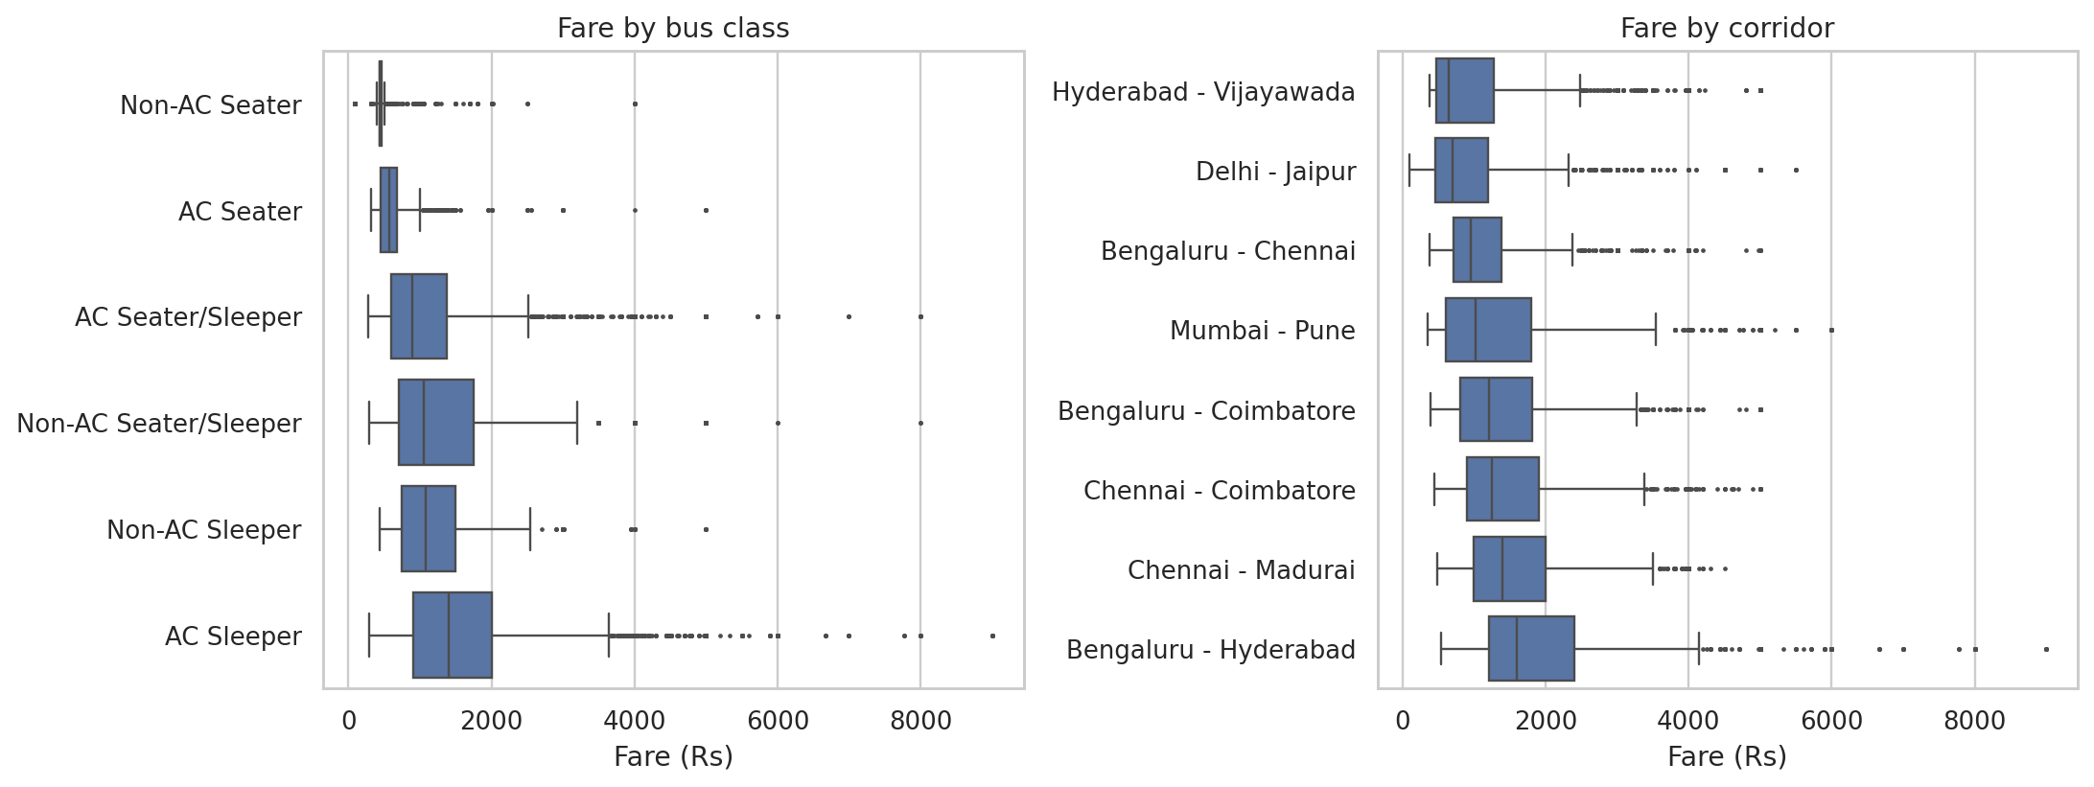
Figure 1: Starting fare by bus class and by corridor.
Averaging fares by date mixes different buses (about 500 are on sale 60 days out against about 2,800 one day out). To isolate timing, each fare was divided by the median fare of the same bus service across all 13 dates (index 100 = that bus's usual fare), using 3,073 services seen on at least five dates. For private operators on ordinary dates the median index stays at 100 from 60 to 5 days out and falls to 80-89 in the last four days: the same bus is 14.3% cheaper late (Figure 3). Only 31% of redBus seats are sold the day before departure (redBus reports 77% final occupancy overall [10], as operators also sell offline), so operators discount seats still unsold online. Government fares never move, while festival departures are 20% above normal. The drop holds for same-weekday pairs of the same services: Monday 3 vs 10 days out -9.1% (2,287 services), Sunday 2 vs 30 days -25.0% (1,110 services).
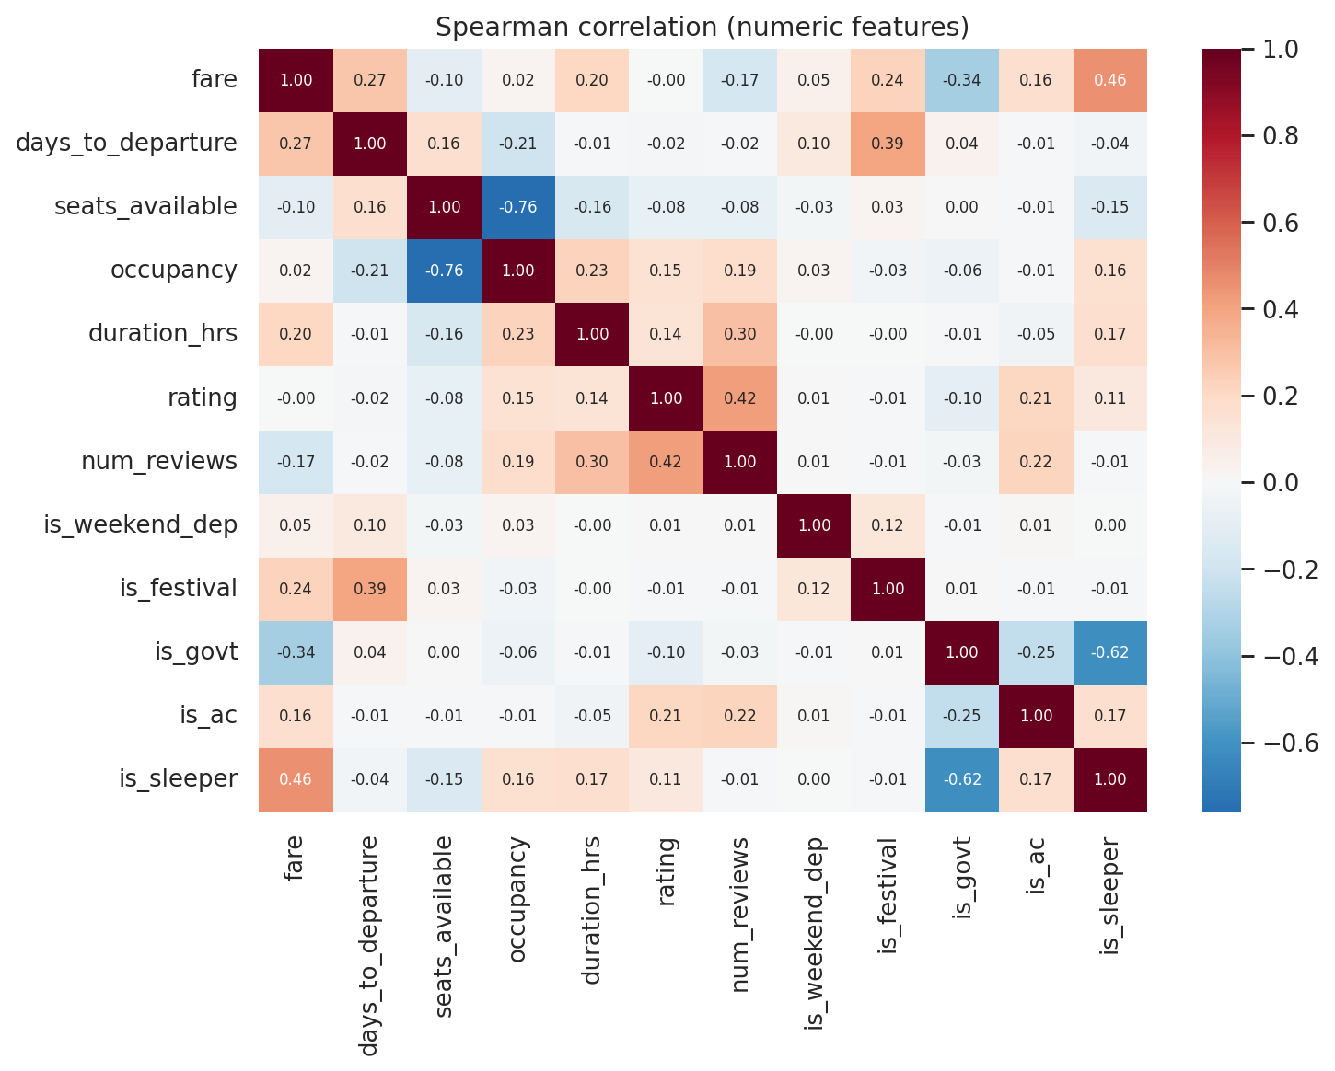
Figure 2: Spearman correlation between fare and numeric features.
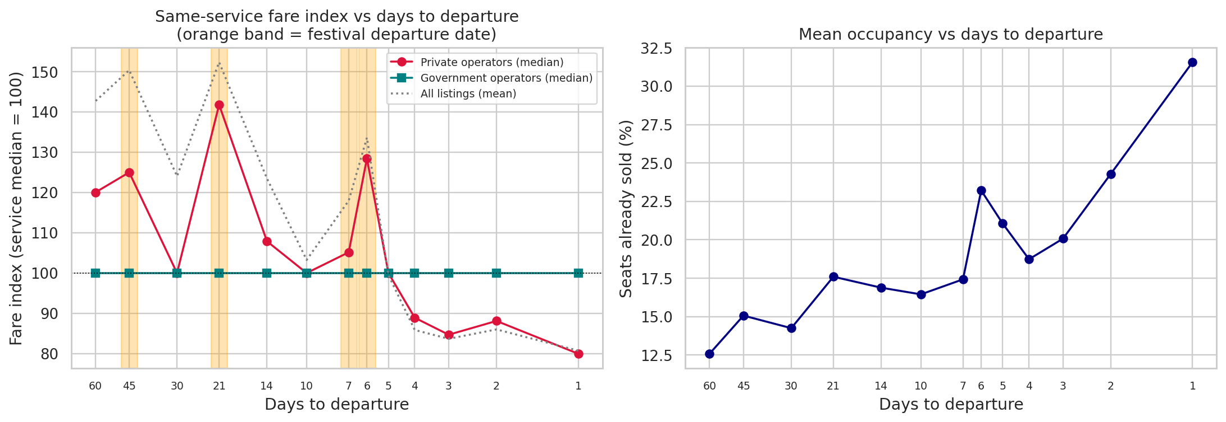
Figure 3: Same-service fare index by days to departure (left) and share of redBus seats sold (right); orange bands mark festival dates.

4. ANALYTICS METHOD AND IMPLEMENTATION
The study has one prediction question (what should this listing cost?) and one decision question (book now or wait?), both supervised learning problems from the syllabus. Multiple linear regression is the interpretable baseline; Random Forest and Gradient Boosting capture the non-linear booking curve and interactions and give feature importance. For the decision, logistic regression is the baseline and a Random Forest classifier the flexible model. Features are days to departure, occupancy, seats, duration, rating, reviews, weekend/festival/government flags and one-hot corridor, operator group, bus class, slot and travel day. The target is log fare, with an 80/20 split and 5-fold cross-validation (Python, pandas, scikit-learn [8], [9]).
The Book Now / Wait label comes from observed fares, not a model: a listing 4 or more days out is Book Now if its fare is at least 5% below the same service's mean fare 1-3 days before departure, otherwise Wait. Festival departures are excluded because the 1-3-day reference dates are ordinary days. This gives 13,010 labelled listings (11.6% Book Now); the classifiers use balanced class weights and a stratified split and are judged by F1 and ROC-AUC against a majority-class baseline.

5. COMPARISON WITH STATE-OF-THE-ART METHODS
Table 2: State-of-the-art comparison
Published study / Year | Dataset | Method used | Evaluation metric | Key result | Comparison with this work
Gaggero et al. [2], 2019 | Flixbus fares scraped daily, 5 city pairs, 28 to 1 days out | Panel fixed effects | Coefficients | Fare rises with seats sold and toward departure | Closest design; single-operator market escalates, while this multi-operator market discounts late. Adds prediction and a buy/wait model.
Branda et al. [3], 2020 | 3.23M bus-ticketing event logs | NB, LR, DT, RF, XGBoost + pricing strategy | Accuracy, revenue | 95% purchase prediction; +9% revenue | Seller-side, private logs vs buyer-side public data; targets differ, so scores are not comparable.
Stavinova et al. [4], 2021 | Renfe rail fares, Madrid-Barcelona | ARIMA, LSTM, MV-LSTM with Google Trends | RMSE, MAPE | MAPE 3.67% vs 4.25% baseline | One aggregate series vs 31,838 listings; search trends could model festival demand here.
Degife & Lin [5], 2023 | 1.03M Ethiopian Airlines records | GRU vs LSTM, MLP, classic ML | MAE, RMSE, R2 | GRU best on all metrics | Internal data and deep learning vs public data and interpretable trees (R2 0.83).
Arneric & Obadic [6], 2026 | FlixBus, 24 Croatian routes, 2022 | Panel FE / RE models | Diagnostics | Occupancy not significant for fares | Consistent: occupancy does not push posted fares up here either.

This study's strengths are a fresh multi-operator Indian dataset, a same-service design that separates timing from bus mix, and a buyer-facing decision model; its main limitation against the panel studies [2], [6] is a single scrape day. Scores from different datasets and settings are not directly comparable.

6. RESULTS, BUSINESS INSIGHTS AND RECOMMENDATIONS
Table 3: Model results on the test set
Model | Key metric | Other metrics
Linear Regression (fare) | R2 (log) 0.575 | MAE Rs 475, MAPE 34.6%
Random Forest (fare) | R2 (log) 0.830 | CV R2 0.801, MAE Rs 282, RMSE Rs 517, MAPE 18.8%
Gradient Boosting (fare) | R2 (log) 0.789 | MAE Rs 331, MAPE 22.5%
Majority baseline (Book Now/Wait) | Accuracy 0.884 | Finds no bargains (ROC-AUC 0.50)
Logistic Regression (Book Now/Wait) | ROC-AUC 0.844 | Accuracy 0.733, F1 0.407
Random Forest (Book Now/Wait) | ROC-AUC 0.893 | Accuracy 0.864, F1 0.546, recall 71%, precision 45%

The Random Forest explains 83% of the variation in log fare (typical error about Rs 280) and cross-validation agrees, so it is stable; the weaker linear model confirms the relationship is non-linear. Bus class, operator, days to departure and corridor are the strongest drivers (Figure 4). The Random Forest classifier ranks listings well (ROC-AUC 0.89) and catches 71% of true bargains (Figure 5); always saying Wait is 88% accurate but useless. A false Book Now costs little, because Wait listings are typically only 14% dearer than the last-minute fare.
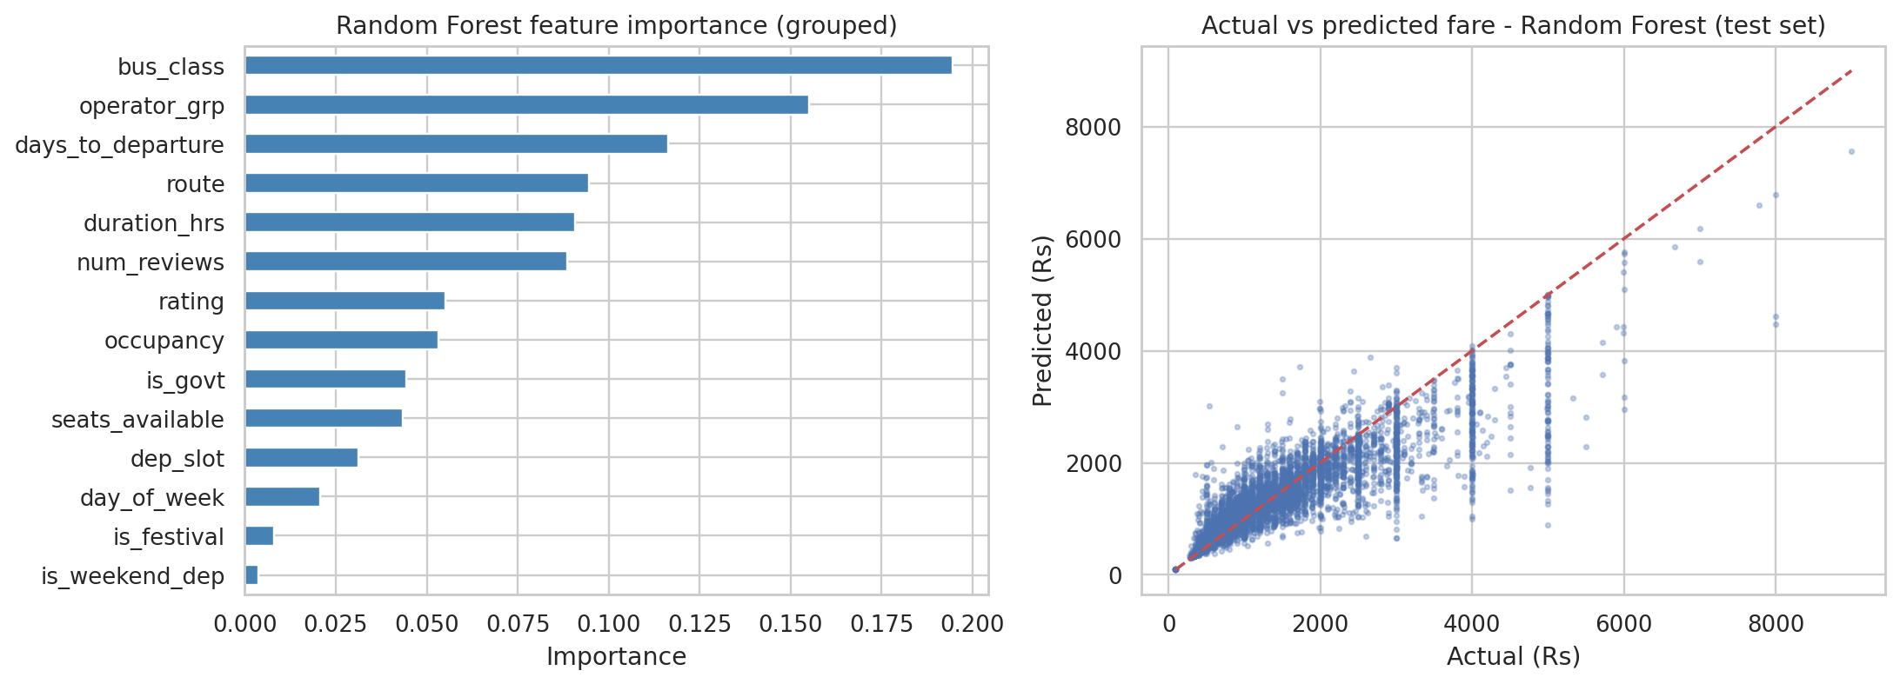
Figure 4: Random Forest feature importance and actual vs predicted fare (test set).
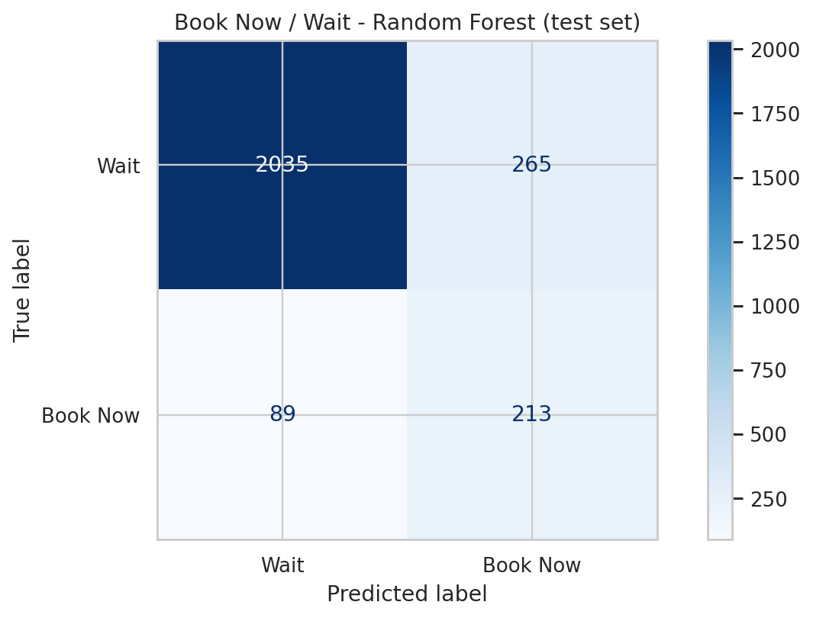
Figure 5: Confusion matrix of the Random Forest classifier (test set).
Insights: of 56 operators with enough data, 36 cut fares by more than 5% in the last four days and none raise them; the deepest cuts come from app-first brands (IntrCity SmartBus -45%, KBS -36%, zingbus plus -26%, NueGo -18%, FlixBus -10%), while VRL, SBM and state corporations stay flat (Figure 6). The late drop is largest on Bengaluru-Chennai and Chennai-Coimbatore (-21%); festival premiums reach 60-66% on the Coimbatore corridors. Recommendations: travellers and travel desks should book private buses 1-4 days out on ordinary dates (about 14% cheaper), book festival and Friday departures early as a precaution, and book government buses whenever convenient; platforms can show a Book Now / Wait badge that also says "likely cheaper later"; operators with deep late cuts should offer early-bird fares, since only 12-18% of online seats sell two weeks or more ahead.
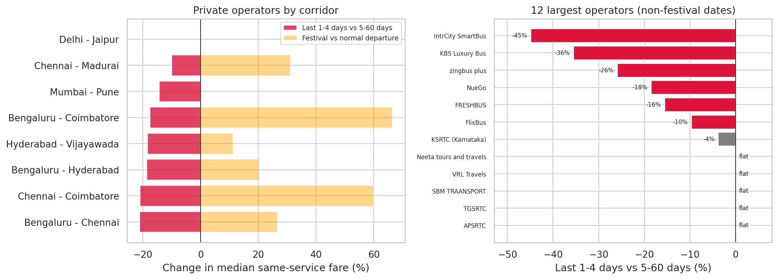
Figure 6: Last-minute change and festival premium by corridor (left) and last-minute change for the 12 largest operators (right).

7. CONCLUSION AND REFERENCES
Using 31,838 real redBus listings, this study finds that Indian intercity bus fares do not follow the airline pattern of rising toward departure: on ordinary dates the same private bus is about 14% cheaper in the last four days, government fares are fixed, and festival departures carry a 20% or larger premium. A Random Forest predicts fares with R2 0.83 and a Book Now / Wait classifier with ROC-AUC 0.89 turns this into a usable buying signal. Limitations: one scrape day (different departure dates, not one ticket over time), seasonal differences between near and far dates, occupancy from the redBus seat map only, and calendar-defined festival windows; repeated daily scrapes and search-trend data [4] are natural extensions.

References
[1] redBus, "Bus ticket search results", https://www.redbus.in.
[2] A. A. Gaggero, L. Ogrzewalla and B. Bubalo, "Pricing of the long-distance bus service in Europe: The case of Flixbus," Economics of Transportation, vol. 19, 100120, 2019. doi:10.1016/j.ecotra.2019.100120
[3] F. Branda, F. Marozzo and D. Talia, "Ticket sales prediction and dynamic pricing strategies in public transport," Big Data and Cognitive Computing, vol. 4, no. 4, 36, 2020. doi:10.3390/bdcc4040036
[4] E. Stavinova, P. Chunaev and K. Bochenina, "Forecasting railway ticket dynamic price with Google Trends open data," Procedia Computer Science, vol. 193, pp. 333-342, 2021. doi:10.1016/j.procs.2021.10.034
[5] W. A. Degife and B.-S. Lin, "Deep-learning-powered GRU model for flight ticket fare forecasting," Applied Sciences, vol. 13, no. 10, 6032, 2023. doi:10.3390/app13106032
[6] J. Arneric and L. Obadic, "Key factors in dynamic pricing of FlixBus fares: A panel analysis of international and domestic routes in Croatia," Research in Transportation Economics, vol. 118, 101794, 2026. doi:10.1016/j.retrec.2026.101794
[7] HappyFares, "India festive travel calendar 2026," https://www.happyfares.in/blog/diwali-festive-season-flight-guide-2026/ (festival dates).
[8] F. Pedregosa et al., "Scikit-learn: Machine learning in Python," JMLR, vol. 12, pp. 2825-2830, 2011.
[9] L. Breiman, "Random forests," Machine Learning, vol. 45, no. 1, pp. 5-32, 2001.
[10] Autocar Professional, "Intercity bus passenger volumes rise 24% in second half of FY2026: redBus report," 21 May 2026.

