Python Log Analyzer – Automation Solution Runbook
Version: 1.0
Author: Deepak Kumar Jha
Language: Python 3
Repository: PythonUtility

1. Objective
The objective of this project is to automate log file analysis using Python. The application reads a log file, processes log entries, extracts useful information, and generates a summary report in CSV format.

2. Features Implemented
Version 1 – Basic Log Analysis
• Read application log file
• Count INFO, WARNING and ERROR messages
• Display summary on console
Version 2 – Error Extraction
• Detect ERROR entries
• Display all ERROR messages separately
Version 3 – CSV Report Generation
• Generate CSV report
• Export log summary for reporting

3. Technologies Used
Python 3
Git
GitHub
CSV Module

4. Project Structure
PythonUtility/
├── application.log
├── log_analyzer.py
├── log_analyzer_upgraded.py
├── log_analyzer_v3.py
├── README.md
└── log_report.csv

5. Input
INFO Application Started
INFO User Login Successful
WARNING Low Disk Space
ERROR Database Connection Failed
INFO File Uploaded
ERROR Timeout Occurred

6. Processing Flow
Application Log → Read File → Analyze Log Entries → Count INFO/WARNING/ERROR → Extract ERROR Messages → Generate CSV Report

7. Execution Steps
1. Open Git Bash
2. cd /c/PIP/PythonUtility
3. python log_analyzer_v3.py
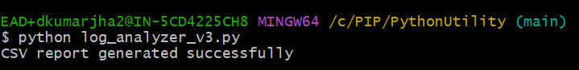
4. Open log_report.csv
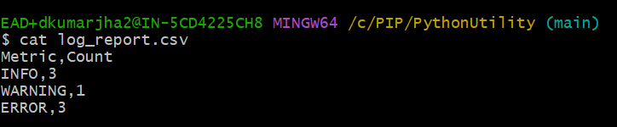

8. Git Repository
Repository contains source code, version history, README and sample output.

9. Business Benefits
• Automates log analysis
• Reduces manual effort
• Generates structured reports
• Helps identify application issues quickly

10. Future Enhancements
• User input for custom log files
• Advanced error trend analysis
• Reusable utility functions
• Unit testing
• Additional reporting capabilities

11. Conclusion
The Python Log Analyzer automates log analysis by processing application logs, summarizing statistics, extracting errors and generating CSV reports. It demonstrates Python file handling, data processing and report generation.

