Log Analyzer REST API Runbook
Version: 1.0
Author: Deepak Kumar Jha
Technology: Python, Flask, REST API

1. Objective
Develop a REST API using Flask to expose the Log Analyzer functionality through HTTP endpoints and return log analysis results in JSON format.

2. Project Overview
The project wraps the existing Log Analyzer utility in a Flask application, allowing clients to invoke log analysis without running the Python script manually.

3. Technologies Used
Python 3
Flask
REST API
JSON
Git
GitHub

4. Project Structure
LogAnalyzer-REST-API/
├── app.py
├── log_analyzer_v5.py
├── application.log
├── requirements.txt
└── README.md

5. Architecture
Client (Browser/Postman)
|
v
Flask REST API
|
v
Log Analyzer Utility
|
v
application.log
|
v
JSON Response

6. API Endpoints
GET /
- Returns API health status.
GET /analyze
- Returns log statistics in JSON format.

7. Sample JSON Response
{
"INFO": 3,
"WARNING": 1,
"ERROR": 3,
"Most Common Error": "Database Connection Failed",
"Occurrences": 3
}

8. Execution Steps
1. pip install flask
2. cd Log_Analyzer_REST_API
3. python app.py
4. Open http://127.0.0.1:5000/
5. Open http://127.0.0.1:5000/analyze

9. Testing
Verify the home endpoint returns a success message and the /analyze endpoint returns JSON output.
10. Screenshots
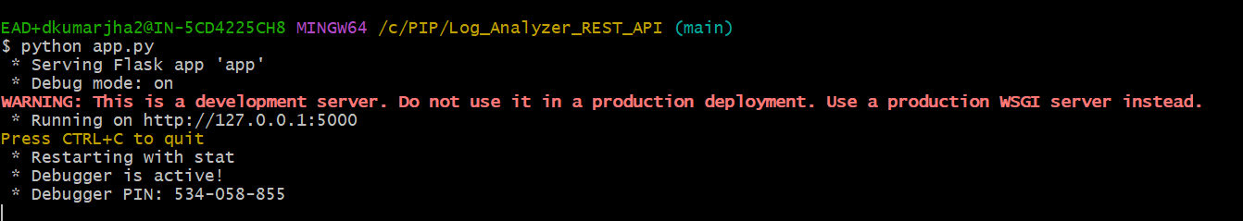
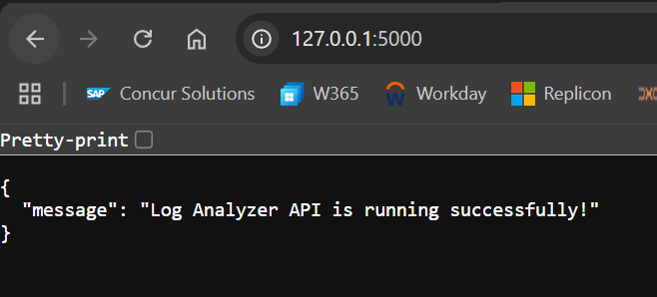
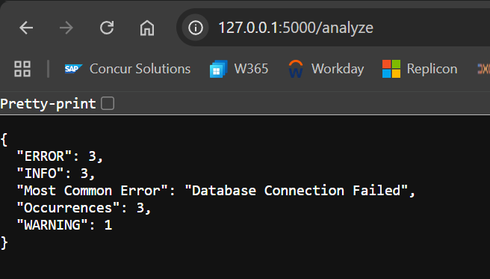

11. Business Benefits
• Exposes log analysis as a reusable service
• Enables integration with dashboards and applications
• Returns structured JSON responses
• Demonstrates REST API development using Flask

12. Screenshots to Include
• app.py
• Flask server running
• Browser showing /
• Browser showing /analyze
• GitHub repository
• Commit history

13. Conclusion
The Log Analyzer REST API successfully exposes the existing Log Analyzer through REST endpoints, demonstrating Flask, JSON responses, HTTP communication, and code reuse.

