  - Web Application Testing Summary
Reference | Vulnerability | Severity | Remediation
1 | Cross-site scripting (stored)  Stored cross-site scripting vulnerabilities arise when user input is stored and later embedded into the application's responses in an unsafe way. | High | In most situations where user-controllable data is copied into application responses, cross-site scripting attacks can be prevented using two layers of defences.
2 | Insecure JavaScript Libraries Utilised  The application utilises third-party JavaScript libraries in order to assist with the functionality of the application, however some of the libraries utilised are known to be affected by vulnerabilities. | Medium | It is recommended to upgrade to the most recent supported version of the library published by the vendor.
3 | Lack of Rate Limiting  The application lacks rate limiting, allowing users or attackers to send an excessive number of requests in a short period without restriction. | Medium | Implement rate limiting which involves controlling the number of requests that clients can make within a certain time frame.
4 | Security Enhancing HTTP Headers Not Utilised/Misconfigured (Application)  HTTP headers which add additional security to applications were not being utilised by the web application. | Low | The recommended HTTP security headers should be configured on the web application.
5 | Information Disclosure Via HTTP Header (IIS)  HTTP Response leaks Server type and Version. | Low | The frame-ancestors directive of the Content Security Policy (CSP) HTTP response header can be used to restrict which sites if any can embed the application within frame/iframe tags.
7 | Insufficient Input Validation  The reviewed application/service does not validate some supplied input parameters/fields for inappropriate characters, or does so to a lesser extent than could be the case. | Low | It is recommended that all aspects of the application/service that permit entry of supplied input should be checked and validated against invalid/malicious character input.
8 | Default Web Server Installation Pages  A default server page poses a risk because it exposes critical information about the server, such as the version being used. | Low | Replacing or removing the default page is essential to mitigate these risks.
9 | Additional HTTP Options Supported  HTTP offers a number of methods that can be used to perform actions on the web server (the HTTP 1.1 standard refers to them as methods, but they are also commonly described as verbs). | Informational | Prevent the use of the OPTIONS method.
10 | Concurrent Logins Supported  The application supports concurrent logins as the same user. Concurrent logins allow the same user to be authenticated in multiple places simultaneously. | Informational | Concurrent logins should be prevented, particularly for privileged accounts.
11 | Cacheable HTTPS response  Several HTTP responses were cacheable. | Informational | Add effective Cache Control.

  - Build Review Testing Summary
Reference | Vulnerability | Severity | Remediation
1 | Outdated and/ Vulnerable Software  Multiple outdated software identified with some being vulnerable. | High | Keep all software updated to the latest version.
2 | Missing Third Party Patches  Outdated and vulnerable software was identified as being installed upon the systems tested. | High | Upgrade software to latest versions.
3 | Failed CIS Benchmarks  A CIS Benchmark was conducted against the Server in scope. | Low | Where possible, remediate failed CIS benchmark checks by implementing the recommended configurations and settings outlined.

  - Cross-site scripting (stored)
Severity | High
Fix Effort | Intermediate
Status | Ongoing
Reference | 1

    - Summary
Stored cross-site scripting vulnerabilities arise when user input is stored and later embedded into the application's responses in an unsafe way. An attacker can use the vulnerability to inject malicious JavaScript code into the application, which will execute within the browser of any user who views the relevant application content.
The attacker-supplied code can perform a wide variety of actions, such as stealing victims' session tokens or login credentials, performing arbitrary actions on their behalf, and logging their keystrokes. Methods for introducing malicious content include any function where request parameters or headers are processed and stored by the application, and any out-of-band channel whereby data can be introduced into the application's processing space (for example, email messages sent over SMTP that are ultimately rendered within a web mail application).
Stored cross-site scripting flaws are typically more serious than reflected vulnerabilities because they do not require a separate delivery mechanism in order to reach target users, and are not hindered by web browsers' XSS filters. Depending on the affected page, ordinary users may be exploited during normal use of the application. In some situations, this can be used to create web application worms that spread exponentially and ultimately exploit all active users.
Note that automated detection of stored cross-site scripting vulnerabilities cannot reliably determine whether attacks that are persisted within the application can be accessed by any other user, only by authenticated users, or only by the attacker themselves. You should review the functionality in which the vulnerability appears to determine whether the application's behavior can feasibly be used to compromise other application users.
    - Technical Information
During testing, it was found that by leveraging built-in HTML functionality within the Reporting creation feature, an attacker could create a malicious “button” that, when clicked, executed the Cross-Site Scripting (XSS) payload in the victim’s browser. This malicious element could also be placed in shared folders, making it accessible to other users.
Note: This was only possible from the "DEV" user account as the standard user was unable to create the inputs required to carry out this attack.
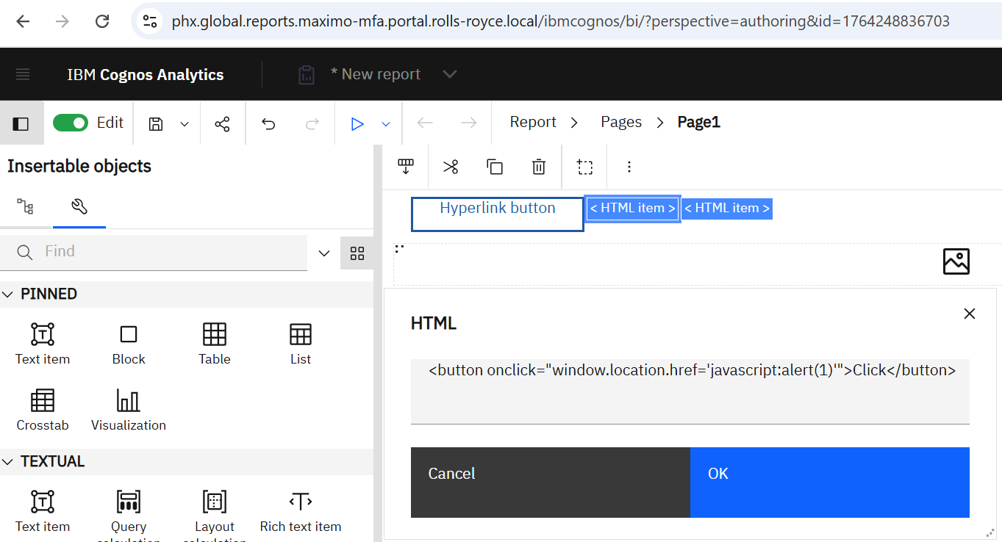
Figure 1 - Inserting malicious script into the new report through the "DEV" account

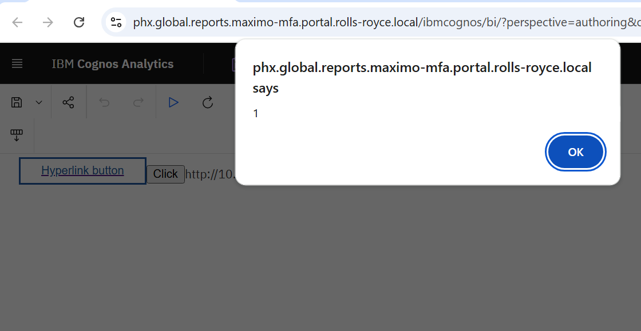
Figure 2 - Script executing on user’s browser from the button click

This allows for further script execution that allows for malicious attackers to execute payloads on the victim’s browser, the example below shows how the cookie can be grabbed from the browser:
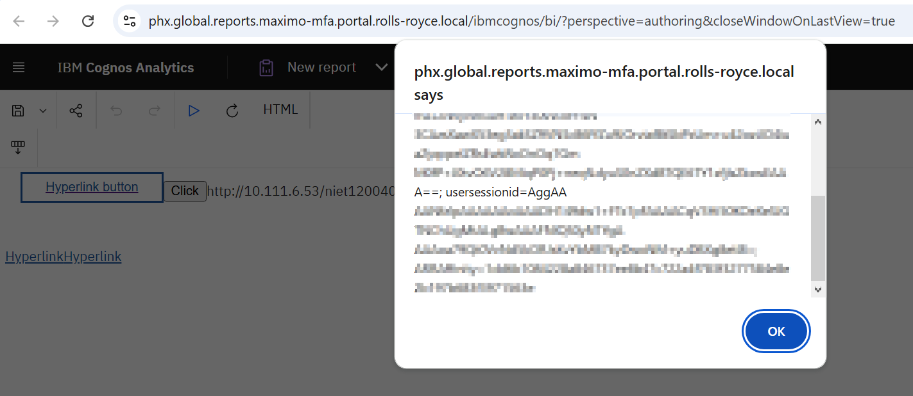
Figure 3 - User Session Cookie being extracted as an example of further functionality.
    - Recommendations
In most situations where user-controllable data is utilised in application responses, cross site scripting attacks can be prevented using the following methods:
Input Validation: Ensure that all user-supplied input is strictly validated upon arrival. Use a white-list approach, where only a specific set of characters is allowed, to validate user input. Input which fails the validation should be rejected, not sanitised. Syntactic validation should enforce correct syntax of structured fields and semantic validation should enforce correctness of their values in the specific business context.
Encode (escaping/sanitising) Output: Ensure that all dynamic data is properly encoded before being rendered in the browser. This will help prevent any malicious code being executed. For example, All HTML metacharacters, including < > " ' and =, should be replaced with the corresponding HTML entities (&lt; &gt; etc).
Use Content Security Policy (CSP): CSP is a security feature that helps prevent cross site scripting attacks by specifying which sources of content are allowed to be loaded by the browser. A Content Security Policy can be used to block inline scripts, restrict the types of resources that can be loaded, and control other aspects of content loading.
Implement a Security-focused Development Process: Incorporate security testing into development processes to identify vulnerabilities early.
Keep software up to date: Regularly update all software and libraries utilised by the application to ensure that any known cross site scripting vulnerabilities are patched. Utilise modern web frameworks that steer developers towards good security practices and help mitigate cross site scripting by using templating, auto-escaping.
Employ Web Application Firewalls: WAFs can provide an additional layer of protection complementing other measures. They typically work by blocking known attack strings; however, it is not uncommon for new bypass techniques that evade the WAF to be identified.
    - References
https://cwe.mitre.org/data/definitions/79.html
https://cwe.mitre.org/data/definitions/80.html
https://cwe.mitre.org/data/definitions/116.html
https://www.owasp.org/index.php/XSS
https://cheatsheetseries.owasp.org/cheatsheets/Cross_Site_Scripting_Prevention_Cheat_Sheet.html
https://cheatsheetseries.owasp.org/cheatsheets/Input_Validation_Cheat_Sheet.html
https://cheatsheetseries.owasp.org/cheatsheets/Content_Security_Policy_Cheat_Sheet.html
    - Affected Systems
IP | Hostname
10.111.134.146 - TCP/443 | phx.global.reports.maximo-mfa.portal.rolls-royce.local

