Statistical Inference course project

Georges Bodiong

Saturday, February 21, 2015

## Overview

This is the project for the Coursera Statistical Inference class. We will use simulation to explore inference and do some basic inferential data analysis. There are two parts:

* A simulation exercise
* Basic inferential analysis

## Simulations

#set lambda to 0.2  
lambda = 0.2  
  
# 40 samples  
n = 40  
  
# A thousand simulations  
sims <- 1000  
  
# Set seed for reproducibility  
set.seed(820)  
  
# Simulate   
sim_expo <- replicate(sims, rexp(n, lambda))  
  
# Calculate mean of exponentials  
means_expo <- apply(sim_expo, 2, mean)  
  
head(means_expo)

## [1] 5.750000 3.808205 4.058154 3.999241 4.312532 4.418246

Calculate simulation mean to show where the simulation is centered at and compare it to theoretical center.

dist_mean <- mean(means_expo)  
dist_mean

## [1] 4.998812

theo_mean <- 1/lambda  
theo_mean

## [1] 5

# Let's visualise it...  
hist(means_expo, xlab = "mean", main = "Exponential Function Simulations")  
abline(v = dist_mean, col = "blue")  
abline(v = theo_mean, col = "red")

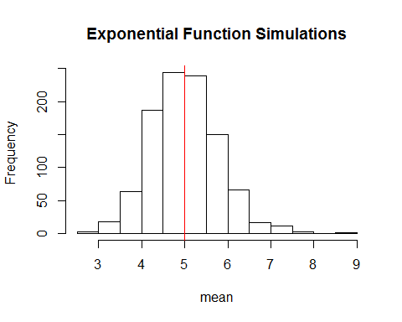

The analytical mean here is 4.9988117 and the theoretical mean 5. The two averages are very close.

## Variability

# standard deviation of distribution  
stand_dev <- sd(means_expo)  
stand_dev

## [1] 0.7909422

# standard deviation from analytical expression  
theo_sd <- (1/lambda)/sqrt(n)  
theo_sd

## [1] 0.7905694

# variance of distribution  
dist_var <- stand_dev^2  
dist_var

## [1] 0.6255895

#variance from analytical expression  
theo_var <- ((1/lambda) * (1/sqrt(n)))^2  
theo_var

## [1] 0.625

The standard deviation of the distribution is 0.7909422 and the theoretical standard deviation is 0.7905694. The theoretical variance is 0.625 while the actual variance of the distribution is 0.6255895.

## Is the distribution approximately normal?

xfit <- seq(min(means_expo), max(means_expo), length=100)  
yfit <- dnorm (xfit, mean=1/lambda, sd=(1/lambda/sqrt(n)))  
hist(means_expo, breaks=n, prob=T, col="green", xlab="means", main="density of means", ylab="density")  
lines(xfit, yfit, pch=22, col="black", lty=5)

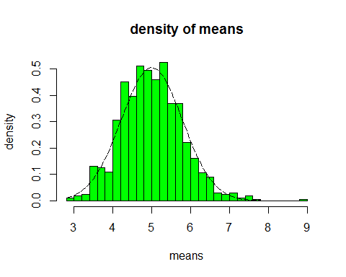

Let's compare distribution of averages of 40 exponentials to normal distribution

qqnorm(means_expo)  
qqline(means_expo, col=2)

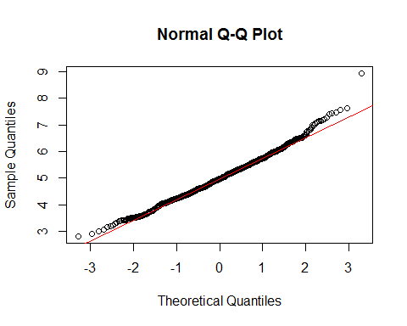

It is obvious that the distribution is close to normal.