iGeoDesktop
Manual
(Bonn, 2011-02-03)

lat/lon GmbH | Fon ++49 - 228 - 184 96-0
Aennchenstr. 19 | Fax ++49 - 228 - 184 96-2
53177 Bonn | info@lat-lon.de
Germany | www.lat-lon.de

Table of Content
1 Introduction 5
2 Basics 6
2.1 Installing the application 6
2.2 Starting the application 6
2.3 Applying the help menu 7
2.4 Description of the GUI 8
2.5 Program architecture 11
2.6 Data model/ Definitions 11
3 Basic functionalities 12
3.1 Working with projects 12
3.1.1 Opening projects 12
3.1.2 Creating projects 13
3.1.3 Saving projects 13
3.2 Working with layers 14
3.2.1 Importing layers 14
3.2.2 Creating layer groups 20
3.2.3 Combining layers with files 20
3.2.4 Editing layers 21
3.2.5 Saving/exporting the data base of layers 27
3.2.6 Invoking information on the layer 27
3.2.7 Printing the map 29
3.3 Navigating within the map 30
3.3.1 Moving a map section 30
3.3.2 Zooming in/out of the map section 30
3.3.3 Centering the map section 30
3.3.4 Changing the scale 31
3.3.5 Working with bookmarks 31
3.4 Working with Geo-objects 31
3.4.1 Selecting and invoking information on Geo-objects 31
3.4.2 Importing/exporting Geo-objects 33
3.4.3 Creating Geo-objects (digitizing) 34
3.4.4 Editing Geo-objects 36
3.5 Geo-Processing 39
3.5.1 Buffers (layers and single objects) 39
3.5.2 Intersection (layers and single objects) 40
3.5.3 Web Processing Service Buffer 41
3.5.4 Creating a representative point within a polygon 41
3.6 Geo-Imaging 41
3.6.1 Selecting geo data from exif format 41
3.6.2 Add coordinates to image files 41
4 Search 42
4.1 Hotlink 42
4.2 Starting external programs 42
4.3 Attributive queries 42
5 Attachment 43
Modules and functions 43
IgeoDesktop Main 43
MapModules 44
CopyPasteModules 44
AnalysisModules 44
DigitizerModules 45
AddLayerModules 45
LayerInfoModules 45
LayerListTreeViewModules 45
MeasureModules 46
PrintModules 46
ZoomByCoordinateModules 46
BufferModules 47
ExifModules 47
MapOverviewModule 47
GazetteerModule 47
ScaleModule 48
PointForPolygonModule 48
BookmarkModule 48
IntersectionModule 48
Configuration of the modules 49
Modules 50
ModuleGroup 52
Map models (MapModel) 53
Automatic creation of Dictionaries 55
Integrating code lists/Dictionaries into a project 56
Local Dictionaries 56
Remote/dynamic Dictionaries 58
Linking layers with meta data 60
Integrating WMS/WFS/WCS layers 61

1 Introduction

This document is focused on users of iGeoDesktop and describes the use of the graphical user interface (GUI).
For further information please use the deegreeWiki at: http://wiki.deegree.org/deegreeWiki/deegreeTools
The functional basic scope of the software is explained in the following.

Shortcut keys/ Key combinations | F1 / Ctrl+F
Navigating through the menu | Program > open > ...
Buttons | [OK]
Data types/ layers | configuration.xml
Tabs | 'polygons'
Menu items within the tabs | add symbol

2 Basics

2.1 Installing the application
If Linux is used as the operating system, then the linux-x86-Install file needs to be run. Please note that all visual effects of the operating system need to be deactivated for the correct depiction of the program elements when using Linux.

If Windows is used as the operating system, the file setup.exe is used.
In both cases you are guided through the installation dialog which installs the program on the respective computer after opening the corresponding files.

2.2 Starting the application
If Windows is used as the operating system, the application can either be started via the desktop icon that was created during installation or via the run.bat file which can be found in the subfolder iGeoDesktop of the installation directory of iGeoDesktop.

On Linux there is the possibility to run the run.sh file (which can be found in the subfolder iGeoDesktop of the installation directory of iGeoDesktop) or start the application by using the console by navigating to the installation directory.

After having started the following start screen should become visible.

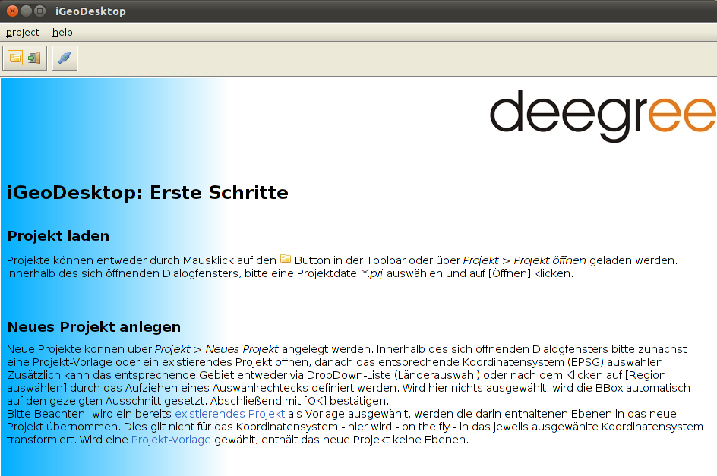
Follow the instructions in open project and load the project example innerframe_layout_utah_county.prj. This configuration contains all currently available functionalities in iGeoDesktop as well as example layers (symbol, line, polygons).

2.3 Applying the help menu
The help menu can either be applied as an online help (internet connection as a precondition) or as an integrative program element.

To apply the online help one can navigate to help > online help via the menu bar. Alternatively you can also use the respectively marked key combination.

The internal hel menu can either be opened via the menu bar help > open help, the respectively marked key combination, via the F1 Key or the corresponding buttons within the different program elements.

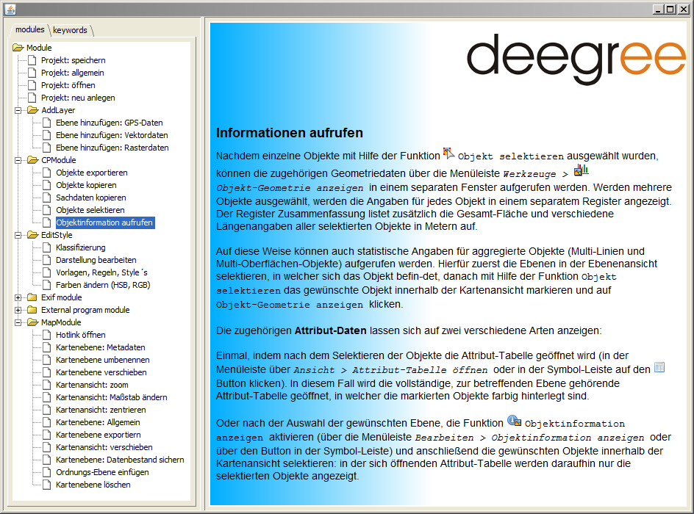
The help has a modular structure corresponding to the included functions and summarized by means of the modules.

2.4 Description of the GUI
In the upper pane there is a menu bar which is used for most of the functions. Furthermore a selection of these functions can be found in the tool bar below as well as in the context menu of the map view.
There are more layer-specific functionswithin the context menus of the layer view and the legend which cannot be opend using the menu or tool bar.
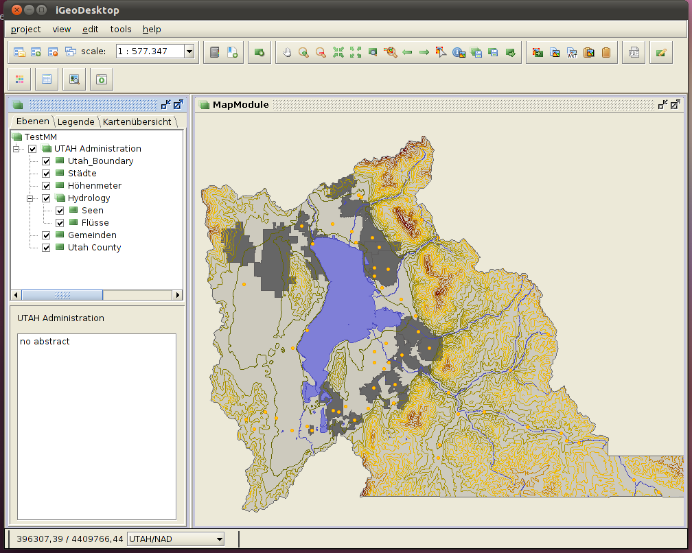
Menu bar
Tool bar
Map view
Layer view
Layer info

Functions of the toolbar
 | Open project |  | Zoom map to full extent |  | Move history backward
 | Save project |  | Center the map to clickpoint |  | Move history forward
 | Add new layer |  | Zoom to selected layers |  | Start external program
 | Open project info |  |  |  | Open imageviewer
 | Pan |  | Zoom to selected features |  | Commit all layers
 | Zoom in |  | Select an object |  | Commit selected layers
 | Zoom out |  | Shows object info |  | Export selected layers
 | Print |  | Extract selected features to new layer |  | Open map window
 | Edit style |  | Copy selected features |  | Add map window
 | Place label |  | Paste selected features |  | Remove map window
 | Digitizer |  | Clear clip board |  | Open bookmark manager
 | Open attribute table |  |  |  | Add new bookmark for current map extent

Functions of the menu bar
Project |  | View
 | New project |  | Close windows
 | Open project |  | Order windows
 | Save project |  | Set look and feel
 | Save project as |  | History backward
 | Open file |  | History forward
 | Add new layer |  | Pan
 | Export selected layers |  | Zoom in
 | Commit selected layers |  | Zoom out
 | Commit all layers |  | Center
 | Save map as image |  | Zoom to full extent
 | Export map as image |  | Zoom to selected layers
 | Print |  | Zoom to selected features
 | Print as PDF |  | Zoom to coordinate
 |  |  | Layerinfo
Edit |  | Tools
 | Undo |  | Add georeferenced images
 | Redo |  | Add Exif header
 | Select an object |  | Measure distance
 | Shows object info |  | Measure area
 | Extract selected features to new layer |  | Add area or length
 | Copy selected features |  | Geometry statistic
 | Copy selected features as WKT |  | Buffer
 | Paste selected features |  | Buffer (WPS)
 | Clear clip board |  | Intersection
 | Hyperlink |  | digitizer
 |  |  | Edit style
 |  |  | Select by attributes
 |  |  | Add table

Functions of the context menus
Layer view |  | Map view
 | Remove layer |  | Pan
 | Add structure layer |  | Zoom in
 | Rename |  | Zoom out
 | Show layer info |  | Center
 | Edit style |  | Zoom to full extent
 | editable |  | Zoom to selected features
 | Export legend
 | Copy legend

Further functions and symbols
Layer invisible/visible
Layer not queryable/queryable
Layer not editable/editable
Layer not selected/selected for queries
Layer not selected/selected for edit
Add rule
Rename rule
Remove rule
Duplicate rule
Import style
Export style

2.5 Program architecture
iGeoDesktop allows the access to files that are stored centrally on the server as well as to local files. The following services can be used:
- WFS (Web Feature Service): delivers crude vector data which can only be displayed graphically edited within the client. These data allow a complex data search.
- WMS (Web Map Service): delivers ready-made non-editable maps (raster graphics) and allows queries.
- WCS (Web Coverage Service): delivers raster data

Moreover the following formats are supported.:
- raster data in terms of: georeferenced images (with WordFile)
- vector data in terms of: *.gpx, *.shp, *.xml, *.gml

2.6 Data model/ Definitions
The services used (WMS. WFS, WCS) implement standardized interfaces of a uniform geographical data model which is explained shortly in the following.

The geo-data of an object consist of two components: its geometry and the attribute data that are assigned to this geometry.

Object (Feature) | Instance-element of a type of object: it contains spatial and non-spatial attribute data (Properties)
Type of Object  (Feature Type) | Amount of objects with equal characteristics and operations. Characteristics (also Properties/Attributes) can be spatial or non-spatial.
Attributes (Property) | Geometry and attribute data of the respective object
Layer | Thematic information layer. Every laxer is assigned to exactly one data source.
Layer Group | Groups of layers. A layer group has no own data source.

3 Basic functions

3.1 Working with projects
iGeoDesktop can be configured differently with regard to the available range of functions. It is not possible yet, to run this configuration via the GUI. This can only be done using a respective xml-editor (for further information on the functionality of the corresponding modules and their parameters have a look at the chapter 'Modules and functions' and 'Module configuration' in the attachment).
Projects (*.prj) can be created, loaded or edited within every configuration. Every project receives the range of functions that is provided for the configuration automatically.
All project characteristics can be looked at via project > open project info and partly be edited (name, description, external resources).
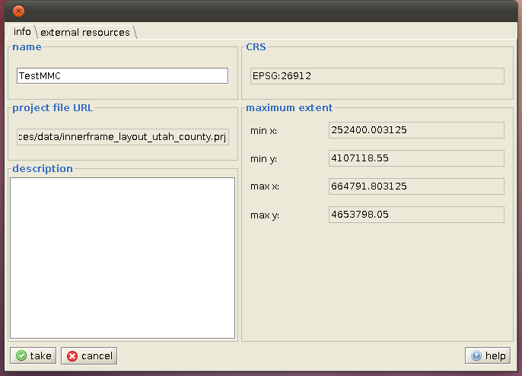
Multiple map windows can either be created , opened or closed via the respective button in the tool bar within the project; then the layer composition of the corresponding active map window is always depicted in the layer and legend view. With the help of the button all opened map windows are synchronized by the currently active map window with regard to its BBOX.

3.1.1 Opening projects
The dialog box for opening existing projects can either be opened via project > open project, by using the key combination Ctrl+O or by pressing the button within the tool bar. The operator can choose and load from the available projects within the dialog box .

3.1.2 Creating projects
The dialog box for creating projects can either be reached via project > new project or by using the key combination Ctrl+N. Within the dialog box you can choose between preconfigured project templates (xml-templates) or use the settings of an already existing project as a template. Additionally the region (either as a country from the pull-down menu or by drawing a Rectangular Marquee) and the coordinate system (EPSG) can be selected, which is later on applied on all layers within the project.
You can also create a project directly with or for a special data file, for this see vector data from files in chapter 3.2.1. .
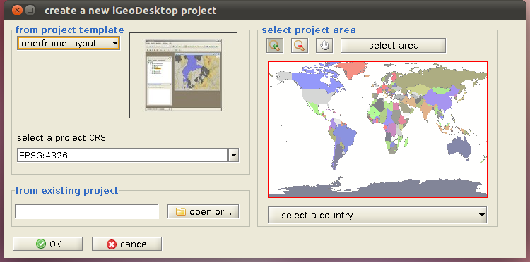

3.1.3 Saving projects
Already opened projects can either be saved under a consisting name (preserving the working progress) or under an alternative name. In the first case this can happen via project > save project, the key combination Ctrl+S or via the button within the tool bar.
In case the project shall be saved under a new name, use project > save project as …. Here the file extension *.prj needs to be given. In both cases data pool as well as the depiction definitions are saved.

3.2 Working with layers

3.2.1 Importing layers
Further map layers can be added in a newly created or in an already existing project in forms of vector or raster data. This happens with the help of the dialog Add new layer which can be reached by using the button in the tool bar or be invoked via project > Add new layer in the menu bar.
Importing vector data

Vector data can be imported using the WFS (Web Feature Service), a database connection or as a file (also see GPS files 3.4.2).
Vector data from files (*.gml, *.xml, *.shp) can be loaded in three different ways.
- via the menu bar project > Open file – allows a fast and direct loading of the respective file
- via the dialog Add new layer in the tool bar – this one offers more influence on the respective file: You may also assign a title and an abstract as well as the scale range and lazy loading.
- Directly after having started iGeoDesktop by loading a new project with the desired file using project > Open data file. After having selected the corresponding *.shp file and confirmed by pressing [Open] you can choose the needed EPSG code within main ID (the corresponding coordinate system is displayed in name) in the following dialog.
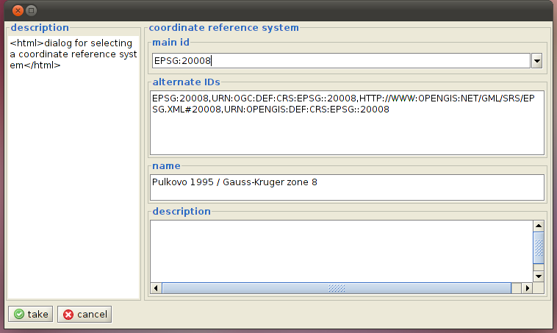

The WFS is accessed as follows:
Navigating to WFS via going to the dialog box Add new layer and clicking on > vectordata, marking this entry and clicking [> Next]. You can either select the desired service from out of the preconfigured servicesor assign an URL manually and click on [Finish] within the following dialog box.
After doing that, select the available FeatureType which shall be added to the project as a new layer. Load the desired layer by pressing [Finish].
Additionally there is the possibility before loading a layer to filter it according to certain criteria and depicting only the results of this query in the new layer. Here do not press [Finish] but [> Next]. In the following dialog box different attributive and/or spatial filters, after which the the file you want to import is searched, can be defined.

Attributive filters
This filter unit searches the attributes of an object for criteria the user defined before. With the button [Add new criterium] a list of characteristics can be arranged, whereas the features can be linked together using 'and' (presetting) or 'or'. If the single features are linked with 'and', only objects that contain all specified features are displayed. If the setting 'or' is chosen, only objects that contain one of the specified features are displayed.
The following settings can be adjusted per feature: The property name represents the available attributes of an object, which is linked with a value using the operator > / >= / <= / < / = / is like.
An attribute can be selected several times with different range perimeters within a query. If the operator is like is used, one can choose additionally whether upper and lower case letters shall be considered (in this case the check box needs to be ticked).

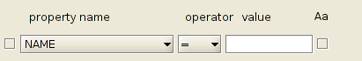
Already created features can be deleted using the button [Remove selected criteria] after having ticked the check box in front of them.

Spatial filters

This filter unit checks the objects within the loaded laser with regard to their topological features. The query either refers to the currently selected map section (BBox), a previously selected layer or a geometry (object) as the comparison geometry. The following queries are possible (object, comparison geometry):
No spatial query | (Presetting)
BBox | All objects that lie completely or partly within the current map section are chosen.
contains |   Completely included: Supplies objects, that are completely surrounded by the comparison geometry.The borders of the respective objects may not overlap or touch each other.
crosses | To cross: delivers objects that share few but not all points with the comparison geometry. The dimensionality of the intersection quantity is smaller than the one of at least one of both comparison geometries.  Valid for: polygon/line, line/line  
disjoint | Delivers objects that neither touch, overlap the comparison geometry or are contained in it.
equals | 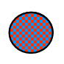  Spatially identical: delivers objects that take up the same room like the comparison geometry.  Valid for: polygon/polygon, line/line, symbol/symbol
intersects | Delivers objects that share one or more points or symbols.  Valid for: line/symbol, line/line, polygon/symbol, polygon/line
overlaps |   Delivers objects that share few but not all points or symbols with the comparison geometry. The dimensionality of the intersection quantity is equal to the one of both quantities.  Valid for: polygon/polygon, line/line
touches | Delivers objects that touch and/or share the borders of the comparison geometry.  Exception: symbol/symbol
within |   Delivers objects that are completely within the comparison geometry. The borders can touch or overlap.  Valid for: polygon/polygon, polygon/line, polygon/symbol, line/line
beyond | Delivers objects that are outside within certain distance to the comparison geometry
within | Delivers objects that are within a certain distance to the comparison geometry.

After having defined one or more filters, they need to be created in the next step. For this click on the register filter and then on [Create filter]: the the composed filter is displayed and can finally be checked again, the layer can also be loaded into the project by clicking on [Finish].
You can also adjust changes concerning title, name and abstract in a final step.
You access a data base as follows:
Navigate to database going to the dialog box Add new layer and then to > vectordata. Mark this entry and click [> Next]. The following data can be done within the next dialog box:
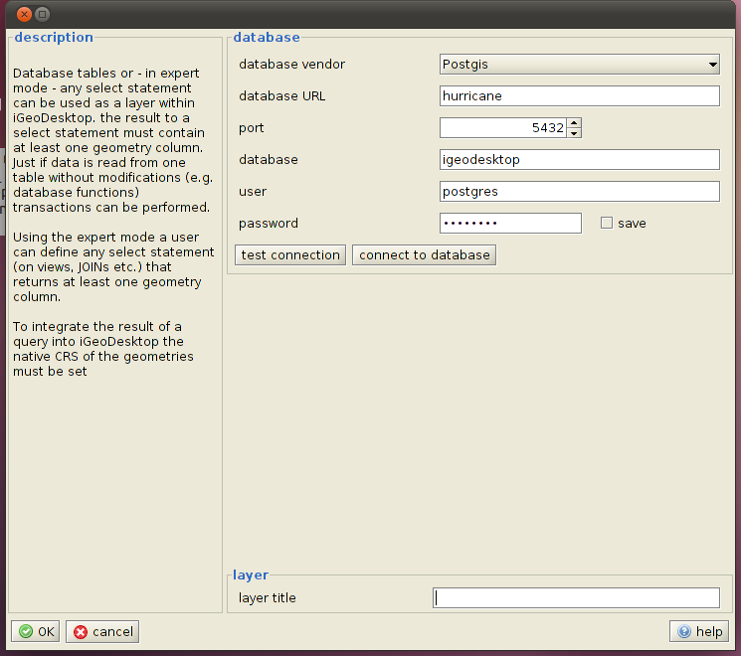
Before starting the connection it can be checked – this is not essential. If the data are valid, the connection can be established and a new dialog box opens:
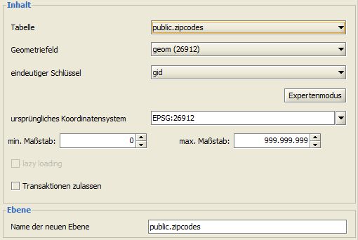

There can be more influence on the content of the new layer with additional settings using the [expert mode]. Here you can
- define your own SQL statements
- set primary keys
- choose geometry fields for queries
- set SRID/CRS identifiers

It is always a good idea to check the SQL statements with the help of [Überprüfen].

Importing raster data

Raster data can be loaded into a project in forms of georeferenced image files (with WorldFile), a WMS (Web Map Service) or a WCS (Web Coverage Service).

Image files (*.gif, *.tif, *.png, *.jpg, *.bmp) can be loaded as follows:
Going to the start dialog Add new layer and then to rasterdata > file, marking this entry [> Next] and clicking on [Select file]. Choose the respective file from the list and confirm by pressing the button [Open]. Then you can add further information on the name, title, abstract and the coordinate system. After having clicked on [Finish], the selected layer is displayed lowest in the layer view.
You can access the WMS as follows:
Go to Add new layer and navigate to WMS via rasterdata. Mark this entry and click [> Next]. Either select a preconfigured Service or type in an URL manually, then click [> Next]. The now available layers differ in their query possibilities as follows:
= GetMap and GetFeatureInfo query possible
= GetMap possible but no GetFeatureInfo
= GetMap and GetFeatureInfo query impossible (WMS cannot be loaded)
After this, the desired layers can be selected by clicking on and being added to the layer selection as a thematic group or piece by piece or by pressing to remove them from the layer selection. By clicking on all available layers are loaded into the layer selection or they can be removed by clicking on . If several layers are chosen, their order can be adapted with the help of the buttons . To load a layer into the selection or move it, it needs to be selected before.
If the selection and the order is set, the desired layers can be loaded into the project without any further settings by clicking on [Finish]. In this case the map background is not depicted transparently and all selected layers are summarized to one layer in the indicated order. The layer is loaded in the *.gif format.

You can also adjust further settings before finally loading the layer(s). Click [> Next]:
- Preview of selected style: tick the check box in the respective field and click on the desired layer
- Selection of the image format: *.gif, *.png, *.jpg, *.tif, *.bmp
- transparent background: always recommended if is not displayed as the
- request layers separately: in this case name, title and abstract can be assigned for the single layers
- editing the layer information: name, title, abstract, definition of the scale range
You can access the WCS as follows:
Click on Add new layer and navigate to rasterdata > WCS. Mark this entry and click [> Next]. Either choose from the preconfigured services or type in an URL manually. Click [> Next].
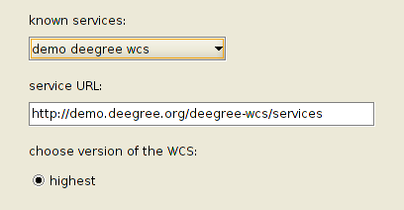
Select the desired Coverages from the available ones within the next dialog, adopt your selection by pressing and click [Finish]. In this case the desired Coverage is loaded in *.jpeg format.
It is also possible to modify the desired image format (*.jpeg, *.GeoTIFF, *.png) within the next two dialog boxes and adopt further information on the new layer (see image). For this, click [> Next].
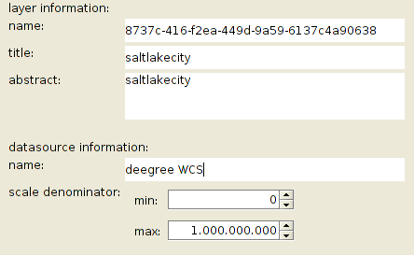

3.2.2 Creating layer groups
A new empty layer group can be added using the context menu of a layer within the layer view. In this group different new layers can be loaded or already existing groups can be moved there.

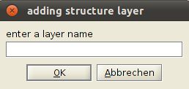
The creation of a single empty layer is currently not possible yet. Alternatively one or more previously selected objects can be copied from an already existing layer into another one, which is then added to the layer and map view.

3.2.3 Combining layers with files

With the help of the function tools > Add table already existing layers can be combined with further data using a suitable key. Therefore you have got the possibility either to create a View (temporary connection) or construct a new layer. Files and data bases can be a possible data source.

- *.cvs (Comma-Separated Values)
text file for saving or exchanging easily structured data
- *.xls (Excel Spreadsheet up to 1997) and *.xlsx (Excel Spreadsheet 2007/2008)
Spreadsheet application by Microsoft
- *.dbf (dBASE IV)

Loading tables from files: Click [> Next] after having selected the linkage type (new layer or view) and the data source type (file or database) and then press [Select file]. Navigate to the location of the desired file and open it, Click [> Next]. In the next step you need to define the keys via which the layer is combined with the table (You can also define keys by pressing [Add]). Click [> Next]. Now assign the column postfix and – if selected – the name of the new layer. Finish the process by pressing [Finish].

Loading tables from data bases: Select the linkage type (new layer or view) and the datasource type (database). Click [> Next]. Adjust all needed settings in database and click on [test connection] or [connect]. If your information is valid you can now choose a table from the shortlist by clicking on it. Now press [> Next]. In the next step you define the keys and confirm by clicking on [> Next]. Assign the column postfix and – if selected – a new layer name. Finish the process by pressing [finish].

3.2.4 Editing layers
The single layers or layer groups can be changed in their order. The order influences the visibility of layers in the map view. The first layer is displayed as the upmost layer, the last layer as the undermost one. To move a layer or layer group, you need to click left on the layer or -group and then find a new position keeping the mouse button pressed.
Once a layer or layer group is moved there is a green mark showing where it is inserted when releasing the mouse button.

The listed layers in the layer view can be edited using the context menu (right-click on the respective layer) as follows:

Remove layer | Removes the selected layer or layer group from the layer and map view.
Add structure layer | Allows the addition of an empty layer group in which layers or layer groups can be moved or added in the following. The layer or layer group is added last.
Rename | Opens a dialog box in which the selected layer or layer group can be renamed.
Zoom to selected layer | Enlarges the map view to the selected layer.
Export layer | Exports the selected layers.
Show layer info | Shows available information on the respective layer: info, metadata, linked resources, datasources, statistics
Edit style | Sets whether a layer can be edited (geometry). If yes, the layer name is depicted in red color.

Within the register legend the depiction of the visible switched layers is displayed as well as the register map overview, which shows the entire covered area. The legend can be exported as an image using the context menu (right-click in the legend) and then copied to the clipboard. The current map view can be exported as an image as or be copied to the clipboard as well. For this, navigate to Copy selected features / Extract selected features to new layer within the menu bar.

If available, there is an abstract of the respectively selected layer within the layer information field below the layer view.

Edit style

With the help of the function Edit style either raster or vector data can be changed according to their appearance. After having switched the corresponding layer visible and having selected it, this function can either be applied by going to tools > edit style in the menu bar or by pressing the button in the tool bar. The startup dialog shows the feature type, the geometry property, the geometry type and the scale range. Using settings > units the applied unit (pixels or meter) can be set globally. These settings can be overwritten locally within the single tabs.

With the help of the button [Open style editor] you open the actual application. Here you can activate the single registers (polygons, lines, symbols, label). As one layer can contain more than one geometry type, several registers can be activated at the same time. Geometry types which registers have not been activated are not displayed on the map but they can be edited.

Vector data including their labeling options can be changed concerning the following parameters, depending on which geometry type they represent;

Polygons | lines | symbols | label
Line color | color | Line color | Color
Line transparency | transparency | transparency | Transparency
Line width | width | size | Front family
Line style | Line cap | mark | transparency
Fill color |  | Fill color | Front style
Fill transparency |  |  | Front weight
Fill graphic |  |  | Fill color
 |  |  | Front size
 |  |  | Point anchor
 |  |  | Point displacement
 |  |  | Point rotation
 |  |  | Halo radius
Classification | Classification | Classification | Halo color
Presets | Presets | Presets | Presets

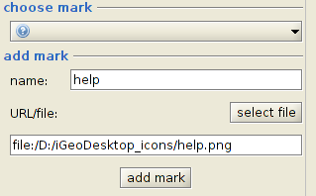
Within the tab symbols new symbols can be added from the list choose mark in the *.jpg, *.tiff, *.png and *.gif format. After having selected and opened the respective file, the name of the symbol needs to be assigned and saved with the help of the button [Add mark].

You can also add new patterns to the list of fill graphics.

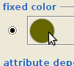
The color scheme can be opened via the color circle as a separate dialog. It is possible to choose between predefined patterns, HSB and RGB color spaces and the function Grab from Screen. The changes are adopted by pressing [OK] and then by clicking [apply].

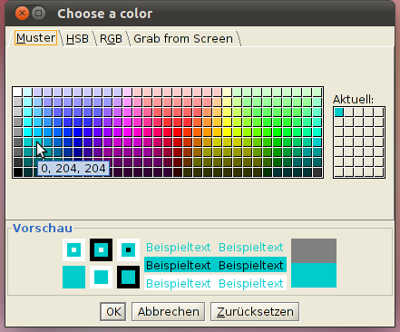
The predefined patterns in the first register have been created on the basis of the RGB color scheme and can be selected simply by clicking on them. The chosen colors appear in the selection area on the right side, in which they can also be selected.

RGB:

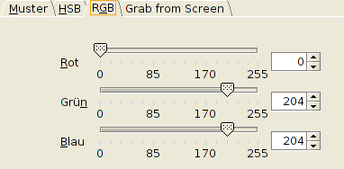
The RGB model is based on the principle of additive color mix of the primary colors red, green and blue: these three colors result in white light, none of them results in black. The additive paint mixing process is always used when light reaches the human eye without reflecting upon an object (see color screen as an example). It is less suitable for halftone printing on paper. Each of these three primary colors can take an intensity of 256 color steps, which results in about 16 million representable colors for the depiction on a computer screen.

HSB:

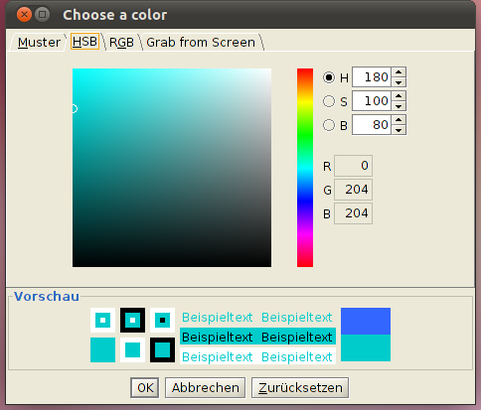
The HSB color model has the advantage to be orientated towards the color perception of the human eye. The eye does not cut the color information into three, but into two canals: hue+saturation and brightness.
Hue: color appearance of a certain electromagnetical wavelength
Satuation: the color's purity degree relative to a neutral gray. Unsaturated colors look grayish.
Brightness: The perception of the color intensity, the glowing of a color.

Grab from Screen:
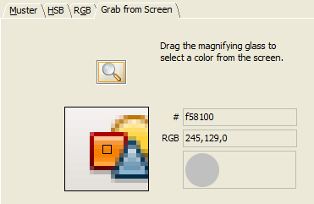
With the help of this function colors can be selected and adopted from illustrations or similar. For this one has to click on the magnifying glass with the left mouse button, after that the cursor is moved over an area of the screen which contains the desired color while keeping the left mouse button pressed. In the window below the magnifying glass these areas are enlarged. The color within the small square is selected after releasing the left mouse button.

Furthermore polygons, lines and symbols can be classified. This classification can be used as a tool for structuring and compaction of information. The following coarse guideline should be taken into account when defining the class number:

If a black and white depiction or a brightness graduation of a color is selected, only up to seven classes can be clearly distinguished by the human eye. In color gradients that offer two colors 14 classes are visible. This should be given more attention when classifying as well as the fact that groups may not contain more than two elements. A class with one element is contrary to the principle that elements of one class are more similar to each other than those in different classes. Exceptions are extreme values or factually logical values (index numbers, zero values, threshold values that are physical or set by law), which should be emphasized depending on the context.

The main aim of a classification is the visualization of spatial patterns and structures, not the depiction of statistical individual values. A basic principle of the Thematic cartography lies in less is more: due to reducing the detail information of objects to the characteristics of a few classes the essential features of spatial patterns becomes clearly evident.

The following classifications are currently available:

Unique value | Initial point of the classification
Equal interval | The easiest method of the classification is used for qualitative data and assigns the same distance between the class' upper limit and lower limit to all classes. This classification is suited for evenly distributed amounts of data and for the comparison of different maps in both time and place. A disadvantage is that empty classes often cannot be avoided, especially with an uneven data distribution occurring.
Quantile | Easy method for classifying qualitative data, all classes are usually occupied with an identical number of values. This classification only suits for linear distributed data, because gaps are not regarded in the data distribution and because the class width can vary greatly.
Unique value | This kind of classification is used for qualitative, nominal attributes and normally does not follow absolute rules but conceptual definitions and classification schemes. The number of classes is defined by the degree of aggregation of the information.

If there is an unknown data set, it is better to have a look at the distribution of data before classifying to choose the suitable classification method. For this choose the option [Open histogram] after selecting the respective attribute.

Every automatically generated classification can be adapted manually concerning its upper class limit. After correcting the value and confirming with the [Enter] key, the sequence of the classes is resorted, the other class widths are not changed. Already applied color schemes or patterns can be reapplied (right-click on the respective entry > choosing the desired operation from the context menu).

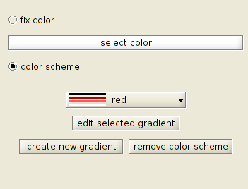
Defining color schemes:

- Right-click on [fill color] in the second column of the table and select [edit fill color] from the context menu.

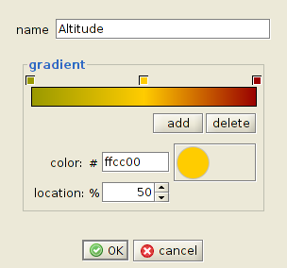
- Within the new dialog box one can either assign the same color to all values (select fix color and choose the respective color)or define a color scheme (activate color scheme). If there are already defined color schemes, they can be chosen from the pull-down menu. If that is not the case or if you want to define a new color scheme, press the button [Create new gradient]. In a new opening dialog box the gradient can now be defined:

- A certain color and position can be assigned to each of the three fields above the color schemes. For this, the respective field needs to be selected by clicking on it first. The color dialog box is opened by clicking on the color circle, the color fields can be moved directly by clicking and dragging the mouse cursor or by stating a percentage value. Using [Add / Delete] further colors can be added or removed.
- By assigning a description and then clicking on [OK] the data input is accepted.

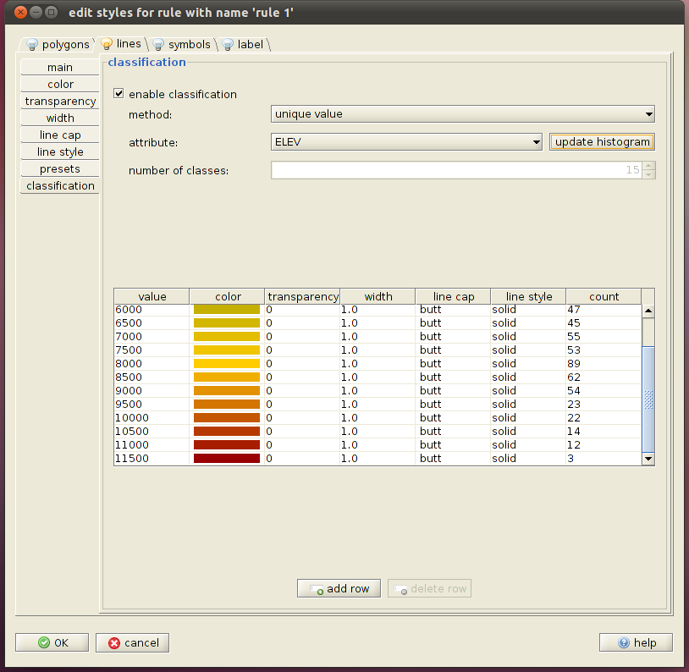

Regardless of the usage of a predefined color scheme every color can be adjusted manually and/or provided with a pattern (double-click on the respective color/row > choose the desired operation from the opening dialog box). The same applies to all the listed style criteria like line style, color etc.

Currently only the adjustment of the brightness and transparency using the respective dialogs is intended for raster data.

Within the single registers (polygons, lines, symbols, label) the newly created depictions can be saved as a template. For this you need to switch to the register presets, assign a name and click on [save current style].

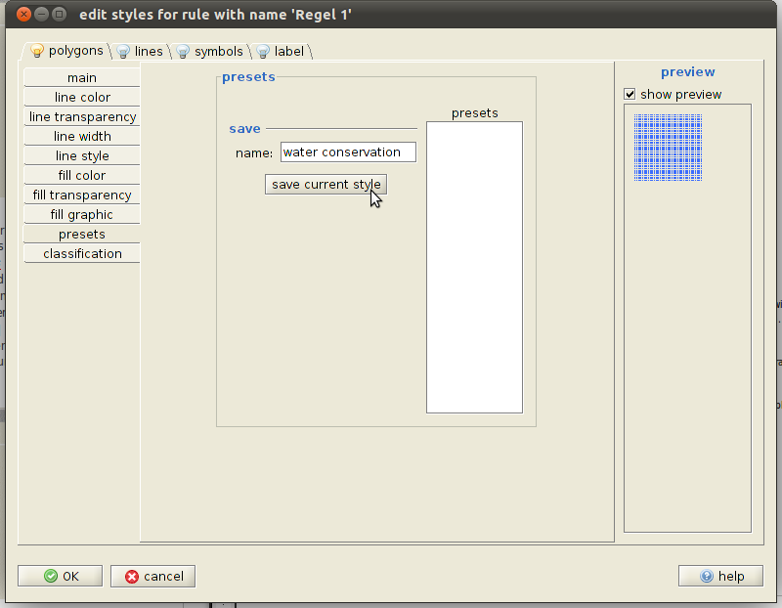
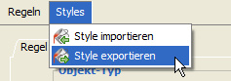
If the defined styles are also made available for other projects, they need to be exported. This happens within the start dialog of the style editor by going to styles > export styles. In the opening window name and file location can be assigned. The exported style definitions can now be imported into other projects. If a new definition was loaded this way, it can be visualized by pressing [apply] and then by adopting with [OK]. The already existing styles for the respective geometry can be seen in the window presets and can there be chosen by clicking on them and can be looked at in the preview.

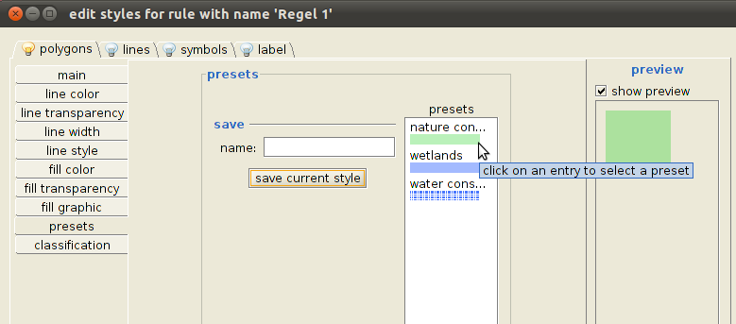

Working with rules

You can work with different style rules within a layer. It is possible to define an own style rule for every kind of geometry (select the respective geometry type within the rule) or to create rules for different scale ranges of a geometry type. Furthermore rules can be duplicated or removed.

3.2.5 Saving/exporting the data base of layers
Either single or all loaded layers can be saved at the same time within a project. If only the changes of a single layer are saved, it needs to be selected in the layer view first and then the changes can be saved either by going to project > commit selected layers or by pressing the button in the menu bar. The current working progress of all layers can be preserved by going to project > commit all layers or by pressing the button . In both cases only the data pool of the layers belonging to the data base is saved or updated – not the style definitions.

If single layers are also needed for other projects, they have to be exported (*.gml, *.xml, *.shp). For this purpose select the respective layer in the layer view, then go to project > export layer in the menu bar or open the context menu by pressing the button to see the corresponding dialog box.

3.2.6 Invoking information on the layer
After having selected a layer in the layer view, a new window with further information can be opened by clicking on show layer info in the context menu.

In the register info detailed information on state, description, scale and legend can be assigned. The legend's symbols cannot be edited here, but the description and scale (influences the layer's depiction on the map) can be changed. By clicking on [take] the changes can be saved.

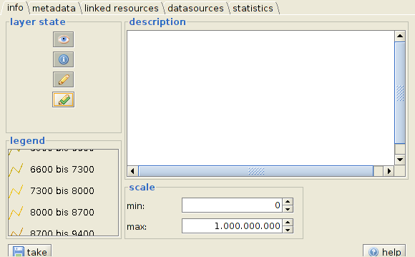
= visible = queryable = editable = selected for edit

New data sources can be added [add metadata URL] or removed [remove metadata URL] within the register metadata. Already existing linkages can be looked at by pressing [open metadata].

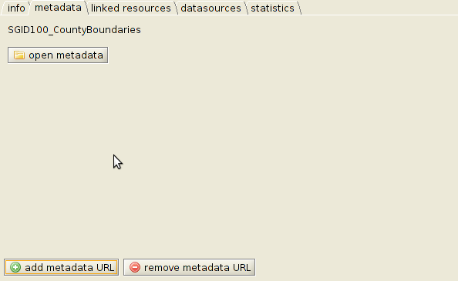
Within the register linked resources linkages to text/html or image files can be added via [add row], by clicking on [go to] these linkages are then opened in a separate browser window. It is always advisable to check the entered URL.

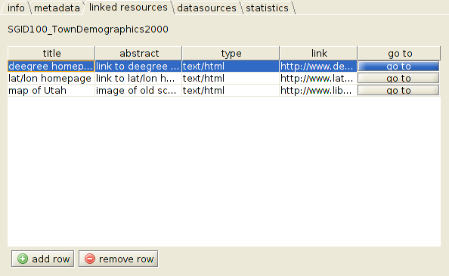
Within the register datasources you can find information on names and file paths of the Bbox's data sources (extent), the scale (concerning the depiction) and the loading performance (lazyLoading).
To navigate between the single data sources, the respective data source needs to be selected on the left side of the dialog box by clicking on it.

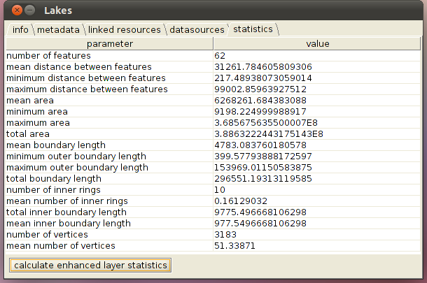
Within the register statistics there is the possibility of Implementing another calculation of the statistical information for this layer. For this purpose press the button [calculate enhanced layer statistics].

3.2.7 Printing the map
With the help of the function Print as PDF you can create a PDF based on the current map and legend. At present there are two setting copies which can be chosen in the opening dialog box for printing as a preview. When choosing the print range the following options can be taken:

- print at least the visible area
- select scale for printing
- printed map image resolution in pixel

After that the location and the name need to be specified. The following data are optional:

- title
- author
- date
- description
- data source

With the help of the function Print. The respective dialog boxes may open in a new window depending on the printer in your network.

3.3 Navigating within the map

3.3.1 Moving a map section
The map section can either be moved by using the respective arrow keys on the keyboard or by activating the function drag the map by mouse with pressed mouse button and then by clicking and dragging the map with the help of the cursor. This function can be found in the map's context menu, by going to view > pan in the menu bar and in the tool bar as the button. Basically dragging a map section is also possible while editing object geometries.

3.3.2 Zooming in/out of the map section

General

By pressing the keys [ + ] and [ - ] on the keyboard. In this case the map's center is maintained and the map is accordingly magnified or reduced.

By activating the respective buttons in the tool bar, by navigating to view > zoom in/out or by opening the context menu of the map and then clicking on it with the cursor. In this case the new map's center complies with the dot you chose on the map. Furthermore you can draw a Rectangular Marquee on the map on which you can zoom in or out after having activated the zoom in function.

Particular

Within the application it is also possible to center and magnify selected objects, layers or certain coordinates. These functionalities can be found in the menu bar navigating to view > zoom to selected features / selected layer / coordinate , in the context menu and in the tool bar as corresponding buttons.

By activating the function zoom to full extent the map is displayed in its total extension. This function can either be invoked via the context menu of the map, by navigating to view > zoom to full extent in the menu bar or by pressing the respective button in the tool bar.

As the respective map view is saved according to their sequence within the current session, it is possible to navigate within its history. This can be done by using the buttons in the tool bar and the menu bar (view > history backward/forward).

3.3.3 Centering the map section
Apart from the indirect opportunities of centering a map (see 3.3.2) it is also possible to center a map to a certain point which was clicked on in the map without changing the original size. This function can be found when navigating to view > center, in the map's context menu and in the tool bar as the button .

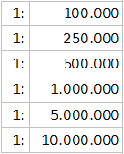
3.3.4 Changing the scale
Basically the current scale range is displayed in the tool bar when changing the map section. Here it can be changed manually by entering a desired value.

Additionally one can also choose from predefined scales within the tool bar apart from the opportunities of changing the scale (3.3.2):

3.3.5 Working with bookmarks
Different map sections can be saved as bookmarks within the application. Furthermore one can navigate between them. The bookmark manager can be reached using the button in the tool bar. Here all bookmarks including a short description are displayed. After bookmarking the corresponding row by clicking left one can navigate to the respective section within the active map window by activating the button .

New bookmarks can either be created within the bookmark manager or directly with the help of the buttons to be found in the tool bar. Here you can set whether the corresponding bookmark applies to all or only to one special map window.

By using the function export bookmarks into a file / import bookmarks from a file it is possible to export the bookmark collection as *.xml files and import them to other projects.

3.4 Working with Geo-objects

3.4.1 Selecting and invoking information on Geo-objects
Before selecting an object, the respective layer needs to be switched visible (tick the check box) and marked in the layer view. After that the function select an object has to be activated either by navigating to edit > select objects (???) in the menu bar or by pressing the button in the tool bar. Symbols and lines can only be selected by drawing a Rectangular Marquee, polygons by clicking left on the respective area.

A multiple selection is possible in all cases as long as the Ctrl key is pressed while selecting. The selection can be partly or completely be removed by clicking again on the selected objects while keeping the Ctrl key pressed. In the case of symbols and lines another Rectangular Marquee needs to be drawn. One can also click on an area which does not contain any objects to cancel the selection.

Selected objects can: be copied to a new layer (3.2.2), serve as a reference geometry (3.2.1 WFS, 3.5 Geo-processing, 3.6 Geo-imaging, search 4), the map can be centered and magnified to these objects (3.3.2) and geometry and attribute information can be opened (see the following aspect).

After having selected single objects with the help of the function Select an object the corresponding geometry files can be opened in a separate window by navigating to tools > geometry statistic via the menu bar. If several objects are selected, the information on every object is displayed in a separate register.
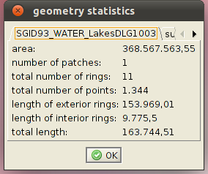
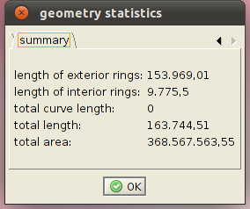

The register summary lists the total area and different length specifications of all selected objects in meters additionally.

You can also invoke statistical data on aggregated objects (multi-lines and multi-surface-objects) by this means. First select the layers in the layer view in which the object can be found, then mark the desired object on the map with the help of the function select an object and finally press geometry statistic.

The corresponding attribute files can be displayed in two different ways: first by opening the attribute table after having selected (navigate to the context menu of a layer and press [layerinfo] or click on the button in the tool bar): in this case the complete attribute table belonging to the respective layer which contains the colored and marked objects is opened.
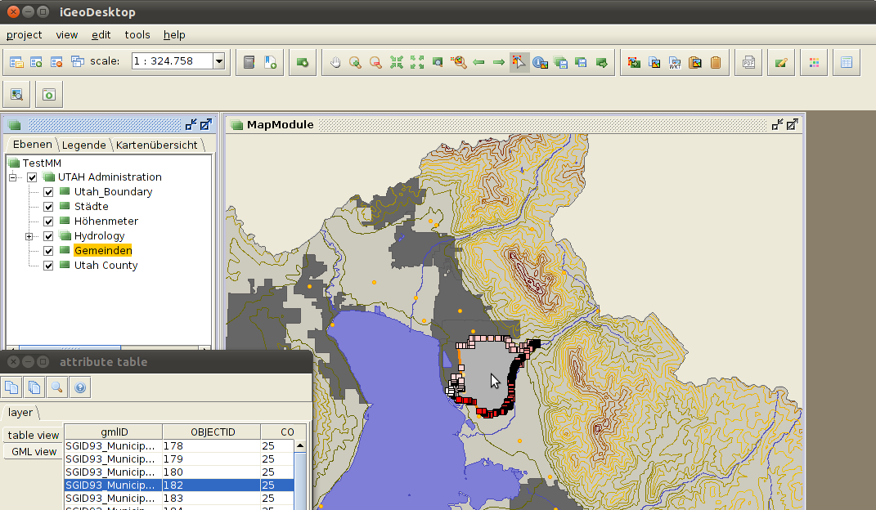

Or navigate to the function shows object info (by pressing the button in the tool bar) after having selected the desired layer and then choose the respective objects on the map: in the opening attribute table only those objects are displayed. In both cases the files can be sorted column by column within the table: ascending when clicking left( descending when clicking right on the column name.

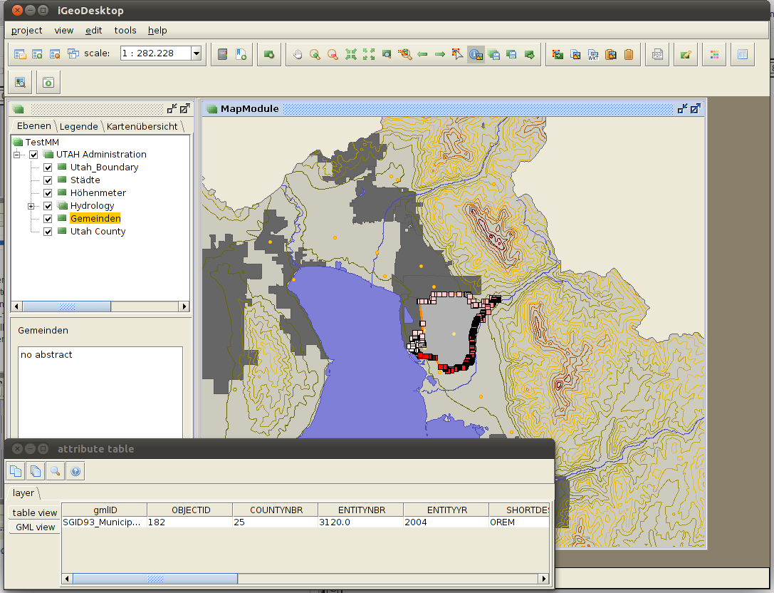

3.4.2 Importing/exporting Geo-objects

Importing GPS files

GPS files can be loaded as a new layer by navigating to project > add new layer > vectordata > file, by pressing the respective button in the tool bar or by navigating to project > open file as long as they exist in the *.gpx format. Then the application creates a new layer with the corresponding coordinates as symbols.

Copying Geo-objects

After having selected single or several objects either on the map or in the attribute table, they can be copied:

- as a WKT note: Copy selected features as WKT in the tool bar. These copied files can be used in other editors.
- As FeatureCollection (*.gml): pressing copy selected features. These copied files can be used in another layer by pressing the button paste selected features or be used in other editors.

Copying Geo-objects to a new layer

Single or several objects can be saved in a new layer after having selected them on the map. The respective function can be used by pressing extract selected features to new layer in the tool bar. After having assigned a name for the new layer, click [OK] to confirm and the layer appears in the layer view and on the map.

Copying attribute data

The attribute data of a layer are opened by activating the respective function (either by opening the context menu of a layer and then pressing layerinfo or by clicking on the button open attribute table in the tool bar. Objects that have been selected by clicking on them within the table are highlighted on the map. You can select single, several (keeping Ctrl key pressed) or all (Ctrl + A) objects. If one or several objects have been marked this way, the following options can be taken within the attribute table:

- Zoom to selected features
- Copy selected features or (Ctrl + C)
- Copy all features or (Ctrl + C)

The copied files can also be used as a text in other editors.

3.4.3 Creating Geo-objects (digitizing)

The digitizing function can be opened either by pressing the respective button in the tool bar or by navigating to tools > digitizer. With the help of the functions within the register create new symbols, lines and polygons can be created. Before drawing a new object the corresponding layer needs to be switched editable (using the context menu of the layer). The respective layer needs to contain or support the particular geometry type (this applies to all new objects). Otherwise the created objects cannot be saved.

To construct single objects every object has to be saved separately after finishing the digitizing process. If there are multi-object geometries created, the geometry is saved as a whole when the respective number of newly created objects is reached (multi-symbols, multi-lines, multi-polygons).

Draw rectangle
New rectangle with defined size
Values for x and y can be assigned.
Fills a hole bordered by a connected set of geometries with a polygon
This function fills a hole which is formed by neighboring polygons with a polygon.
Draw a circle
New circle with defined radius
Width and height can be stated.
New arc object
Draw polygon
Draw a hole into an already existing polygon
Here note the following rules:
- the hole needs to be completely within the polygon
- the hole must not share any vertices with the polygon
- several holes must not overlap each other and vertices must not be shared.
Cuts one or more holes into a polygon by using selected overlapping polygons
Draw a linestring
Create parallel line
After having selected a line you can create parallels to both sides.
Linking lines
- directly
- arc
- Extending and intersecting
Set angle for constructing polygons and curves
Both values can be assigned for polygons and lines while drawing.
Draw a point
New point by entering its coordinates

Furthermore already existing objects can be included into the digitizing process. First the respective object needs to be selected after having activated the button.
After that it is useful to apply the suited settings within the register snapping. Snapping is an automatic editing operation where symbols that next to other symbols or lines can be moved so they correspond. As a result the construction of topologically correct geometries is simplified.

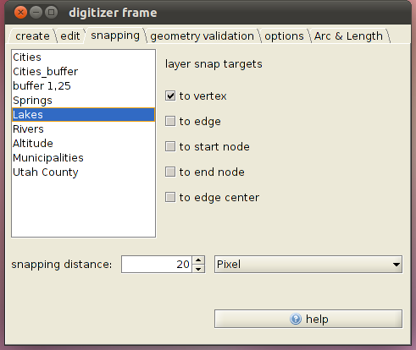
Within the register snapping all available layers of the current project are displayed on the left side and can be selected by clicking on them. On the right side the layer's settings in terms of snapping are depicted and can there be edited.
Apart from the layer snap targets and the snapping distance the underlying unit can be adjusted: pixels or map units. While editing the adjusted distance is displayed as a green circle.

The following topological terms are used:
node | A node can either be one in symbol geometry or the start- and end node of a line or an edge.
vertex | Vertices can be found between a start- and end node of a line or an edge.
edge | Edges have exactly one start- and end node as well as no or any number of vertices.

After having created the new objects the validity of the geometry and topography features needs to be checked. This can either be done with a single object or for the whole layer. The necessary settings can be adjusted within the register geometry validation.
Within the tab geometry metrics  - check for valid geometries  - dissallow repeated points  - check for polygon orientation  - dissalow double geometries in collections  - ensure simple lines  - minimum segment length/polygon area | Within the tab geometry types  - allow points/linestrings/polygons  - allow multipoints/multilinestrings/multipolygons  - allow geometry collections  - allow holes in polygons and multipolygons  - allow nonlinear interpolations

Within the tab topology
- allow intersecting geometries
- allow touching geometries
- allow equal geometries

The newly created objects can now be saved and/or be edited in a following step (see 3.4.4 Editing Geo-objects).

3.4.4 Editing Geo-objects
Editing Geo-objects includes the modification of the geometry data as well as the adaptation of the attribute data belonging to them. Before editing the data, the respective layer has to be selected and then switched editable.

Attribute data

The editing functions can be opened either by navigating to tools > digitizer in the menu bar or by pressing the respective button in the tool bar. Choose the tab edit in the opening dialog box. It is possible to select one or several objects after activating the button select feature(s) by click/rectangle. The display of the attribute data of the selected objects takes place in a separate window where they can be edited as well. After having made modifications they must be confirmed by pressing the return key and [save] or [save and close].

Essential: the date that were edited this way are not written back to the data source automatically but are saved project-related in this form. If the data are also used apart from the project, they have to be written back to the respective data source by clicking on commit selected layers / commit all layers. This is not done automatically when saving and closing a project.

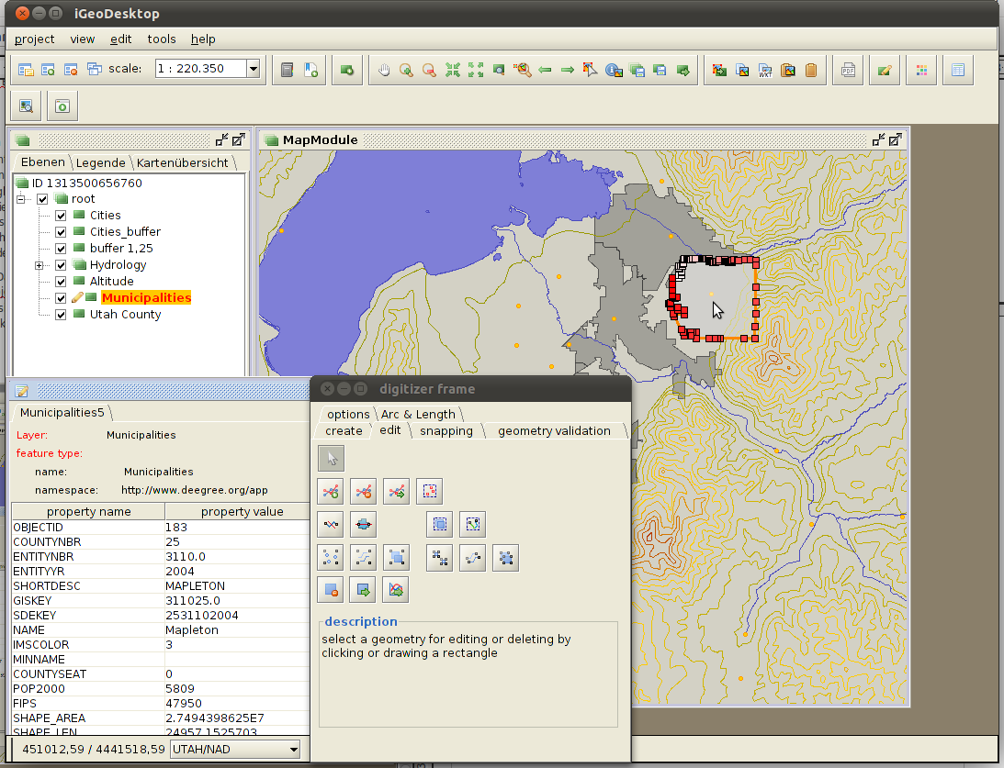

Geometrical data

The corresponding editing functions can be opened either by navigating to tools > digitizer in the menu bar or by pressing the button in the tool bar. With the help of the functions within the register edit symbols, lines and polygons can be edited after having marked them with the help of the function select feature(s) by click/rectangle.

The following editing options are available:

Select feature(s) by click/rectangle:
Selects the desired object for editing. Symbols and lines are selected by drawing a Rectangular Marquee, polygons are selected by left-clicking once on the respective object.
Insert a vertex:
Vertices can only be added within lines or polygons. The vertices can either be set on an existing line or edge or next to it. In the latter case the line structure adjusted automatically.
Move a vertex:
Vertices can either be moved on an existing line/border (does not change the object's shape) or be moved within the map. In the latter case the object's shape is adapted automatically.

Delete a vertex:
Vertices can only be deleted within line pr polygon geometries.
Merge vertices:
Any number of vertices can be merged to receive a new vertex, features referring to a point or symbol cannot be merged with this function.

Group points to a multipoint:
The previously selected objects are grouped to a multipoint geometry.

Ungroup a multipoint:
The previously selected multipoint geometry is ungrouped.

Split a line/curve:
A line can be drawn that intersects the selected object. Please note the following rules:
- one or several objects can be intersected with one line.
- A line can intersect an object more than once.
- Any number of vertices can be set while drawing.
- The vertices of neighboring objects can be used as the starting point or endpoint of the intersection process. In this case both objects are intersected at the respective vertices.

Unite two or more linestrings into one:
The previously selected objects are united resulting in a new object.
Group lines/curves to a multicurve:
The previously selected objects are grouped to a multiline geometry.
Ungroup a multicurve:
The previously selected multiline geometry is ungrouped.
Split a polygon/surface:
A line can be drawn that intersects the selected object. Please note the following rules:
- Only one object can be intersected at once.
- A line can intersect an object several times.
- Any number of vertices can be set while drawing.
- The vertices of an object can be used as the starting point or endpoint of the intersection process.

Unite two or more polygons into one:
The previously selected objects are united resulting in a new object, no interior boundary is left.
Group polygons/surfaces to a multisurface:
The previously selected objects are grouped to a multisurface geometry. The single objects of this geometry cannot be selected individually, the boundaries of the single objects remain.

Ungroup a multisurface:
The multisurface geometry is ungrouped.
Move a feature by dragging:
The previously selected objects can be moved within the map.
Move selected objects by defining moving distances in x- and y- direction:

Delete a feature:
The previously selected objects are deleted.

The changes you have made can also be rejected: either by skipping the saving operation after the respective editing steps or by using the function edit > undo / redo in the menu bar.

3.5 Geo-processing
igeoDesktop offers different functionalities for advanced editing and the analysis of geodata. This currently includes the creation of buffers, the intersection function, the Web Processing Service Buffers and the construction of symbol within a polygon.

3.5.1 Buffers (layers and single objects)
It is possible to create different buffers surrounding symbols, lines and polygons. This can either be done for all objects of a layer or for selected objects of a layer. In both cases the layer that shall be edited needs to be selected in the layer view. If you want to buffer all objects that are situated in the layer, the buffer function can then be activated. If you want to buffer certain objects, these need to be marked after activating the function select an object.

The buffer function can be opened by navigating to tools > buffer within the menu bar. In the opening dialog bix different settings can be adjusted concerning the buffer characteristics. Please note that the calculation process can take some time depending on the amount of data.

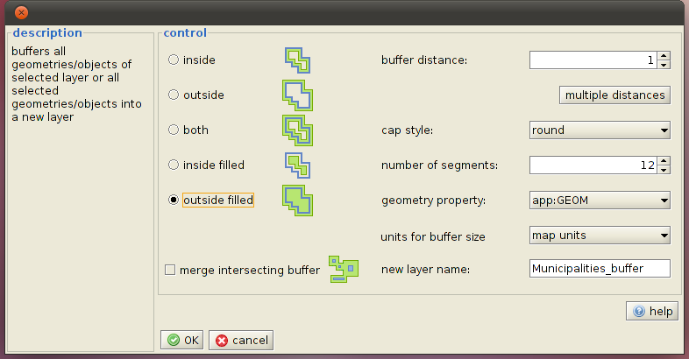

3.5.2 Intersection (layers and single objects)
This function offers the possibility of intersecting single objects with a layer or layers with each other. If you want to use single objects of a layer as templates, they need to be selected before starting the the function (first select the respective layer, then the object). This is not necessary if you intersect layers with each other.

This function can be opened by navigating to tools > intersection within the the menu bar. The basis is the layer which contains the objects and which shall be intersected. The second layer serves as a template. The result of the buffering operation is saved in a new layer and added to the layer view. The calculation process can take some time depending on the amount of data. The created layers can be edited and exported/saved as *.xml files.

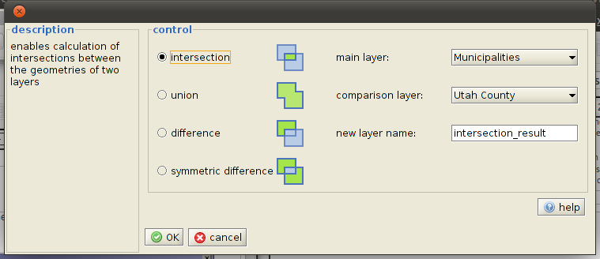

3.5.3 Web Processing Service Buffer
This functionality contains the invocation of a predefined geo-process, in this case the creation of a spatial buffer is included as an example. With the help of this function single or several previously marked objects of a layer as well as entire layers can be edited.

Before invoking the function the respective layer needs to be marked in the layer view and the corresponding objects need to – if necessary – be selected. After that the function buffer (WPS) (menu bar > tools) is activated. In the opening dialog box the respective settings can be adjusted analogous to 3.5.1, additionally the URL of the desired WPS as well as the process (currently only buffer) can be chosen. After clicking [OK] to confirm the buffer is calculated and depicted in a new layer.

Basically other operating procedures can be defined as well.

3.5.4 Creating a representative point within a polygon
With the help of this function it is possible to generate a representative point that definitely lies within the polygons within a layer which contains polygons. The respective layer needs to be selected in the layer view first, then the button in the tool bar needs to be pressed. Underneath the basic layer the new layer is created which contains the corresponding points.

Essential: The created layer only exists within the respective working session because it was stored within the temporary memory. If you want to use these layers permanently, they have to be exported via . Load the exported layer into your project again and then define the style rules.

3.6 Geo-Imaging

3.6.1 Selecting geo data from exif format
This function can be found by navigating to tools > Add georeferenced images in the menu bar. After having activated the function a new window opens where you can navigate to the location of the image file. You can either choose and load single images or image groups (with the help of the directory or by multiple selection while keeping the Ctrl key pressed). These image files need to be available in *.jpg or *.tiff and they have to contain valid coordinates within their exif header. All selected image files are displayed as points in the new layer after having assigned a new layer name.

To view these imported images, the respective symbol can be selected on the map which is opened in an image viewer after having activated the button.

3.6.2 Add coordinates to image files
With the help of this function coordinates can be linked with image files. First of all either an existing point needs to be marked on the map () or a new one has to be digitized and then be marked (). Only then the function can be opened by navigating to tools > Add exif header in the menu bar. After having activated the function a new window opens in which you can navigate to the image file that shall contain the coordinates of the selected point. After having chosen the image and clicked [OK] to confirm the coordinates are stored in the exif header of the image.

4 Search

4.1 Hotlink
This functionality enables the user to open hyperlinks in a separate browser window. The hyperlink has to be completely present in the form of a http-URL which is linked with an object. There are two ways to open a hotlink: either by activating the respective button in the tool bar and then by on the object linked with a hotlink or by marking the object and then choosing Hyperlink öffnen in the context menu. In both cases the corresponding link is opened in a separate browser window.

4.2 Starting external programs
With the help of the button a special external program can be opened, e.g. a text editor. The program Notepad is configured as the presetting here. You can define as many different programs as you like.

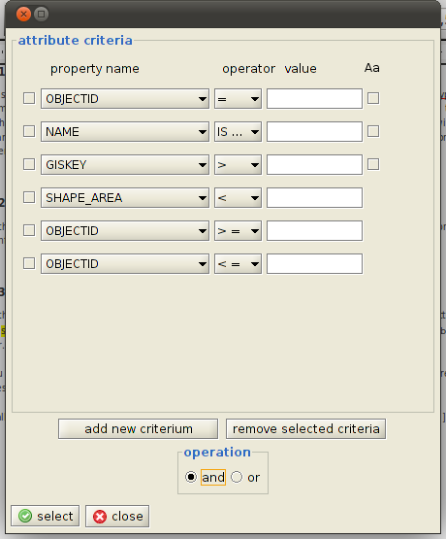
4.3 Attributive queries
With the help of this function you can search a special layer in terms of defined criteria. The respective layer needs to be selected in the layer view first, then you have to navigate to tools > select by attributes in the menu bar.

You can define individual filters within the opening dialog box. Tick the check box in front of the respective row and press [remove selected criteria] to remove a criterion.

If all filters are defined, the respective objects can be visualized on the map by clicking on [select].

5 Attachment

Modules and functions

In the following the functions which are included in modules and functions of iGeoPortal and which can be opened via drop down menus, the pop-up menus and buttons are described. The assignedActions indicate the respective function the way it has been registered in a project configuration, the name is case-sensitive and is assigned within the element <assignedAction> of the definition of a menu or tool bar entry.

<ns4:ToolBarEntry assignedGroup="TBMeasureGroup">
<identifier>
<value>MD</value>
</identifier>
<ns4:name/>
<ns4:tooltip>measureDistances.tooltip</ns4:tooltip>
<ns4:assignedAction>measureDistance</ns4:assignedAction>
<ns4:icon ns2:href="../icons/ruler.gif"/>
</ns4:ToolBarEntry>

Sometimes it is necessary to deliver init-parameters as well apart from the assignedActions.

Apart from the modules which offer the functions there is a range of modules which do not have any functions to be opened via menus.
They mostly apply <ns4:className>org.deegree.igeo.modules.DefaultModule</ns4:className> as a module class within a project configuration.

iGeoDesktop Main

Description of the operations that are not tied to a module but directly to iGeoDesktop.

assignedAction | Description
newproject | Opens a dialog for creating a new project
open | Opens a dialog for loading an already existing project.
undo | Cancels the last applied functions – if they support an UNDO
redo | Repeats the operation that was canceled with Undo
save | Saves the currently opened project
saveas | Saves the currently opened project under a new name
orderWindows | Puts all opened windows within the FrameLayout in the predefined order
closeWindows | Closes all opened windows within the FrameLayout except the main window
login | Opens a dialog box in which a user can log in the authentification service of the currently loaded project.
logout | Resets the login/authentification of the user
iGeoDesktop:open help | Opens the iGeoDesktop help
iGeoDesktop:about | Opens a window with information on the version of the applied igeodesktop.jar

MapModules
assignedAction | Description
center | Centers a map to a point on which the user is clicking
commitAll | Rewrites changes that have been done with the data of all available layers within the MapModule to the respective backend
commitSelected | Rewrites changes that have been done with the data of the currently selected layer to the respective backend.
historyBackward | Resets the map to the last respective BoundingBox (if available)
historyForward | Resets the map to the next respective BoundingBox if historyBackward was applied once before
objectInfo | Initializes the mode in which a user can request attribute data on objects within the map by clicking on the map or by drawing a Rectangular Marquee (the use of the Rectangular Marquee only works when using vector data)
pan | Initializes the mode in which the user can move a map while keeping the mousebutton pressed
select | Initializes the mode in which the user can select objects for further editing
zoomIn | Initializes the mode in which the user can enlarge a map by clicking on it or by drawing a Rectangular Marquee
zoomOut | See ZoomIn
zoomToFullExtent | Zooms to the initial BoundingBox of a project
zoomToSelectedFeatures | Zooms the map to the currently selected objects
zoomToSelectedLayers | Zooms to the joint Boundingbox of the selected layer in the LayerTree
exportLayer | Exports the selected layer in relation to the data type in shape, GML or image files.

CopyPasteModules
assignedAction | Description
copy | Copies the selected objects to the clipboard as GML
copyAsWKT | Copies the selected objects to the clipboard as WKT
paste | Combines copied objects from the clipboard with the selected layer
selectedFeaturesToLayer | Adds the selected objects to the map as a new layer

AnalysisModules
assignedAction | Description
addOrUpdateAreaAndLength | Opens a dialog box which makes it possible to add the length and area (in the case of polygons) as properties to all objects of a layer
geometryStatistics | Calculates and shows different statistical characteristics of the selected objects

DigitizerModules
assignedAction | Description
open | Opens a window which allows the access to the digitizing functions; the module is normally defined as <ns4:windowState>closed</ns4:windowState> in project configurations

AddLayerModules
assignedAction | Description
addLayer | Opens a dialog box which allows adding layers of different data sources; the module is normally defined as <ns4:windowState>closed</ns4:windowState> in project configurations
addDatabase | Adds a layer based on a database table (not yet implemented; will be moved to the AddLayerModule if necessary)
addService | Adds a layer based on an OWS (not yet implemented; will be moved to the AddLayerModule if necessary)
openFile | Adds a layer based on a file (e.g. shape file or georeferenced image; will be moved to the AddLayerModule if necessary)

Init-Parameter
knownWMS | Comma-separated list of tuples of predefined WMS. The tuples contain the WMS' name and its basic URL (separated by a “:”)
WMSversions | Comma-separated list of the available WMS versions
knownWFS | See knownWMS, only for WFS

LayerInfoModules
assignedAction | Description
open | Opens a window which contains the attribute data of the selected layer; the module is either defined by <ns4:windowState>closed</ns4:windowState> or by <ns4:windowState>normal</ns4:windowState> in project configurations depending on the basic layout

LayerListTreeViewModules
assignedAction | Description
addLayerGroup | Adds a new empty layer group
layerInfo | Opens a window which displays detailled and partly alterable information on selected topics
removeLayer | Removes the selected layer from the map
setEditing | Puts the selected topic into the editing mode (if it is vaild for the topic)
setVisibility | Hides the topic
rename | Opens a dialog box which allows renaming a layer or a layer group

MeasureModules
assignedAction | Dscription
measureArea | Initializes the mode which allows the user to measure areas within a map
measureDistance | Initializes the mode which allows the user to measure the length/distance within a map

PrintModules
assignedAction | Description
print | Opens a dialog box which allows the user to start printing
editSettings | Opens a dialog box which allows the user to edit settings of the print function
editTemplates | If iReport is installed on the computer it will be started and the user can edit print templates

Init-Parameter
templates | Comma-separated triples consisting of name, Jasper/print template and preview (image). The latter is optional, e.g:  Standard templates;../jaspertemplates/simple.xml; ../jaspertemplates/simple.png,  Enhanced templates; ../jaspertemplates/enhanced.xml; ../jaspertemplates/enhanced.png, Super templates; ../jaspertemplates/super.xml,  Faulty template 1; ../jaspertemplates/faulty1.xml,  Faulty template 2; ../jaspertemplates/faulty2.xml
noTemplateImage | Refers to an image file which is displayed within the template catalogue if there was no preview defined for Jasper/print template
ireportLocation | Refers to the home directory of iReport. If this is defined, iReport can directly be started from iGeoDesktop for defining new templates
dpi | Resoulution in which the printable files shall be constructed

ZoomByCoordinateModules
assignedAction | Description
open | Opens a dialog which allows the user to center a map to an entered coordinate system and then zoom the respective map width. The module is mostly defined as <ns4:windowState>closed</ns4:windowState> in project configurations.
clear | Closes the dialog that was opened before.

Init-Parameter | Description
size | Map width in units of the current CRS on which shall be zoomed to.

BufferModules
assignedAction | Description
open | Opens a window that allows the access to define the buffer calculation; the module is mostly defined as <ns4:windowState>closed</ns4:windowState> in project configurations.

ExifModules
assignedAction | Beschreibung
addImages | Constructs a new layer with a symbol geometry for each loaded exif image; one can either choose single images or entire directories.
linkImage | After clicking on a symbol representing an exif image a link opens and offers the user a download possibility for the respective image.

MapOverviewModule
assignedAction | Beschreibung
None

Init-Parameter | Beschreibung
mapImage | Reference to background map (jpeg, png, gif, tif, bmp)
mapEnvelope | Bounding box of the spatial extend reproduced by mapimage.

GazetteerModule
assignedAction | Beschreibung
The GazetteerModule accepts any number of init-parameters whose names, however, do not have a meaning. The init-parameter describes a gazetteer.
<Hierarchy name="Kreise/Gemeinden/Gemeindeteile"
address="http://isk.geobasis-bb.de/ows/gaz.php">
<Type name="Kreise" freeSearch="false">
<FeatureType name="Kreise" namespace="http://www.deegree.org/app">
<GeographicIdentifier property="geographicIdentifier"/>
<GeographicExtent property="geographicExtent"/>
</FeatureType>
<Type name="Gemeinden" freeSearch="false">
<FeatureType name="Gemeinden" namespace="http://www.deegree.org/app">
<GeographicIdentifier property="geographicIdentifier"/>
<ParentIdentifier property="parentIdentifier"/>
<GeographicExtent property="geographicExtent"/>
<Position property="position"/>
<DisplayName property="kreis"/>
</FeatureType>
<Type name="Gemeindeteile" freeSearch="false">
<FeatureType name="Gemeindeteile"
namespace="http://www.deegree.org/app">
<GeographicIdentifier property="geographicIdentifier"/>
<ParentIdentifier property="parentGeographicIdentifier"/>
<GeographicExtent property="geographicExtent"/>
</FeatureType>
</Type>
</Type>
</Type>
</Hierarchy>

The example shows the description of a gazetteer as it is defined as a value (within a CDATA element) of an init-parameter. The root element <Hierarchy> contains the name under which the gazetteer is presented in a GUI. The attribute address contains the basic URL of the gazetteer. Underneath the hierarchy element any deeply nested sequence of type elements can be found. Every type represents a hierarchy level of the gazetteer and is displayed on one of the available feature types. Within the feature type element the mapping of the feature type's properties onto the standard gazetteer properties takes place. "geographicIdentifier", "parentGeographicIdentifier", "geographicExtent" and "position" are supported.
The properties GeographicIdentifier and GeographicExtent need to be depicted, ParentGeographic-Identifier may only be absent in the root type. Additionally there is the possibility to enter an alternative property for the depiction of the lists of results to the surface. This happens by mapping one of the feature properties onto the element <DisplayName>; if there is no explicit mapping,the values are applied to the element's feature properties. Type elements can be any deeply nested, in other words every type element can contain another one. The hierarchical structure of different subjects can be depicted within a gazetteer. Moreover every type element contains an attribute with the name 'freeSearch'. If this has the value 'true', the user can make use of a text search function for the respective type within the GUI, otherwise a combobox receives … [?]

ScaleModule
assignedAction | Beschreibung
None

Init-Parameter | Beschreibung
scales | Comma-separated list of the units that can be chosen.

PointForPolygonModule
assignedAction | Beschreibung
calculate | Starts the calculation of a representative point for each polygon within the selected layer.

BookmarkModule
assignedAction | Beschreibung
Add Bookmark | Adds a new entry to the list.
open | Opens a dialog box for setting a new bookmark.

IntersectionModule
assignedAction | Beschreibung
open | Opens a window which allows the access to define the intersection to be performed; the module is mostly defined as <ns4:windowState>closed</ns4:windowState> in project configurations.

Configuration of the modules
The configuration always starts with basic information:

<?xml version="1.0" encoding="UTF-8" standalone="yes"?>
<ns4:Project xmlns="http://www.deegree.org/coremapmodel" xmlns:ns2="http://www.w3.org/1999/xlink"
xmlns:ns3="http://www.deegree.org/jdbc"
xmlns:ns4="http://www.deegree.org/project"
xmlns:ns5="http://www.deegree.org/settings" xmlns:xsi="http://www.w3.org/2001/XMLSchema-instance"
xsi:schemaLocation="http://www.deegree.org/project ../schema/jaxbschema/project.xsd">
<ns4:name>TestProject</ns4:name>
<identifier>
<value>TP1</value>
</identifier>
<ns4:View hasFooter="true">
<ns4:ViewForm>
<ns4:FrameViewForm resizeable="true">
<ns4:containerClass viewPlatform="Application">
org.deegree.igeo.views.map.DefaultMapFrame
</ns4:containerClass>
<ns4:ComponentState modal="false" active="true">
<ns4:windowState>normal</ns4:windowState>
</ns4:ComponentState>
<ns4:frameTitle>$FVF1.FrameTitle</ns4:frameTitle>
</ns4:FrameViewForm>
<ns4:Layout>
<ns4:NoneLayout/>
</ns4:Layout>
</ns4:ViewForm>
<ns4:SupportedViewPlatform>Application</ns4:SupportedViewPlatform>
<ns4:Window width="1000" height="900" top="10" left="10"/>

Except the layout (<ns4:Layout>) and the size of the application (<ns4:Window>) no modifications should be made here first. The layout sets how the modules are arranged within the application. The following are available:

<ns4:Layout>
<ns4:NoneLayout/>
</ns4:Layout>

<ns4:Layout>
<ns4:TabLayout/>
</ns4:Layout>

<ns4:Layout>
<ns4:SplittedLayout isVertical="false"/>
</ns4:Layout>

<ns4:Layout>
<ns4:GridLayout>
<ns4:rows>2</ns4:rows>
<ns4:rows>1</ns4:rows>
</ns4:GridLayout>
</ns4:Layout>

All embedded modules contain information on their location within the layout of the application or on their location within the higher-ranking module. Following the basic definitions of the application the definition of the available modules takes place. Basically there is need to distinguish between two types of modules:

- Modules, that provide a special functionality <Module>
- Modules, that serve for grouping further modules <ModuleGroup>

The relation between Module and ModuleGroup is more or less equal to the relation between Feature and FeatureCollection. Every ModuleGroup is consequently a Module as well. Modules are either directly defined within a project file or are embedded via a reference.

<ns4:ModuleReference>
<OnlineResource ns2:href="map_module_iframe.mdx" />
</ns4:ModuleReference>

Modules

The integration of Modules within a project file:

<ns4:ModuleRegister>
<ns4:AbsolutePosition>
<ns4:Window width="732" height="748" top="0" left="261" />
</ns4:AbsolutePosition>
<ns4:ModuleReference>
<OnlineResource ns2:href="map_module_iframe.mdx" />
</ns4:ModuleReference>
</ns4:ModuleRegister>

<ns4:ModuleRegister>
<ns4:AbsolutePosition>
<ns4:Window width="400" height="210" top="250" left="270" />
</ns4:AbsolutePosition>
<ns4:Module>
<ns4:name>ZoomByCoordinates</ns4:name>
<identifier>
<value>ZoomByCoordinates</value>
</identifier>
<ns4:className>org.deegree.igeo.modules.ZoomByCoordinatesModule</ns4:className>
<ns4:ViewForm>
<ns4:FrameViewForm resizeable="false">
<ns4:containerClass viewPlatform="Application">
org.deegree.igeo.views.swing.zoom.ZoomByCoordDialog
</ns4:containerClass>
<ns4:windowState>closed</ns4:windowState>
</ns4:ComponentState>
<ns4:frameTitle>$F4.FrameTitle</ns4:frameTitle>
</ns4:FrameViewForm>
<ns4:Layout>
<ns4:NoneLayout />
</ns4:Layout>
</ns4:ViewForm>
<ns4:Menu>
<identifier>
<value>ZbCMB</value>
</identifier>
<ns4:parent>
<value>MB1view</value>
</ns4:parent>
<ns4:name />
<ns4:MenuItem>
<ns4:name>$ZoomCoord</ns4:name>
<ns4:assignedAction>open</ns4:assignedAction>
<ns4:icon ns2:href="http://blizzard:8280/igeodesktop/resources/icons/zoombycoord.png"/>
</ns4:MenuItem>
</ns4:Menu>
<ns4:init-param>
<ns4:name>size</ns4:name>
<ns4:value>100000</ns4:value>
</ns4:init-param>
</ns4:Module>
</ns4:ModuleRegister>

Controls of the menu, the popup menu and the tool bar:

<ns4:ToolBarEntry>
<identifier>
<value>AddLayer_Open_TB</value>
</identifier>
<ns4:name>$AddNewLayer.name</ns4:name>
<ns4:tooltip>$AddNewLayer.tooltip</ns4:tooltip>
<ns4:assignedAction>addLayer</ns4:assignedAction>
<ns4:icon ns2:href="http://blizzard:8280/igeodesktop/resources/icons/addLayer.png"/>
<ns4:entryType>PushButton</ns4:entryType>
</ns4:ToolBarEntry>

<ns4:PopUpEntry>
<identifier>
<value>LLTV5</value>
</identifier>
<ns4:name>$addLayerGroup.name</ns4:name>
<ns4:assignedAction>addLayerGroup</ns4:assignedAction>
<ns4:icon ns2:href="http://blizzard:8280/igeodesktop/resources/icons/s_add_layergroup.png"/>
</ns4:PopUpEntry>

<ns4:MenuBar>
<ns4:Menu>
<identifier>
<value>MB1</value>
</identifier>
<ns4:name>$MB1.name</ns4:name>
<ns4:mnemonic>p</ns4:mnemonic>
<ns4:MenuItem>
<ns4:name>$MB03.name</ns4:name>
<ns4:assignedAction>newproject</ns4:assignedAction>
<ns4:icon ns2:href="http://blizzard:8280/igeodesktop/resources/icons/s_newProjectOpen.png" />
<ns4:mnemonic>n</ns4:mnemonic>
<ns4:accelerator>
<ns4:mnemonic>n</ns4:mnemonic>
<ns4:mask>CTRL</ns4:mask>
</ns4:accelerator>
</ns4:MenuItem>
</ns4:Menu>
</ns4:MenuBar>

Especially the following information are important:

- The identifier has to be obvious within the project
- A module is linked to a map model (see below) depending on the function; in this case the identifier of the map model needs to be specified by means of assignedMapModel.
- One module usually has NoneLayout as the layout (because it does not contain further modules)
- A module can be defined using the elements which shall be visible as controls in the menu bar or in an already existing menu entry, in the module-specific popup menu and/or in the tool bar. The implemented class must provide the methods which names are identically equal to the assignedActions.
- A module has to indicate its location within the module's layout or within the application. This takes place by means of the SplitterPosition, AbsolutePosition, GridPosition, TabPosition or BorderPosition depending on the module's layout or the one of the application.
- Any amount of the parameters init-param can be assigned to the module. It is for the module implementation to evaluate these.
- For the purpose of the internationalization it is advisable to indicate names of windows, menu entries etc. in terms of keys ('$'+'identifier'.'key name'). The value which is assigned to a key is indicated within the file messages_en.properties or messages_de.properties.

<ns4:name>$MB67.name</ns4:name>
<ns4:tooltip>$MB67.tooltip</ns4:tooltip>
<ns4:paneTitle>$F4.FrameTitle</ns4:paneTitle>

ModuleGroup
Module groups serve the summary and structure. As every Module group is a module at the same time, any deep nestings can be defined.

<ns4:ModuleGroup>
<ns4:name />
<identifier>
<value>LayerGroup</value>
</identifier>
<ns4:className>org.deegree.igeo.modules.DefaultModuleGroup</ns4:className>
<ns4:ViewForm>
<ns4:InnerFrameViewForm>
<ns4:containerClass viewPlatform="Application">org.deegree.i geo.views.swing.DefaultInnerFrame
</ns4:containerClass>
<ns4:ComponentState modal="false" active="true">
<ns4:windowState>normal</ns4:windowState>
</ns4:ComponentState>
<ns4:frameTitle>$F5.FrameTitle</ns4:frameTitle>
</ns4:InnerFrameViewForm>
<ns4:Layout>
<ns4:TabLayout />
</ns4:Layout>
</ns4:ViewForm>
<ns4:ModuleRegister>...</ns4:ModuleRegister>
<ns4:ModuleRegister>....</ns4:ModuleRegister>
</ns4:ModuleGroup>

The definition of a ModuleGroup more or less equals the one of a module. Differences only occur in the information of a layout (not NoneLayout) and in the list of the grouped modules.

Map models (MapModel)

Within a project file one can define several more or less independent map models (currently only one is supported). The definition's root element is <MapModelCollection>. The definition of the real map modules takes place via elements with the name MapModel after having assigned meta information such as the name or the maximum of the bounding box.

<MapModelCollection>
<name>TestMMC</name>
<maxExtent crs="EPSG:325833" maxy="5950000.0" maxx="3500000.0"
miny="5670000.0" minx="3230000.0" />
<externalResource>
<OnlineResource ns2:href="docs/deegree_client_portal_specification.odt" />
</abstract>
<externalResourceTitle>...</externalResourceTitle>
<externalResourceType>Open Office document</externalResourceType>
</externalResource>
<mapModel current="true">
<name>TestMM</name>
<identifier>
<value>MM1</value>
</identifier>
<targetDevice>
<pixelWidth>722</pixelWidth>
<pixelHeight>717</pixelHeight>
<dpi>96</dpi>
</targetDevice>
<supportedCRS>EPSG:325833 EPSG:25833 EPSG:4326</supportedCRS>
<extent crs="EPSG:325833" maxy="5755103.405270887" maxx="3433092.832176123" miny="5682336.933570095" minx="3359818.923434183" />
<maxExtent crs="EPSG:325833" maxy="5950000.0" maxx="3500000.0"
miny="5670000.0" minx="3230000.0" />
<layerGroup queryable="false" visible="true">
<identifier>
<value>LKEE</value>
</identifier>
<title>LKEE</title>
<layer editable="true" queryable="true" visible="true">
<identifier>
<value>d2bdbfef-5ce5-4e6e-84d9-8bc9d28b3adf</value>
</identifier>
<title>AMT</title>
<maxScaleDenominator>1.7976931348623157E308</maxScaleDenominator>
<minScaleDenominator>0.0</minScaleDenominator>
<Datasource>
<WFSDatasource xmlns:xsi="http://www.w3.org/2001/XMLSchema-instance" xsi:type="WFSDatasourceType" supportToolTips="true" editable="true"
queryable="true" lazyLoading="false">
<name>AMT demo_WFS</name>
<extent crs="EPSG:325833" maxy="5749924.0" maxx="3423196.0"
miny="5691535.0" minx="3365123.0" />
<nativeCRS>EPSG:325833</nativeCRS>
<minScaleDenominator>0.0</minScaleDenominator>
<maxScaleDenominator>1.7976931348623157E308</maxScaleDenominator>
<capabilitiesURL>
<OnlineResource ns2:href="http://blizzard:8280/owsproxy/proxy? SERVICE=WFS&amp;REQUEST=GetCapabilities" />
</capabilitiesURL>
<geometryProperty>
<localName>geom</localName>
<namespace>http://www.deegree.org/app</namespace>
</geometryProperty>
<GetFeatureRequest version="1.1.0">&lt;?xml version=&quot;1.0&quot; encoding=&quot;UTF-8&quot;?&gt;&lt;wfs:GetFeature xmlns:wfs=&quot;http://www.opengis.net/wfs&quot; handle=&quot;&quot; outputFormat=&quot;text/xml; subtype=gml/3.1.1&quot; resultType=&quot;results&quot; service=&quot;WFS&quot; version=&quot;1.1.0&quot;&gt;&lt;Query xmlns:app=&quot;http://www.deegree.org/app&quot; typeName=&quot;app:AMT&quot; xmlns=&quot;http://www.opengis.net/wfs&quot;/&gt;&lt;/wfs:GetFeature&gt;</GetFeatureRequest>
</WFSDatasource>
</Datasource>
<Style>
<DirectStyle current="true">
<name>default</name>
<title>default</title>
<abstract>default</abstract>
<legendImage>...</legendImage>
<sld>...</sld>
</DirectStyle>
</Style>
</layer>
</layerGroup>
<description />
</mapModel>
</MapModelCollection>

A MapModel contains four essential details next to the name and the identifier:

- The size and resolution of the platform where the depiction takes place (usually the screen, but it might also be a printer) <targetDevice>
- the immediate geographical map size including the current reference system <extent>
- the maximum geographical map size which is permissable <maxExtent>
- the assigned layer <layer>

The layers for their part essentially consist of the elements that were already used in the configuration process of deegree WMS or WPVS. Any number of data sources can be assigned to every layer. The following are available:

- <FileDatasource> (vector: *.shp, *.gml, *.xml and raster: *.bmp, *.jpg, *.tiff, *.png)
- <DatabaseDatasource> (Oracle, PostgreSQL)
- <WMSDatasource>
- <WCSDatasource>
- <WFSDatasource>
- <MemoryDatasource> (only for the internal use with temporary data sources)

Every data source contains information on which operations are supported:
- queryable="true/false"
- lazyloading="true/false"
- editable="true/false"
- supportToolTips="true/false"

Furthermore the valid scale range <minScaleDenominator> <maxScaleDenominator> and the spatial extent <extent> are assigned. Additionally one can indicate information on a user's authentication towards a data source, if this is necessary. One can also assign any number of styles to each layer. Bacically one distinguishes between style definitions in terms of SLD fragments (either directly or by using a reference) and styles which are familiar to the data source by name. Additionally the reference to a legend and/or a base64-encoded legend can be specified for each style. Layers can be nested into each other by defining the element <parent> within a layer. This refers the assigned parent layer to the identifier.
If no parent is defined, a root layer is involved; a map model can contain any number of root layers. To construct complex layer structures, layer can be defined without a data source; in this case they serve a mere function of organization. Layers like this can be applied to any place within a layer structure.

Automatic creation of Dictionaries
Remote Dictionaries can be created automatically. For this purpose there is a program available in iGeoDesktop which selects the list of the FeatureTypes and the Properties that shall be used for creating Dictionaries and which creates or updates the configurations described above from a meta table (LookupDefinition). Value lists for Properties that are not described in this table are deleted in the course of an automatic Update. The needed meta table is created with the help of the following SQL script:
CREATE TABLE igeo_lookupdefinition
(
id number(10) not null,
featuretype varchar2(500) not null,
property varchar2(500) not null,
namespace varchar2(500) default 'http://www.deegree.org/app',
dictionaryTable varchar2(50),
updateMode char(1) default 'n'
)
;

The Field 'id' serves as the primary key and has no further internal function. In the fields 'featureType' and 'property' the local names of the Property for which a value list shall be created and the ones of the FeatureType to which it belongs are specified. In the field 'namespace' the namespace of the featureType or Property is deposited. The field 'dictionaryTable' is optional. Here one can indicate the name of the table in where the value list assigned to a Property is deposited. If no table is indicated, the help tool of iGeoDesktop creates an explicit name when starting the first time. The field 'updateMode'is optional as well. About this there is the possibility to set for each Property how the update of the respective assigned value list shall be done when starting the help tool again. Three values are permissible:
- new (default performance) (n): A value list is always created in a completely new way, an already existing value list is deleted if necessary.
- append (a): if there is already a value list available, not yet available ones are attached to it; at the time of updating values that are no longer available in the backend are not deleted and remain available.
- lock (l): The value list of a respectively marked Property is not updated. This can be useful if value lists – if necessary after an automatic initialization – are maintained manually for a certain time.

If no value is entered or another one as the defined values above is indicated in the field 'updateMode', [….....]
The script that initiates the creation of the Dictionary tables is called updateDictionary.sh and points at the the deeegree tool org.deegree.igeo.tools.DictionaryUpdater.

Integrating code lists/Dictionaries into a project
To simplify the collection of alphanumeric Properties for the user, so-called code lists in the form of GML Dictionaries can be integrated. If there is a registered code list for a Property, the user receives a drop down list where he can choose a value for the respective Property instead of a text field or spinner (for numbers) within the window for editing alphanumeric Properties.
Code lists are deposited in the form of GML 3.2.1 Dictionaries. As GML is unspecified here and the structure is variable, iGeoDesktop determines a certain structure for the use. Furthermore Dictionaries can be local, which means that they can be integrated as files or remote (special Java servlet). In the latter case Dictionaries are set up dynamically while requesting from the content of database tables.
Dictionaries are integrated into the respective project via <Settings>.

<dgp:Settings>
<ns5:Dictionaries>
<OnlineResource xlink:href="../dictionaries/test.xml"></OnlineResource>
<OnlineResource xlink:href="../dictionaries/reference.xml"></OnlineResource>
</ns5:Dictionaries>
</dgp:Settings>

Any number of Dictionaries can be registered via relative and absolute paths.

Local Dictionaries
<?xml version="1.0" encoding="UTF-8"?>
<gml:Dictionary gml:id="ExternalCodeLists" xmlns:gml="http://www.opengis.net/gml" xmlns:xsi="http://www.w3.org/2001/XMLSchema-instance" xsi:schemaLocation="http://www.opengis.net/gml http://schemas.opengis.net/gml/3.1.1/base/gml.xsd">
<gml:description>External Code Lists Example</gml:description>
<gml:name codeSpace="testspace">test</gml:name>
<gml:dictionaryEntry>
<gml:DefinitionCollection gml:id="id_1">
<gml:csName codeSpace="http://www.deegree.org/app">Counties</gml:csName>
<gml:dictionaryEntry>
<gml:Definition gml:id="id_1_1">
<gml:description>bla bla</gml:description>
<gml:name codeSpace="urn:org:deegree:igeodesktop:code">100</gml:name>
<gml:name codeSpace="urn:org:deegree:igeodesktop:de">Dorf</gml:name>
<gml:name codeSpace="urn:org:deegree:igeodesktop:en">Village</gml:name>
</gml:Definition>
</gml:dictionaryEntry>
<gml:dictionaryEntry>
<gml:Definition gml:id="id_1_2">
<gml:description>bla bla</gml:description>
<gml:name codeSpace="urn:org:deegree:igeodesktop:code">200</gml:name>
<gml:name>City</gml:name>
</gml:Definition>
</gml:dictionaryEntry>
<gml:dictionaryEntry>
<gml:Definition gml:id="id_1_2">
<gml:description>bla bla</gml:description>
<gml:name codeSpace="urn:org:deegree:igeodesktop:code">300</gml:name>
</gml:Definition>
</gml:dictionaryEntry>
</gml:DefinitionCollection>
</gml:dictionaryEntry>
<gml:dictionaryEntry>
<gml:DefinitionCollection gml:id="id_2">
...
</gml:DefinitionCollection>
</gml:dictionaryEntry>
</gml:dictionaryEntry>

The content of the Dictionary text.xml which is integrated further up is presented. Here two code lists are registered,

<gml:csName codeSpace="http://www.deegree.org/app">Counties</gml:csName>
<gml:csName codeSpace="http://www.deegree.org/app">
SGID100_CountyBoundaries/SHAPE_AREA</gml:csName>

Basically any number of code lists can be registered within a local Dictionary. Every list equals a <dictionaryEntry> and is realised as a <DefinitionCollection>. The name <gml:name> or <gml:csName> of a DefinitionCollection consists of the property's name the list is arranged to, the FeatureType it belongs to and the Namespace where it can be found together. The latter is specified in the code in the attribute codeSpace, the first two represent the actual value of the element <gml:name> or <gml:csName> and are separated by “/”.

Within a DefinitionCollection there can be any number of <dictionaryEntry> or <Definition>. Every definition implements the mapping of a code onto value the user can read. A definition can also contain any number of <gml:name> elements. The existence of a <gml:name> element with the codeSpace 'urn:org:deegree:igeodesktop:code' is absolutely necessary. The code that shall be mapped is indicated via this element. Mapping considering the language: In the first definition two more <gml:name> elements apart from the code, which receive a language via the codeSpace. They represent the target of the depiction of the code. This means that another Mapping is implemented depending on a language used by an application.

Depiction regardless of the language: The second definition only receives another <gml:name> element apart from the code which does not have a codeSpace and for this reason has no language assigned in this case. Here a code is mapped onto a legible value regardless of the respective language. In the third case no further <gml:name> element is indicated apart from the code. In this case we did not map and the code is returned unchanged instead. The following rules apply concerning the mapping of codes onto legible values, which are checked in the following order:

- If there is a depiction applying the demanded language defined for the code, use it.
- If there is no depiction defined which applies the demanded language, map the code onto the English language variant.
- If this one is not defined as well, map the code onto the <gml:name> element without assigning a language (without codeSpace).
- If there is no further element defined apart from the code and if there is respectively no depiction possible, return the unchanged value. This rule allows to use code lists that are already constructed of legible values.

Remote/dynamic Dictionaries
Apart from the possibility to store code lists locally and therefore completely in GML Dictionaries, one can also use the option Remote Dictionaries in iGeoDesktop which content is created dynamically. The first example shows the registration of such a Dictionary in iGeoDesktop by indicating a reference to the file reference.xml. At first sight there might be no difference between it and the one of a local Dictionary, but the content of reference.xml shows the differences:

<?xml version="1.0" encoding="UTF-8"?>
<gml:Dictionary gml:id="ExternalCodeLists" xmlns:gml="http://www.opengis.net/gml" xmlns:xlink="http://www.w3.org/1999/xlink"
xmlns:xsi="http://www.w3.org/2001/XMLSchema-instance" xsi:schemaLocation="http://www.opengis.net/gml
http://schemas.opengis.net/gml/3.1.1/base/gml.xsd">
<gml:description>External Code Lists Example</gml:description>
<gml:name codeSpace="testspace">test</gml:name>
<gml:indirectEntry>
<gml:DefinitionProxy gml:id="id_1">
<gml:csName>my dict</gml:csName>
<gml:definitionRef
xlink:href="http://localhost:8080/deegree-dictionary/dictionary"/>
</gml:DefinitionProxy>
</gml:indirectEntry>
</gml:Dictionary>

Here we have a valid GML Dictionary but it only contains <gml:indirectEntry> or a<gml:DefinitionProxy> with a reference to a net resource <gml:definitionRef> instead of the complete definition of code lists.The latter then delivers the actual Dictionary with the definition of the code lists.

A servlet was implemented which generates code lists or GML Dictionaries dynamically from the the content of database tables. If the servlet is accessed like the xlink:href attribute without further parameters, it returns a GML Dictionary with code lists for all registered tables.

The servlet can only create GML Dictionaries dynamically when the database connection and the tables are registered at the servlet via a configuration file. The name and location of the configuration file is indicated by the deployment descriptor.

<?xml version="1.0"?>
<!DOCTYPE web-app PUBLIC "-//Sun Microsystems, Inc.//DTD Web Application 2.3//EN" "http://java.sun.com/dtd/web-app_2_3.dtd">
<web-app>
<display-name>deegree dictionary</display-name>
<description>deegree dictionary</description>
<servlet>
<servlet-name>dictionary</servlet-name>
<servlet-class>org.deegree.igeo.enterprise.DictionaryServlet</servlet-class>
<init-param>
<param-name>ConfigFile</param-name>
<param-value>WEB-INF/conf/dictionary/configuration.xml</param-value>
</init-param>
</servlet>
<servlet-mapping>
<servlet-name>dictionary</servlet-name>
<url-pattern>/dictionary</url-pattern>
</servlet-mapping>
<error-page>
<error-code>500</error-code>
<location>/error.jsp</location>
</error-page>
</web-app>

The configuration file contains a mapping of names of tables onto the <dict:name> and <dict:codeSpace> of the assigned <dict:definition>.

<?xml version="1.0" encoding="UTF-8"?>
<dict:DictionaryResource xmlns:dict="http://www.deegree.org/dectionary"
xmlns:jdbc="http://www.deegree.org/jdbc">
<dict:connection>
<jdbc:Driver>org.postgresql.Driver</jdbc:Driver>
<jdbc:Url>jdbc:postgresql://localhost:5432/igeodesktop</jdbc:Url>
<jdbc:User>postgres</jdbc:User>
<jdbc:Password>postgres</jdbc:Password>
</dict:connection>
<dict:definition>
<dict:name>SGID100_CountyBoundaries/SHAPE_AREA</dict:name>
<dict:codeSpace>http://www.deegree.org/app</dict:codeSpace>
<dict:table>testdict</dict:table>
</dict:definition>
<dict:definition>
<dict:name>SGID100_CountyBoundaries/SHAPE_LENGTH</dict:name>
<dict:codeSpace>http://www.deegree.org/app</dict:codeSpace>
<dict:table>anotherTable</dict:table>
</dict:definition>
</dict:DictionaryResource>

Any number of tables with any differing assignments of names and codeSpaces can be registered. A mapping onto the described structure of local Dictionaries is only possible if the development of registered tables contains the following rules:

- Every table must have a column with the name 'CODE' which is the primary key of the table at the same time.
- The column names where the depictions of the code are stored – if the code does not already have a legible form (see above) – need to be named after the language's abbreviation where the depiction is stored, e.g. 'de', 'en' etc. (the respective ISO codes need to be used).
- Codes and depictions allow numeric values, strings as well as time and date.

Linking layers with meta data
A reference to a document containing meta data for the respective layer needs to be defined to invoke meta data referring to a layer. This happens within a project file beneath a <layer> element.

<ns2:layer queryable="true" visible="true" editable="true">
<ns2:identifier>
<ns2:value>SGID100_CountyBoundaries</ns2:value>
</ns2:identifier>
<ns2:abstract>Utah_ SGID100 County Boundaries provided by UTAH and set up by lat/lon</ns2:abstract>
<ns2:title>SGID100_CountyBoundaries</ns2:title>
<ns2:metadataURL>
<ns2:OnlineResource ns3:href="http://demo.deegree.org/deegree-csw/services? request=GetRecordById&amp;version=2.0.0&amp;id={42AE2814-FCC1-4BC2-BAF4- CA3E55514997}"/>
</ns2:metadataURL>
<ns2:metadataURL>
<ns2:OnlineResourcens3:href="http://testing.deegree.org/deegree- csw/services?request=GetRecordById&amp;
service=CSW&amp;version=2.0.2&amp;elementsetname=full&amp;
id={42AE2814-FCC1-4BC2-BAF4-CA3E55514997}"></ns2:OnlineResource>
</ns2:metadataURL>

Any number of references concerning meta data can be assigned to a layer. The --- of a reference has to be a meta data document that is compliant to an ISO 19139 0.9.3 (CSW 2.0.0) or an ISO 19139 1.0.0 (CSW 2.0.2 / INSPIRE). It does not matter if the reference is defined by means of a CSW GetRecordById query or a direct one (http://eineServerURL:8080/metadaten/bebauungsplaene.xml).

Integrating WMS/WFS/WCS layers
The following documentations can be downloaded:

deegree documentation:
http://wald.intevation.org/plugins/scmsvn/viewcvs.php/docs/documentation/?root=deegree

deegree demo WMS with a number of example configurations (SLDs and raster data source for instance):
http://download.deegree.org/deegree2.2/deegree-wms_v2_2.zip
http://download.deegree.org/deegree2.3/deegree-wms_2.3-rc3.zip
SLD specifications:
http://www.opengeospatial.org/standards/sld

Configuration of WMS layers
The following data sources (LOCALWFS, LOCALWCS, REMOTEWMS) need to be integrated. Note that every change to the configuration only comes into operation when restarting the web application or the Apache Tomcats (see previous chapter).

The wms_configuration.xml is the central configuration file. Apart from the service meta data the layers along with their hierarchical structure are defined. Consecutively there is an example concerning a layer configuration:

<Layer queryable="1">
<Name>alleen</Name>
<Title>Allee</Title>
<SRS>EPSG:325833</SRS>
<LatLonBoundingBox maxx="13.746957889587458" maxy="51.82894188615371" minx="13.2105250076482" miny="51.3752895193541" />
<BoundingBox SRS="EPSG:325833" maxx="3412800.0" maxy="5742770.0"
minx="3376670.0" miny="5693050.0" />
<Style>
<Name>default</Name>
<Title>default</Title>
<StyleResource xmlns="http://www.deegree.org/wms">
styles/alleen.sld</StyleResource>
</Style>
<DataSource xmlns="http://www.deegree.org/wms" failOnException="0" queryable="1">
<Name>app:ALLEE</Name>
<GeometryProperty>app:geom</GeometryProperty>
</DataSource>
</Layer>

The queryable="1" attribute of the <Layer> element defines the availability of GetFeatureInfo (GFI). The <Name> element is equal to the explicit technical identifier of the layer (without special characters, blank character etc.) the way it is addressed in a GetMap query. The <Title> element contains a respective personally comprehensible identifier which can also contain blank space and special characters.
The style rule is referenced within the <StyleResource> element. Within the element <DataSource> the data source – in this case the Feature Type's name – as well as the geometry property which should be applied when drawing need to be indicated. The parts of the configuration that have to be adapted imperatively are highlighted in yellow in the example above.
2. Defining the style rule (SLD). Basically one can say that SLD was implemented completely with deegree. In so far those specifications should be used for a complete description.
So what needs to be considered when creating the style rule? The geometry type of the data source should be familiar to make use of PolygonSymbolizer, LineSymbolizer, PointSymbolizer or TextSymbolizer respectively. The style is identified via its <UserStyle> → <Name>. This one also needs to be found in the wms_configuration.xml as well as in the *.sld document. It will do to assign 'default' as the <UserStyle> → <Name> in the wms_configuration.xml. The <UserStyle> → <Name> 'default':layername can be assigned in the SLD and the reference is established. In the following there is an example of a style rule (SLD) without referring to an attribute:

Polygon style:

<?xml version="1.0" encoding="UTF-8"?>
<StyledLayerDescriptor xmlns="http://www.opengis.net/sld" xmlns:app="http://www.deegree.org/app" xmlns:gml="http://www.opengis.net/gml" xmlns:ogc="http://www.opengis.net/ogc" xmlns:xlink="http://www.w3.org/1999/xlink" xmlns:xsi="http://www.w3.org/2001/XMLSchema-instance" version="1.0.0" xsi:schemaLocation="http://www.opengis.net/sld http://10.224.1.83/schemas/sld/1.0.0/StyledLayerDescriptor.xsd">
<NamedLayer>
<Name>alleen</Name>
<UserStyle>
<Name>default:alleen</Name>
<FeatureTypeStyle>
<Rule>
<Name>Allee</Name>
<PolygonSymbolizer>
<Fill>
<CssParameter name="fill">#ff0070</CssParameter>
<CssParameter name="fill-opacity">1.0</CssParameter>
</Fill>
<Stroke>
<CssParameter name="stroke">#46c814</CssParameter>
<CssParameter name="stroke-width">3</CssParameter>
<sld:CssParameter name="stroke-opacity">1.0
</sld:CssParameter>
<sld:CssParameter name="stroke-dasharray">1
</sld:CssParameter>
</Stroke>
</PolygonSymbolizer>
</Rule>
</FeatureTypeStyle>
</UserStyle>
</NamedLayer>
</StyledLayerDescriptor>

Line style:

<NamedLayer>
<Name>alleen</Name>
<UserStyle>
<Name>default:alleen</Name>
<FeatureTypeStyle>
<Rule>
<Name>Allee</Name>
<LineSymbolizer>
<Stroke>
<CssParameter name="stroke">#46c814</CssParameter>
<CssParameter name="stroke-width">3</CssParameter>
<sld:CssParameter name="stroke-opacity">1.0
</sld:CssParameter>
<sld:CssParameter name="stroke-dasharray">1
</sld:CssParameter>
</Stroke>
</LineSymbolizer>
</Rule>
</FeatureTypeStyle>
</UserStyle>
</NamedLayer>

The basic directory structure of the WMS:

wms/
|-- META-INF
|-- WEB-INF
| |-- classes
| | `-- org
| | `...
| |-- conf
| | `-- wms
| | `-- LOCALWCS_capabilities.xml
| | `-- wms_configuration.xml
| | `-- styles
| | |-- Amt_Kompakt.sld
| | |-- …
| | `-- zw_jgdrev.sld
| `-- lib
|-- css
`-- images

Integrating layers cascading as a REMOTEWMS
If there is an external service that has to be integrated cascading via the own service, the configuration is to be done as follows: A technical <Name> and personally comprehensible <Title> that are clear to the own WMS have to be assigned. Furthermore the <Name> of the removed WMS layer has to be declared in the <DataSource>. A fully adequate GetCapabilities URL has to be entered within the <OnlineResource> of the <OWSCapabilities>. The <WMSRequest> contains a GetMap fragment where the layer's name is to be entered. The parts of the configuration that have to be adapted imperatively are highlighted in yellow.

<Layer queryable="1">
<Name>xxxxxxx</Name>
<Title>BPlan Außengrenzen</Title>
<!-- <ScaleHint max="1.7976931348623157E308" min="4.285714285714286E8"/>-->
<LatLonBoundingBox maxx="25.979835719116485" maxy="66.932441881931425"
minx="1.924423997215769" miny="4.274319364471914" />
<BoundingBox SRS="epsg:325833" maxx="3428860.0" maxy="6754030.0"
minx="3157260.0" miny="5682320.0" />
<BoundingBox SRS="epsg:25833" maxx="428860.0" maxy="6754030.0"
minx="157260.0" miny="5682320.0" />
<ScaleHint max="9999999999" min="0.0001"/>
<Style>
<Name>default</Name>
<Title>default</Title>
</Style>
<DataSource xmlns="http://www.deegree.org/wms" failOnException="0" queryable="1">
<Name>xxxxxxx</Name>
<Type>REMOTEWMS</Type>
<OWSCapabilities>
<OnlineResource xmlns:xlink="http://www.w3.org/1999/xlink"
xlink:href="http://xxxxxxx/wms/services SERVICE=WMS&amp;VERSION=1.1.1&amp;REQUEST=GetCapabilities"
xlink:type="simple"/>
</OWSCapabilities>
<FilterCondition>
<WMSRequest>Version=1.1.1&amp;FORMAT=image/png&amp;TRANSPARENT=true&amp
;EXCEPTIONS=application/vnd.ogc.se_inimage&amp;BGCOLOR=0xffffff&amp;LAY
ERS=xxxxxx&amp;STYLES=</WMSRequest>
</FilterCondition>
</DataSource>
</Layer>

Integrating raster layers
The following steps have to be taken when integrating one's own raster data:

- Die Eingangsdaten für einen performanten Zugriff Vorprozessieren (Rastertreebuilder). As a result tiles for different resolution levels along with shape index as well as a Coverage configuration file are created.
- The configuration WCS (within WMS) to extent the Coverage configuration.
- Integrating the LOCALWCS data source within the WMS configuration (wms_configuration.xml).

The first two aspects are explained in detail in the deegree WCS documentation. A sample invoking concerning the RasterTreeBuilder (RTB) can be found within the rastertreebuilder.sh. Please edit before running it.

Please note that the central configuration file which is decribed in the WCS documentation is called LOCALWCS_capabilities.xml within the WMS and can be found in the directory wms/WEB-INF/conf/wms/.

<Layer queryable="0">
<Name>TG400LKGrau_Kompakt</Name>
<Title>TG400LK Grau – K</Title>
<!-- <ScaleHint max="1.7976931348623157E308" min="4.285714285714286E8"/>-->
<Style>
<Name>default</Name>
<Title>default</Title>
</Style>
<DataSource xmlns="http://www.deegree.org/wms" failOnException="0" queryable="1">
<Name>TG400LKGrau_Kompakt</Name>
<Type>LOCALWCS</Type>
<OWSCapabilities>
<OnlineResource xmlns:xlink="http://www.w3.org/1999/xlink"
xlink:href="LOCALWCS_capabilities.xml" xlink:type="simple"/>
</OWSCapabilities>
<FilterCondition>
<WCSRequest>VERSION=1.0.0&amp;TRANSPARENT=TRUE&amp;FORMAT=png&amp;EXCEP
TIONS=application/vnd.ogc.se_xml&amp;coverage=TG400LKGrau_Kompakt
</WCSRequest>
</FilterCondition>
</DataSource>
</Layer>

