Admin Module

Configuration:

<deegree:Module hidden="true" type="content" left="100" top="50" width="620" height="710" scrolling="no" overlay="true">
<!-- this module is integrated into the north area automatically -->
<deegree:Name>AdminConsole</deegree:Name>
<deegree:Content>./modules/admin/admin.jsp</deegree:Content>
<deegree:ModuleJS>./modules/admin/adminconsole.js</deegree:ModuleJS>
</deegree:Module>

Attribute 'overlay' shall be true

For reading available user a deegree user and rights management database (u3r) must be available. Connection to u3r-database must be configured in file:

WEB-INF/conf/igeoportal/securityDatabase.xml

<?xml version="1.0" encoding="UTF-8"?>
<JDBCConnection xmlns="http://www.deegree.org/jdbc">
<Driver>org.postgresql.Driver</Driver>
<Url>jdbc:postgresql://localhost:5432/security</Url>
<User>postgres</User>
<Password>postgres</Password>
<SecurityConstraints />
<Encoding>iso-8859-1</Encoding>
</JDBCConnection>

If no u3r database is defined/available just default user will be considered.

Messages

Following messages (i18n) are defined for the admin module

IGEO_STD_ADMIN_AV_MODULES=Available Modules
IGEO_STD_ADMIN_SEL_MODULES=Selected Modules
IGEO_STD_ADMIN_SELM_GUI=GUI
IGEO_STD_ADMIN_SELM_CENTER=center
IGEO_STD_ADMIN_SELM_EAST=east
IGEO_STD_ADMIN_SELM_WEST=west
IGEO_STD_ADMIN_SELM_SOUTH=south
IGEO_STD_ADMIN_SELM_NORTH=north
IGEO_STD_ADMIN_SELUSERS=Selected Users
IGEO_STD_ADMIN_SELUSERS_NAME=name
IGEO_STD_ADMIN_SELUSERS_FNAME=first name
IGEO_STD_ADMIN_SELUSERS_LNAME=last name
IGEO_STD_ADMIN_AVUSERS=Available Users
IGEO_STD_ADMIN_AVUSERS_NAME=name
IGEO_STD_ADMIN_AVUSERS_FNAME=first name
IGEO_STD_ADMIN_AVUSERS_LNAME=last name
IGEO_STD_ADMIN_WMC_NAME=context file name:
IGEO_STD_ADMIN_BT_PUBLISH_TOOLTIP=publish new WMC
IGEO_STD_ADMIN_BT_PUBLISH=publish
IGEO_STD_ADMIN_BT_CANCEL_TOOLTIP=leave without publishing a WMC
IGEO_STD_ADMIN_BT_CANCEL=cancel
IGEO_STD_ADMIN_ERROR_HEADER=E R R O R
IGEO_STD_ADMIN_ERROR_1_MSG=You must enter a name for the context!
IGEO_STD_ADMIN_SUCCESS_HEADER=S U C C E S S
IGEO_STD_ADMIN_SUCCESS_MSG=context has been created
IGEO_STD_ADMIN_MODULE_SELECT=module selection
IGEO_STD_ADMIN_SELECT_MODULES=selected modules
IGEO_STD_ADMIN_AVAIL_MODULES=available modules
IGEO_STD_ADMIN_USER_SELECT=user selection
IGEO_STD_ADMIN_SELECTED_USERS=selected users
IGEO_STD_ADMIN_AVAIL_USERS=available users

GUI
The admin module's GUI will open if a user (if the module is available) clicks onto the menu item 'open admin console':

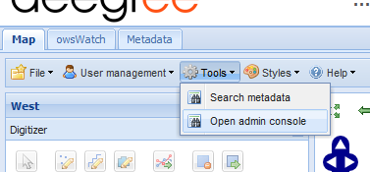

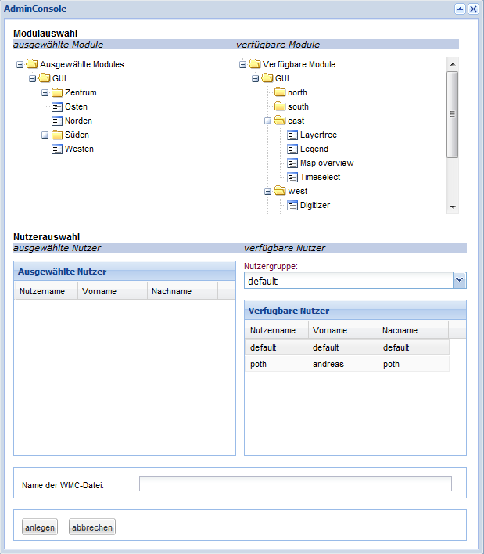

The first section enables selecting modules that shall be available in a new web map context / project file. On the right you see a tree containing all modules that are available at the moment (current project), on left there is a tree that will contain all modules you like to have in a new project. Both trees contains one node for each of the five gui areas known by iGeoPortal (north, east, south, west, center). As default the tree containing selected modules already conatins Toolbar and OLMap assigned to the center and MenuBarTop assigned to the south area. These modules are essential and shall not be removed!

All other modules can be assigend to a new project by moving them from the right tree to the left by drag&drop. Please ensure that you drop modules onto the area nodes of the tree on the left. You also can changed the order of the modules by drag&drop. If you decide to remove a module you already has selected you can move it back to the right tree by drag&drop. Be carefule if you assigne further modules to the center area!

Underneath the module selection area you find two tables enabling selection of users to which you want to publish a new project. On the rigth you first see a drop-drown-list containing all user groups read from deegree user and rights database. If you select one group all users contained in this group will be listed within the table below. You now can select one or more user in this table and move them to the table on the left by drag&drop. You can repeat this step for as much groups/users you like. The table on the left now contains the users for which you will make a new project available. If you decide to remove a user from this table you can drag him back to the table of avialable users. If you do not select any user either explictly by not selecting a user or because no deegree user and rights database is available a new project will be published to the default user.

After you have selected modules and users, you have to give a name to the new project. Please avoid using spaces, german Umlaute and special characters; use; a..z;A..Z;0..9;_-

If you are satisfied on what you have done: press the 'publish' button. A new context
- containing all modules you have selected
- all layers that are actualy loaded
- with the current map extent and scale
will be created for each user you have selected. If the deegree user and rights database contains one or more users that has not been already registered to iGeoPortal each of this users will registered and a directory for each of them will be created.

If you think invoking the admin console has been a stupid idea: press the 'cancel' button.

