**Introduction**

In this tutorial I have decided to use Firefox Quantum Developer Tools as these have recently been updated and I much prefer Firefox.

Here’s an example of the user interface,

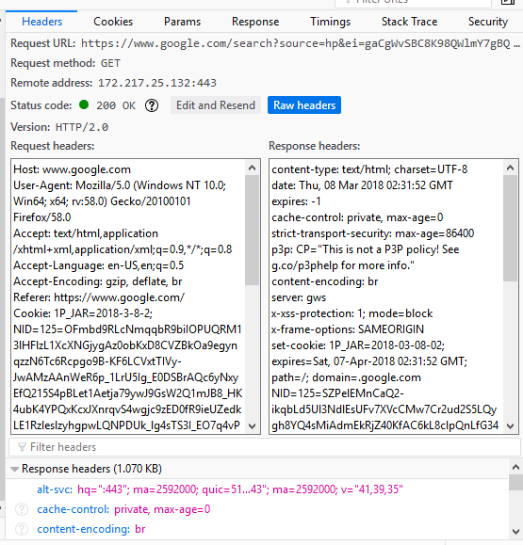

**Part A**

1. The browser will be using the same version of HTTP as the server. They both use HTTP/2.0
2. The search query “cookies” was sent to the server using a POST request to the address google.com on port 443 which indicates it’s a secure connection using TLS. Google’s server will then process this request and return a GET (using a resource that is routed to the address ‘search’). The params returned in the URL can be seen below. Google use ‘q’ as the param to store the search term.

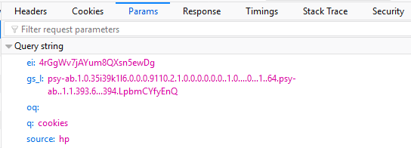

1. 200 OK, as seen above.
2. Connection: keep-alive indicates the TCP stream is to remain open and therefore is persistent.
3. Yes, the browser is caching.  
   

The client will check if the browser has the most recent version of the file. If it does, the resource doesn’t need to be downloaded. Otherwise, it’ll download it. It reduces network load on the server and speeds up browsing for the user.

1. Yes. This determines what server the request is going to.
2. Majority of JavaScript and images such as profile picture, loading GIFs are cached, while for example the main HTML document providing the search result is sourced from Google’s server.

**Part B**

1. No
2. I get status code OK rather than 304 (Not Modified). HTTP-wireshark-file2.html is not in the browser’s cache as suggested “Cache-Control: no-cache”
3. Yes, I also get a status code of 304 Not Modified. Contents of If-Modified-Since: Wed 07 Mar 2018 06:59:01 GMT
4. 304: Not Modified which means the client has a local version that is most recent so it uses it from cache. No contents returned from server.

**Part C**

1. The initial response is status code 401: Unauthorized
2. Authorization: Basic [hash] – status code 200 OK which means I’m authorized.