**Part A**

**1) Identify the errors**

a) On line 8 and 15, they’re not valid closing tags. It should be </play>.

b) Attribute value is not enclosed by quotes on line 2 (publicationYear).

c) On line 3, “&” must be an entity reference, &amp;

d) For all play tags which have a parent play tag, attribute ‘description’ does not have a value. It would be recommended to make a description tag contained within the nested play tags.

**Part B**

**2) Derive an XML schema (XSD) which is equivalent to this DTD**

**3)**

For 2), 3) please check the files provided (.xsd, .xml).

**Part C**

**4) What result will the following XPath expression return**

It would return nothing. That is, the XPath expression is wrong and there is no 2nd members element.

However, if the XPath expression was instead /MemberData/members/member[2]/member-info/lastname then it would return the 2nd member’s last name, which’ll be <lastname>Byrne</lastname>

**5) How many elements will this XPath expression return**

//member-info[party=’D’]/state will return 197 states. That is, all the parties that is equal to ‘D’, return all member states of who belongs to this party. I used [count](http://www.xqueryfunctions.com/xq/fn_count.html)(doc("xml/MemberData.xml")//member-info[party='D']/state) to count how many states there were.

**6) Write an XQuery to list the last and first names of all republican members from Arizona.**

Refer to q6.xq

**7)** Refer to q7.xq

**8)** Describe in plain English what the query …does

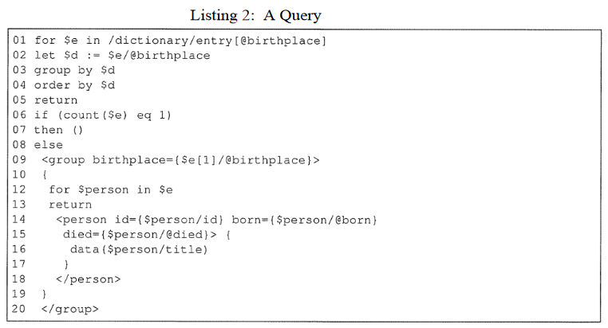

1. The query will select all entries with the birthplace attribute.  
2. It will then group all birthplaces so that there are no duplicates.  
3. It will then order the grouped birthplaces A-Z.  
4. If there is only one entry with the attribute birthplace, return nothing.  
5. Otherwise, return a group for the first birthplace containing all people (and their data) that belong to that birthplace.

In other words, it gets the first birthplace where the birthplace’s name is closest to the letter A, and formats the XML into a nice output containing a group element with all the people and their information that belong to this birthplace.