# Results

## Qualitative (Visualization) Results

The project includes several key visualizations to demonstrate the model's performance:

1. Training and validation accuracy/loss curves are plotted, showing the model's learning progress over 48 epochs.

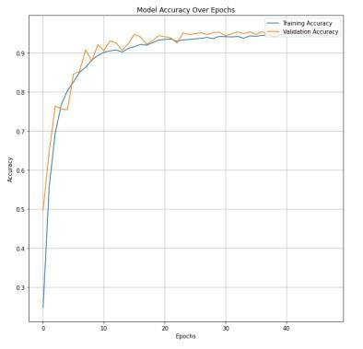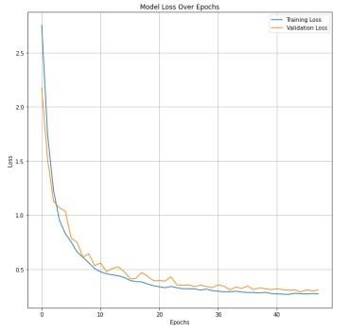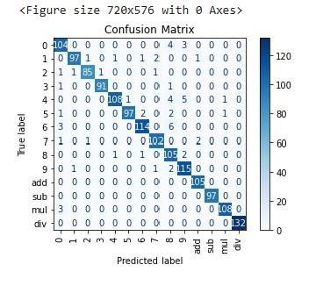

1. A confusion matrix is generated, visualizing the model's performance across different symbol classes. Also, have classification report showing different evaluation metrics values.
2. The detect_number and equation_solver include visual output, displaying the original equation image with bounding boxes and predicted labels for each detected symbol.

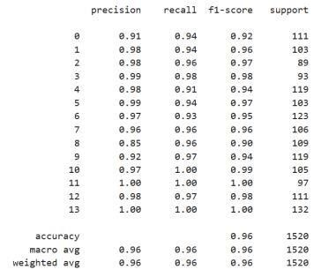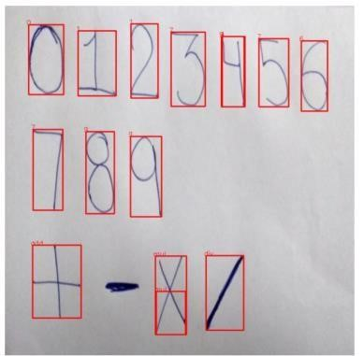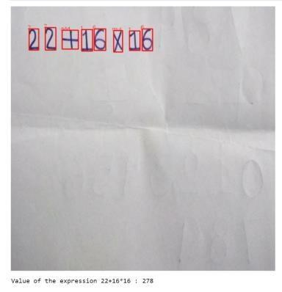

These visualizations provide valuable insights into the model's behavior, strengths, and potential areas for improvement. Here we can see that the written equation is successfully predicted by the model and calculated by it and all other visualizations indicate success of the model.