# Anzahl der Sozialhilfebeziehenden pro Kanton (2009-2022)

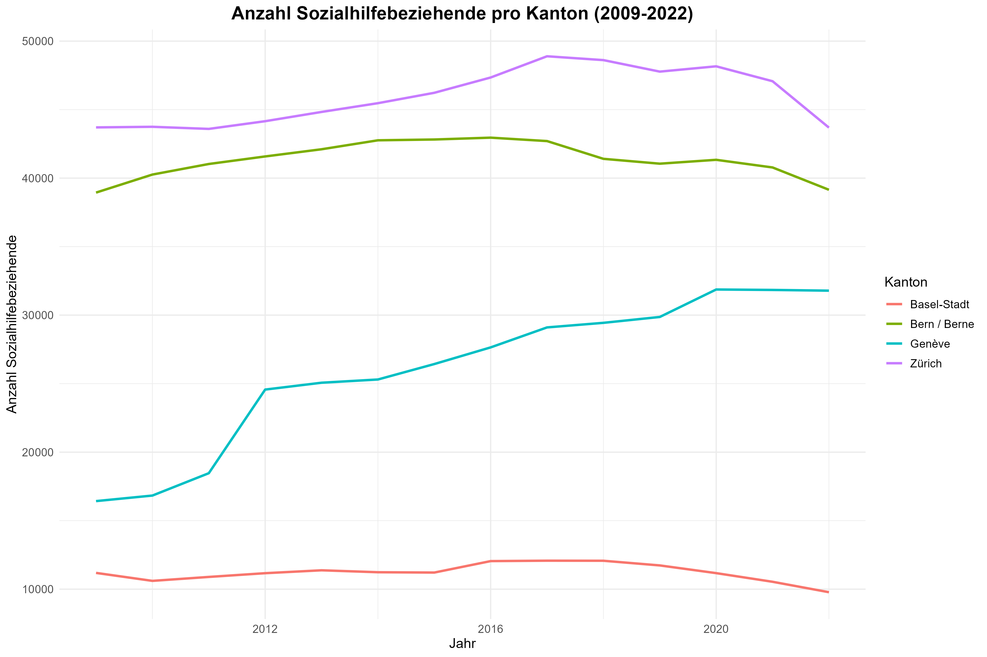

## Beispieltabelle der Daten

| Kanton | Jahr | Anzahl |
| --- | --- | --- |
| Zürich | 2,009 | 43,702 |
| Zürich | 2,010 | 43,746 |
| Zürich | 2,011 | 43,592 |
| Zürich | 2,012 | 44,154 |
| Zürich | 2,013 | 44,830 |
| Zürich | 2,014 | 45,469 |
| Zürich | 2,015 | 46,227 |
| Zürich | 2,016 | 47,344 |
| Zürich | 2,017 | 48,893 |
| Zürich | 2,018 | 48,613 |
| Zürich | 2,019 | 47,773 |
| Zürich | 2,020 | 48,160 |
| Zürich | 2,021 | 47,072 |
| Zürich | 2,022 | 43,686 |
| Bern / Berne | 2,009 | 38,944 |
| Bern / Berne | 2,010 | 40,260 |
| Bern / Berne | 2,011 | 41,031 |
| Bern / Berne | 2,012 | 41,582 |
| Bern / Berne | 2,013 | 42,106 |
| Bern / Berne | 2,014 | 42,760 |
| Bern / Berne | 2,015 | 42,819 |
| Bern / Berne | 2,016 | 42,953 |
| Bern / Berne | 2,017 | 42,704 |
| Bern / Berne | 2,018 | 41,408 |
| Bern / Berne | 2,019 | 41,054 |
| Bern / Berne | 2,020 | 41,336 |
| Bern / Berne | 2,021 | 40,778 |
| Bern / Berne | 2,022 | 39,149 |
| Basel-Stadt | 2,009 | 11,187 |
| Basel-Stadt | 2,010 | 10,605 |
| Basel-Stadt | 2,011 | 10,893 |
| Basel-Stadt | 2,012 | 11,166 |
| Basel-Stadt | 2,013 | 11,377 |
| Basel-Stadt | 2,014 | 11,236 |
| Basel-Stadt | 2,015 | 11,212 |
| Basel-Stadt | 2,016 | 12,048 |
| Basel-Stadt | 2,017 | 12,078 |
| Basel-Stadt | 2,018 | 12,073 |
| Basel-Stadt | 2,019 | 11,733 |
| Basel-Stadt | 2,020 | 11,170 |
| Basel-Stadt | 2,021 | 10,539 |
| Basel-Stadt | 2,022 | 9,778 |
| Genève | 2,009 | 16,427 |
| Genève | 2,010 | 16,832 |
| Genève | 2,011 | 18,463 |
| Genève | 2,012 | 24,567 |
| Genève | 2,013 | 25,067 |
| Genève | 2,014 | 25,303 |
| Genève | 2,015 | 26,430 |
| Genève | 2,016 | 27,646 |
| Genève | 2,017 | 29,104 |
| Genève | 2,018 | 29,438 |
| Genève | 2,019 | 29,867 |
| Genève | 2,020 | 31,871 |
| Genève | 2,021 | 31,839 |
| Genève | 2,022 | 31,786 |