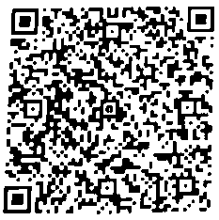

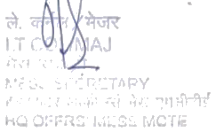
MCTE MHOW
HEADQUARTERS OFFICERS' MESS BILL
MCTE Mhow, Indore (M.P). MOB NO:7999060653

MESS ACCOMMODATION CHARGES

Bill No: 28 Month: Oct-26
Rank Maj
Name Dhanjit Kumar Singh
Status : Basic Cyber Security-09 FacWing: FCT&S
From 28-Jun-2026
To 17-0ct-2026
Sr. |  | Room Type | Amount Payable
 | Accommodation Charges |  | 99,491.00
Total Amount (Rounded off) |  |  | 99,491.00

Seal/Stamp
Mess Secretary
Date
Note :
1. Payment may please be made through Cash or 'at par' crossed cheque in
favour of "HQ Offrs' Mess MCTE'" and Credit /Debit Card through POS
Machine at Reception. HKC and HQ Offrs' Mess.
2. Payment also made through "QR Code" (UPI ID) at HQ Offrs' Mess.

