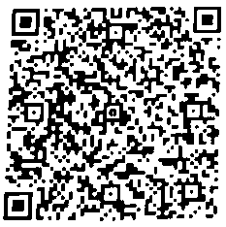
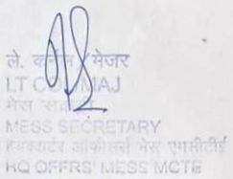
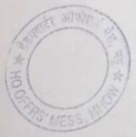
MCTE MHOW
HEADQUARTERS OFFICERS' MESS BILL
MCTE Mhow, Indore (M.P). MOB NO : 7999060653

Mess ACCOMMODATION CHARGES

BillNo : 28 Month : Oct-26
Rank : Maj
Name : Dhanjit Kumar Singh
Status : Basic Cyber Security-09 Fac/Wing: FCT&S
From : 28-Jun-2026
To 17-Oct-2026
Sr. |  | Room Type | Amount Payable
1 | Accommodation Charges |  | 99,491.00
Total Amount (Rounded off) |  |  | 99,491.00

Seal/Stamp
Mess Secretary
Date :
Note :
1, Payment may please be made through Cash or ‘at par’ / crossed cheque in
favour of "HQ Offrs' Mess MCTE" and Credit /Debit Card through POS
Machine at Reception. HKC and HQ Offrs' Mess.
2. Payment also made through "QR Code" (UPI ID) at HQ Offrs' Mess.

