AWS IAM
Attack & Defence Lab
A Hands-On Cloud Security Simulation

Privilege Escalation | Persistence Attacks | Least-Privilege Defence

University of Maryland, College Park
Master of Engineering in Cybersecurity

Services: AWS Cloud Shell | AWS IAM | AWS CLI

1. Overview
This project demonstrates how misconfigured AWS Identity and Access Management (IAM) permissions can be exploited to perform privilege escalation and persistence attacks. It also showcases how to mitigate these risks using least-privilege principles and explicit deny policies.

2. Objectives
- Simulate IAM-based attack scenarios
- Demonstrate privilege escalation via misconfigured permissions
- Show persistence using access keys
- Implement least-privilege security controls
- Validate mitigation using real attack attempts

3. Environment
- AWS CloudShell
- AWS IAM
- AWS CLI
- IAM Users, Policies, and Access Keys

PHASE 1 — Attack

4. Attack Phase

4.1 Creation of Insecure IAM User
A low-privileged IAM user lab-insecure-user was created to simulate an attacker's initial foothold. An access key was immediately generated to enable programmatic access via AWS CLI.

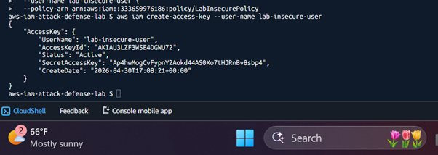
Figure 1: IAM User Creation and Initial Access Key

WARNING AccessKeyId and SecretAccessKey values have been redacted (****REDACTED****) for security.

4.2 Creation of Over-Permissive Policy
A custom IAM policy (LabInsecurePolicy) was created with excessive permissions. The policy list confirms its creation and availability for attachment:
- IAM enumeration (List, Get)
- Access key creation
- Policy modification capabilities

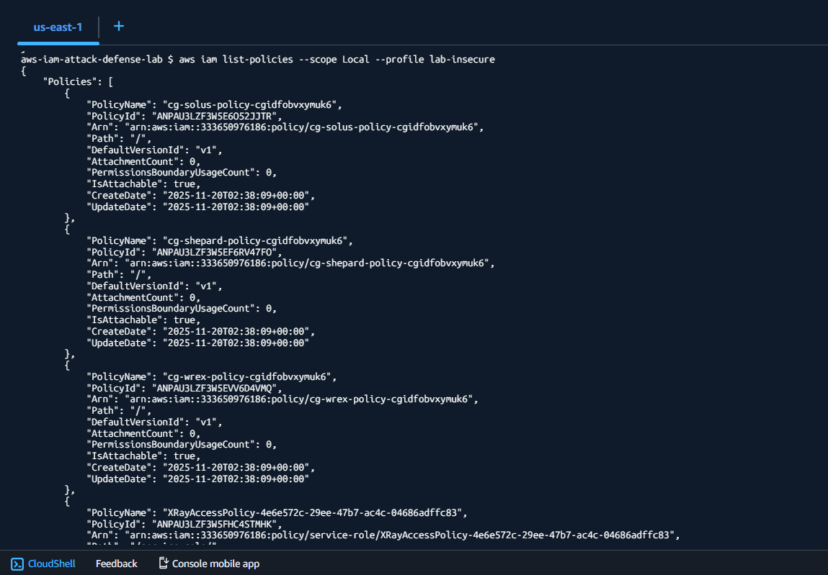

Figure 2: List of IAM Policies — LabInsecurePolicy Visible

4.3 Attaching Policy to User
The insecure policy was attached to the attacker user. The CLI then confirmed attacker identity and demonstrated initial enumeration of IAM users:

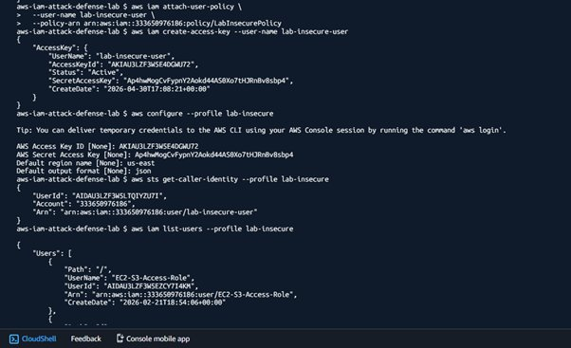
Figure 3: Policy Attachment and Attacker Credential Configuration

4.4 Access Key Generation
A second set of access keys was generated for the attacker user to simulate programmatic credential theft and persistence setup:

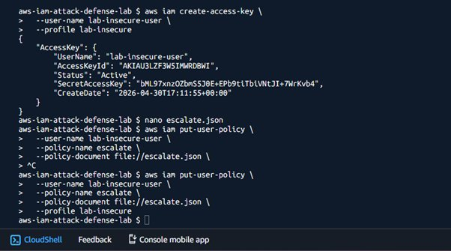
Figure 4: Access Key Generation and Privilege Escalation Setup

WARNING All AccessKeyId and SecretAccessKey values shown are redacted (****REDACTED****) in the submitted version.

4.5 Enumeration of IAM Environment
Using attacker credentials, IAM resources were enumerated. The attacker confirmed their identity and listed all IAM users in the account:

aws sts get-caller-identity --profile lab-insecure aws iam list-users --profile lab-insecure

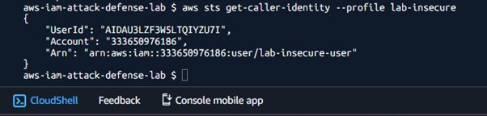
Figure 5: Attacker Identity Confirmed via get-caller-identity

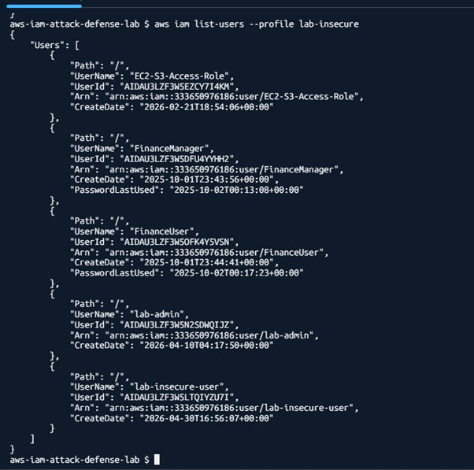
Figure 5b: Full IAM User Enumeration — All Account Users Exposed

RESULT Attacker has full visibility into IAM environment: 5 users including EC2-S3-Access-Role, FinanceManager, FinanceUser, lab-admin, and lab-insecure-user.

4.6 Persistence via Access Keys
The attacker created additional access keys to establish persistence. Two active keys were confirmed, demonstrating the ability to maintain long-term access:

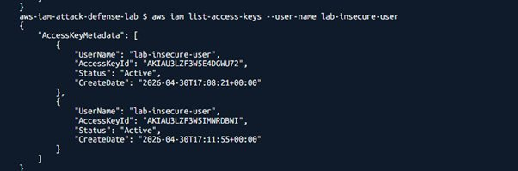
Figure 6: Two Active Access Keys — Persistence Established

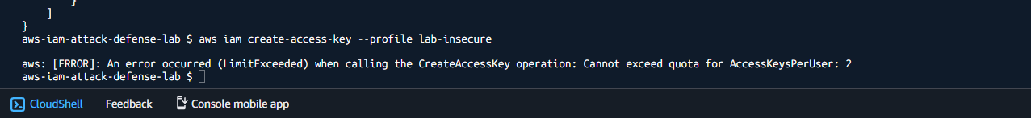

Figure 6b: LimitExceeded Error — Maximum 2 Access Keys Reached

RESULT Attacker successfully persisted two active access keys. Any future revocation of one key still leaves a live credential. The LimitExceeded error confirms both slots were filled.

4.7 Privilege Escalation Attack
CRITICAL This is the core attack — a low-privileged user gains full admin access via inline policy injection.

The attacker used the put-user-policy API to attach an inline policy granting full administrative access. Verification confirmed the escalation policy was successfully applied:

aws iam put-user-policy --user-name lab-insecure-user \ --policy-name escalate \ --policy-document file://escalate.json \ --profile lab-insecure

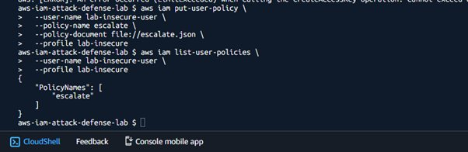
Figure 7: Privilege Escalation — "escalate" Policy Confirmed in list-user-policies

RESULT lab-insecure-user now has an inline policy named "escalate" granting full admin rights. A low-privileged user has achieved complete account control.

PHASE 2 — Defense

5. Defence Phase

5.1 Removal of Malicious Policy
The escalation inline policy was deleted using delete-user-policy. Verification with list-user-policies confirmed PolicyNames returned an empty array:

aws iam delete-user-policy --user-name lab-insecure-user --policy-name escalate

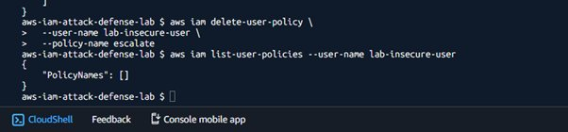
Figure 8: Escalation Policy Deleted — PolicyNames: []

CONFIRMED Inline escalation policy removed. PolicyNames is empty.

5.2 Detachment of Insecure Policy
The overly permissive managed policy (LabInsecurePolicy) was detached from the user. Verification confirmed AttachedPolicies returned an empty array:

aws iam detach-user-policy --user-name lab-insecure-user \ --policy-arn arn:aws:iam::333650976186:policy/LabInsecurePolicy

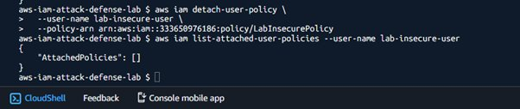
Figure 9: LabInsecurePolicy Detached — AttachedPolicies: []

CONFIRMED Insecure managed policy detached. User has no attached policies.

5.3 Implementation of Least-Privilege Policy
A new secure IAM policy (LabSecurePolicy) was created from a minimal JSON definition and attached to the user. The policy enforces:
- Limited read-only permissions for required resources only
- Explicit Deny rules blocking all sensitive IAM actions

aws iam create-policy --policy-name LabSecurePolicy \ --policy-document file://secure-policy.json aws iam attach-user-policy --user-name lab-insecure-user \ --policy-arn arn:aws:iam::333650976186:policy/LabSecurePolicy

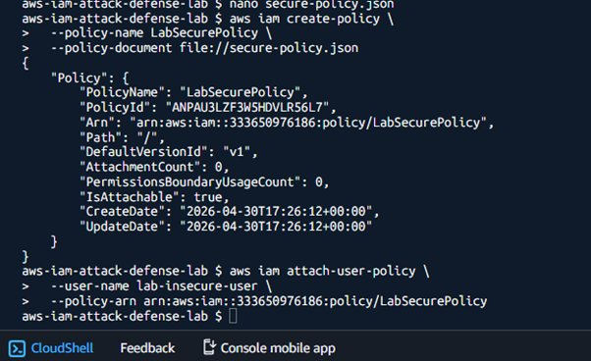
Figure 10: LabSecurePolicy Created and Attached to User

5.4 Validation of Security Controls
With LabSecurePolicy applied, all previous attack commands were retried. The explicit deny rules blocked every attempt:

Result of Every Re-attempted Attack:
ACCESS DENIED

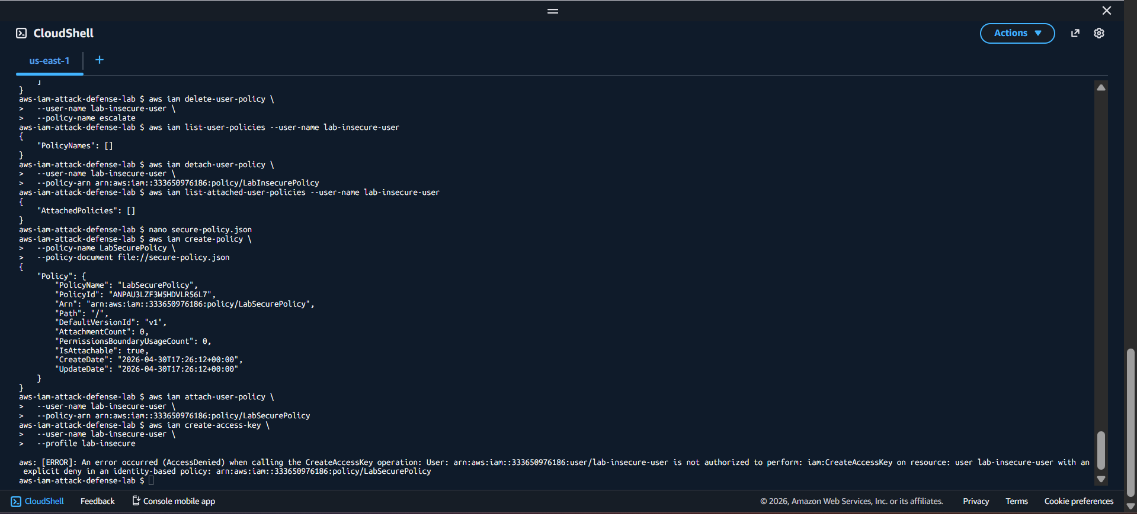
Figure 11: Full Defense Sequence — AccessDenied on All Attack Attempts

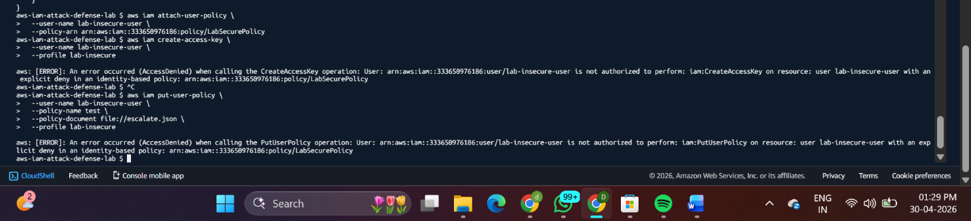

Figure 11b: AccessDenied on create-access-key AND put-user-policy — Both Blocked

CONFIRMED Both create-access-key and put-user-policy are explicitly denied. Least-privilege model fully validated — all attack vectors mitigated.

6. Key Findings

Finding | Impact / Implication
Over-Permissive Policies | Enable privilege escalation by low-privileged users
Access Key Persistence | Attackers can maintain long-term programmatic access
Inline Policy Risk | Can lead to full account compromise if unchecked
Explicit Deny Rules | Critical; override any other policy grants
Least-Privilege Model | Effectively mitigates all demonstrated attack vectors

7. Conclusion
This project successfully demonstrated how IAM misconfigurations can lead to severe security risks, including privilege escalation and persistent access. By implementing least-privilege policies and explicit deny controls, these risks were mitigated and validated through real-world attack simulation.

The lab reinforces a fundamental principle of cloud security: permissions must be the minimum required, and sensitive operations should always be protected by explicit deny rules that override any other policy grants.

