**AWS CI/CD Project**

IAM: No of services user has access to or services having access to resources.

KMS(Key Management services): If you want to encrypt or decrypt your file

Artifact/S3: when your code is build it is stores here.

CodeCommit: repo like a github

CodeBuild: provides CI . Pulls code from CodeCommit build It and save it in Artifact

CodeDeploy: pull build from artifact and deploy it on EC2 instance

CodePipeline: codecommit-> codebuild-> CodeDeploy

**AWS CodeCommit**

Steps:

* Create a repository in code commit
* You cannot configure SSH connections for root account and https connections.
* So create a IAM user
* Add permission-> attach policies-> select [AWSCodeCommitPowerUser](https://us-east-1.console.aws.amazon.com/iam/home#/policies/arn:aws:iam::aws:policy/AWSCodeCommitPowerUser)

* Go to IAM ->Users->Deeksha-> Security Credentials-> HTTPS Git credentials for AWS CodeCommit -> generate credentials
* Go to CodeCommit-> repositories-> demo-app-> clone your repo

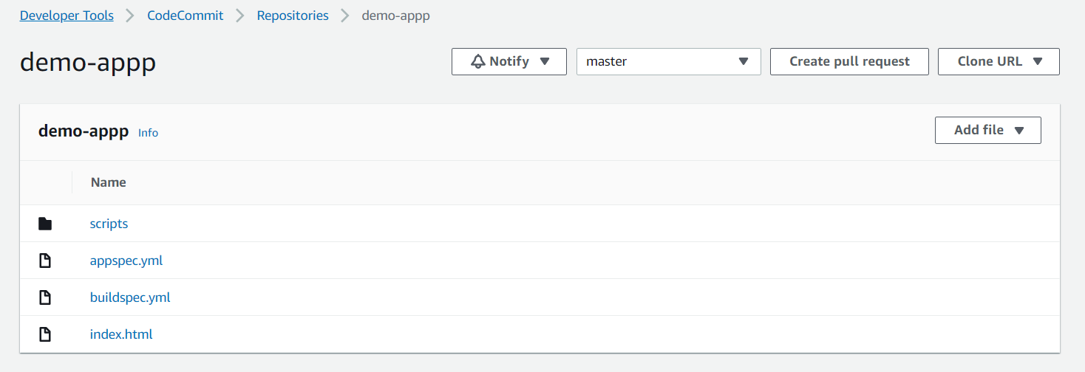

**AWS CodeBuild**

Steps:

* Create Build project
* Project name- demo-app-build
* Source- AWS CodeCommit
* Repository- demo-app
* Branch- master
* Environment image- Managed Image
* OS- ubuntu
* Runtime- Standard
* Latest- Standard 6.0
* Create service role for code build
  + codebuild-demo-app-build-service-role
* Buildspec- use a buildspec file
* Artifacts
  + Type- Amazon s3
  + Bucket name: enter your bucket name
  + Name: enter your s3 folder
  + Path: artifact.zip
* Save changes

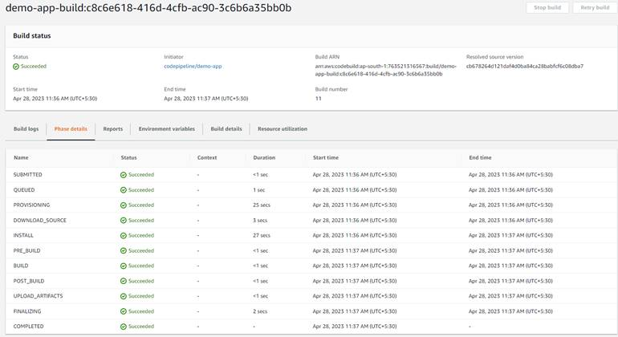

**AWS CodeDeploy**

Steps:

* Go to codeDeploy and create an application

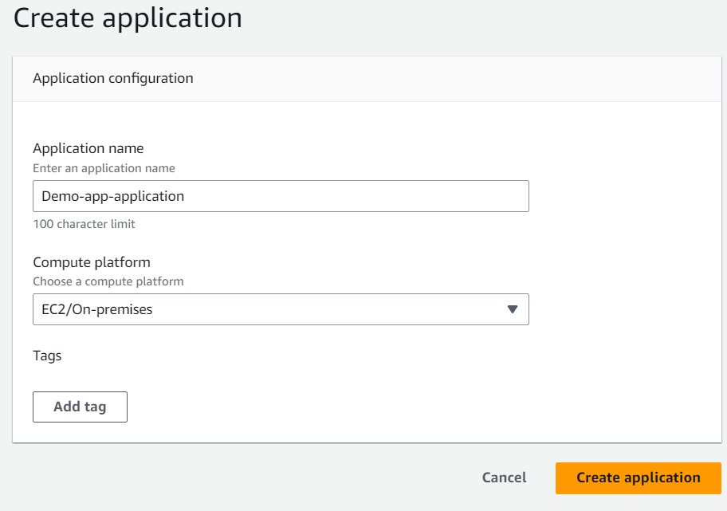

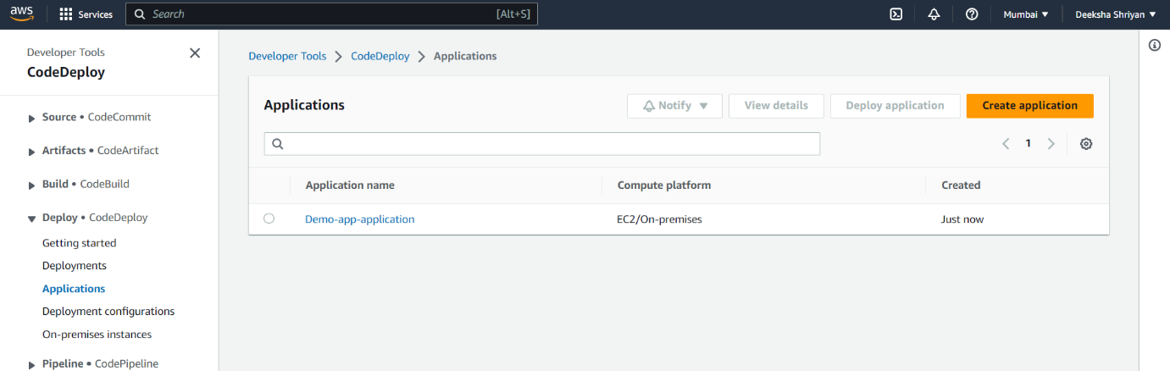

* Create a service role for code build can communicate with ec2 using IAM



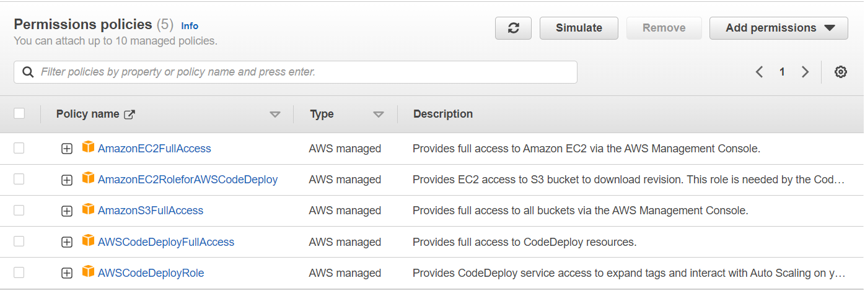

* Create an ec2 instance ubuntu image

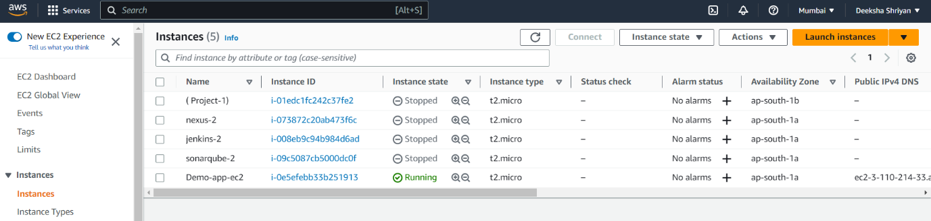

* Create deployment grp
  + Deployment group name: demo-app-deploy-grp
  + Service role: code-deploy-service-role
  + Deployment type: In-place
  + Environment configuration: ec2 instances-> key: Name, value: Demo-app-ec2
  + Install AWS CodeDeploy Agent: never
  + Enable load balancing: untick it
  + Create deployment grp

Setting Up AWS CodeDeploy Agent on Ubuntu EC2

* On ec2
* vim install.sh
* Copy paste the contents of above file
* Update the script as per your region
* Save it and exit
* bash install.sh

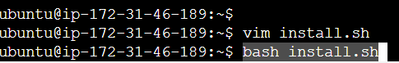

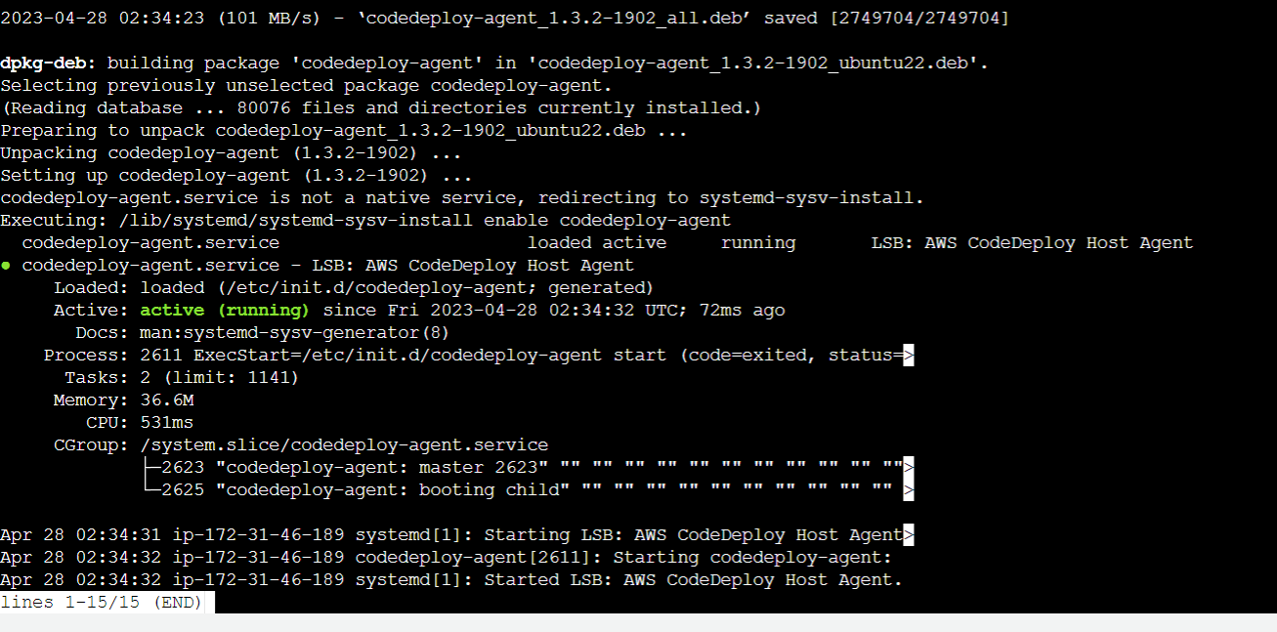

* Push the appspec file to codecommit->build it using codebuild
* After build is successful cope the s3 link of zip file created.

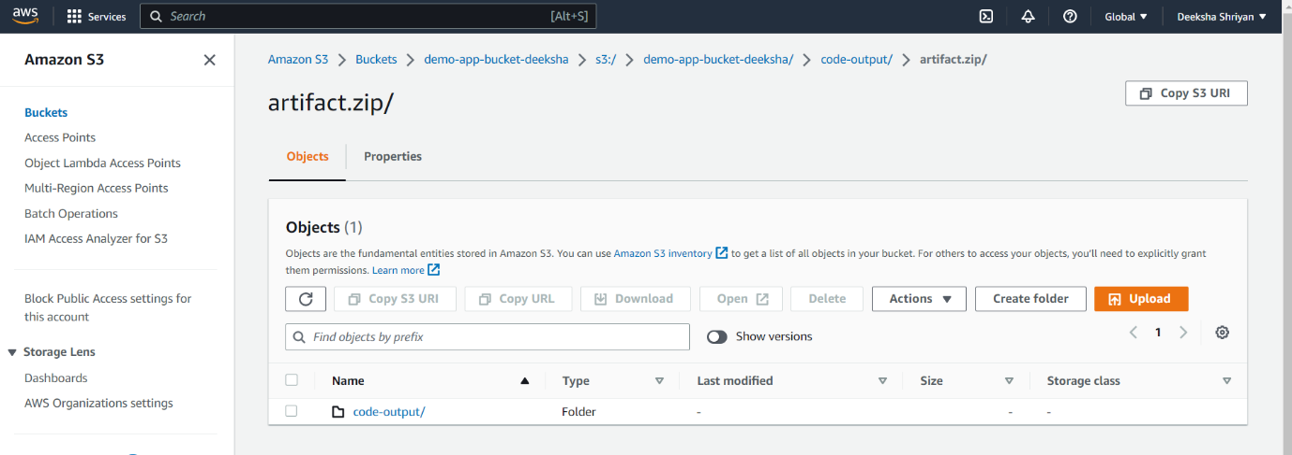

* Create deployment and paste it in codeDeploy Revision Location section
* Create deployment.
* Create ec2 service role to communicate with s3 and code deploy

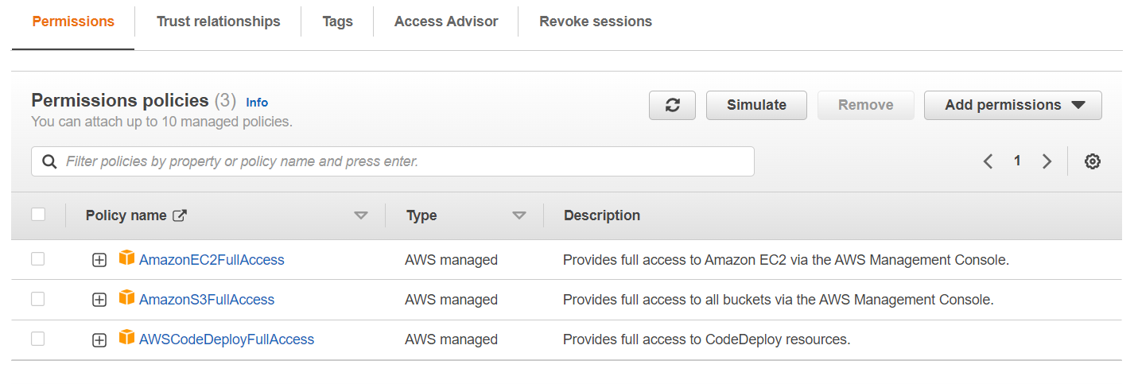

* Now assign this service role to ec2
  + Go to ec2-> select your instance-> actions-> security-> modify IAM role-> choose ec2-deploy-role
  + Select your instance-> connect-> open new terminal
  + Cat install.sh
  + sudo service codedeploy-agent restart
  + access index.html using public ip of ec2

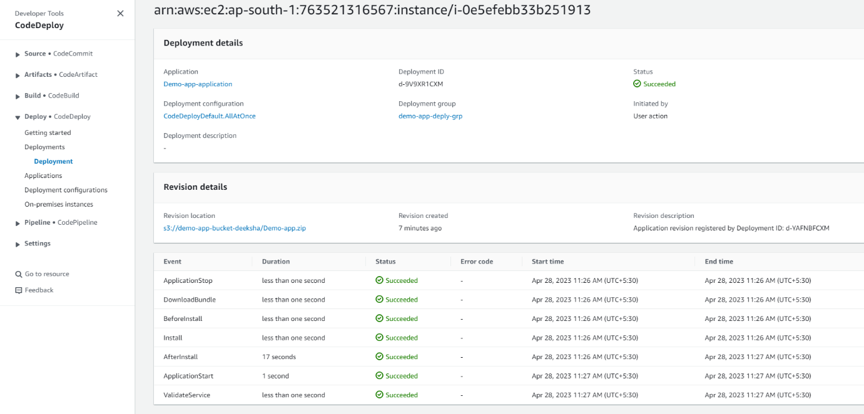

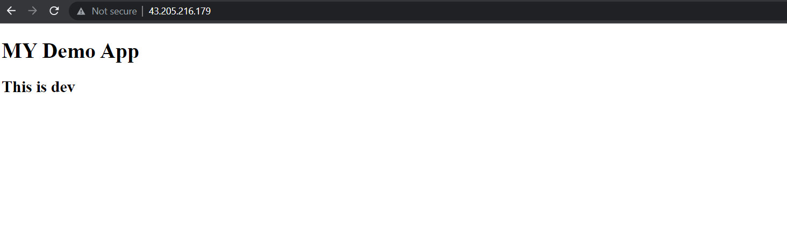

**AWS CodePipeline**

* Create pipeline
* Name:demo-app-pipeline
* 
 