LIST OF BOOKS :

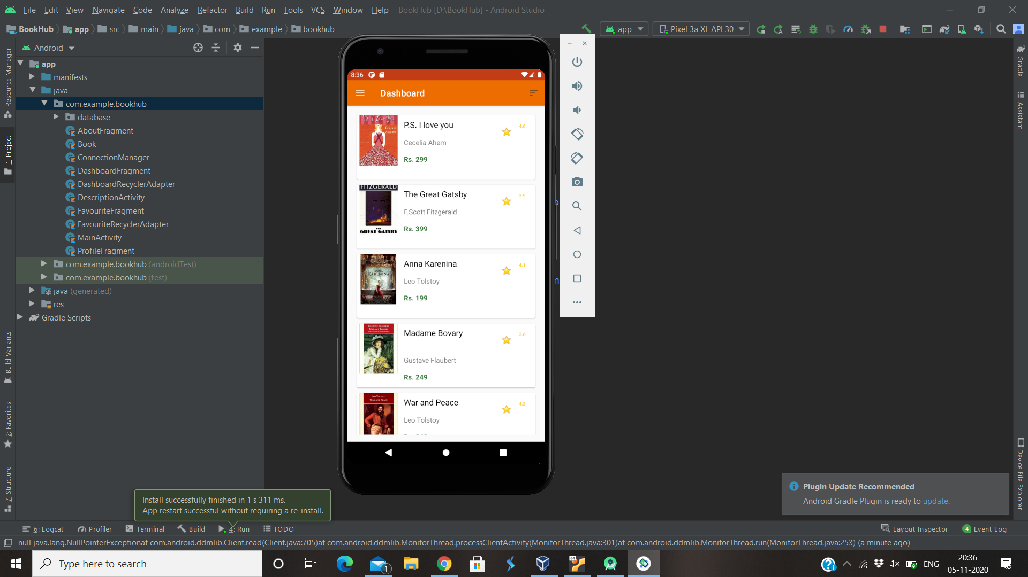

DESCRIPTION OF A BOOK:

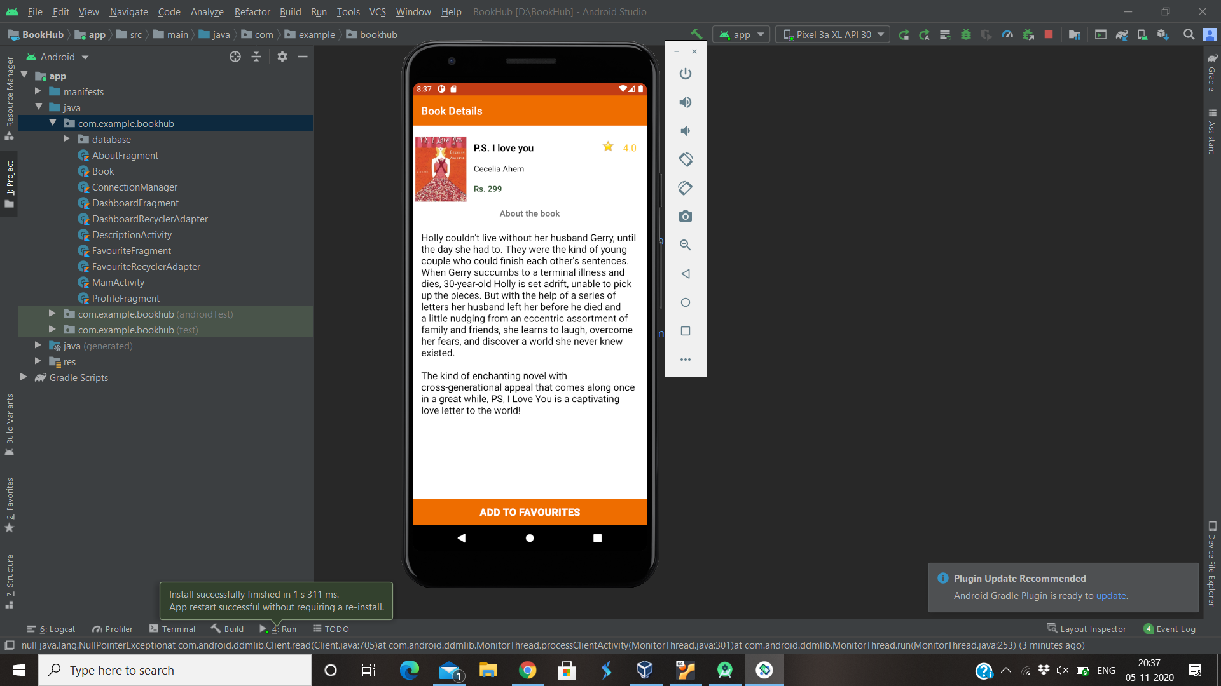

ADDING A BOOK TO THE FAVOURITES . IT CAN BE REMOVED FROM THE FAVOURITES ONCLICKING THE BUTTON

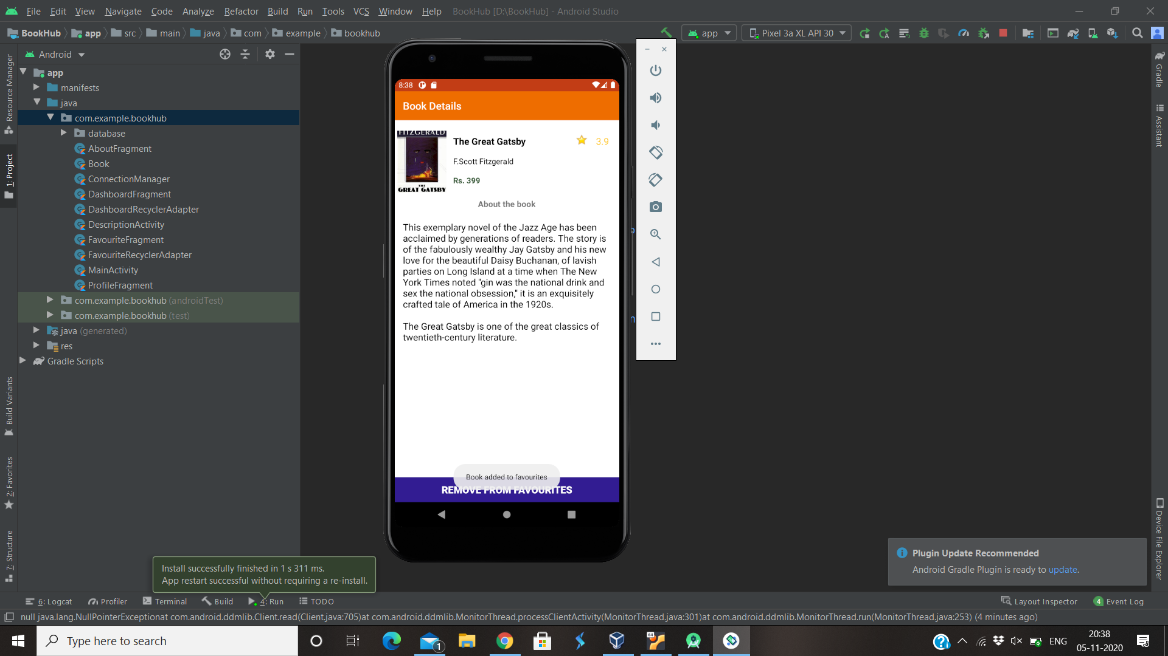

NAVIGATION DRAWER

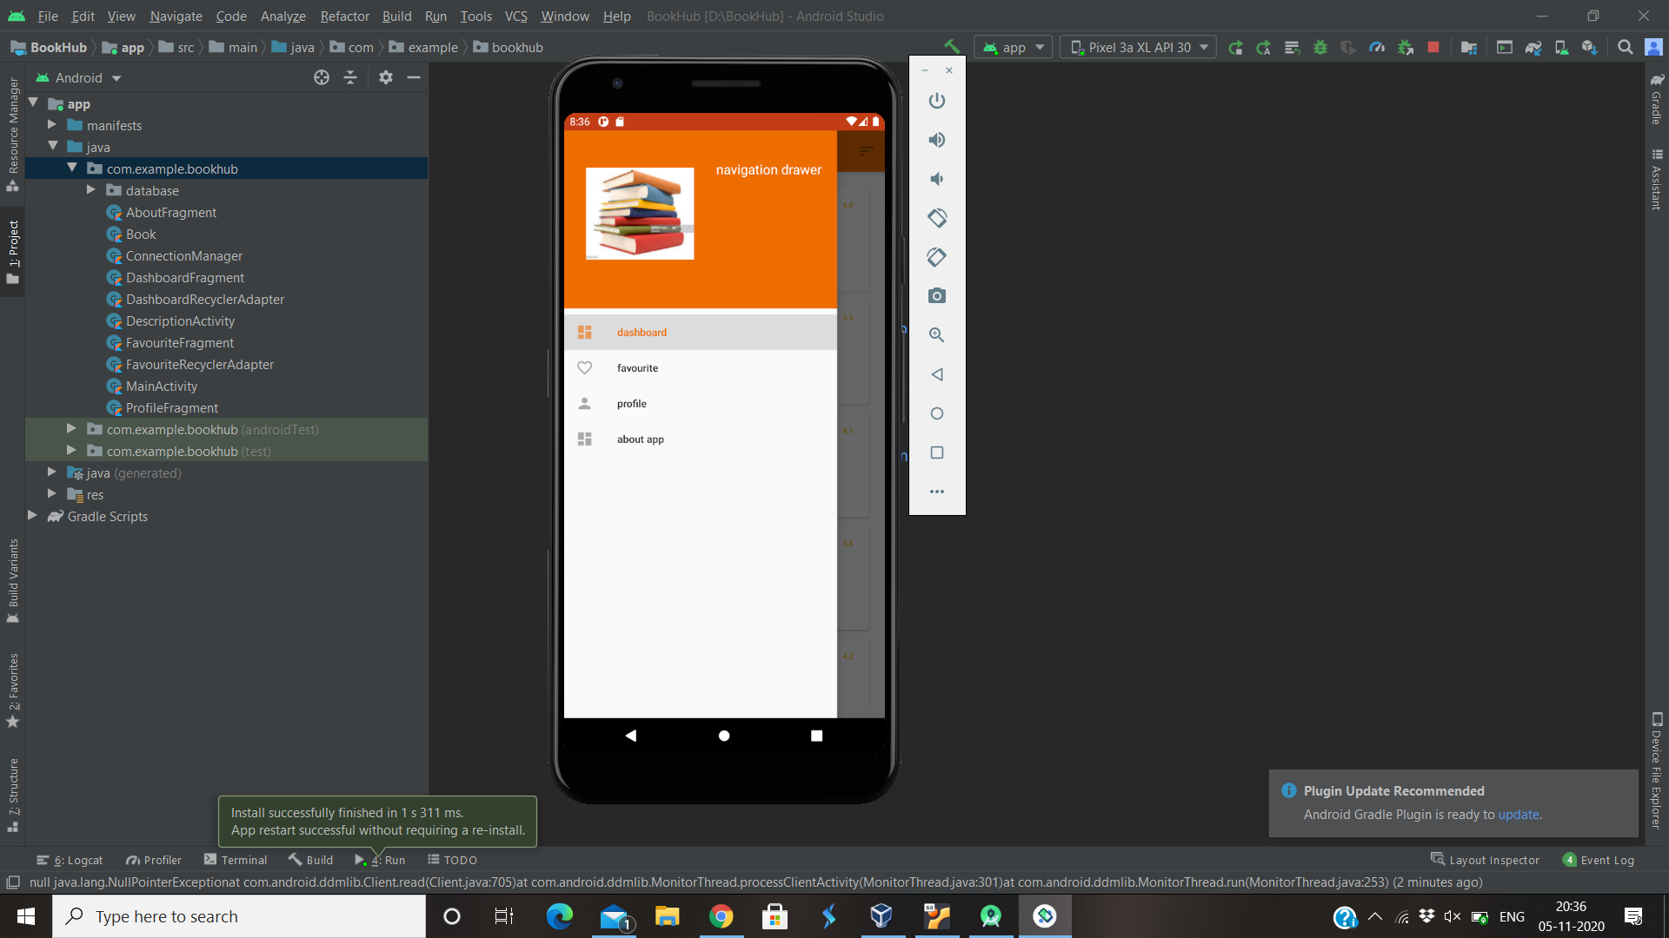

FAVOURITES :

