 LOGIN PAGE

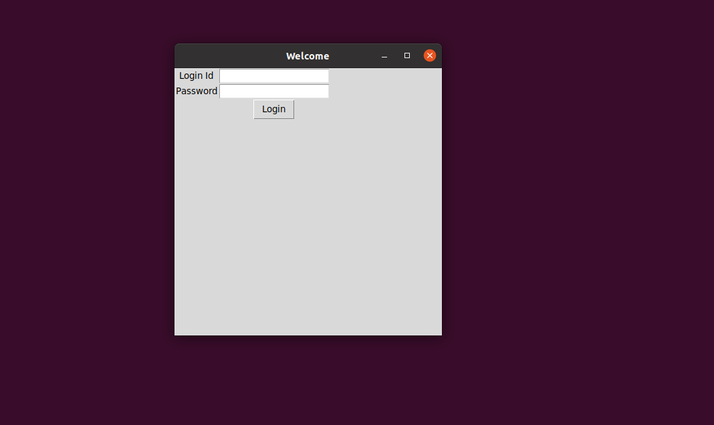

CATEGORY PAGE:

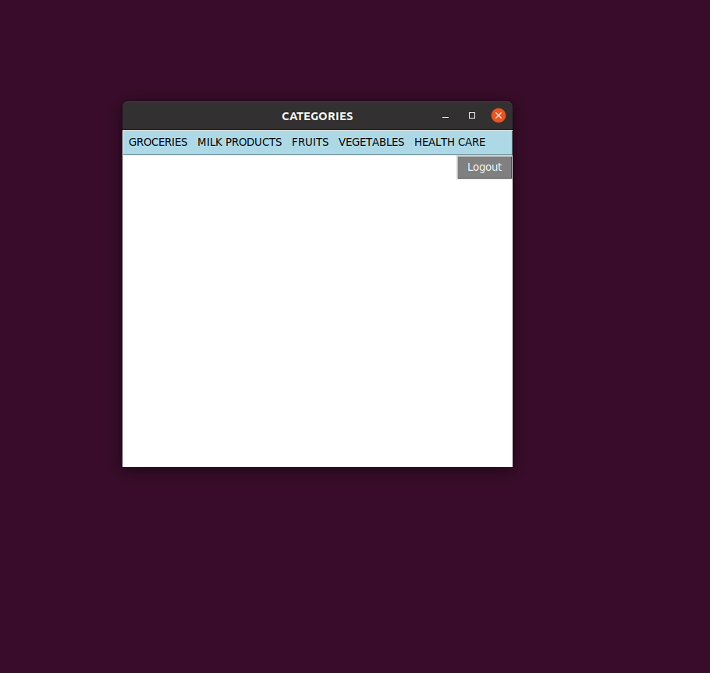

CATEGORY PAGE SHOWING A PRODUCT AND OPTIONS TO - GO TO CART OR LOGOUT OR ADD TO CART:

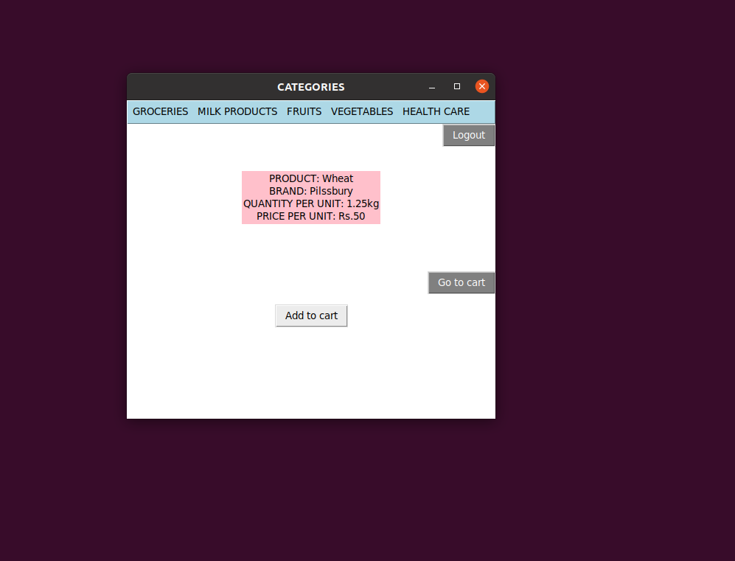

CART PAGE:

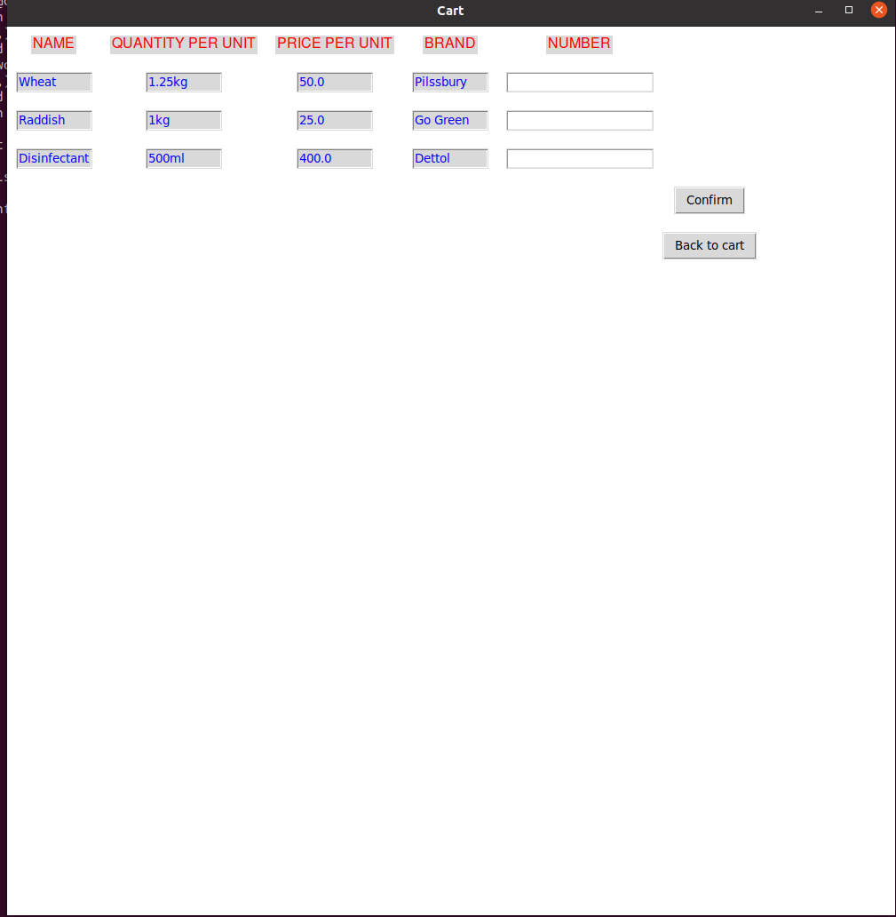

CART PAGE AFTER ADDING THE NUMBER OF PRODUCTS-IT DISPLAYS THE TOTAL PRICE:

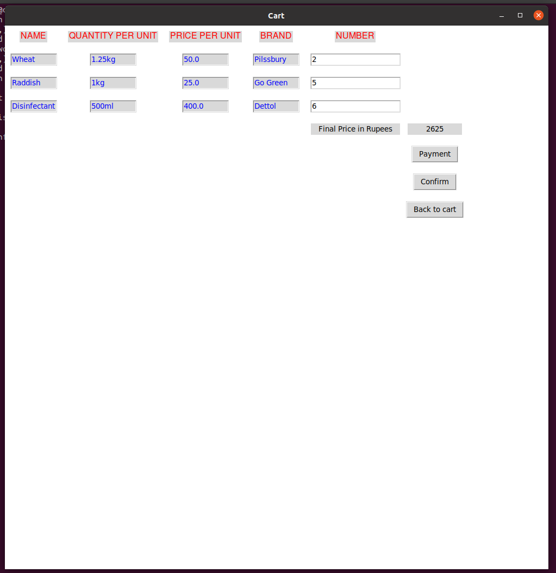

AFTER GOING BACK TO CATEGORY PAGE USING THE BACK TO CART OPTION AND ADDING A NEW ITEM:

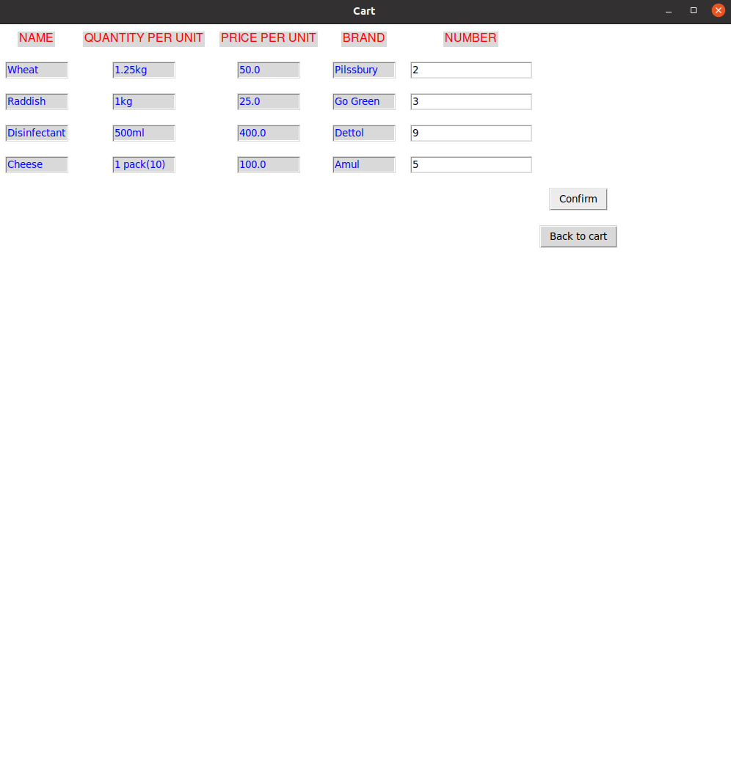

PAYMENT PAGE:

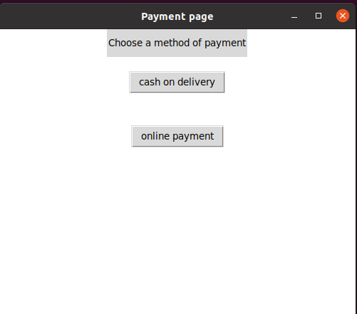

ON CHOOSING CASH ON DELIVERY  WE GET THE CONFIRMATION PAGE:



ON CHOOSING ONLINE PAYMENT:

ON ENTERING THE VALUES AND CLICKING ON THE CONFIRM BUTTON THE CONFIRMATION PAGE WILL BE DISPLAYED

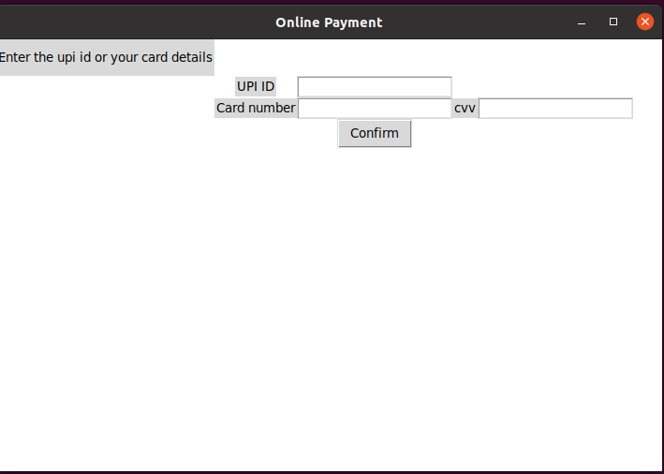

CONFIRMATION PAGE:

