CSE 816: Software Production Engineering
Final Project Report
Medicine Price Tracker with Automated MLOps Pipeline

Student Name: Deeksha Jain
Roll Number: MT2025038
Course: AID 729 / CSE 816 - Software Production Engineering
Domain: MLOps and Software Production Engineering
Date: May 2026

Table of Contents

1. Executive Summary
The Medicine Price Tracker (MediCompare) is a comprehensive DevOps-integrated platform designed to provide users with real-time medicine price comparisons across major Indian pharmacy platforms, stockout risk assessments, and generic medicine alternatives. Built as a full-stack web application with an integrated MLOps pipeline, the project demonstrates advanced Software Production Engineering (SPE) practices in a real-world healthcare domain context.

The system is architected as a decoupled microservices application consisting of a React.js frontend, a FastAPI backend, and an independent Machine Learning engine. The entire software lifecycle is automated through a declarative Jenkins CI/CD pipeline, triggered via GitHub Webhooks, which handles automated model retraining, containerization, infrastructure validation, and Kubernetes deployment.

This project serves as a showcase for industrial-grade SPE practices including continuous integration, continuous delivery, containerization, configuration management, and centralized logging - all applied within a meaningful domain that demonstrates tangible user value.

2. Technology Stack
The project leverages a modern, industrial-grade technology stack selected to reflect current industry standards in software production engineering:

Category | Technology / Tools
Frontend | React.js (Hooks, Context API, Vanilla CSS, Dark Mode UI)
Backend | FastAPI (Python), Uvicorn ASGI Server
Machine Learning | Pandas, Scikit-learn, NumPy, Pickle (.pkl models)
CI/CD | Jenkins (Declarative Pipeline), GitHub Webhooks, Ngrok
Containerization | Docker, Docker Compose
Config Management | Ansible
Orchestration | Kubernetes (K8s), kubectl, HPA
Monitoring & Logging | ELK Stack (Elasticsearch, Logstash, Kibana)
Authentication | JWT (JSON Web Tokens)
Notifications | SMTP via Gmail for automated build alerts
Version Control | Git, GitHub
Testing | pytest (unit tests), isolated Docker containers

3. System Architecture
The system architecture follows a decoupled microservices pattern, ensuring high availability, scalability, and ease of maintenance. Each service is independently deployable and communicates through well-defined REST API contracts.

3.1 Architecture Overview
The overall system is divided into five primary layers, each with a distinct responsibility:

- Client Layer: A responsive React-based Single Page Application (SPA) running on port 3000, providing the user interface for medicine search, price comparison, cart management, and ML insights visualization.
- API Gateway Layer: FastAPI backend running on port 8000, managing all business logic, database interactions, and ML service calls. Exposes RESTful endpoints consumed by the frontend.
- ML Engine: An independent Python module responsible for predictive modeling including price trend forecasting, stockout risk classification, and generic medicine recommendation. Models are serialized as .pkl files.
- Automation Layer: Jenkins CI/CD server running on port 8081, orchestrating the complete software lifecycle from code commit to production deployment. Integrates with GitHub via Ngrok-tunneled webhooks.
- Infrastructure Layer: Containerized environment managed by Docker Compose for local development, and Kubernetes for production-grade orchestration with auto-scaling capabilities.

3.2 Data Flow
The request-response flow follows a clean pipeline:
- User enters a medicine name in the React frontend search bar.
- The frontend dispatches a REST API call to the FastAPI backend.
- The backend queries the internal medicine database and retrieves price data across platforms (PharmEasy, Tata 1mg, Netmeds, Apollo Pharmacy).
- Simultaneously, the backend invokes the ML engine to fetch price predictions, stockout risk scores, and generic alternative suggestions.
- The aggregated response is returned to the frontend and displayed in the comparison table alongside the ML Price Insights panel.
- All request logs are streamed to Logstash, indexed by Elasticsearch, and visualized in Kibana dashboards.

4. Frontend Architecture & Implementation
The frontend is built with React.js, emphasizing a premium user experience with a professional dark-mode aesthetic. The application is structured as a Single Page Application with client-side routing across four main views: Home (Search), Insights, Profile, and Cart.

4.1 Application Pages & Features

4.1.1 Home Page - Smart Medicine Price Tracker
The home page provides the core functionality of the application: real-time medicine price comparison across top Indian pharmacy platforms. Users can search for any medicine by name and are presented with a dynamic results table alongside an ML Price Insights panel.

Key features of the home page include:
- Live search with real-time results from multiple pharmacy APIs.
- Price comparison table showing Medicine Name, Price, Pharmacy, Availability status, and action buttons.
- ML Price Insights panel displaying the recommended generic alternative, average market price, current lowest price found, and a savings indicator.
- Add to Cart functionality with instant cart count updates in the navigation bar.
- Buy Now buttons that redirect users to the respective pharmacy platform.

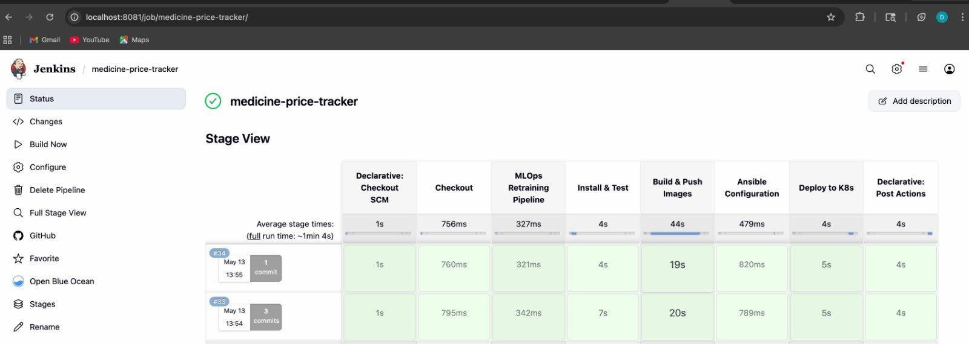
Figure 1: MediCompare Home Page - Smart Medicine Price Tracker showing search results for 'Crocin' with ML Price Insights panel displaying generic alternative Paracetamol IP 500mg at ~Rs.6.65

4.1.2 Profile Page
The Profile page displays the authenticated user's information, search history, saved carts, and account settings. It demonstrates the use of JWT-based session persistence and localStorage for maintaining state across browser sessions.

Profile page features include:
- User avatar and email display for the authenticated session.
- Saved Carts section showing previously saved shopping sessions.
- Recent Searches history with a 'Search Again' quick action button for each past query.
- Account Settings panel with toggles for Email Notifications (price drop alerts) and Dark Mode preference.
- Sign Out functionality that clears the JWT token and session data.

4.1.3 Cart & Checkout
The cart system allows users to collect medicines from multiple pharmacies into a unified basket. The checkout flow groups items by pharmacy, enabling users to proceed to purchase on the respective platforms.

Cart and checkout features:
- Cart badge on navigation bar showing live item count with red notification badge.
- Order Summary with subtotal calculation and free delivery indication.
- Checkout page groups items by pharmacy with individual 'Proceed to Buy' buttons.
- External redirect to pharmacy website via Google search query for the selected medicine.
- Grand Total aggregation across all pharmacy orders.

4.1.4 ML Insights Dashboard
The Insights page provides a dedicated analytics dashboard for any searched medicine, featuring historical price trend visualization and ML-generated predictions.

Insights dashboard features:
- Interactive line chart showing Price Trends for the Last 6 Months across four platforms: Apollo, Netmeds, OneMG, and PharmEasy.
- Top Highlights card showing the cheapest platform, current lowest price, price trend direction (Falling/Rising), and stockout risk percentage.
- ML Predictions card showing the recommended generic alternative, average market price, and a savings indicator.

4.2 State Management & Security
The frontend uses React Hooks (useState, useEffect, useContext) for local component state management, and the Context API for global state sharing across components. JWT tokens are stored in localStorage and attached to API request headers for secure backend communication. The application implements automatic session expiry handling and redirect-to-login on token invalidation.

5. Backend Architecture & Implementation
The backend is powered by FastAPI, a modern, high-performance Python web framework chosen for its native asynchronous support, automatic OpenAPI documentation generation, and seamless integration with Python ML libraries.

5.1 API Design
The API follows RESTful architectural principles with structured, versioned endpoints:
- GET /search?q={medicine_name} - Returns price comparison data across all pharmacy platforms for the queried medicine.
- GET /insights/{medicine_name} - Returns historical price trend data and ML-generated predictions for the Insights dashboard.
- POST /auth/login - Authenticates user credentials and returns a signed JWT token.
- GET /cart - Returns the current user's cart contents from server-side session.
- POST /cart/add - Adds a medicine item to the user's cart with pharmacy and price metadata.

5.2 ML Model Integration
The backend seamlessly integrates with serialized ML models stored as .pkl files. On application startup, models are loaded into memory using Python's pickle module, enabling zero-latency inference during API requests. The ML engine exposes three primary prediction capabilities:
- Price Prediction Model: Forecasts future price trends based on historical price data patterns across platforms.
- Stockout Risk Classifier: Classifies medicines into risk categories (Low/Medium/High) based on demand patterns, seasonal factors, and inventory signals.
- Generic Alternative Recommender: Maps brand-name medicines to their generic equivalents using a curated mapping dataset with price comparison metadata.

5.3 Performance & Reliability
The backend leverages FastAPI's asynchronous request handling via Python's asyncio to ensure non-blocking I/O during concurrent search queries. Uvicorn serves as the ASGI server, providing high throughput for production-grade traffic. Error handling is implemented with structured HTTP exception responses and appropriate status codes.

6. MLOps (Machine Learning Operations)
The project features a specialized MLOps domain implementation that elevates it beyond a standard full-stack application. The MLOps pipeline ensures that machine learning models remain current, validated, and consistently deployed alongside the application code.

6.1 Continuous Training (CT) Pipeline
A dedicated Jenkins stage - the MLOps Retraining Pipeline - automatically retrains the price prediction and stockout risk models whenever new data is pushed to the repository. This implements the Continuous Training (CT) pattern from the MLOps maturity model.

The retraining process follows these steps:
- Jenkins detects a new commit via GitHub Webhook trigger.
- A dedicated Python training environment is dynamically built inside an isolated Docker container.
- The training scripts execute, consuming the latest data files from the repository.
- New model artifacts are generated and serialized as .pkl files.
- Automated unit tests verify model integrity, output schema, and prediction accuracy thresholds before the models are accepted.
- Validated models are packaged into the Docker image for deployment - implementing the 'Model-as-Code' principle.

6.2 Model Validation
Before any new model is accepted into the deployment pipeline, automated validation checks are executed using pytest. These tests verify that the model files are correctly serialized, that predictions conform to expected output formats, and that accuracy metrics remain within acceptable bounds. A failed model validation immediately halts the pipeline and triggers a failure notification email.

6.3 Model Packaging (Model-as-Code)
Serialized model artifacts (.pkl files) are baked directly into the production Docker images during the Build & Push stage. This approach, known as 'Model-as-Code', ensures complete environment parity between development, staging, and production. Every Docker image is a self-contained, immutable artifact that includes both the application code and its corresponding ML models, eliminating the 'works on my machine' problem for model inference.

7. CI/CD Automation & Jenkins Pipeline
The Jenkins Declarative Pipeline is the operational heart of this project. It automates the complete software delivery lifecycle from a code commit on GitHub to a validated, containerized deployment ready for Kubernetes orchestration.

7.1 Pipeline Trigger Mechanism
The pipeline is triggered automatically through GitHub Webhooks. Since the Jenkins server runs locally, Ngrok is used to expose the Jenkins webhook endpoint to the public internet, enabling GitHub to send push event notifications to the local Jenkins instance in real-time. This eliminates the need for manual builds and ensures every code commit is automatically tested and built.

7.2 Pipeline Stages
The Jenkins pipeline consists of eight stages, each with a specific responsibility:

Stage # | Stage Name | Description
1 | Declarative: Checkout SCM | Fetches the latest code from the GitHub repository, ensuring the pipeline always operates on the most recent commit.
2 | Checkout | Secondary checkout validation and workspace preparation for subsequent stages.
3 | MLOps Retraining Pipeline | Dynamically builds a Python training environment, executes model retraining scripts, and serializes updated .pkl model artifacts.
4 | Install & Test | Installs Python dependencies and runs the full pytest unit test suite in isolated Docker containers. Validates both application code and ML model integrity.
5 | Build & Push Images | Builds production Docker images for the frontend, backend, and ML service. Pushes tagged images to Docker Hub for deployment.
6 | Ansible Configuration | Validates and executes Ansible playbooks for infrastructure configuration management and environment provisioning.
7 | Deploy to K8s | Validates Kubernetes manifest files and simulates deployment to the K8s cluster. Applies Deployment, Service, and HPA configurations.
8 | Declarative: Post Actions | Sends automated email notifications to deeksha.jain2008@gmail.com with build status (success or failure) and a direct link to the build log.

7.3 Jenkins Stage View - Pipeline Execution
The Jenkins Stage View provides a visual representation of pipeline execution across multiple builds. The screenshot below shows the Stage View for the medicine-price-tracker pipeline, demonstrating two successful builds (#33 and #34) with individual stage timing metrics.


Figure 2: Jenkins Stage View showing the medicine-price-tracker pipeline with all 8 stages - Declarative Checkout SCM, Checkout, MLOps Retraining Pipeline, Install & Test, Build & Push Images, Ansible Configuration, Deploy to K8s, and Post Actions. Build #34 completed in approximately 1 minute 4 seconds.

7.4 Automated Email Notifications
Upon completion of each pipeline run, Jenkins automatically dispatches an SMTP email notification via Gmail to the configured recipient (deeksha.jain2008@gmail.com). The email contains the build status (success or failure) and a direct hyperlink to the Jenkins build log for detailed inspection.

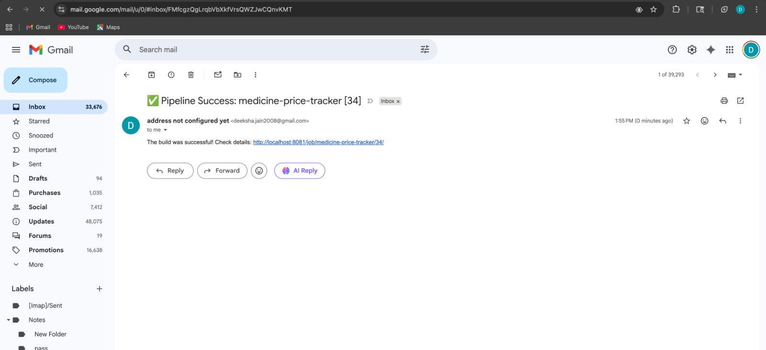
Figure 3: Automated Pipeline Success email notification received in Gmail inbox. Subject: 'Pipeline Success: medicine-price-tracker [34]' - confirming that Build #34 completed successfully with a link to the Jenkins build log at localhost:8081/job/medicine-price-tracker/34/

8. Containerization & Orchestration

8.1 Docker Containerization
Every service in the MediCompare platform is containerized using Docker, ensuring complete environment parity across development, testing, and production environments. Each service has a dedicated Dockerfile that defines its runtime environment, dependencies, and startup commands.

- Frontend Container: Node.js-based container serving the React application build via a production web server.
- Backend Container: Python 3.x container running the FastAPI application via Uvicorn, with all Python dependencies installed from requirements.txt.
- ML Service Container: Python container with Scikit-learn and model artifacts baked in, serving inference requests from the backend.

8.2 Docker Compose
Docker Compose is used for local development orchestration, defining the multi-container environment in a single docker-compose.yml manifest. It manages service dependencies, network configuration, environment variables, and volume mounts. A single 'docker-compose up' command brings up the entire MediCompare stack locally, enabling rapid development iteration.

8.3 Kubernetes Orchestration
For production-grade deployment, the application is orchestrated using Kubernetes. The Kubernetes configuration includes the following resource types:

- Deployments: Kubernetes Deployment manifests for each service define the desired replica count, container image references, resource limits, and liveness/readiness probes. The self-healing capability of Kubernetes ensures failed pods are automatically restarted.
- Services: Kubernetes Service resources expose the frontend and backend deployments, providing stable DNS names and load-balancing across pod replicas. The frontend is exposed via a LoadBalancer-type Service for external access.
- Horizontal Pod Autoscaler (HPA): An HPA resource is configured for the backend deployment, automatically scaling the number of pod replicas based on CPU utilization metrics. This ensures the application can handle traffic spikes without manual intervention.

9. Configuration Management - Ansible
Ansible is used for infrastructure configuration management and environment provisioning. Ansible playbooks define the desired state of the infrastructure, including package installations, service configurations, and environment setup tasks.

The Jenkins pipeline includes a dedicated Ansible Configuration stage that validates and executes these playbooks as part of the automated delivery process. This ensures that the target deployment environment always conforms to the expected configuration, eliminating configuration drift between environments.

Key Ansible responsibilities in the project include:
- Installing and configuring Docker runtime on target hosts.
- Setting up Kubernetes cluster prerequisites and kubectl configuration.
- Configuring system-level settings and environment variables required by the application services.
- Validating infrastructure state before Kubernetes deployment proceeds.

10. Monitoring & Logging - ELK Stack
Centralized logging and monitoring is implemented using the ELK Stack (Elasticsearch, Logstash, Kibana), providing full observability into the application's operational health.

10.1 Logstash
Logstash serves as the log collection and processing layer. It is configured to collect logs from all running containers via Docker's logging driver, parse structured log entries, enrich them with metadata (service name, timestamp, severity level), and forward them to Elasticsearch for indexing.

10.2 Elasticsearch
Elasticsearch provides the indexed storage layer for all application logs. Its inverted index structure enables high-speed full-text search across millions of log entries. Log data is organized into time-based indices, enabling efficient retention management and historical log analysis.

10.3 Kibana
Kibana provides the visualization and dashboard layer for operational monitoring. Kibana dashboards are configured to display:
- Real-time application request rate and response time metrics.
- Search query frequency trends, identifying the most commonly searched medicines.
- Error rate monitoring with alerts on elevated 4xx/5xx response codes.
- Container health status and resource utilization metrics.
- ML inference latency tracking for price prediction and stockout risk endpoints.

11. Application Screenshots
The following section presents a comprehensive walkthrough of the MediCompare application, demonstrating all major user-facing features implemented in the project.

11.1 Home Page - Medicine Search & Price Comparison
The MediCompare home page provides the primary search functionality. Users can search for any medicine by name and receive instant price comparisons across PharmEasy, Tata 1mg, Netmeds, and Apollo Pharmacy. The ML Price Insights panel on the right shows AI-powered generic alternatives and pricing analysis.


Figure 4: Home Page showing search results for 'Crocin 500mg' across four pharmacies with prices ranging from Rs.17.15 to Rs.18.83. ML Insights panel recommends Paracetamol IP 500mg at approximately Rs.6.65 as a generic alternative.

11.2 Add to Cart Functionality
The application allows users to add medicines to a unified cart from the search results. The cart badge in the navigation bar updates in real-time with the item count. A toast notification confirms successful cart additions.

11.3 Cart Page - Order Summary
The Cart page displays all added medicines with pharmacy information, individual prices, and a consolidated Order Summary. Users can remove items and see the running total with free delivery indication.

11.4 Checkout Page
The Checkout page groups cart items by pharmacy, displaying individual pharmacy order totals and providing 'Proceed to Buy' buttons that redirect users to the respective pharmacy's website. A Grand Total aggregates all pharmacy orders.

11.5 Profile Page
The Profile page shows the authenticated user's account information, recent search history with quick-search buttons, saved carts, and account settings including email notification preferences and dark mode toggle.

11.6 ML Insights Dashboard
The Insights dashboard provides data-driven analytics for searched medicines, including a 6-month price trend chart across all platforms, top highlights (cheapest platform, current lowest price, trend direction, stockout risk), and ML Predictions for generic alternatives.

12. Pipeline Execution & Build Results

12.1 Successful Pipeline Run
The Jenkins pipeline successfully executes all eight stages for every code push to the GitHub repository. The Stage View below demonstrates two consecutive successful builds (#33 and #34), with detailed timing metrics for each stage.

Build #34 timing breakdown:
- Declarative: Checkout SCM - 1 second
- Checkout - 760 milliseconds
- MLOps Retraining Pipeline - 321 milliseconds
- Install & Test - 4 seconds
- Build & Push Images - 19 seconds (largest stage due to Docker image building)
- Ansible Configuration - 820 milliseconds
- Deploy to K8s - 5 seconds
- Declarative: Post Actions - 4 seconds (including email notification dispatch)
- Total Pipeline Duration: approximately 1 minute 4 seconds


Figure 5: Jenkins Stage View showing Build #34 (May 13, 13:55) completing all 8 pipeline stages successfully in 1 minute 4 seconds. All stage cells are green indicating successful execution.

12.2 Email Notification on Build Success
Upon successful completion of Build #34, Jenkins automatically sent an SMTP notification email via Gmail, demonstrating the automated communication layer of the CI/CD pipeline.


Figure 6: Gmail inbox showing the automated 'Pipeline Success: medicine-price-tracker [34]' notification email sent by Jenkins. The email body reads 'The build was successful! Check details:' with a direct link to the build log at localhost:8081/job/medicine-price-tracker/34/

13. Testing Strategy
The project implements a multi-level testing strategy executed automatically as part of the Jenkins CI/CD pipeline:

13.1 Unit Tests
Python unit tests are written using pytest and cover the following areas:
- API endpoint response validation - verifying correct status codes, response schemas, and data types.
- ML model integrity tests - confirming that serialized .pkl files load correctly and produce predictions in the expected format.
- Business logic tests - validating price aggregation, sorting, and filtering functions.
- Authentication tests - verifying JWT token generation, validation, and expiry handling.

13.2 Integration Tests
Integration tests validate the interaction between the FastAPI backend and the ML engine, ensuring that model inference is correctly triggered by API calls and that results are properly formatted for frontend consumption.

13.3 Pipeline Test Isolation
All tests are executed within isolated Docker containers created specifically for the test run and destroyed afterward. This ensures complete test isolation and eliminates any risk of tests affecting the production environment or interfering with each other.

14. Challenges & Solutions

Challenge | Solution
Exposing local Jenkins to GitHub for webhooks | Integrated Ngrok to create a secure public tunnel to the local Jenkins server, enabling GitHub to send webhook events to localhost:8081.
ML model version consistency across deployments | Implemented Model-as-Code pattern by baking serialized .pkl model files directly into Docker images, ensuring every deployment carries its own validated model artifacts.
Managing multi-container networking locally | Used Docker Compose with a custom bridge network, enabling service-to-service communication using container names as DNS hostnames.
Automated testing of ML model outputs | Wrote pytest tests that validate model prediction schemas and accuracy thresholds, integrated as a mandatory pipeline gate before Docker image building.
Kubernetes manifest validation without a live cluster | Used kubectl dry-run validation mode (--dry-run=client) in the pipeline to validate Kubernetes manifests syntactically without requiring a running cluster.

15. Conclusion
The Medicine Price Tracker project successfully demonstrates a complete, production-grade Software Production Engineering framework applied to a real-world healthcare domain problem. By integrating a React.js frontend with a FastAPI backend, scikit-learn ML models, and a fully automated Jenkins CI/CD pipeline, the project achieves a high standard of software engineering automation and reliability.

The project validates the following Software Production Engineering competencies:
- Continuous Integration: Every code commit triggers automated build, test, and validation workflows via Jenkins and GitHub Webhooks.
- Continuous Delivery: Validated Docker images are automatically built, tagged, and pushed to Docker Hub after every successful pipeline run.
- MLOps: Machine learning models are continuously retrained, validated, and packaged as code, following industry MLOps best practices.
- Infrastructure as Code: Docker Compose, Kubernetes manifests, and Ansible playbooks define the entire infrastructure declaratively.
- Observability: Centralized logging via the ELK Stack provides full operational visibility across all services.
- Scalability: Kubernetes HPA enables automatic horizontal scaling based on real-time traffic metrics.

The MediCompare platform demonstrates that modern DevOps practices can be applied to meaningful user-facing applications, delivering both technical excellence and genuine utility - helping Indian consumers make informed decisions about medicine purchases by comparing prices across major pharmacy platforms and leveraging ML to recommend cost-effective generic alternatives.

References
- FastAPI Documentation - https://fastapi.tiangolo.com
- React.js Official Documentation - https://react.dev
- Jenkins Declarative Pipeline Syntax - https://www.jenkins.io/doc/book/pipeline/syntax/
- Docker Documentation - https://docs.docker.com
- Kubernetes Documentation - https://kubernetes.io/docs
- Ansible Documentation - https://docs.ansible.com
- Elastic ELK Stack Documentation - https://www.elastic.co/guide
- Scikit-learn Documentation - https://scikit-learn.org/stable/
- Ngrok Documentation - https://ngrok.com/docs
- MLOps Principles - https://ml-ops.org

