**README**

First we have created the virtual environment, the virtual environment is necessary because we can accommodate all the required software in that and it will be save the on our primary computer and won’t conflict with the installations that are there on our local computer.

First Install the virtual environment by following below steps:

The below steps are for the windows machine →

1. Use windows powershell for this and run it as the administrator. Change directory as below

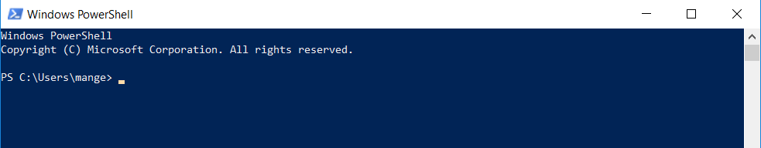

In my case it’s “mange”, specify your own pc name.

1. Run below command

**Set-ExecutionPolicy -Scope CurrentUser**

1. Once pressed enter it will ask for the execution policy hence enter below text:

**RemoteSigned**

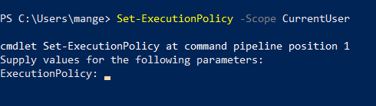

1. After this below screen will appear

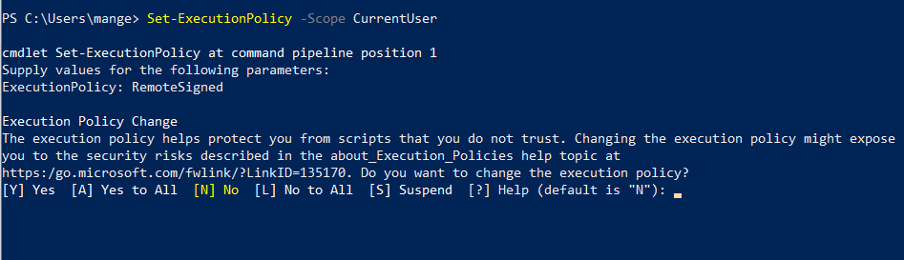

Type **“Yes”**

1. Run below command:

**Get-ExecutionPolicy -List**

1. Now run the below command:

**$script = New-Object Net.WebClient**

1. Run below command:

**$script | Get-Member**

Something like below should appear in the powershell terminal

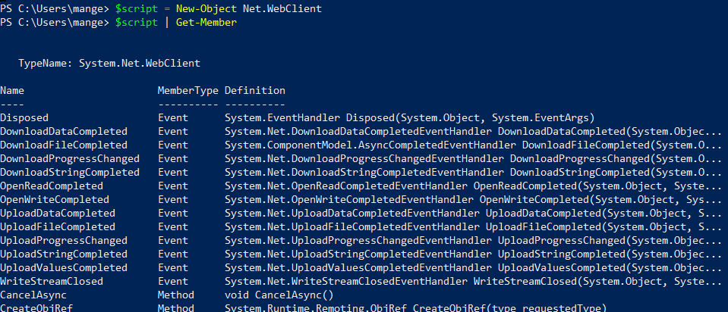

1. Now run the below command:

**$script.DownloadString("**[**https://chocolatey.org/install.ps1**](https://chocolatey.org/install.ps1)**")**

1. Run below command in the powershell terminal:

**iwr https://chocolatey.org/install.ps1 -UseBasicParsing | iex**

Now try typing **choco** it should work.

If choco needs to be upgraded run below command:

**choco upgrade chocolatey**

1. Run below command:

**choco install -y nano**

1. Now install python by using below command:

**choco install -y python3**

Once install you should get below screen:

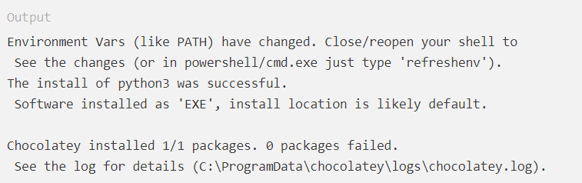

1. Try typing below command:

**Python -V**

It should get below output:

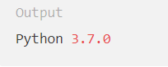

1. Now make sure pip should be upto date, hence run the below command:

**python -m pip install --upgrade pip**

1. Now create a “Environment” folder on the desktop and change directory as shown below:

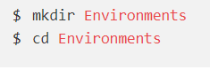

1. Now in the same folder, for creating virtual environment run below command:

**python -m venv new_env**

Where as **new_env** is the **name** of the virtual environment. You can give any name.

Now if run below command the output should list of files available for the virtual environment.

Run: **ls new_env**

Output should be something like below screen:

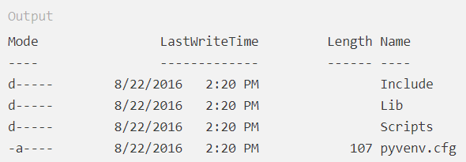

16) To run virtual environment, run below command:

**new_env\Scripts\activate**

**Reference:** <https://www.digitalocean.com/community/tutorials/how-to-install-python-3-and-set-up-a-local-programming-environment-on-windows-10>

17) This should give you below screen:

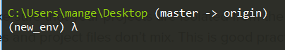

18) Now unzip the folder which has program files.

19) Now in the same terminal navigate to the unzipped folder as shown below:

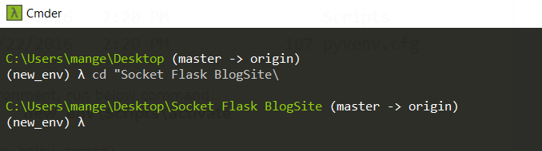

20) check if “requirements.txt” in the same folder.

Now run the below command in the :

**pip install -r requirements.txt**

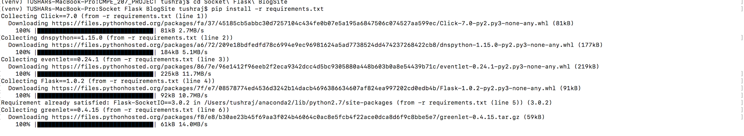

This should install all the required dependencies in th our virtual environment.

Now run the final.py file as follows:

**python final.py**

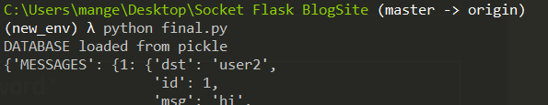

**Now run below url in the browser:**

**127.0.0.1:5000**

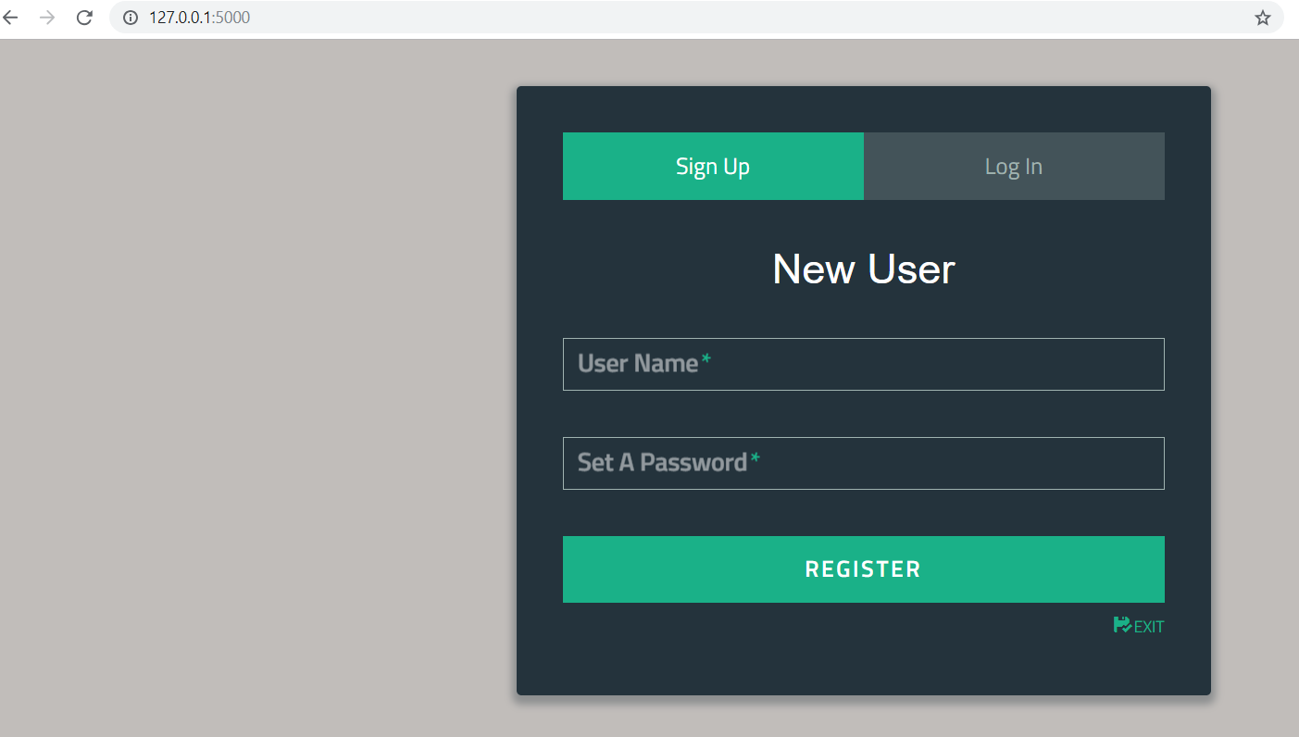

**For every user repeat this url in the separate tab.**

**For mac OS follow below tutorial for creating virtual environment:**

<https://www.digitalocean.com/community/tutorials/how-to-install-python-3-and-set-up-a-local-programming-environment-on-macos>

**For linux follow below tutorial for creating virtual environment:**

[**https://www.digitalocean.com/community/tutorials/how-to-install-python-3-and-set-up-a-local-programming-environment-on-ubuntu-16-04**](https://www.digitalocean.com/community/tutorials/how-to-install-python-3-and-set-up-a-local-programming-environment-on-ubuntu-16-04)

**Sample TEST USERS and their respective Username and Passwords**

1)

username -user1

Password -pass1

2)

username -user2

Password -pass2

3)

username -user3

Password -pass3

Like we have 20 users, for logging in as the particular user user below format:

Username - user**X**

Password - pass**X**

**Where X is the number of the user you are trying to access.**