TOPOLOGICAL SORTING:

Output

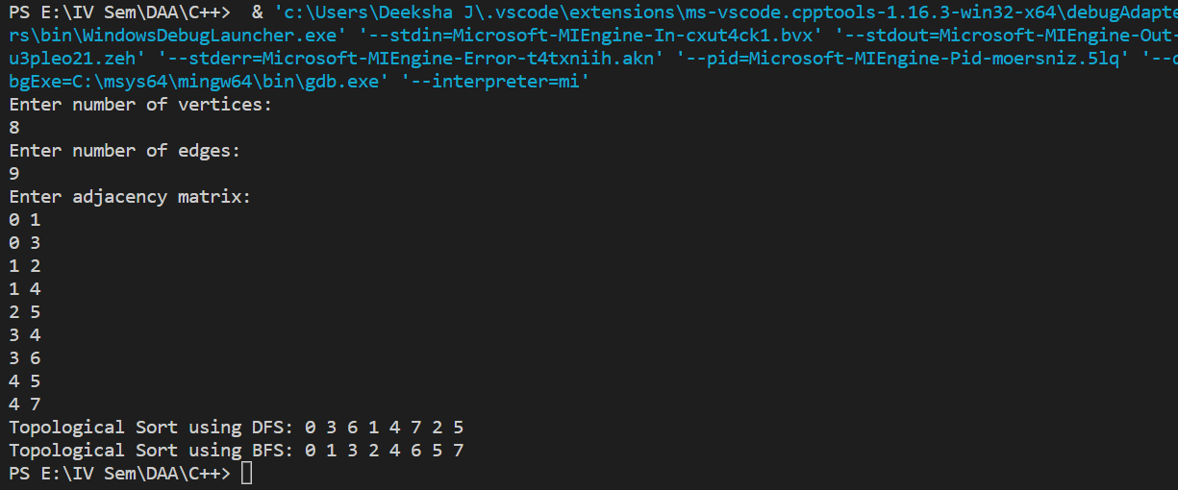

INSERTION SORTING:

Output

