PRIMS ALGORITHM

Output:

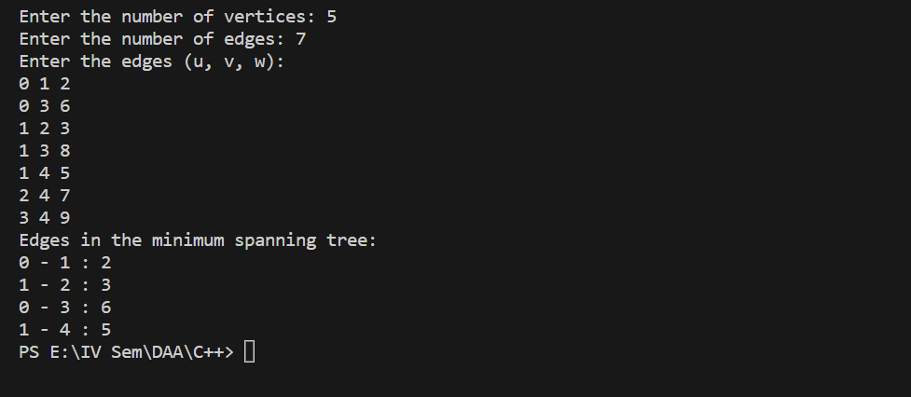

KRUSKALS ALGORITHM

Output:

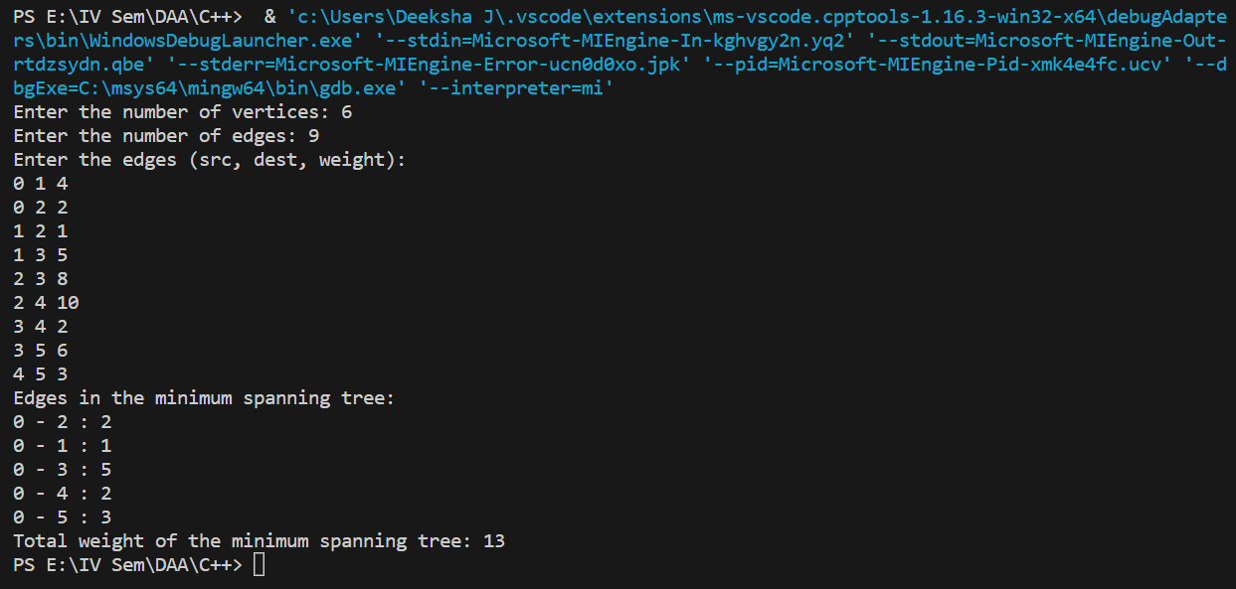

DIJIKSTRAS ALGORIHTM

Output:

