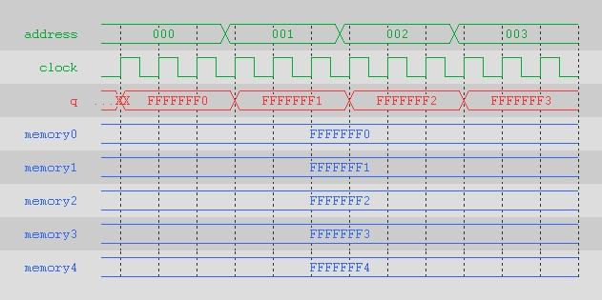

Here, the read operation from the memory is taking place. The program is reading the values that are stored in the memory. There is no output until the first rising edge. Also the read operation happens only at the rising edge of the clock cycle. Eg – at the first memory location FFFFFF0 is stored and so on.

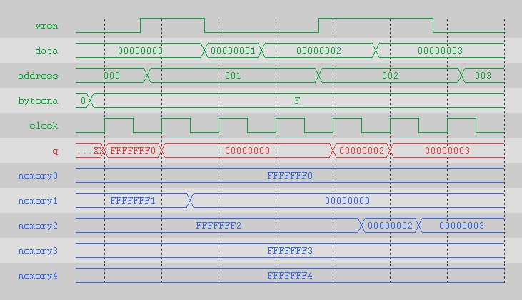

In this waveform, the write operation is taking place. When wren is 0, the write enable option is disabled but when wren is 1, the write enable option is enabled and we can write to the memory. During write enable new data goes into the output. Write enable is set to 1 at the rising edge but the write operation takes place at the falling edge. Also overwrite at memory location 2 takes place. First it writes 00000002 at it and then overwrites it with 00000003.

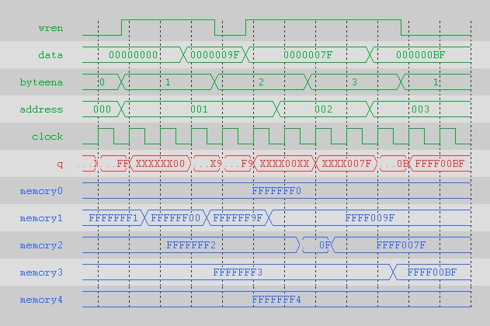

In the above waveform, we have used byteena. With byteena, we can write to specific bytes. So this way we are not writing to all the bytes but only a few of them. In the output only the bytes that are set flow through and rest of the bytes are unknown.