CprE 381, Computer Organization and Assembly-Level Programming, Fall 2012

Lab Report for Lab 2

Lab Partners DEEKSHA JUNEJA
ASIM VERMA

Section /Lab Time FRIDAY 2pm-4pm

Refer to the highlighted language in the lab 1 instruction for the context of the following questions.

Number of points: 10
Bonus points: 4

- [Part 1 (c)] Include a waveform screenshot in your report PDF. (1 point)

Waveform of the testbench of 1’s compliment using structural and dataflow.

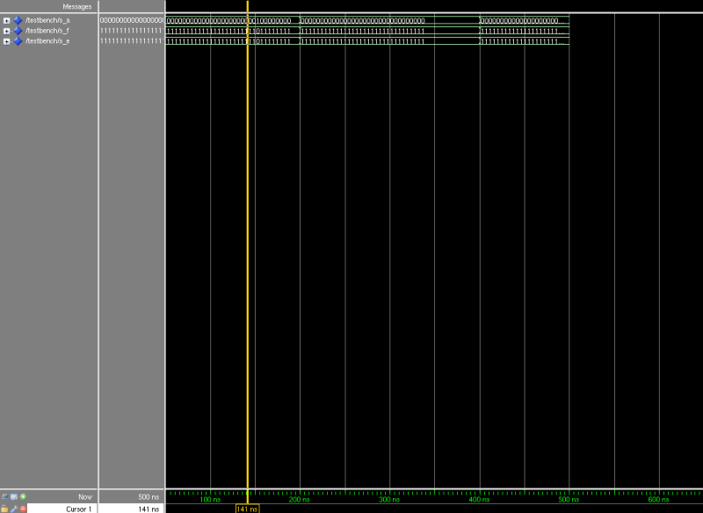

- [Part 2 (a)] Draw the truth table, Boolean equation, and Boolean circuit equivalent (using only two-input gates) that implements a 2:1 mux. Include this in your report PDF. (2 point)

Input 1 | Input 2 | Signal | Output
0 | 0 | 0 | 0
0 | 0 | 1 | 0
0 | 1 | 0 | 0
0 | 1 | 1 | 1
1 | 0 | 0 | 1
1 | 0 | 1 | 0
1 | 1 | 0 | 1
1 | 1 | 1 | 1

Boolean Equation:
Output = (Input1 AND (NOT(Signal)) OR (Input2 AND Signal)

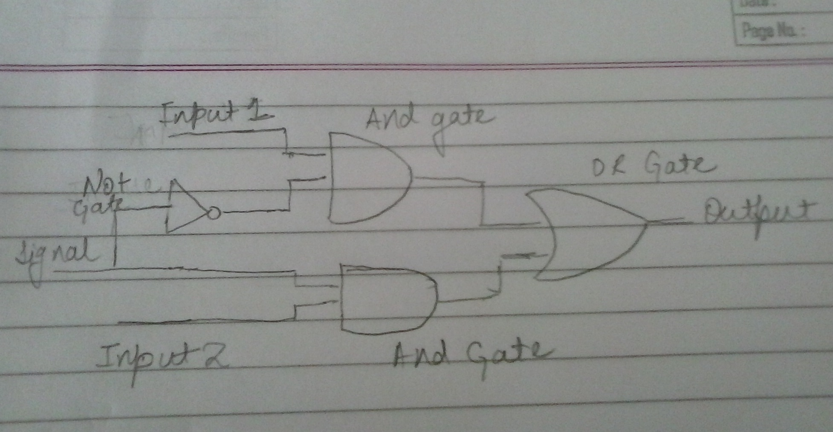

- [Part 2 (e)] Include a waveform screenshot in your write-up. (1 point)
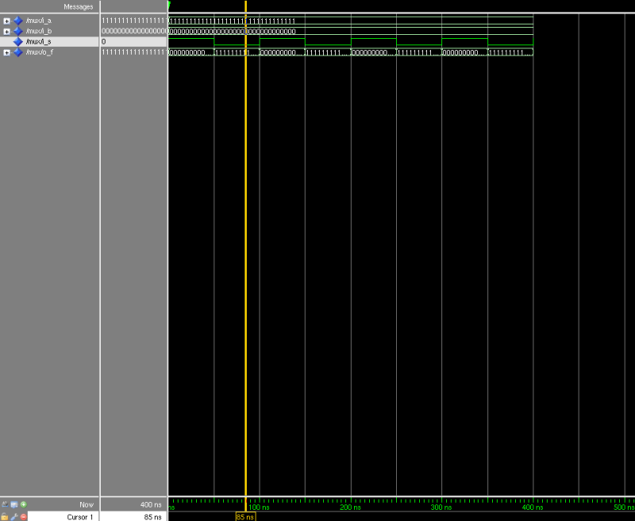

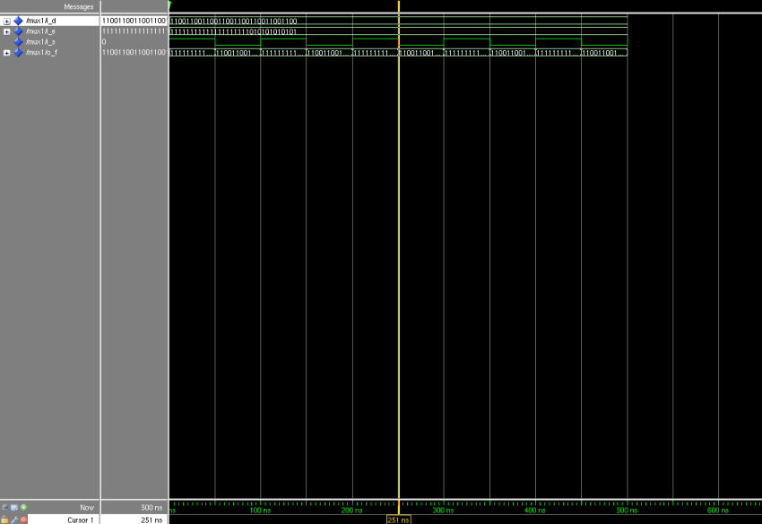

- [Part 2 (f)] Bonus points: use a VHDL process inside the testbench to test the designs (as opposed to forcing values in ModelSim. (2 points)

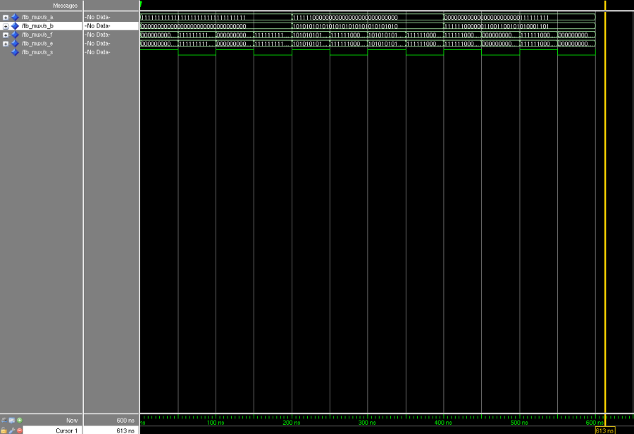

- [Part 3 (a)] Draw the truth table, Boolean equation, and Boolean circuit equivalent (using only two-input gates) that implements a full adder. Include this in your report PDF. (2 points)

Truth Table
Input 1 | Input 2 | Carry In | Sum | Carry Out
0 | 0 | 0 | 0 | 0
0 | 0 | 1 | 1 | 0
0 | 1 | 0 | 1 | 0
0 | 1 | 1 | 0 | 1
1 | 0 | 0 | 1 | 0
1 | 0 | 1 | 0 | 1
1 | 1 | 0 | 0 | 1
1 | 1 | 1 | 1 | 1

Boolean Equation:
Sum = (A XOR B) XOR C
Carry Out = (A AND B) OR (C AND (A XOR B))

Boolean Circuit Equivalent

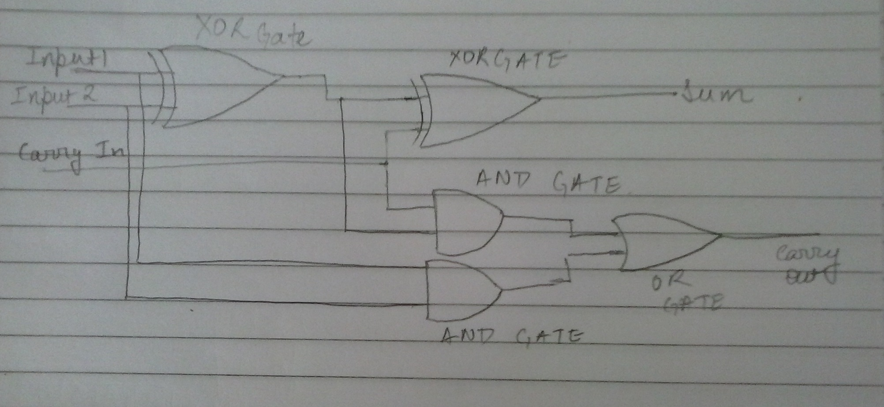

- [Part 3 (e)] Include a waveform screenshot in your write-up. (1 point)

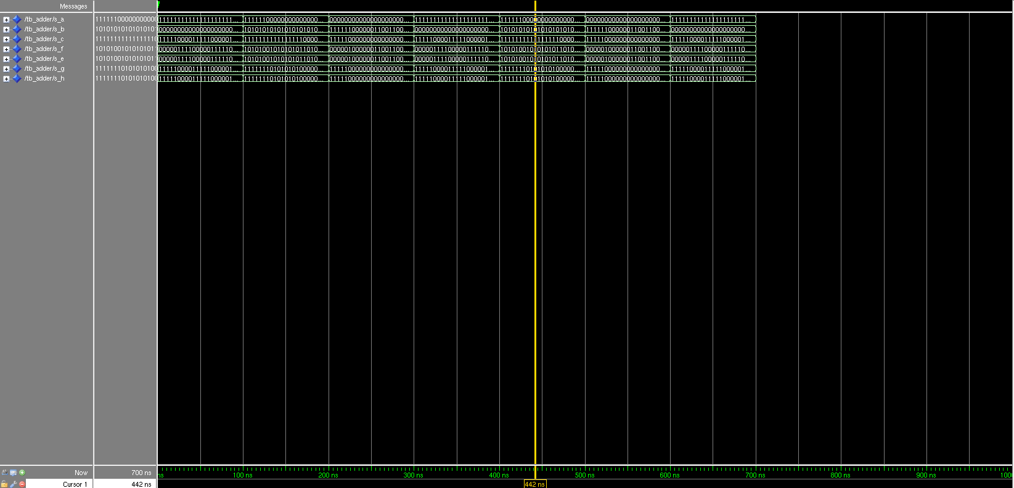

- [Part 3 (e)] Bonus points: use the “report” feature in VHDL to print out a meaningful message when the outputs of both designs are consistent. [2 points]

- [Part 4, (a)] Draw a schematic showing how an N-bit adder/subtractor with control can be implemented using only the three main components designed in problems 1), 2), and 3) (the N-bit inverter, N-bit 2:1 mux, and N-bit adder). How is the ‘nAdd_Sub’ bit used? Include this in your report PDF. [2 points]

- [Part 4, (c)] Provide multiple waveform screenshots in your write-up to confirm that this component is working correctly. What test-cases did you include and why? [1 point]

