CprE 381, Computer Organization and Assembly-Level Programming, Fall 2012

Lab Report for Lab 3

Lab Partners Deeksha Juneja
Asim Verma

Section /Lab Time Friday 2pm to 4pm

Refer to the highlighted language in the lab 3 instruction for the context of the following questions.

Number of points: 10
Bonus points: 4

- [Part (a)] Include a waveform screenshot in your report PDF. (1 point)

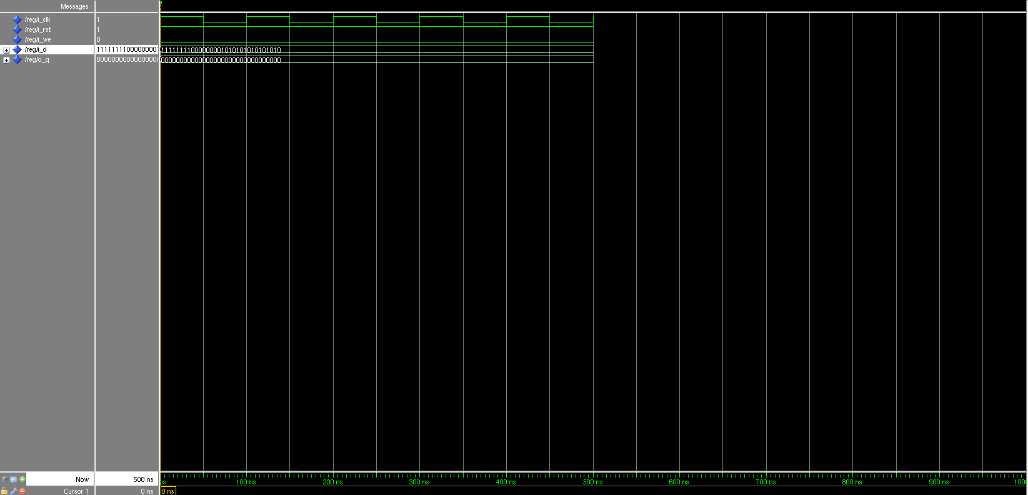
Please note that we renamed the reg to reg32 and it can be found in folder P1.

- [Part (c)] What type of decoder would be required by the MIPS register file and why? (1 point)

A 5:32 decoder is required by the MIPS register file. It takes a 5 bit input and gives a 32bit output.

- [Part (e)] In your write-up, describe and defend the design you intend on implementing for the next part. (4 points)

We used a dataflow design due to:
1. Simplified implementation
2. Deterministic performance – We can focus on functionality rather than performance optimization
3. Flexible use of resources

- [Part (g)] Draw a (simplified) schematic for the MIPS register file, and using only the VHDL components you have created in parts a), d), and f). (4 points)

