**Cpre 530 - Assignment 1**

**Fall 2011**

**Suganya Baskaran**

**Question 1 Do homework problems 1 and 11 in Chapter 3 of the book.**



1. http://www.pnas.org/content/104/27/11150.full

A model of internet topology using k shell decomposition. Good image at http://cscis12.dce.harvard.edu/lecture_notes/2009/20090623/images/500px_internet_map_pnas2007.png

The above topology is the outcome of the research in Boston University. Instead of node degree, “k-shell” decomposition is used to assign a shell index to each node in the Internet. Although node degrees can range from one or two up to several thousands, this procedure splits the network into 40–50 shells only, the precise number depending on the measurement details. This is a limitation. Agent population of the topology comes from over 90 countries. Over all, this is a very general topology but is useful when studying other complex networks.

2. http://cheleby.cse.unr.edu/ This is Cheleby: An Internet Topology Mapping System, Internet Telescope will collect topology information from the Internet using PlanetLab. Goal is Subnet-level Internet Mapping. Good picture at

http://cheleby.cse.unr.edu/images/Internet.jpg

This topology considers the following details into account:

* Alias IP addresses that belong to the same router,
* Star (*) occurrences that stand for the same router,
* IPs that belong to the same subnet are identified.



The DNS root servers are thirteen DNSserver clusters which are responsible for delegating DNS requests to the top level domain (TLD) nameservers.

The DNS Root Servers

A.ROOT-SERVERS.NET.

Operator: Verisign Naming and Directory Services

IP Address: 198.41.0.4

B.ROOT-SERVERS.NET.

Operator: Information Sciences Institute

IP address: 192.228.79.201

C.ROOT-SERVERS.NET.

Operator: Cogent Communications

IP Address: 192.33.4.12

D.ROOT-SERVERS.NET.

Operator: University of Maryland

IP Address: 128.8.10.90

E.ROOT-SERVERS.NET.

Operator: NASA Ames Research Center

IP Address: 192.203.230.10

F.ROOT-SERVERS.NET.

Operator: Internet Systems Consortium, Inc.

IP Address: 192.5.5.241

G.ROOT-SERVERS.NET.

Operator: U.S. DOD Network Information Center

IP Address: 192.112.36.4

H.ROOT-SERVERS.NET.

Operator: Autonomica/NORDUnet

IP Address: 128.63.2.53

I.ROOT-SERVERS.NET.

Operator: Autonomica/NORDUnet

IP Address: 192.36.148.17

J.ROOT-SERVERS.NET.

Operator: VeriSign Naming and Directory Services

IP Address: 192.58.128.30

K.ROOT-SERVERS.NET.

Operator: Reseaux IP Europeens – Network Coordination Centre

IP Address: 193.0.14.129

L.ROOT-SERVERS.NET.

Operator: Internet Corporation for Assigned Names and Numbers

IP Address: 198.32.64.12

M.ROOT-SERVERS.NET.

Operator: WIDE Project

IP Address: 202.12.27.33

The DNS root servers have not been changed between 29 January, 2004 and today — 22

November, 2006

**Question 2 Do lab experiments 1-6 in Chapter 3**



List of websites:

1. [www.google.com](http://www.google.com)
2. [www.facebook.com](http://www.facebook.com)
3. [www.twitter.com](http://www.twitter.com)
4. [www.microsoft.com](http://www.microsoft.com)
5. [www.wikipedia.org](http://www.wikipedia.org)

List of Email servers:

1. [www.gmail.com](http://www.gmail.com)
2. [www.yahoomail.com](http://www.yahoomail.com)
3. [www.rediff.com](http://www.rediff.com)
4. James.apache.org
5. Hotmail.com

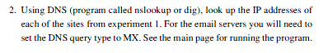

IP addresses of websites:

1. 74.125.225.80/84
2. 63.69.189.16
3. 199.59.149.198
4. 207.46.232.182
5. 208.80.152.2

IP addresses of email servers:

1. 209.85.225.26
2. 68.180.131.16
3. 213.155.153.132
4. 192.87.106.230
5. 65.54.188.110

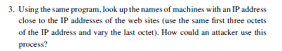

a.The nslookup of google is

74.125.225.84 – www.l.google.com. In this case, the neighboring IP’s obtained by changing the last octet are not found.

b. If we change the last octet of an IP address in some case we get a different instance of the same site. For eg: the IP address for facebook.com is mentioned as 63.69.189.16, if we try 63.69.189.14 another instance opens up.

While using nslookup it returned the following:

63.69.189.16 name = www.11-01-ash2-facebook.com.

63.69.189.14 name = www.register-10-01-ash2.facebook.com.

c. Twitter - 199.59.149.198 – www2.twitter.com

199.59.149.200 - r-199-59-149-200.twttr.com

d. Microsoft - 207.46.232.182 – windowsruby.ae. In this case too, the neighboring IP’s obtained by changing the last octet are not found.

e. Wikipedia - 208.80.152.2 - rr.pmtpa.wikimedia.org

208.80.152.3 - upload.pmtpa.wikimedia.org

Thus in most cases, another server/IP address belonging to that domain is exposed. The attacker can use this process to address spoof a vulnerable user.

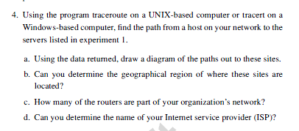

My computer

129.186.182.194

129.186.183.254

129.186.254.131

192.245.179.52

164.113.232.225

64.57.21.253

137.164.130.150

72.14.236.178

209.85.250.30

74.125.225.80

129.186.183.254

129.186.254.131

[192.245.179.52]

4.53.34.13

4.69.135.233

12.122.131.165

4.69.135.230

4.69.151.153

4.69.145.140

4.68.62.34

Trace complete

152.63.97.57

Request timeout 19 times

129.186.254.131

192.245.179.52

164.113.232.225

64.57.21.253

137.164.130.174

129.186.254.131

192.245.179.52

64.57.21.253

164.113.232.225

206.223.119.27

64.125.26.253

64.125.26.141

64.125.26.202

64.125.30.178

199.59.149.198

209.66.115.6

199.16.159.51

129.186.183.254

207.46.35.146

Destination unreachable

4.53.34.13

4.69.135.233

4.69.135.230

4.69.151.153

Trace complete

Trace complete

207.46.35.134

207.46.46.11

207.46.47.70

207.46.43.163

207.46.40.94

207.46.40.217

Request timeout 11 times

129.186.183.254

129.186.254.131

192.245.179.52

4.71.0.14

4.69.133.62

4.69.133.41

4.69.137.117

4.69.151.150

208.80.152.222

208.80.152.222

84.40.25.102

84.40.24.50

Trace complete

B: No geographical region of where these sites are located cannot be determined.

C: Three of them are part of iastate’s network. Their IP addresses are 129.186.183.254, 129.186.254.131 and 192.245.179.52

D: The name of Internet Service Provider cannot be determined.

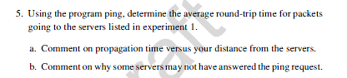

Average round trip time for:

IP addresses of websites:

1. [www.google.com](http://www.google.com) – 15ms
2. [www.facebook.com](http://www.facebook.com) – 39ms
3. [www.twitter.com](http://www.twitter.com) – 61ms
4. [www.microsoft.com](http://www.microsoft.com) – 63ms
5. [www.wikipedia.org](http://www.wikipedia.org) – 55ms

IP addresses of email servers:

1. [www.gmail.com](http://www.gmail.com) – 15ms
2. [www.yahoomail.com](http://www.yahoomail.com) – 40ms
3. [www.rediff.com](http://www.rediff.com) – 1ms
4. James.apache.org – 51ms
5. Hotmail.com – 49ms

Propagation time: The propagation time is directly proportional to the geographical distance of the server.

Ping request time out: The reason for the time out could be because there is no reply from the host, or the packet is lost on its way back.

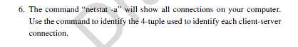

“netstat –a” returns Protocol, Local Address, Foreign Address and State

Below is the list of those connections:

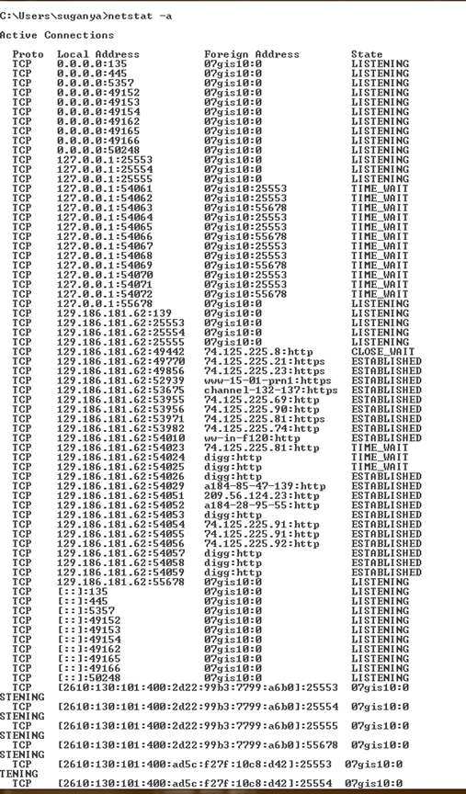

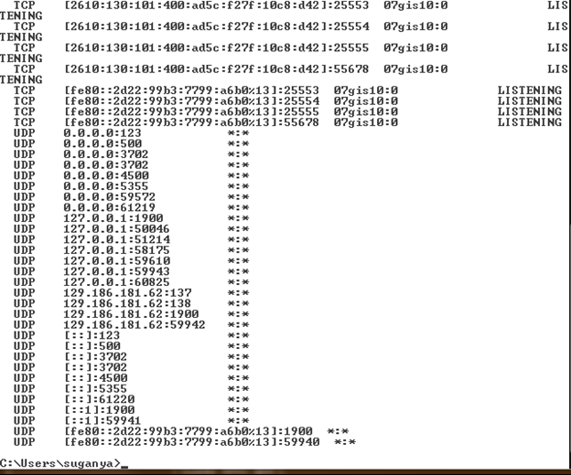

**Reference:**

1. <http://www.tech-faq.com/dns-root-servers.html>
2. <http://www.exclamationsoft.com/exclamationsoft/netmailbot/help/reference/find_mail_server.asp>