**Cpre 530 - Assignment 2**

**Fall 2011**

**Suganya Baskaran**

**1. Do Homework problems 5,6,9 from Chapter 6 in book.**

**Problem 5: The route tables for all the devices are as follows**

H1

|  |  |  |
| --- | --- | --- |
| Destination | Next hop | Interface |
| 129.186.5.0/24 | 129.186.5.30 | Eth0 |
| 127.0.0.1 | 127.0.0.1 | Loopback |
| Default | 129.186.5.254 | En0 |

H2

|  |  |  |
| --- | --- | --- |
| Destination | Next hop | Interface |
| 129.186.100.0/24 | 129.186.100.40 | Eth0 |
| 127.0.0.1 | 127.0.0.1 | Loopback |
| Default | 129.186.100.252 | En0 |
| 129.186.5.0/24 | 129.186.100.254 | En1 |

H3

|  |  |  |
| --- | --- | --- |
| Destination | Next hop | Interface |
| 129.186.4.0/24 | 129.186.4.133 | Eth0 |
| 127.0.0.1 | 127.0.0.1 | Loopback |
| Default | 129.186.4.254 | En1 |

R1

|  |  |  |
| --- | --- | --- |
| Destination | Next hop | Interface |
| 129.186.5.0/24 | 129.186.5.254 | En0 |
| 129.186.100.0/24 | 129.186.100.254 | En1 |
| 127.0.0.1  Default | 127.0.0.1  129.186.100.252 | Loopback  En0 |

R2

|  |  |  |
| --- | --- | --- |
| Destination | Next hop | Interface |
| 129.186.100.0/24 | 129.186.100.252 | En0 |
| Default | 10.0.0.5 | En1 |
| 127.0.0.1 | 127.0.0.1 | Loopback |
|  |  |  |

R3

|  |  |  |
| --- | --- | --- |
| Destination | Next hop | Interface |
| 129.186.5.0/24 | 129.186.100.254 | En1 |
| 129.186.100.0 | 129.186.100.253 | En0 |
| Default | 129.186.100.252 | En0 |
| 127.0.0.1  129.186.4.0 | 127.0.0.1  129.186.4.254 | Loopback  En1 |

**Problem 6: The fragment for the network segment between the two routers is as follows:**

|  |  |  |  |  |
| --- | --- | --- | --- | --- |
| **Layer** | **Filed name** | **Original** | **Fragment 1** | **Fragment 2** |
|  | Destination | N/A | 00:88:88:38:12:EC | 00:88:88:38:12:EC |
| Ethernet | Source | N/A | 00:86:40:34:45:00 | 00:86:40:34:45:00 |
|  | Type/field | N/A | N/A | N/A |
|  | Ver/HL | 4/5 | 4/5 | 4/5 |
|  | Type  Len  Id | 0  2740  3486 | 0  1536  3486 | 0  1244  3486 |
| IP | Flags  Offset  Protocol  TTL  Checksum  Source Ip  Destination Ip | 000  0  17  Computed  Computed  129.186.5.4  68.10.7.4 | 001  0  17  Computed  Computed  129.186.5.4  68.10.7.4 | 000  187  17  Computed  Computed  129.186.5.4  68.10.7.4 |
| Data |  | 2700 | 1496 | 1204 |

**Problem 9:**

**9a. How many entries would be there in H1’s ARP table due to the messages?**

**Two**

H1 →H5 → Arp for H5

H1 →H2 → Arp for R2

H1→ H3,H4,Int,Ibm.com → Arp for R2.

There are two ARP entries one for H5 and other for R2.

**9b. Assume all caches are cleared before H3 sends a single ping request to H1**

**9c. How many packets are transmitted on the network segment NET 1 (including ping and reply)?**

**Six**

2 ARP (to and from H1)

2 ICMPS (to and from H1)

1 ping + 1 reply (to and from H1)

**9d. How many packets are transmitted on the network segment NET 3(including ping and reply)?**

**Six (same as above)**

**9e. How many packets are transmitted on the network segment NET 2 (including ping and reply)?**

**Six (same as above)**

**9.f Same questions for hosts H6 and H7**

For H6:

1. Four → ARP for R2, ARP for H2, ARP for R3, ARP for R1.

c) Zero

d) Six →2 ARP, 2 ICMPS, 1 ping and 1 reply

Since Arp cache is lost, H3 does not know about H6

e) Four → 2 ICMPS, 1 ping and 1 reply on N3

H3 knows about R3)

For H7:

1. Two → ARP for H3, ARP for R3

c) Zero

d) Zero

e) Six →2 ARP, 2 ICMPS, 1 ping and 1 reply

**2. Do lab experiments 1-8 from Chapter 6 in the book.**

**Problem 1:**

Network address →129.186.251.0

Netmask → 255.255.255.0

**Problem 2: IP address of following machines**

**2a.** [www.nasa.gov](http://www.nasa.gov)

Addresses: 209.56.124.24, 209.56.124.25

Aliases: www.nasa.gov, [www.nasa.gov.speedera.net](http://www.nasa.gov.speedera.net)

www.nasa.gov.edgesuite.net

**2b**. www.iac.iastate.edu

Name: iac.ece.iastate.edu

Address: 129.186.105.22

Aliases: www.iac.iastate.edu

**2c.** www.cnn.com

Name: www.cnn.com

Addresses: 157.166.226.25, 157.166.226.2, 157.166.224.25, 157.166.224.26

**2d.** www.iseage.org

Name: www.iseage.org

Address: 129.186.105.37

**2e.** www.iastate.edu

Address: 129.186.140.50

Aliases: www.iastate.edu

**2f.** Spock.ee.iastate.edu

Name: Spock.ee.iastate.edu

Address: 129.186.215.40

**Problem 3: Ping to find average delay for above machines**

[www.nasa.gov](http://www.nasa.gov) → Time – 1ms ; TTL -59

[www.iac.iastate.edu](http://www.iac.iastate.edu) → Time < 1ms ; TTL -62

[www.cnn.com](http://www.cnn.com) → Request Timed out

[www.iseage.org](http://www.iseage.org) → Time < 1ms ; TTL -62

[www.iastate.edu](http://www.iastate.edu) → Time < 1ms ; TTL -62

Spock.ee.iastate.edu → Time – 1ms; TTL -61

**Problem 4: Dump the route table for the machine used**

**Netstat – r –n**

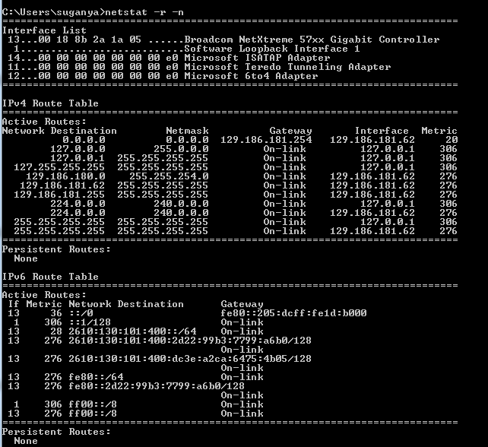

**Problem 5: Ethernet address of Gateway**

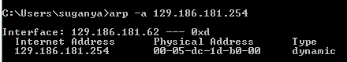

**Problem 6: nslookup for IP addresses of mail servers in Problem 2**

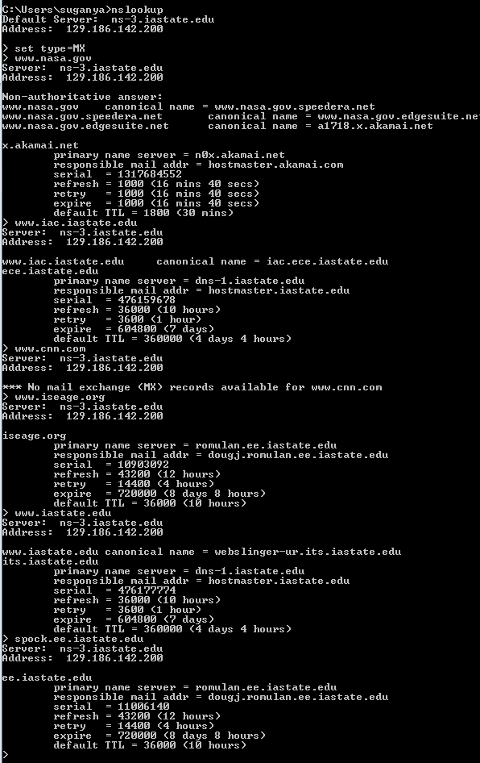

**Problem 7: Use nslookup to find the machine name of several IP addresses.**

Address: 129.186.179.254

Name: router-129-186-176-0.iastate.edu

Address: 129.186.177.160

Name: pub402.lib.iastate.edu

**Problem 8: Use traceroute to determine addresses of first five routers between test lab and** [**www.cnn.com**](http://www.cnn.com)**.**

traceroute to www.cnn.com (157.166.226.25), 64 hops max, 52 byte packets

1 r62 (129.186.215.62) 0.830 ms 0.851 ms 0.791 ms

2 router-129-186-105-0.iastate.edu (129.186.105.254) 1.488 ms 0.541 ms 0.526 ms

3 b31gb1-vlan254.tele.iastate.edu (129.186.254.131) 0.612 ms 0.547 ms 0.527 ms

4 b31gb2-438.tele.iastate.edu (192.245.179.52) 0.528 ms 0.637 ms 0.615 ms

5 te-1-3-212.car2.KansasCity1.Level3.net (4.53.34.13) 4.907 ms 4.894 ms 4.820 ms

|  |  |  |
| --- | --- | --- |
| **Packet Size** | **Machine Address** | **Average delay** |
| Size =50  No. of packets=5 | 129.186.215.62  129.186.105.254  129.186.254.131  192.245.179.52  4.53.34.13 | 0.771 ms  0.853 ms  0.774 ms  2.320 ms  5.102 ms |
| Size = 100  No. of packets = 5 | 129.186.215.62  129.186.105.254  129.186.254.131  192.245.179.52  4.53.34.13 | 0.821 ms  0.906 ms  0.649 ms  0.776 ms  79.234 ms |

**Reference:**

1. [Network](http://www.tech-faq.com/dns-root-servers.html) Security – Dr.Douglas W.Jacobson
2. <http://www.mediacollege.com/internet/troubleshooter/traceroute.html>