**ASSIGNMENT 2**

1. **Do Homework problems 5, 6 and 9 from Chapter 6 in book.**

**5: The route tables for all the devices are as follows**

**H1**

|  |  |  |
| --- | --- | --- |
| **DESTINATION** | **NEXT HOP** | **INTERFACE** |
| 129.186.5.0/24 | 129.186.5.30 | Eth0 |
| 127.0.0.1 | 127.0.0.1 |  |
| Default | 129.186.5.254 | En0 Loopback |

**H2**

|  |  |  |
| --- | --- | --- |
| **DESTINATION** | **NEXT HOP** | **INTERFACE** |
| 129.186.100.0/24 | 129.186.100.40 | Eth0 |
| 127.0.0.1 | 127.0.0.1 | Loopback |
| Default | 129.186.100.252 | En0 |
| 129.186.5.0/24 | 129.186.100.254 | En1 |

**H3**

|  |  |  |
| --- | --- | --- |
| **DESTINATION** | **NEXT HOP** | **INTERFACE** |
| 129.186.4.0/24 | 129.186.4.133 | Eth0 |
| 127.0.0.1 | 127.0.0.1 | Loopback |
| Default | 129.186.4.254 | En1 |

**R1**

|  |  |  |
| --- | --- | --- |
| **DESTINATION** | **NEXT HOP** | **INTERFACE** |
| 129.186.5.0/24 | 129.186.5.254 | En0 |
| 129.186.100.0/24 | 129.186.100.254 | En1 |
| 127.0.0.1  Default | 127.0.0.1  129.186.100.252 | Loopback  En0 |

**R2**

|  |  |  |
| --- | --- | --- |
| **DESTINATION** | **NEXT HOP** | **INTERFACE** |
| 129.186.100.0/24 | 129.186.100.252 | En0 |
| Default | 10.0.0.5 | En1 |
| 127.0.0.1 | 127.0.0.1 | Loopback |
|  |  |  |

**R3**

|  |  |  |
| --- | --- | --- |
| **DESTINATION** | **NEXT HOP** | **INTERFACE** |
| 129.186.5.0/24 | 129.186.100.254 | En1 |
| 129.186.100.0 | 129.186.100.253 | En0 |
| Default | 129.186.100.252 | En0 |
| 127.0.0.1  129.186.4.0 | 127.0.0.1  129.186.4.254 | Loopback  En1 |

**6: The fragment for the network segment between the two routers is as follows:**

|  |  |  |  |  |
| --- | --- | --- | --- | --- |
| **LAYER** | **FILED NAME** | **ORIGINAL** | **FRAGMENT 1** | **FRAGMENT 2** |
|  | Destination | N/A | 00:88:88:38:12:EC | 00:88:88:38:12:EC |
| Ethernet | Source | N/A | 00:86:40:34:45:00 | 00:86:40:34:45:00 |
|  | Type/field | N/A | N/A | N/A |
|  | Ver/HL | 4/5 | 4/5 | 4/5 |
|  | Type  Len  Id | 0  2740  3486 | 0  1536  3486 | 0  1244  3486 |
| IP | Flags  Offset  Protocol  TTL  Checksum  Source Ip  Destination Ip | 000  0  17  Computed  Computed  129.186.5.4  68.10.7.4 | 001  0  17  Computed  Computed  129.186.5.4  68.10.7.4 | 000  187  17  Computed  Computed  129.186.5.4  68.10.7.4 |
| Data |  | 2700 | 1496 | 1204 |

**9a. Assume H1 sent a message to H2, H3, H4, H5and a machine on the internet (ibm.com). How many entries would be there in H1’s ARP table due to the messages?**

**Solution:**

**2**

There are two ARP entries one for H5 and other for R2.

**9b. For the nest three parts assume all caches are cleared before H3 sends a single ping request to H1 ( the command = ping H1).**

**9c. How many packets are transmitted on the network segment NET 1 (including the ping request and reply)?**

**Solution:**

6

**9d. How many packets are transmitted on the network segment NET 3 (including the ping request and reply)?**

**Solution:**

6

**9e. How many packets are transmitted on the network segment NET 2 (including the ping request and reply)?**

**Solution:**

6

**9.f Answer the same questions for hosts H6 and H7, again assuming caches are all clear before starting.**

**Solution:**

**H6:**

1. 4
2. 0
3. 6
4. 4

**H7:**

1. 2
2. 0
3. 0
4. 6
5. **Do lab experiments 1-8 from chapter 6 in the book.**
6. **Determine the network address for the test laboratory and the netmask value.**

**Solution:**

**Network address**: 129.186.251.0

**Netmask**: 255.255.255.0

1. **Use the test lab and nslookup to find the ip address of each of the following machines.**

a. www.nasa.gov: 63.151.118.105,

b. www.iac.iastate.edu: 129.186.105.22

c. www.cnn.com: 157.166.226.25

d. www.iseage.org: 129.186.105.37

e. www.iastate.edu: 129.186.140.50

f. Spock.ee.iastate.edu: 129.186.215.40

1. **Use command ping to find the average time delay.**

**C:\Users\harish>ping www.nasa.gov**

Pinging a1718.dscg.akamai.net [63.151.118.105] with 32 bytes of data:

Reply from 63.151.118.105: bytes=32 time=76ms TTL=52

Reply from 63.151.118.105: bytes=32 time=77ms TTL=52

Reply from 63.151.118.105: bytes=32 time=75ms TTL=52

Reply from 63.151.118.105: bytes=32 time=70ms TTL=52

Ping statistics for 63.151.118.105:

Packets: Sent = 4, Received = 4, Lost = 0 (0% loss),

Approximate round trip times in milli-seconds:

**Minimum = 70ms, Maximum = 77ms, Average = 74ms**

**C:\Users\harish>ping www.iac.iastate.edu**

Pinging iac.ece.iastate.edu [129.186.105.22] with 32 bytes of data:

Request timed out.

Request timed out.

Request timed out.

Request timed out.

Ping statistics for 129.186.105.22:

Packets: Sent = 4, Received = 0, Lost = 4 (100% loss),

**C:\Users\harish>ping www.cnn.com**

Pinging ouzo-cnn-671716670.us-west-2.elb.amazonaws.com [50.112.248.126] with 32

bytes of data:

Request timed out.

Request timed out.

Request timed out.

Request timed out.

Ping statistics for 50.112.248.126:

Packets: Sent = 4, Received = 0, Lost = 4 (100% loss),

**C:\Users\harish>ping www.iseage.org**

Pinging www.iseage.org [129.186.105.37] with 32 bytes of data:

Request timed out.

Request timed out.

Request timed out.

Request timed out.

Ping statistics for 129.186.105.37:

Packets: Sent = 4, Received = 0, Lost = 4 (100% loss),

**C:\Users\harish>ping www.iastate.edu**

Pinging www.iastate.edu [129.186.23.166] with 32 bytes of data:

Reply from 129.186.23.166: bytes=32 time=14ms TTL=248

Reply from 129.186.23.166: bytes=32 time=16ms TTL=248

Reply from 129.186.23.166: bytes=32 time=28ms TTL=248

Reply from 129.186.23.166: bytes=32 time=17ms TTL=248

Ping statistics for 129.186.23.166:

Packets: Sent = 4, Received = 4, Lost = 0 (0% loss),

Approximate round trip times in milli-seconds:

**Minimum = 14ms, Maximum = 28ms, Average = 18ms**

**C:\Users\harish>ping spock.ee.iastate.edu**

Pinging spock.ee.iastate.edu [129.186.215.40] with 32 bytes of data:

Reply from 129.186.215.40: bytes=32 time=15ms TTL=56

Reply from 129.186.215.40: bytes=32 time=15ms TTL=56

Reply from 129.186.215.40: bytes=32 time=15ms TTL=56

Reply from 129.186.215.40: bytes=32 time=17ms TTL=56

Ping statistics for 129.186.215.40:

Packets: Sent = 4, Received = 4, Lost = 0 (0% loss),

Approximate round trip times in milli-seconds:

**Minimum = 15ms, Maximum = 17ms, Average = 15ms**

1. **Dump the route table for machine used in step 3.**

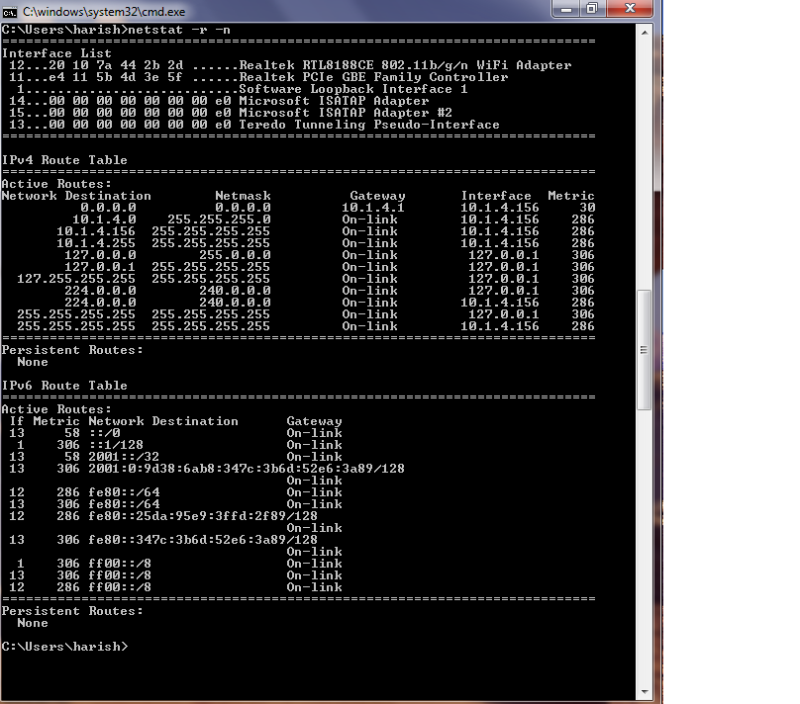

1. **Use the command arp –a to determine Ethernet address of the host.**

**C:\Users\harish>arp -a**

Interface: 10.1.4.156 --- 0xc

Internet Address Physical Address Type

10.1.4.1 00-50-da-08-6f-fd dynamic

10.1.4.33 00-26-5e-55-4b-1f dynamic

10.1.4.78 28-cf-da-e0-5d-8c dynamic

10.1.4.95 74-e5-43-39-5f-15 dynamic

10.1.4.98 e0-06-e6-5e-5a-95 dynamic

10.1.4.120 70-f1-a1-fc-27-42 dynamic

10.1.4.140 30-46-9a-1f-a7-36 dynamic

10.1.4.142 68-a3-c4-11-0f-27 dynamic

10.1.4.162 88-9f-fa-80-3c-65 dynamic

10.1.4.177 1c-65-9d-8e-a6-69 dynamic

10.1.4.207 24-be-05-3e-64-f2 dynamic

10.1.4.210 00-16-ea-55-79-6c dynamic

10.1.4.255 ff-ff-ff-ff-ff-ff static

224.0.0.22 01-00-5e-00-00-16 static

224.0.0.251 01-00-5e-00-00-fb static

224.0.0.252 01-00-5e-00-00-fc static

224.0.0.253 01-00-5e-00-00-fd static

239.255.255.250 01-00-5e-7f-ff-fa static

255.255.255.255 ff-ff-ff-ff-ff-ff static

1. **Use nslookup to find ip address of mail servers stated above in experiment 2.**

**C:\Users\harish>nslookup**

Default Server: 420-428swalnut.rentiowatech.com

Address: 10.1.4.1

**> set type=MX**

**> www.nasa.gov**

Server: 420-428swalnut.rentiowatech.com

Address: 10.1.4.1

Non-authoritative answer:

www.nasa.gov canonical name = www.nasa.gov.speedera.net

www.nasa.gov.speedera.net canonical name = www.nasa.gov.edgesuite.net

www.nasa.gov.edgesuite.net canonical name = a1718.dscg.akamai.net

dscg.akamai.net

primary name server = n0dscg.akamai.net

responsible mail addr = hostmaster.akamai.com

serial = 1349332906

refresh = 1000 (16 mins 40 secs)

retry = 1000 (16 mins 40 secs)

expire = 1000 (16 mins 40 secs)

default TTL = 1800 (30 mins)

**> www.iac.iastate.edu**

Server: 420-428swalnut.rentiowatech.com

Address: 10.1.4.1

Non-authoritative answer:

www.iac.iastate.edu canonical name = iac.ece.iastate.edu

ece.iastate.edu

primary name server = dns-1.iastate.edu

responsible mail addr = hostmaster.iastate.edu

serial = 476340848

refresh = 36000 (10 hours)

retry = 3600 (1 hour)

expire = 604800 (7 days)

default TTL = 360000 (4 days 4 hours)

**> www.cnn.com**

Server: 420-428swalnut.rentiowatech.com

Address: 10.1.4.1

Non-authoritative answer:

www.cnn.com canonical name = www.cnn.com.vgtf.net

www.cnn.com.vgtf.net canonical name = cnn-atl.gslb.vgtf.net

gslb.vgtf.net

primary name server = pdns1.ultradns.net

responsible mail addr = Mark\.Reed.turner.com

serial = 2012100322

refresh = 10800 (3 hours)

retry = 3600 (1 hour)

expire = 2592000 (30 days)

default TTL = 86400 (1 day)

**> www.iseage.org**

Server: 420-428swalnut.rentiowatech.com

Address: 10.1.4.1

iseage.org

primary name server = romulan.ee.iastate.edu

responsible mail addr = dougj.romulan.ee.iastate.edu

serial = 10903093

refresh = 43200 (12 hours)

retry = 14400 (4 hours)

expire = 720000 (8 days 8 hours)

default TTL = 36000 (10 hours)

**> www.iastate.edu**

Server: 420-428swalnut.rentiowatech.com

Address: 10.1.4.1

iastate.edu

primary name server = dns-1.iastate.edu

responsible mail addr = hostmaster.iastate.edu

serial = 476130574

refresh = 3600 (1 hour)

retry = 900 (15 mins)

expire = 604800 (7 days)

default TTL = 360000 (4 days 4 hours)

**> spock.ee.iastate.edu**

Server: 420-428swalnut.rentiowatech.com

Address: 10.1.4.1

ee.iastate.edu

primary name server = romulan.ee.iastate.edu

responsible mail addr = dougj.romulan.ee.iastate.edu

serial = 11006140

refresh = 43200 (12 hours)

retry = 14400 (4 hours)

expire = 720000 (8 days 8 hours)

default TTL = 36000 (10 hours)

1. **Use traceroute to www.cnn.com**

C:\Users\harish>tracert www.cnn.com

Tracing route to cnn-atl.gslb.vgtf.net [157.166.226.25]

over a maximum of 30 hops:

1 4 ms 5 ms 4 ms 420-428swalnut.rentiowatech.com [10.1.4.1]

2 * * * Request timed out.

3 20 ms 21 ms 16 ms 172.30.6.21

4 21 ms 14 ms 14 ms 172.30.1.149

5 12 ms 17 ms 21 ms 12.249.52.13

6 22 ms 22 ms 23 ms cr81.desia.ip.att.net [12.122.153.50]

7 31 ms 34 ms 31 ms cr2.cgcil.ip.att.net [12.122.153.41]