**Instruction Manual for creating a Paper Airplane**

**Disclaimer**

The instructions below present one approach of creating a paper airplane. Even though there are many methods to make a paper airplane, only one method will be explained in these instructions. Any injuries that occur as a result of following the outlined instructions is not the responsibility of the instruction manual writers.

**Safety Warning**

* Reckless handling of the paper around its edges may result in paper cuts.
* These instructions are written with the ability of students in middle school and high school in mind.

**Introduction**

**Overview**

A paper airplane is one of the simplest forms of flying objects that can be made. Making a paper-airplane involves taking a piece of paper and progressively folding it until the desired structure is achieved. Paper airplanes are typically made by younger age groups in a classroom setting as a source of entertainment. Students may find themselves in competitive paper airplane constructing situations during down time in the classroom. These instructions will help teach students how to make a functional paper airplane tailored for classroom use and launch it in a step by step manner. Each step of the paper airplane instructions includes some sort of folding and creasing of the newly formed edges. While following these instructions, it is important to make folds that line up correctly and are sustained. This can be achieved by consistently pinching and creasing the paper folds with one’s finger nail, which will be outlined more specifically later on.

**Steps**

Making a paper airplane of this design involves the following six major steps:

1. Making the initial fold
2. Folding in the corners
3. Double-folding in the corners
4. Folding the wings out
5. Rolling the wings
6. Launching the airplane

**Discussion**

**Materials Required**

* One piece of 8.5” x 11” computer paper
* One pen or pencil (or other similarly sized writing utensil)

**Step 1: Making the Initial Fold**

The purpose of the first fold is to set a guideline for all the following future folds. All the subsequent folds are made with reference to the initial fold. Thus, it is important to keep the initial fold neat and straight. The first step provides the overall basis for forming the rest of the paper airplane.

**Directions:**

Making the initial fold involves folding the paper in a single direction and creasing it. To start off, take the sheet of paper and fold it in half evenly lengthwise, making sure that the opposite edges line up. Push down on the folded crease against a flat surface with your nail and drag your nail across the length of the fold to make it permanent. Repeat this motion until the fold is well compressed. It is important to make folds precisely, or you could risk hurting the construction of the paper airplane later on.

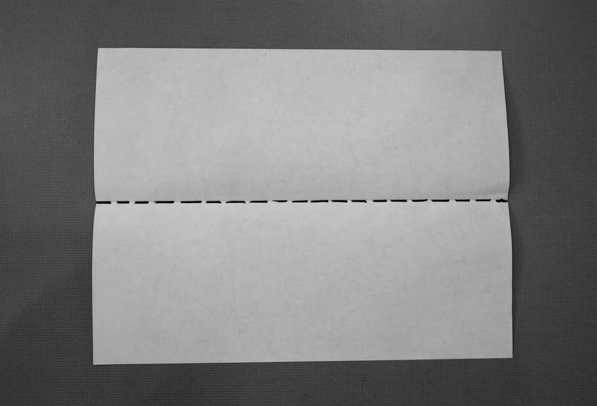

Captured by Yiru Gao, English 314 student

**Step 2: Folding in the Corners**

With the completion of this step, the paper-airplane starts to take shape. If one looks at any real airplane, it is evident that the front end, or tip, is narrower than the rear. To accomplish that result in a paper-airplane and make it truly look like a real airplane, we fold the top .

Open the paper up along the fold made in step one. Then, bring the indicated corner down to line up with the center fold, and fold it in along the dotted line as shown. Repeat this step for the other side.

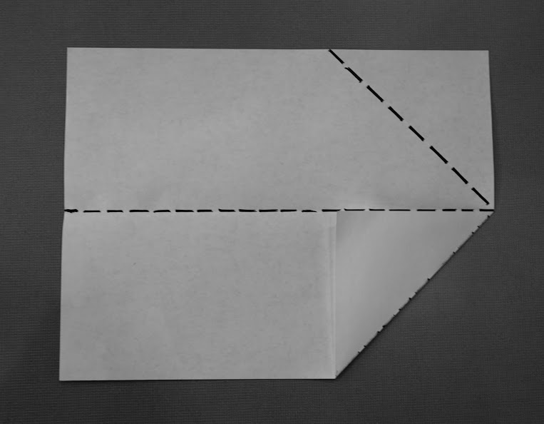

Captured by Yiru Gao, English 314 student

**\*Note (not necessarily just for this step)** - When making folds near the tip of the airplane, it is important to first prime the creases/folds you make with the tip of your fingernail so that they come out straight and in the correct location and orientation.

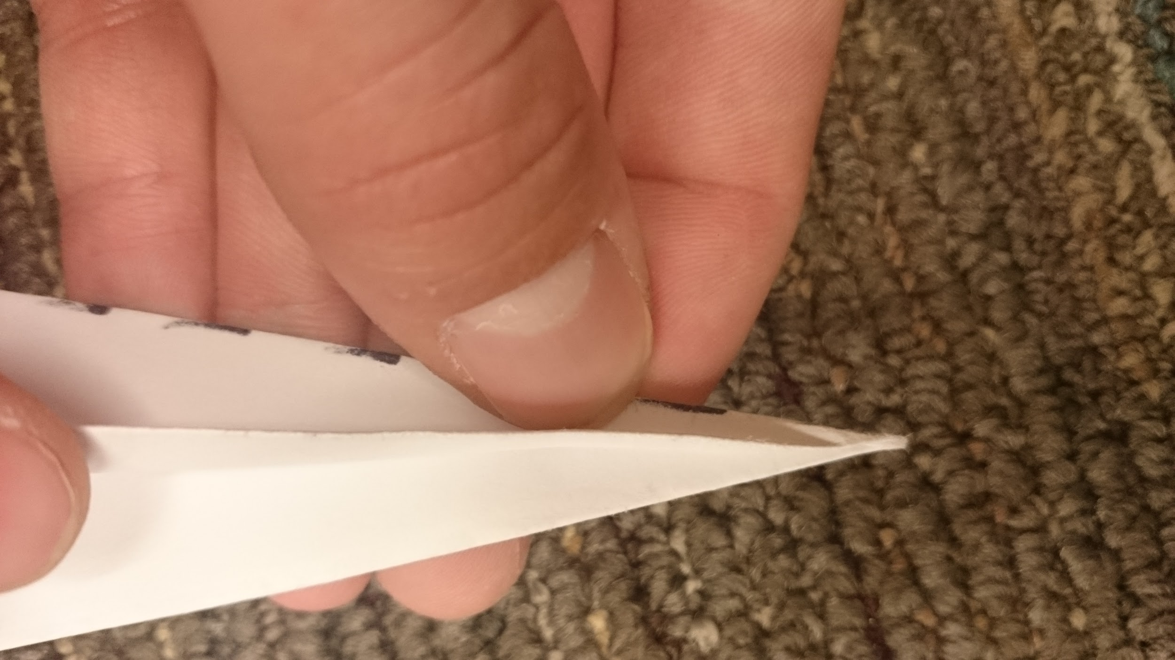

Captured by Colin Jernberg, English 314 student

**Step 3: Tapering the Tip**

Similar to step 2, this step further tapers the front of the airplane. Tapering the tip helps the airplane fly by increasing the lift and decreasing the drag. This step is important for launching the airplane and keeping it afloat in the air.

With the top corners folded down and in (from Step 2), take the newly formed corners at the top and fold them down and in once again in a similar fashion to Step 2. Fold and crease along the dotted line as shown in the image below.

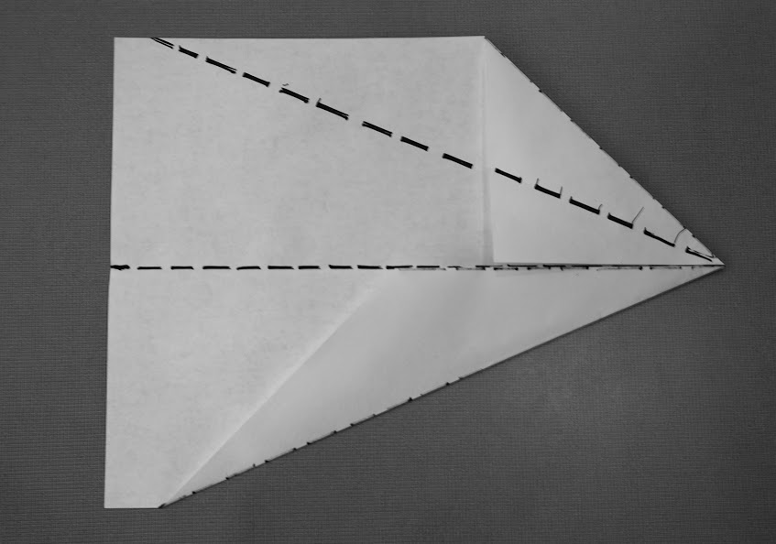

Captured by Yiru Gao, English 314 student

**Step 4: Folding the Wings Out**

Folding the wings out involves folding in the sides to make the paper resemble an airplane. This step is important to make the folded paper into an airplane.

Fold the airplane in half along the original fold from Step 1. Then, take an edge of the wide end of one side of the paper, and fold it back over itself bringing the corner to the center fold as shown. Repeat this step for the other side.

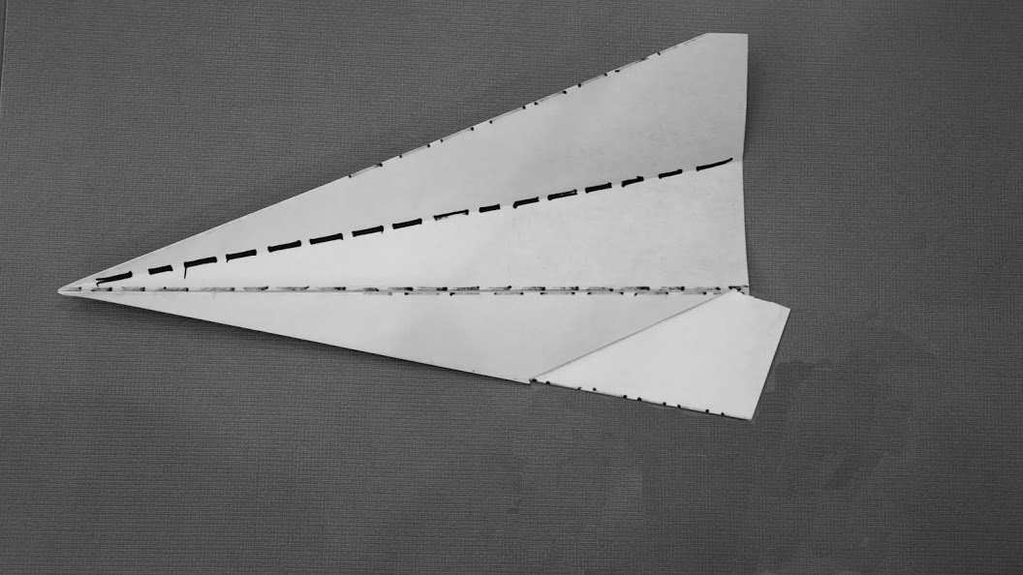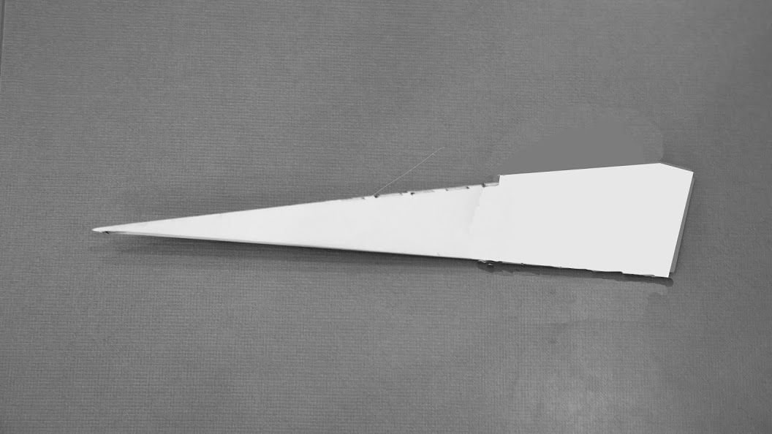

Images captured by Yiru Gao, English 314 student

**Step 5: Rolling the Wings**

Rolling the wings involves taking a pen or pencil and rolling the edges. This step helps keep the plane steady in the air. The rolled edges decrease the speed of the airplane but allow it to stay in the air for a longer period of time. This happens due to the decrease of the surface area of the airplane.

Place the pen or pencil on the edge of a wing and roll the edges of the wings up and in around the utensil. Repeat this step for each wing until the wings hold shape and resemble the second image shown below.

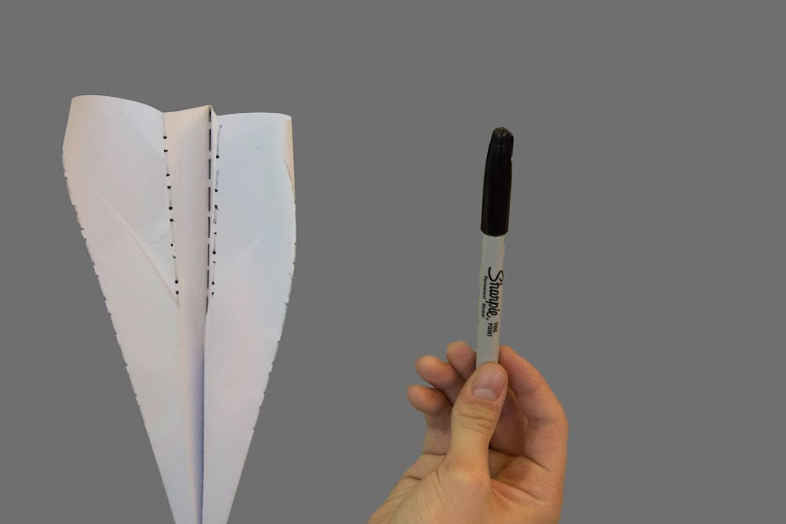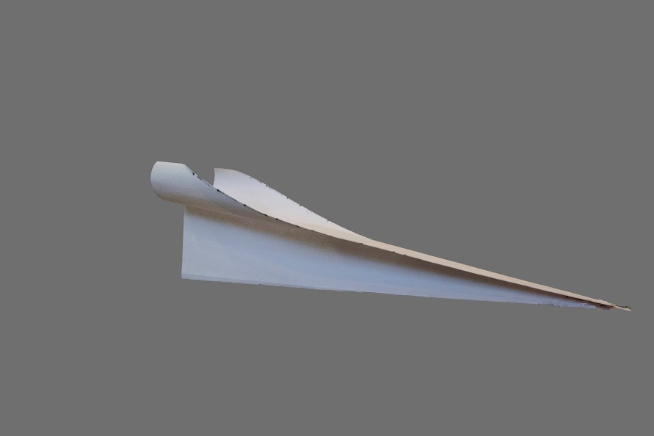

Captured by Yiru Gao, English 314 student

**Step 6: Launching the Paper Airplane**

Launching the paper airplane involves placing your hand properly and aiming the flying object. The final step is necessary for learning how to hold the airplane and launch it. The way the airplane is held determines the direction and duration of flight.

The components of launching the airplane include proper hand placement and proper aiming. Hold the bottom of the airplane between the tips of your fingers, similar to holding a pencil. It is important to hold the airplane at approximately one third of the way down the plane from the tip, close to its center of mass. When you decide to launch the paper airplane, make sure that you point the airplane forward and slightly upward toward an open space. Start with your arm up and move your arm forward to release the paper airplane. You should release the airplane forcefully, like pushing through the air in front of you.

**Warning**

Make sure that the area where you are launching the airplane is clear. If you don’t consider your surroundings before you throw, the airplane could potentially hit someone or get stuck somewhere undesirable. It is also possible to damage the tip of the airplane with harder front-end impacts, which will hinder its future use if the tip is not straightened out consistently during use.

**Conclusion**

Paper airplanes are designed to provide entertainment for students. Making a paper airplane involves making the initial fold, folding the corners , Step 3, Step 4, rolling the wings, and launching the paper airplane.

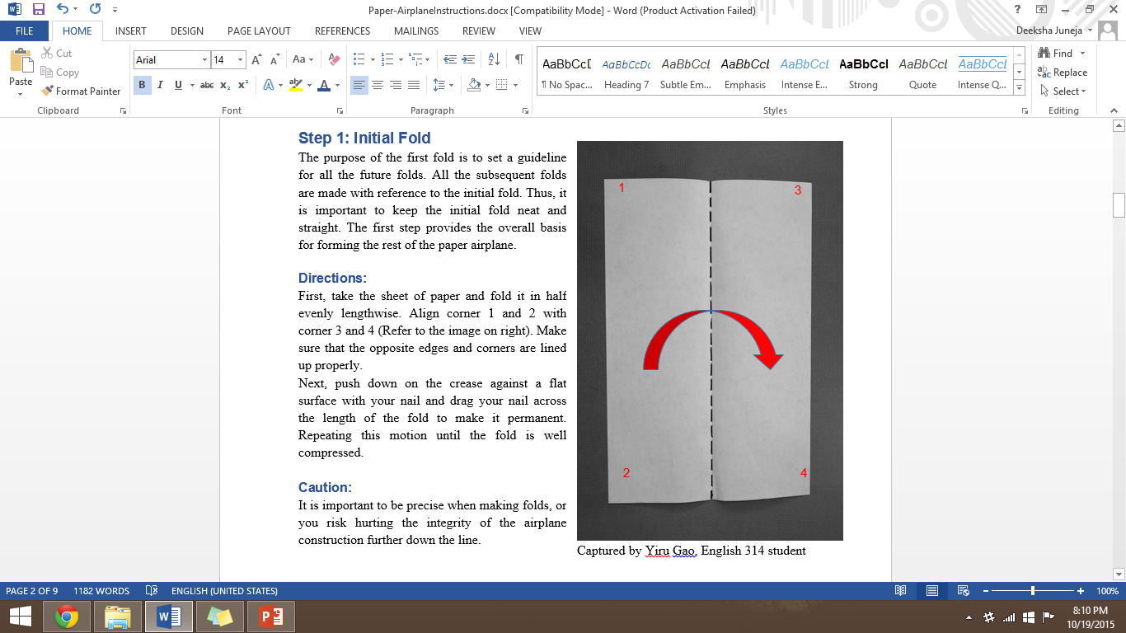

I am planning to do each step like this

Is that okay?

