Dan Conrad

Deeksha Juneja

Colin Jernberg

Yiru Gao

**Instructions for Creating a Paper Airplane**

**Disclaimer**

The instructions below present one approach of creating a paper-airplane. Even though there are many methods to make a paper airplane, only one method will be explained in these instructions.

Any injuries that occur as a result of following the outlined instructions is not the responsibility of the instruction manual writers.

**Safety Warning**

* Reckless handling of the paper around its edges may result in paper cuts.
* These instructions are written with the ability of students in middle school and high school in mind.

**Introduction**

**Overview**

A paper airplane is one of the simplest forms of flying objects that can be made. Making a paper-airplane involves taking a piece of paper and progressively folding it until the desired structure is achieved. Paper airplanes are typically made by younger age groups in a classroom setting as a source of entertainment. Students may find themselves in competitive paper-airplane constructing situations during down time in the classroom. These instructions will help teach students how to make a functional paper airplane and launch it in a step by step manner. Each step of the paper airplane instructions includes some sort of folding and creasing of newly formed edges. While following these instructions, it is important to make folds that line up correctly and are sustained. This can be achieved by consistently pinching and creasing the paper folds with one’s fingernail, which will be outlined more specifically later on. A prototype diagram of the airplane is included in the appendix to help students get started in creating paper airplanes.

**Steps**

Making a paper-airplane of this design involves following six major steps:

1. Making the initial fold
2. Folding in the corners
3. Double-folding in the corners
4. Folding the wings out
5. Rolling the wings
6. Launching the airplane

**Discussion**

**Materials Required**

* One piece of 8.5” x 11” computer paper
* One pen or pencil (or other similarly sized writing utensil)

**Step 1: Making the Initial Fold**

Making the initial fold involves folding the paper in a single direction and creasing it.

The first fold sets the guideline for all the following future folds. All the subsequent folds are made with reference to the initial fold. Thus, it is important to keep the initial fold neat and straight. The first step provides the overall basis for forming the rest of the paper airplane. 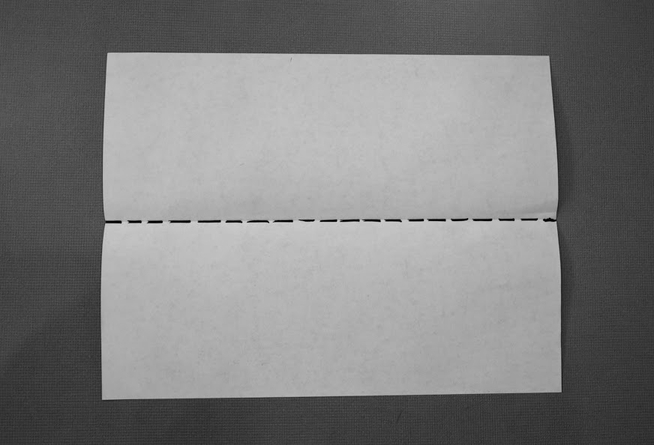

**Directions:**

To start off making a paper airplane, take the sheet of paper and fold it in half evenly lengthwise. Align corner 1 and 2 with corner 3 and 4 (Refer to the image on right). Make sure that the opposite edges and corners line up properly.

Next, push down on the folded crease against a flat surface with your nail and drag your nail across the length of the fold to make it permanent. Repeat this motion until the fold is well compressed.



**Note:**

It is important to be precise when making folds, or you risk hurting the integrity of the airplane construction further down the line. 

**Step 2: Folding in the Corners**

By execution of this step, the paper airplane starts to take shape. If one looks at any real airplane, it is evident that the front end, or tip, is narrower than the rear. To accomplish that result in a paper-airplane and make it truly look like a real airplane, we fold the top. 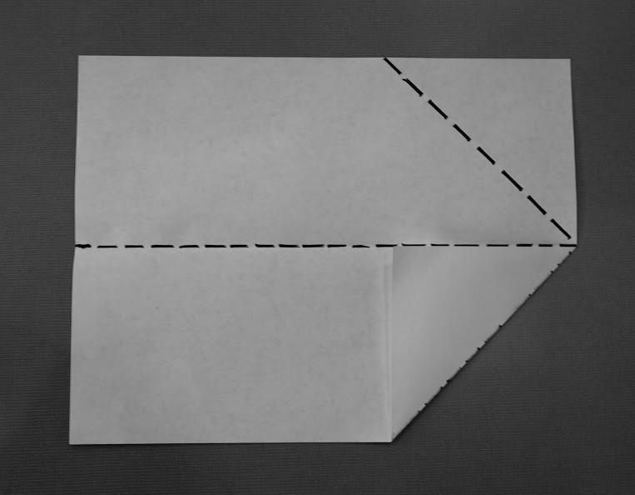



**Directions:**

Open the paper up along the fold made in step one.

Then, bring corner 1 down to line up with the center fold at point 2. Fold it in along the dotted line as shown to the right. Repeat this step for the other side. Push down on the crease to make the fold permanent on both the sides.

**Note:**

It is important to push down on the folds and make the crease permanent to maintain the shape of the airplane.



**Step 3: Double-folding of the Corner**

Similar to step 2, this step further tapers the front of the airplane. Tapering the tip helps the airplane fly by increasing the lift and decreasing the drag. This step is important for launching the airplane and keeping it afloat in the air.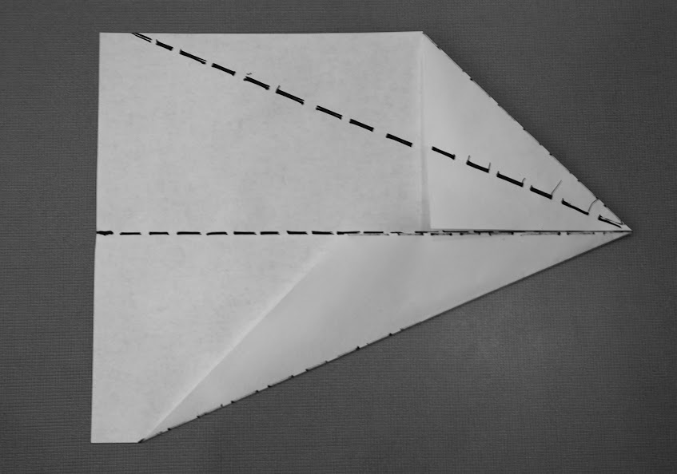



**Directions:**

New corners were formed at the end of step 2.

Take the newly formed corner 1 and fold it along the dotted line to line it up with the center fold. Fold and crease along the dotted line.

Repeat this step for the other side.



**Caution:**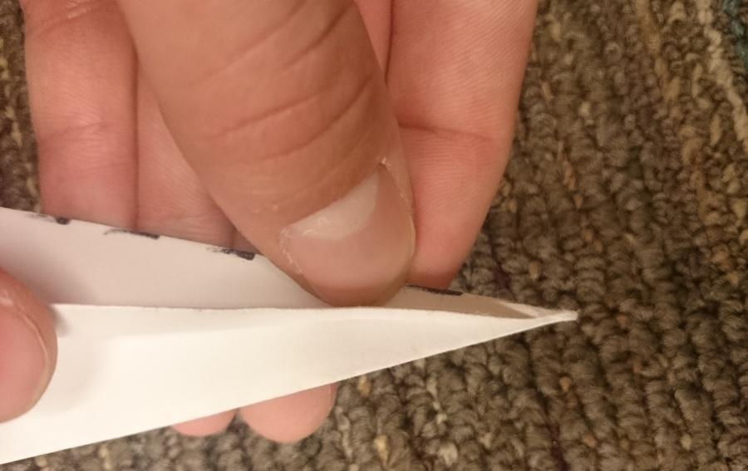

When making folds near the tip of the airplane, it is important to first prime the creases/folds you make with the tip of your fingernail so that they come out straight and in the correct location and orientation.



**Step 4: Folding the Wings Out**

Folding the wings out involves folding in the sides to make the paper resemble an airplane. This step further gives shape to the airplane. The wings of the airplane are folded in this step, which helps the airplane fly.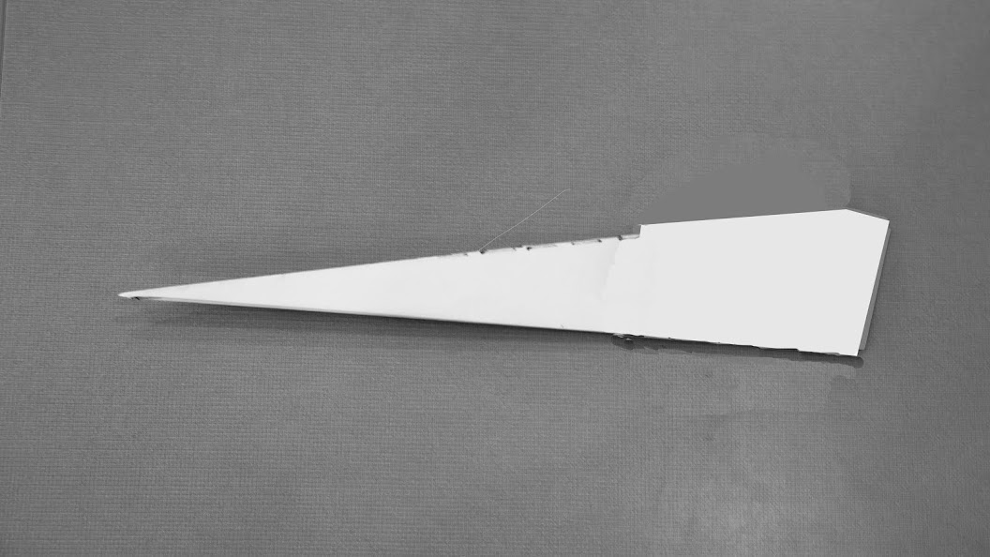

**Directions:**

Fold the airplane in half along the original fold from Step 1 as shown in the first image on the right.

Then, take the edge 1 of the wide rear end of one side of the paper airplane, and fold it back over itself, bringing the corner to the center fold at point 2 as shown in the image 2.

Repeat this step for the other side.

**Caution:**

Execution of this step should be done with extreme care

to maintain the integrity of the wings.

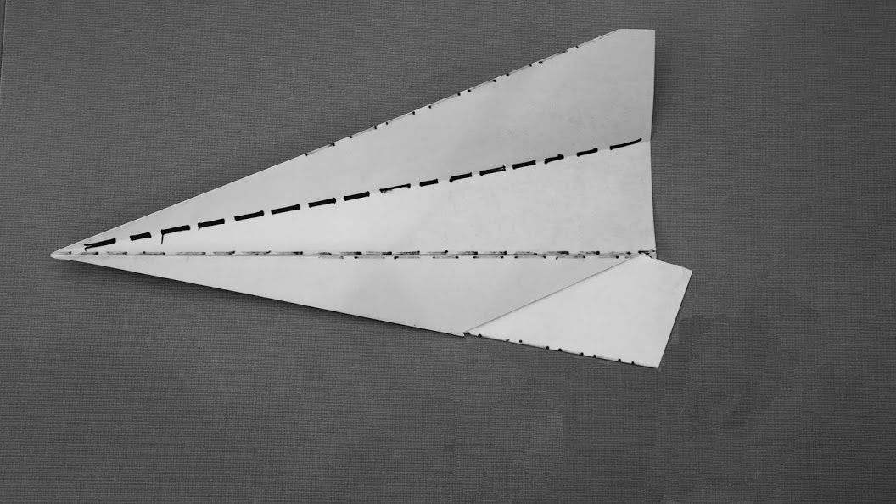









**Step 5: Rolling the Wings**

Rolling the wings involves taking a pen or pencil and rolling the edges. This step helps keep the plane steady in the air. The rolled edges decrease the speed of the airplane, but allow it to stay in the air for a longer period of time. The plane is able to maintain the lift due to the decrease of the surface area of the airplane.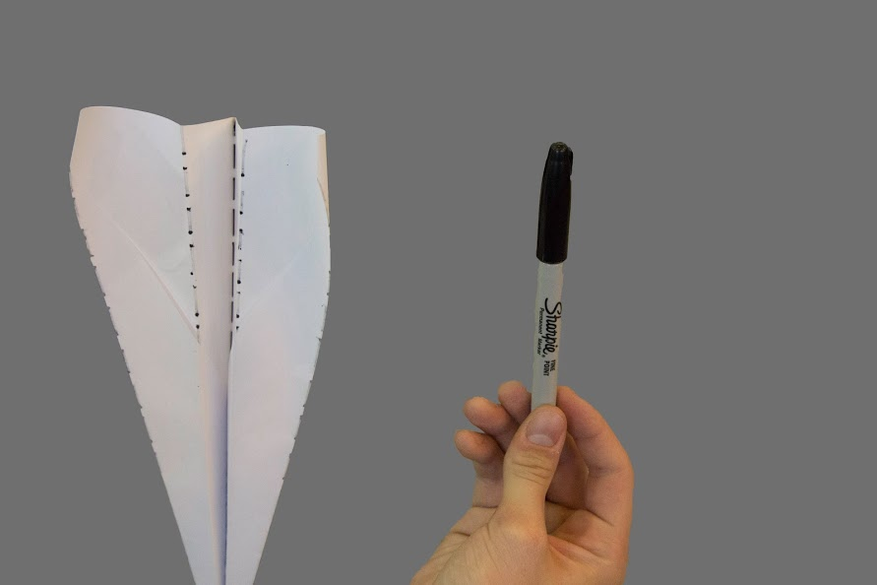

**Directions:**

Place the pen or pencil on the edge of a wing at position 1 and roll the edges of the wings up and in around the pen/pencil. Repeat for each wing until the wings hold shape and resemble the second image to the right. 

**Note:**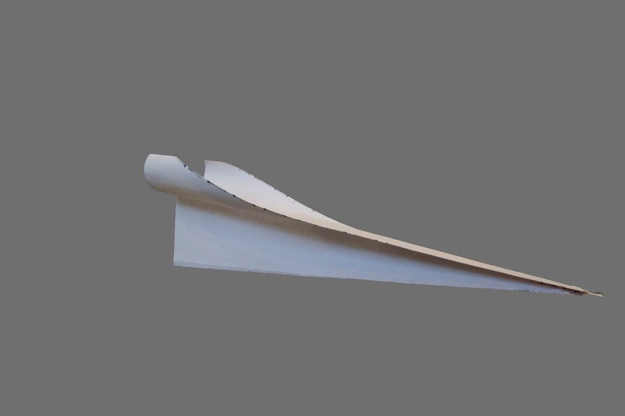

Follow the image carefully while folding the airplane. Do not roll the entire wing. Only a fourth of the airplane needs to be rolled



**Step 6: Launching the Paper Airplane**

Launching the paper airplane involves placing your hand properly and aiming the flying object. The final step is necessary for learning how to hold the airplane and launch it. The way the airplane is held determines the direction and duration of its flight.

**Direction:**

The components of launching the airplane include proper hand placement and aiming. Hold the bottom of the airplane between the tips of your fingers, similar to holding a pencil. It is important to hold the airplane at approximately one third of the way down the plane from the tip, close to its center of mass. This is shown in the image below. When you decide to launch the paper airplane, make sure that you point the airplane forward and slightly upward toward an open space. To launch, start with your arm up and move your arm forward to release the paper airplane. You should release the airplane forcefully, pushing through the air in front of you.

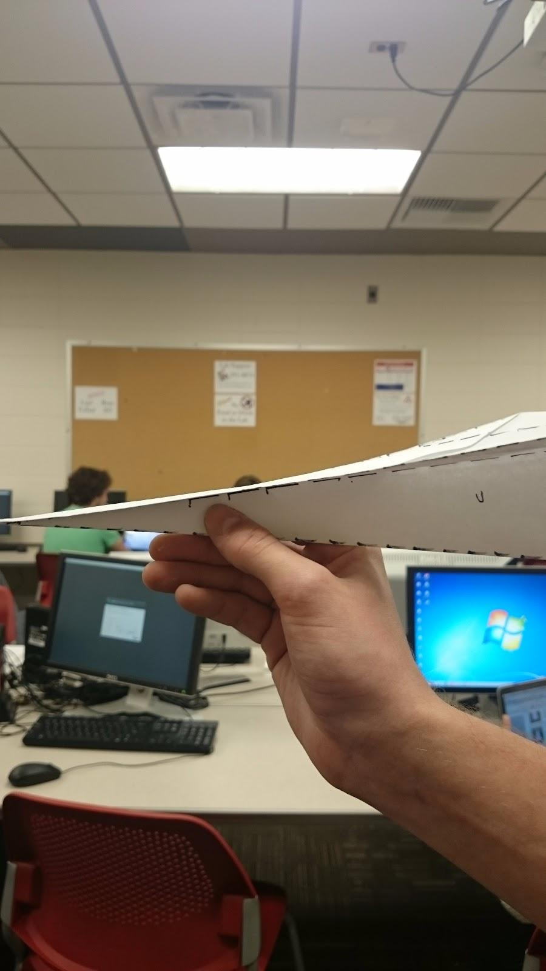



**Caution:**

Make sure that the area where you are launching the airplane is clear. If you don’t consider your surroundings before throwing, the airplane could potentially hit someone or get stuck somewhere undesirable. It is also possible to damage the tip of the airplane with harder front-end impacts, which will hinder its future use if the tip is not straightened out consistently during its use.

**Conclusion**

Paper airplanes are designed to provide entertainment for students. Making a paper airplane involves making the initial fold, folding the corners, folding them again, folding the wings out, rolling the wings, and launching the paper airplane. Following these instructions will help in creating a paper airplane that flies steadily. This design of airplane will give students an edge over their peers’ creations due to its rolled wings and duration of flight.

**Appendix**

**Prototype Diagram of Paper Airplane Folds**

