1.

#include<stdio.h>

int main()

{

int principle;

float time,rate_of_interest,simple_interest;

printf("principle amount");

scanf("%d",&principle);

printf("rate of interest");

scanf("%f",&rate_of_interest);

printf("year");

scanf("%f",&time);

simple_interest=principle*time*rate_of_interest/100;

printf("simple interest:%2f",simple_interest);

return 0;

}

OUTPUT

principle amount1000

rate of interest400

year3

simple interest:12000.000000

2.

#include<stdio.h>

#include<math.h>

int main()

{

int principle;

float time,rate_of_interest,compound_interest;

printf("principle amount");

scanf("%d",&principle);

printf("rate of interest");

scanf("%f",&rate_of_interest);

printf("year");

scanf("%f",&time);

compound_interest=principle*pow(1+rate_of_interest/100,time)-principle;

printf("simple interest:%2f",compound_interest);

return 0;

}

OUTPUT

principle amount3000

rate of interest450

year4

simple interest:2742187.500000

3. #include<stdio.h>

int main()

{

int a,b,c,d,e,sum;

float avg;

scanf("%d %d %d %d %d",&a,&b,&c,&d,&e);

sum=a+b+c+d+e;

avg=sum/5.0;

printf("sum:%d\n",sum);

printf("average:%g",avg);

return 0;

}

OUTPUT

3 4 5 8 9

sum:29

average:5.8

4. #include<stdio.h>

#include<math.h>

int main()

{

float a,b,c,area,s;

scanf("%f %f %f",&a,&b,&c);

s=(a+b+c)/2;

area=sqrt(s*(s-a)*(s-b)*(s-c));

printf("area:%.2f",area);

return 0;

}

OUTPUT

3 4 6

area:5.33

5.

#include<stdio.h>

int main()

{

int x;

scanf("%d",&x);

printf(x%7==0?"multiple of 7":"not multiple of 7");

return 0;

}

OUTPUT

21

multiple of 7

6. #include <stdio.h>

int main()

{

char product_name[20];

int quantity;

float price,bill_amount,discount=0,net_amount;

printf("Product name:");

scanf("%s",product_name);

printf("Quantity:");

scanf("%d",&quantity);

printf("Price:");

scanf("%f",&price);

bill_amount=quantity*price;

if(bill_amount>=5000)

discount=bill_amount*15/100;

net_amount=bill_amount-discount;

printf("Bill amount:%10.2f\n",bill_amount);

printf("Discount(-):%10.2f\n",discount);

printf(" =========\n");

printf(" %10.2f\n",net_amount);

printf(" ========\n");

return 0;

}

OUTPUT:

Product name:sudee

Quantity:2

Price:400

Bill amount: 800.00

Discount(-): 0.00

=========

800.00

========

7. #include <stdio.h>

int main()

{

int x;

scanf("%d",&x);

if(x%2==0)

{

if(x%3==0)

{

printf("%d is divisible by 2 & 3",x);

}

else

{

printf("%d is divisible by 2 not 3",x);

}

}

else

if(x%3==0)

{

printf("%d is not divisible by 2 not 3",x);

}

else

{

printf("%d is not divisible by 2 & 3",x);

}

return 0;

}

OUTPUT:

7

7 is not divisible by 2 & 3

8. #include <stdio.h>

int main()

{

int day;

scanf("%d",&day);

switch(day){

case 1:

printf("BOSS! It's Monday.Concentrate on\"Work\"");

break;

case 2 ... 4:

printf("Still it's week day only");

break;

case 5:

printf("It's friday.Get ready for the week end");

break;

case 6: case 7:printf("Enjoy the holiday");

break;

default:

printf("Invalid day!");

}

return 0;

}

OUTPUT

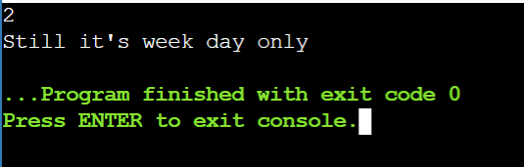

9. #include <stdio.h>

#include<math.h>

int main()

{

double op1,op2,result;

char opr;

scanf("%lf %c %lf",&op1,&opr,&op2);

switch(opr)

{

case '+':

result=op1+op2;

break;

case '-':

result=op1-op2;

break;

case '*':case'x':case'X':

result=op1*op2;

break;

case '/':

result=op1/op2;

break;

case '%':

result=fmod(op1,op2);

break;

default:

printf("Invalid Operator!");

return 0;

}

printf("%g %c %g=%g",op1,opr,op2,result);

return 0;

}

OUTPUT:

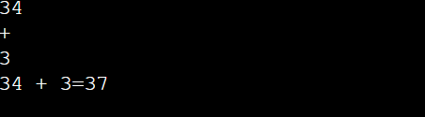

10. #include <stdio.h>

int main()

{

int n;

scanf("%d",&n);

for(int i=1;i<=n;i+=2)

printf("%d",i);

return 0;

}

OUTPUT:

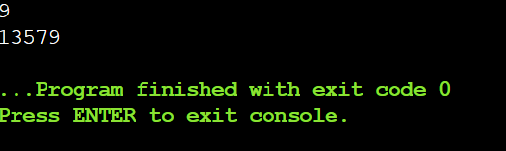

11. #include <stdio.h>

int main()

{

int n;

scanf("%d",&n);

for(int i=n%2?n:--n;i>=1;i-=2)

printf("%d",i);

return 0;

}

OUTPUT:

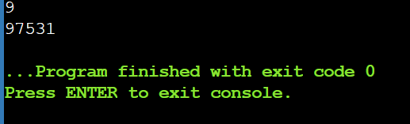

12. #include <stdio.h>

int main()

{

int n=5,sum=0;

scanf("%d",&n);

for(int i=1;i<=n;i++)

sum=sum+i;

printf("%d",sum);

return 0;

}

OUTPUT: 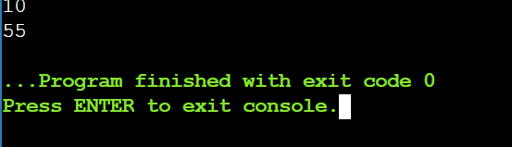

12. //FACTORIAL

#include <stdio.h>

int main()

{

int n=5,sum=1;

scanf("%d",&n);

for(int i=1;i<=n;i++)

sum=sum*i;

printf("%d",sum);

return 0;

}

OUTPUT: 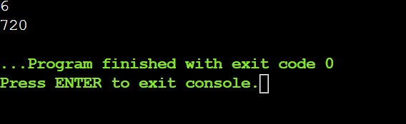

13. //program to reverse a number

#include <stdio.h>

int main()

{

int num,reverse=0,remainder;

printf("enter the integer\n");

scanf("%d",&num);

int temp=num;

while(num!=0)

{

remainder=num%10;

reverse=reverse*10+remainder;

num/=10;

}

printf("reversed number=%d",reverse);

if(temp==reverse)

printf("yes");

else

printf("no");

printf("%d\n",remainder);

return 0;

}

Output:

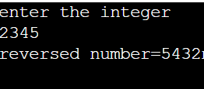

//palindrome

#include <stdio.h>

int main()

{

int num,reverse=0;

scanf("%d",&num);

int temp=num;

while(reverse=reverse*10+num%10,num/=10);

printf("%s",temp==reverse?"yes":"no");

return 0;

}

Output: 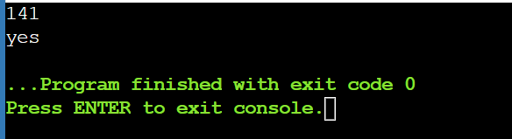

//program to demostrate do while statement

#include <stdio.h>

int main()

{

int n;

char option;

do{

scanf("%d",&n);

if(n>0)

printf("+ve");

else if(n<0)

printf("-ve");

else

printf("zero");

printf("\n\nwant to check more[y]es/[n]o");

scanf("%c",&option);

scanf("%c",&option);

}while(option=='y'||option=='y');

return 0;

}

Output:

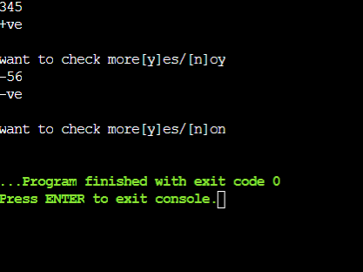

//program to demostrate break statement

#include <stdio.h>

int main()

{

for(int i=1;i<=10;i++){

if(i%4==0)

break;

printf("%d",i);

}

//program to demostrate break statement

#include <stdio.h>

int main()

{

for(int i=1;i<=10;i++){

if(i%4==0)

break;

printf("%d",i);

}

return 0;

}

return 0;

}

Output:

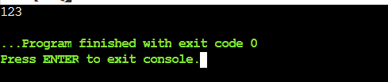

//program to demostrate continue statement

#include <stdio.h>

int main()

{

for(int i=1;i<=10;i++){

if(i%4==0)

continue;

printf("%d",i);

}

return 0;

}

Output:

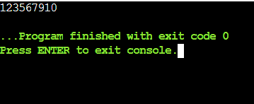

//program to demostrate goto statement

#include <stdio.h>

int main()

{

for(int j=1;j<=5;j++){

for(int i=1;i<=10;i++){

if(i%4==0)

goto exit;

printf("%d",i);

}

}exit:

return 0;

}

Output:

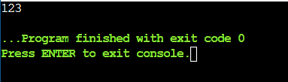

//program to demostrate nested loop statement

#include <stdio.h>

int main()

{

for(int i=1;i<=5;i++)

for( int j=1;j<=5;j++)

{

printf("sudee");

}

return 0;

}

Output:

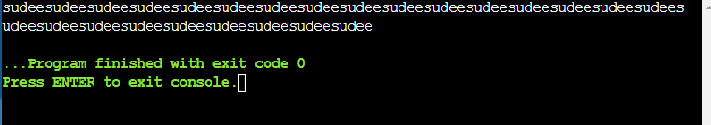

#include<stdio.h>

int main()

{

int n;

scanf("%d",&n);

for(int r=1;r<=n;r++)

{

for(int c=1;c<=r;c++){

printf("%d",c);

}

printf("\n");

}

return 0;

}

Output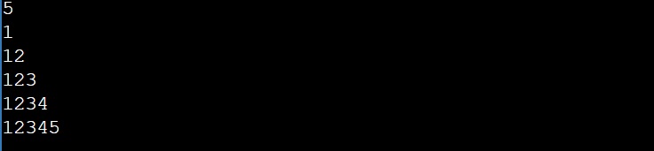

#include<stdio.h>

int main()

{

int n;

scanf("%d",&n);

for(int r=n;r>=1;r--)

{

for(int c=1;c<=r;c++){

printf("%d",c);

}

printf("\n");

}

return 0;

}

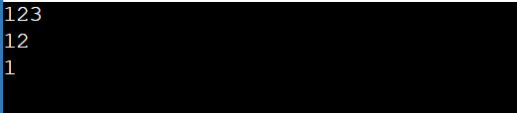

#include<stdio.h>

int main()

{

int n;

scanf("%d",&n);

for(int r=n;r>=1;r--)

{

for(int c=1;c<=r;c++)

printf("*");

for(int c=1;c<=(n-r)*2;c++)

printf(" ");

for(int c=r;c>=1;c--)

printf("*");

printf("\n");

}

return 0;

}

