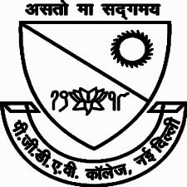

{{ aaa }}

{{participant_name}}

Convenor

**Dr. Ravinder Kumar Gupta**

**PGDAV COLLEGE (EVENING)**

**Dr. Basuki Nath Chaudhary**

Principal

For successfully completing the online webinar on the topic Modern India organized by PGDAV College (Evening) on 31.05.2020 on the online platform zoom under the guidance of Dr. Basuki Nath CHaudhary

**CERTIFICATE**

OF PARTICIPATION

This is proudly presented to