WEEK 1 TASK REPORT
System Requirements Analysis and Block Diagram Design
Selected Application: Smart Home Environment Monitoring System

1. Introduction
Embedded systems combine hardware and software to perform a specific function reliably and efficiently. For this task, a Smart Home Environment Monitoring System is selected as a practical embedded-system application. The proposed device continuously monitors important indoor environmental parameters such as temperature, relative humidity, air quality, and ambient light. The measured values are processed by a microcontroller and presented on a local display. If an environmental value crosses a predefined threshold, the system generates a local alert and can send the information through Wi-Fi for remote monitoring.
The main objective is to design a low-cost, compact, and responsive monitoring device that can operate continuously in a home environment. The design emphasizes clear interfaces between sensors, processing hardware, communication, power, and output devices. Requirement analysis is performed before hardware selection so that each component has a defined role and the complete system can meet functional and performance expectations.

2. System Objective and Intended Functionality
- Measure indoor temperature and relative humidity at regular intervals.
- Monitor indoor air-quality level using a gas/air-quality sensor.
- Measure ambient light intensity for environmental awareness.
- Process sensor readings and compare them with predefined threshold values.
- Display current readings and system status locally using an OLED display.
- Provide an audible/visual alert when a parameter exceeds a selected threshold.
- Transmit monitoring data over Wi-Fi for optional remote observation.
- Operate continuously from a regulated low-voltage power source.

3. Methodology
The design methodology follows a requirement-to-architecture approach. First, the application and its intended users are defined. Next, functional and non-functional requirements are identified, including sensing range, response time, interfaces, power requirements, reliability, and communication. Based on these requirements, the ESP32 is selected as the main controller because it combines sufficient processing capability, digital interfaces, ADC support, and built-in Wi-Fi in a single device. Sensors are connected to suitable GPIO or ADC interfaces, while the display and alert devices provide local feedback. The firmware periodically samples the sensors, validates the readings, updates the display, checks threshold conditions, and communicates data when wireless monitoring is enabled.

4. System Requirements Analysis

4.1 Functional Requirements
Requirement | Specification | Purpose
Temperature sensing | DHT22; approximately -40 to 80 °C | Monitor indoor temperature
Humidity sensing | DHT22; approximately 0–100 % RH | Monitor indoor humidity
Air-quality sensing | MQ-135 analog output | Indicate changes in air quality
Light sensing | LDR with voltage-divider/ADC | Measure ambient brightness
Processing | ESP32 microcontroller | Read, process and manage all functions
Local display | 0.96-inch OLED, I2C | Show readings and status
Alert | Buzzer + LED | Warn when thresholds are exceeded
Wireless | 2.4 GHz Wi-Fi | Optional remote data transmission
Power | 5 V USB input; regulated 3.3 V logic | Provide stable operation

4.2 Non-Functional Requirements
- Reliability: The system should operate continuously with stable sensor reading and fault-tolerant software handling.
- Responsiveness: A normal sensor update should be completed within a few seconds, with alert generation immediately after a threshold violation is detected.
- Low complexity: The design should use readily available components and simple interfaces.
- Maintainability: Firmware should be divided into sensing, processing, display, communication, and alert functions.
- Scalability: Additional sensors can be added through unused GPIO/ADC/I2C interfaces.
- Safety: All logic signals must remain within the permitted voltage levels of the ESP32.

4.3 Input and Output Specifications
Inputs consist of DHT22 temperature/humidity data, the analog output of the MQ-135 air-quality sensor, and an analog light-level signal from the LDR circuit. Outputs consist of the OLED display, buzzer, LED indicator, and Wi-Fi data packets. The controller acts as the central interface between these input and output elements.

4.4 Communication Interfaces
- I2C: Used for the OLED display; it reduces the number of controller pins required.
- Digital GPIO: Used for DHT22 and control of the buzzer/LED.
- ADC: Used to read analog signals from the MQ-135 and LDR circuits.
- Wi-Fi: Used for optional wireless transmission of environmental readings.

4.5 Power Management
The proposed system uses a 5 V USB supply as the main input. A suitable regulator provides the required 3.3 V rail for the ESP32 and compatible logic circuits. The design should include proper decoupling capacitors and a stable supply to reduce measurement errors caused by electrical noise. For a battery-powered version, sleep modes and scheduled sensing could be introduced to reduce energy consumption.

4.6 Real-Time Constraints
This application is a soft real-time monitoring system rather than a hard real-time safety controller. Sensor readings can be sampled periodically, for example every 2–5 seconds depending on sensor characteristics. Once a reading exceeds a configured threshold, the local alert should be generated without unnecessary delay. Wireless communication is treated as a background activity so that temporary network unavailability does not stop local monitoring.

5. Hardware and Software Architecture
The proposed architecture is divided into sensing, processing, communication, output, and power subsystems.
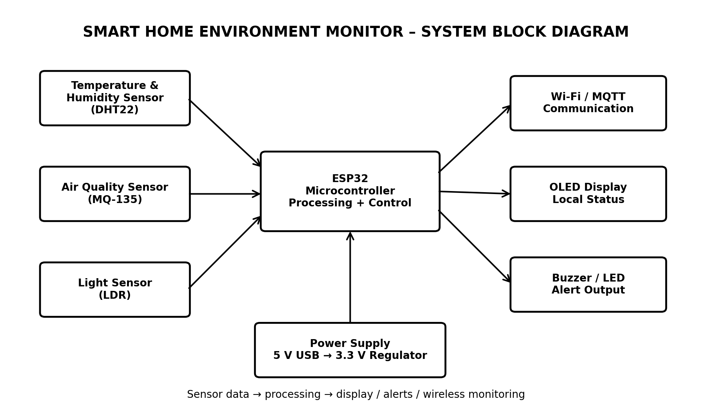
Figure 1. Proposed block diagram of the Smart Home Environment Monitoring System.

5.1 Component Selection and Justification
ESP32 Microcontroller: Selected as the central controller because it provides GPIO, ADC, I2C support, adequate processing capability, and built-in Wi-Fi. This reduces the need for a separate wireless module.
DHT22 Sensor: Provides digital temperature and humidity measurements and is suitable for basic indoor environmental monitoring.
MQ-135 Sensor: Provides an analog response that can be used to observe changes in indoor air-quality-related gases. It is treated as an indicator rather than a laboratory-grade gas analyzer.
LDR: A simple, low-cost light sensor whose resistance changes with illumination. With a voltage divider, the signal can be measured by the ESP32 ADC.
OLED Display: Provides a compact local interface for showing temperature, humidity, air-quality indication, and light level.
Buzzer and LED: Provide immediate local notification when a monitored value exceeds its configured threshold.
Wi-Fi: Allows readings to be transmitted to a suitable dashboard, server, or IoT platform when remote monitoring is required.
Regulated Power Supply: Provides stable voltage rails and protects the controller and sensors from unsuitable supply conditions.

6. Software Operation
1. Initialize the ESP32, sensors, display, thresholds, and communication settings.
2. Read temperature, humidity, air-quality indication, and light level at the selected sampling interval.
3. Perform basic validation and convert raw sensor values into meaningful displayed values.
4. Update the OLED display with current measurements and system status.
5. Compare measurements against configured thresholds.
6. Activate the buzzer/LED if an abnormal condition is detected.
7. If Wi-Fi is available, transmit the latest readings to the selected monitoring service.
8. Repeat the monitoring cycle continuously.

7. Design Integration and Data Flow
The sensors form the input layer of the system. Their signals are delivered to the ESP32 through digital and analog interfaces. The ESP32 performs the central processing and decides how the information should be presented or transmitted. The OLED provides immediate local feedback, while the buzzer and LED provide alert indications. Wi-Fi provides an optional communication path for remote monitoring. The power subsystem supplies the controller and peripherals with regulated voltage. This separation of functions makes the architecture easy to understand, test, maintain, and extend.

8. Testing and Verification Plan
Test Item | Method | Expected Result
Temperature/humidity | Compare readings with a reference room instrument | Values should be reasonably consistent and stable
Air-quality input | Expose sensor to changes in surrounding air conditions | ADC/indicator value should respond to changes
Light input | Change illumination around the LDR | ADC value should change with light level
Display | Observe OLED during normal operation | All selected parameters should be readable
Alert | Set a low test threshold and change the input | Buzzer/LED should activate
Wi-Fi | Connect to a known network and transmit sample data | Data should be sent when network is available
Power | Run system continuously for an extended test | No unexpected reset under stable supply

9. Advantages and Limitations
Advantages
- Combines sensing, processing, local display, alerts, and Wi-Fi in one compact architecture.
- Uses simple and widely available components.
- Can be expanded with additional sensors and IoT features.
- Supports both local and optional remote monitoring.
Limitations
- MQ-135 readings are influenced by environmental conditions and require calibration for meaningful interpretation.
- DHT22 has a relatively slow sampling rate compared with some faster sensors.
- Wi-Fi operation increases power consumption.
- The proposed system is intended for monitoring and awareness, not certified safety-critical environmental control.

10. Conclusion
The Smart Home Environment Monitoring System demonstrates a structured approach to embedded-system planning. The requirements analysis identifies the necessary sensing, processing, communication, power, and output functions before implementation. The ESP32 provides a practical central platform because it combines controller resources with wireless connectivity. The block diagram clearly shows how sensor data moves through the controller to local and remote outputs. The design also considers response time, power, maintainability, scalability, and testing. Overall, the proposed architecture provides a realistic foundation for developing a low-cost smart environmental monitoring device.

11. Future Enhancements
- Add a CO2 sensor for more direct indoor-air monitoring.
- Add cloud data logging and historical graphs.
- Introduce a mobile/web dashboard.
- Add battery backup and power-saving modes.
- Use calibrated sensors for applications requiring higher measurement accuracy.

12. References / Learning Resources
1. ESP32 technical documentation and datasheet.
2. DHT22 sensor datasheet.
3. MQ-135 sensor module documentation.
4. SSD1306 OLED display controller documentation.
5. General embedded-systems design principles and microcontroller interface documentation.

