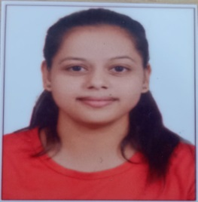**CURRICULUM-VITAE**

**Deeksha Varshney**

**Address:**

Agarwal Mohalla Sasni

Hathras utter Pradesh (204216)

**Contact:7819016009 Email: deekshavarshneysasni@gmail.com**

**Career Objectives:**

To secure a position in an organization with a high degree of responsibility and opportunity where I can enhance my skill & Knowledge as well as to contribute towards growth of the organization.

**Educational Qualifications:**

* 10th from Uttar Pradesh (U.P Board) in 2015
* 12th from Uttar Pradesh (U.P Board) in 2017
* ITI from Uttar Pradesh (Govt.ITI,) session (2017-2018)
* Graduation (Bsc) in Pursuing
* CITS (Computer software Application) from Maharashtra in (NSTI Mumbai)
* ADIT (Advanced diploma international Technology) in (NSTI Mumbai)

**Additional Qualification:**

* O level (NIELIT)
* CCC (Course on Computer Concepts)
* DCA (Diploma in computer application)

**Experience:**

* 3-year experience as teacher in school.

**Personal Skills:**

* Ability to adopt & grasp new technologies soon.
* Ability to communicate effectively with the team members and others.
* Capacity to work in team or individually and take up responsibilities.
* Ability to do work with efficiency and accuracy

**Personal Profile:**

* Father’s name : Rajendra Kumar Varshney
* Date of birth : 10-mar-2001
* Language Known : Hindi, English
* Marital status : Unmarried
* Hobbies : Dancing, listening music

**Declaration:**

I hereby declare that the above furnished details are fully true to the best of my knowledge and belief.

**Date:**

**Place:** (**Deeksha varshney)**