Impact of Extended Discontinuous Reception Cycles on UE Battery Lifetimes and reachability

Vignesh Narasaraju12, Emre A. Yavuz1, Cicek Cavdar2

1 Ericsson AB, Kista, Stockholm, Sweden-164 80

{vignesh.narasaraju, emre.yavuz}@ericsson.com

2 KTH Royal Institute of Technology, Radio Communication Systems, Kista, Stockholm, Sweden-164 40

{vcna, cavdar}@kth.se

***Abstract* -** Extended Discontinuous Reception (eDRX) was proposed by 3GPP in Rel-13. eDRX minimizes UE energy consumption by enabling the UE to sleep for longer duration and wake-up less frequently during paging occasion (PO) to monitor paging messages from eNodeB (eNB). In general, paging messages are sent asynchronously from multiple eNBs to a UE at different time instants, which are positioned as per System-Frame-Number (SFN). In this paper, we analyze how the paging handling by a moving UE, configured with eDRX, becomes inefficient in terms of energy consumption and reachability due to SFN misalignment between eNBs, and propose solutions to overcome these issues. Our system-level simulation is based on two problem causing scenarios wherein an eDRX configured UE receives and responds to the same paging message from different eNBs and/or miss a PO and thus the paging message. Results show that the actual handling of paging message by the UE leads to increased energy consumption in UE and decreased reachability for the network.

***Keywords - LTE, eDRX, Paging, MTC, M2M, IoT, Battery Lifetime, Reachability***

# INTRODUCTION

Reducing energy consumption for UEs is extremely important as this helps them to be operational for longer periods (e.g. weeks, months or even years) without any interruption for maintenance. In general, even though one could argue for having an efficient and high energy capacity battery for the UE, the pace of development of UEs and energy hungry applications has outpaced the slow development of compact sized UE batteries. As a result, the focus was shifted towards saving UE battery energy [1] via DRX. Also, since the energy storage is limited by the size of UE battery and available technology to date, efforts are made to reduce the overall UE energy consumption and yet keep the UE operational for longer duration and make it available for use to the user. Apart from saving UE battery energy, energy saving is also necessary for UEs in critical communication fields where energy supplies are

discontinuous or recharging/changing batteries often is also a challenge [2]. Also, DRX helps to increase system capacity, i.e. by minimizing unnecessary signaling towards the network when the UE is in low energy consumption or sleep mode in DRX. Depending on the network configuration, different traffic situations and required QoS, the length of DRX can vary from small, long to very long periods. Among many other energy consumption optimization techniques for UE, proposed by 3GPP [3] in LTE, eDRX is one such technique where an UE turns off its receiver circuitry over longer periods of time to save battery energy. An DRX configured UE is reachable to the network only via paging messages within the DRX cycle. The paging requests are sent by MME to all the eNBs in the UE registered TA (Tracking Area). The eNBs further deliver paging messages at defined time instants called PO, which repeats every DRX cycle. The PF (Paging frame), which contains the PO, is a function of SFN cycle on the air interface, i.e., the PF is one among the many radio frames which are numbered (0 to 1023) and delivered in a cyclic manner (SFN cycle) by the eNB. However, SFN cycle in each eNB could start at a different point in time and therefore the paging message will be delivered at different time instants by the eNBs for the same UE. The paging message delivered at different time instants by the eNBs is relative to SFN cycle start time in each eNB. As a result, the paging message handling by the UE becomes inefficient, leading to increased UE energy consumption and reduced UE reachability, which are explained further in section II.

Among all the signaling traffic generated by MME (Mobility management Entity), it is estimated that the signaling due to paging alone contributes to around 29% of the total signaling load in the network [4]. Therefore, one cannot ignore the inefficient handling of paging messages by UE and rest of the network elements, which could further lead to increased UE energy consumption, signaling load and reduced UE reachability. The inefficient handling of paging messages intensifies as the DRX cycles are extended longer, i.e. eDRX. Therefore, indirectly it is important to analyze the impact of eDRX cycles on UE energy consumption and reachability due to the paging mechanism.

The paper is structured as follows. Section II provides a description of the problem and briefly introduces two practical problem scenarios or use cases that are simulated in our study. In section III, we describe the simulation environment, performance metrics and system-level simulation results. In section IV, we present our analysis on two potential solutions for solving UE energy consumption and reachability problems described in section II. Finally, the conclusion is presented and discussed in section V.

# PROBLEM DESCRIPTION

Our motivation to say that “eDRX could lead to increased UE energy consumption and reduced UE reachability due to inefficient paging handling” is arrived by analyzing the problem causing scenarios explained further via a simple illustration.

## *SFN Misalignment between eNBs and Paging Message Delivery*

Let cells cell-1, cell-2 and cell-3 belong to the same TA and are managed by an MME, as shown in Fig. 1. Since an idle mode UE location is known to the network only at granularity of TA, MME sends paging request to all the eNBs in TA. The UE wakes up once every DRX cycle at a specified time instant, PO, to check for a possible paging message from eNB. From the eNB perspective, the PO is located within the PF, which is in turn part of the SFN cycle of a eNB. However, the SFN cycles among eNBs are not synchronized. For example, at time t = 0, the SFN may take on different values in each cell, as shown in Fig. 1. As a result, the paging message at a particular PO for a UE is not sent at same time instant from all the eNBs towards a UE. But the UE wakes up, when the time for its PO arrives, to check if it has any paging message. At this juncture, we identify two problems causing scenarios, which can have negative impact on UE energy consumption and reachability for the network. The problem scenarios are described further in subsection B and C.

## *Scenario 1: UE Receiving and Responding to the Duplicate Paging Message*

As shown in Fig. 2, MME sends paging request for UE via all the eNBs in TA. The UE receives its paging message at its PO in cell-1, responds to the paging message and sleeps again. During the sleep period, if the UE is mobile, it ends up in cell-2. When the UE wakes up again, it finds itself in cell-2. Due to SFN misalignment between eNBs, the eNB in cell-2 also delivers the same paging message to UE when the UE PO has arrived. UE being unaware of the fact that it has already answered the same paging message in cell-1, it responds to the same paging message in cell-2, which we call as duplicate paging reception.



Fig. 1. MME sending paging request to eNBs in TA.

In this scenario we can observe that:

* UE answered twice to the same paging message, both in cell-1 and cell-2, and hence UE consumes additional battery energy trying to access the network and process the paging message.
* UE and eNB consumed additional radio network signaling resource while answering the same paging message and thus reduced the system capacity for other UEs in the cell that might have to be served.



Fig. 2. UE receiving duplicate paging message due to SFN misalignment between eNBs.

## *Scenario 2: UE Missing its PO and Receiving Delayed Paging Message*

As shown in Fig. 3, MME sends paging request for UE via all the eNBs in TA. The UE receives its paging message at its PO in cell-1, responds to the paging message and sleeps again. During this sleep period, MME sends a new paging with new information to the UE. When the UE is awake it finds itself in cell-2. Due to SFN misalignment between eNBs, the PF and PO carrying the paging message for the UE has not yet arrived or could have already passed in cell-2. As a result, UE goes back to sleep mode to wake up at its next PO. If the UE moves into cell-3 during this sleep time, UE may either receive its paging message, which is delayed, or again miss its PO and thus miss the paging message. If the UE is moving at a high speed such that it crosses many cells and wakes up once during eDRX cycle in each cell, the possibility of UE missing its PO due to SFN misalignment between eNBs will be high resulting in more time for the network to reach the UE. In this scenario we can observe that:

* UE receives a delayed paging message or might miss the PO and paging message containing time critical information, such as SI updates and warnings.
* Missing a paging message causes increased delay for the network to reach the concerned UE.



Fig. 3. UE missing its PO from eNBs.

# PERFORMANCE EVALUATION AND RESULTS

## *Simulation Environment*

The simulated was run using MATLAB® [5] tool. A network of 36 hexagon cells was created and 100 UEs distributed randomly all over the network of cells. Throughout the simulation time, the UE is made to move randomly but with a specific speed. When mobile, UE takes a pause between each movement. If a UE happens to cross the network boundary, then the UE is redirected back into the network, i.e. no wrap-around, the UE returns back with a random direction. Each cell has a SFN loop count from 0 to 1023, incremented in steps of one sub-frame, but SFN loop count is started randomly among all the cells. That is, cell-1 SFN count might start at 0 (zero), while the SFN count for cell-2 might start from 100 (uniformly distributed random numbers) and so on for other cells. This is done to simulate SFN misalignment of eNBs in the network. The simulation parameters are listed in Table I. The simulations are run with a set of different UE speeds and cell radii. The applicable use cases are scenarios wherein a user is mobile and using an eDRX capable UE (MTC and no-MTC) powered by battery. The DRX parameters, PF and PO are calculated as described in [6]. In our simulation the PO calculation is based on sub-frame pattern for FDD only [6].

|  |  |
| --- | --- |
| **Number of hexagon cells** | 36 |
| **Cell radius [m]** | 500 (Pico),  1000 (Micro),  1500 (Macro) |
| **Number of users** | 100 |
| **User velocity [km/h]** | 3 (Walking) 50 (Motorbike) 100 (Car) |
| **UE DRX cycle lengths (including eDRX cycles) [s]** | 0.32, 0.64, 1.28, 2.56, 5.12, 10.24, 20.48, 40.96, 81.92, 163.84 |
| **Simulation time, T [min]** | 60 |
| **SFN offset for cells** | Random between 0 and 1023 |
| **The antenna in each cell** | Omnidirectional |
| **Radio channel** | Robust, i.e. no path loss. |

TABLE I: Summary of simulation parameters and assumptions.

An MTC UE can experience different events while it is mobile. The different events are, cell change, receive and respond to a paging message and send small amount of data to the network at fixed interval. Due to these events, the UE consumes its battery energy. In our study, we have used the UE energy model presented in [7].

## *Effect of UE mobility, Cell Size, SFN misalignment and eDRX Cycle on Paging Message Reception*

The number of duplicate paging message receptions and missed POs due to SFN misalignment by UEs with different DRX cycle lengths and different speeds which are moving across cells with 500 meters radius is shown in   
Fig. 4 and Fig. 5, respectively. As UE’s paging DRX cycle increases, UE sleeps longer duration and wakes up less frequently. During this sleep duration, when a UE changes cells and wakes up, the possibility of receiving the duplicate paging message and/or missing a PO in new cell due to SFN misalignment also increases. Further, as the UE speed increases, idle UEs cross the cells faster and the probability that they experience such receptions increase, for the same amount of time. If the SFN cycles of eNBs are aligned, UEs

do not receive the duplicate paging message or miss the PO. Similar observation is achieved when the cell radius is 1000 and 1500 meters respectively, but with lesser number of duplicate paging message receptions and missed POs. Because, as the cell size increases, it takes longer time for the UE to switch between the cells and experience duplicate paging message reception and/or miss a PO. Therefore, the possibility of having such an event due to SFN misalignment is less in cells with larger radius.

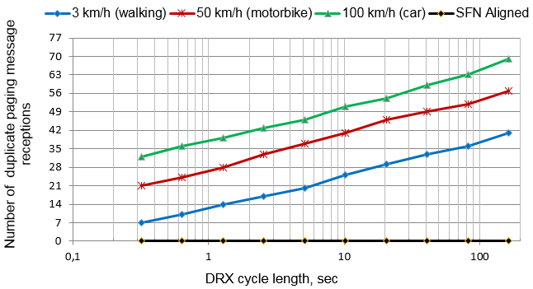 Fig. 4. Number of duplicate paging message receptions at 500 m cell radius.

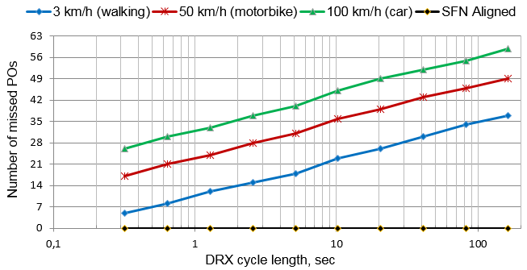

Fig. 5. Number of missed POs at 500 m cell radius.

## *Performance Metric: Percentage of Duplicate Paging Messages Received by UE*

As the UE receives and responds to the duplicate paging messages, it generates an additional load on the network due to number of message exchanges between the UE and eNB. We calculate the percentage of duplicate paging messages received by UEs, defined as,

Percentage of duplicate paging messages,

$\frac{(P_{received - }P_{sent})}{P_{sent}}$ x 100

Here, Preceived denotesthe total number of paging messages received and Psent denotesthe total number of paging messages sent for all T. By calculating the percentage of duplicate paging messages received and answered by UE, we can further ascertain the total energy consumed by the UE due to duplicate paging messages. The total number of paging messages and the percentage of duplicate paging message reception by UEs moving across cells with 500 meter cell radius and at different speeds is as shown in Fig. 6. As the DRX cycle length increase, the number of POs used for sending the paging messages to UE decreases. The difference in the number of duplicate paging message receptions is minuscule for DRX cycle lengths below 10.24 sec. But as the DRX length increases we see more divergence in the duplicate receptions due to longer sleep duration by UEs and SFN misalignment between eNBs. For DRX cycle length of 163.84 seconds, the percentage of duplicate paging receptions at UE speed 3, 50, 100 km/h are 1.9, 2.6, and 3.1, respectively.

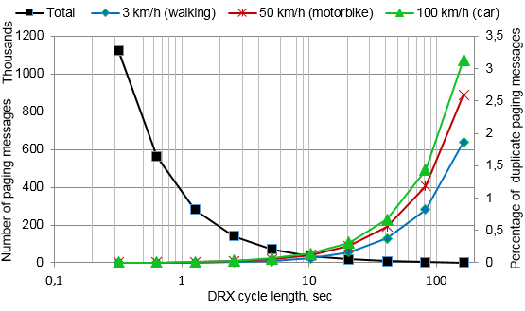

Fig. 6. Total number of paging messages and the percentage of duplicate paging message reception by UEs at 500 m cell radius.

## *Performance Metric: Percentage of Energy Consumption due to Duplicate Paging Reception*

We calculate the percentage of energy consumed by the UE due to reception of duplicate paging messages, Eduplicate, defined as,

Eduplicate = x 100

Here, Etotal denotes the total energy consumed by UE due to the reception of both non-duplicate and duplicate paging messages and Enon-duplicates denotes the total energy consumed by UE due to the reception of non-duplicate paging messages for all T. The total energy consumption and the percentage of energy consumed due to duplicate paging reception by UEs moving across cells with 500 meter cell radius and at different speeds is as shown in Fig. 7. The maximum possible DRX cycle length in the 3GPP specification (as of Rel-12) [8] is 2.56 sec’s. As DRX cycle length is extended to and beyond 10.24 sec we can see that total energy consumption is reduced by more than 90% compared to minimum DRX cycle length of 0.32 sec’s. When the UE is sleeping there is still some energy consumption due to UE’s clock for internal synchronization. While total UE energy consumption can be reduced by extending the DRX cycle length, significant percentage of the total energy is consumed only due to duplicate paging reception. For DRX cycle length of 163.84 seconds, the percentage of energy units consumed due to duplicate paging receptions at UE speed 3, 50, 100 km/h are 13.79, 31.11, and 66, respectively. As the UE DRX cycle length increases, the probability of UE receiving the duplicate paging message due to SFN misalignment also increases. As a result the percentage of energy consumption by UE also increases. This extra energy consumption could have been saved, if the UE was smart enough to decide if the received paging message was the one which was already received and responded.

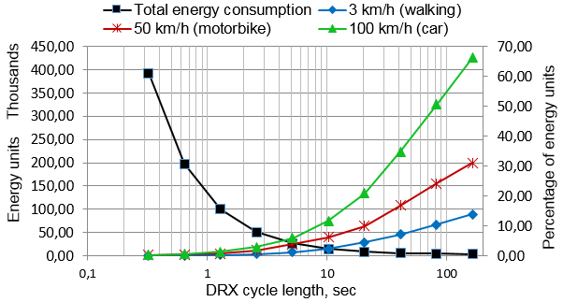

Fig. 7. UE total energy consumption and percentage of energy consumption due to duplicate paging message reception at 500 m cell radius.

## *Performance Metric: Percentage of Missed Paging Occasions by UE*

Due to SFN misalignment and mobility, UE might miss its PO. We calculate the percentage of missed POs by the UEs at different UE speeds and compare it against the total number of POs for the UEs. This gives us an indication of how good the network is and able to reach the UE, despite the SFN misalignment between eNBs in the network.

Percentage of missed PO = $\frac{{PO}_{missed}}{{PO}_{total}}$ x 100

Here, POmissed denotes the number of missed POs by UEs and POtotal denotes the total number of POs for the UEs for all T. If the UE misses its PO due to moving from one cell to another, the time it takes for the network to reach the UE increases. This may be too costly especially when DRX cycles are extended. The total number of POs and the percentage of missed POs by all the UEs moving across cells with 500 meter cell radius and at different speeds is as shown in Fig. 8. The difference in the number of missed POs is minuscule for DRX cycle lengths below 10.24 sec. But as the DRX length increases we see more divergence in PO misses due to longer sleep duration by UEs and SFN misalignment between eNBs. For DRX cycle length of 163.84 seconds, the percentage of missed POs at UE speed 3, 50, 100 km/h are 6.6, 7.3, and 9 respectively. Also, if the UE is configured with a long DRX cycle and it’s moving faster, i.e. UE moves across more number of cells, the possibility of UE missing the POfrom the cells it traverses consecutively is also more. For e.g., we see four PO misses by UE when they are sleeping longer, more than 10.24 seconds, and travelling at a speed of 100 km/h.

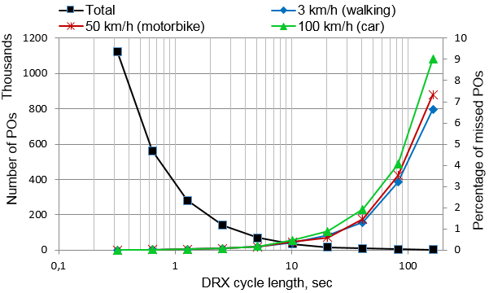

Fig. 8. Total number of POs and the percentage of missed POs by UEs at 500 m cell radius.

## *Performance Metric: Average Delay for Network to reach UE due to SFN Misalignment*

From the network perspective we calculate the delay which the network should wait to reach the UE. This delay is due to SFN misalignment between eNBs and UE DRX cycle length. Note that this delay is excluding the UE DRX cycle length. If a UE misses its PO, the probability of network reaching the UE also decreases or we could also say that it reduces UE reachability. To understand the delay caused for the network to reach the UE, let us look at the illustration of UE PO occurrence, SFN misalignment between eNBs and PO miss by the UE, as shown in Fig. 9.

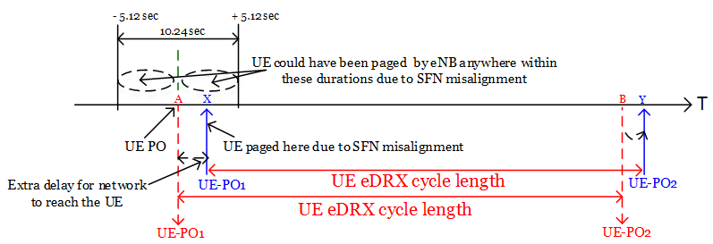

Fig. 9. Illustration of network delay, UE PO occurrence and SFN misalignment.

For example, if the SFN misalignment duration between eNBs is 10.24 sec (i.e. maximum SFN = 1023), then on an average the eNBs are misaligned by ± 5.12 sec w.r.t the UE PO, as illustrated in Fig. 9. If the UE happens to move into a new cell, the eNB in the new cell could page the UE anywhere between ± 5.12 sec of the UE PO at point ‘A’. Let’s say if the eNB in the new cell tried to page the UE at PO occurring at time ‘X’, but with no success to reach the UE, because the UE was awake during its PO at UE-PO at time ‘A’, re-synchronized to eNB in the cell and slept further till its next PO. Therefore the UE missed its PO at time ‘A’. From the network point of view, the network should wait till the next UE PO occurring at time ‘Y’ to page the respective UE. This means that the network should wait an extra time, in addition to the UE DRX cycle length, to reach the respective UE. If the SFN cycle were synchronized, then the network wouldn’t have any delay to reach the UE.

We calculate the average delay for UEs moving at three different speeds across cells of 500 m radius at different SFN offset between eNBs. The average delay for the network to reach the UEs when SFN offset is between 0 to 1023 is as shown in Fig. 10. The combination of DRX cycle lengths and UE speed increases the time delay for the network to reach the UE. We can reduce this delay for the network by reducing the duration of SFN misalignment between the cells. Ideally, if the eNBs are synchronized, the network would have no delay to reach the UE. The average delay for the network to reach the UEs at SFN offsets between 0 to 511 and 0 to 255 is shown in Fig. 11 and Fig. 12.

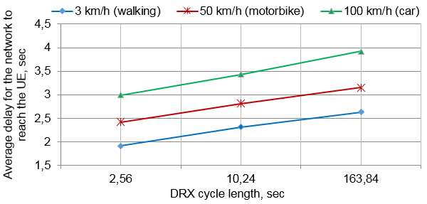

Fig. 10. Average delay for the network to reach the UEs at SFN offset of 0 to 1023 between cells and 500 m cell radius.

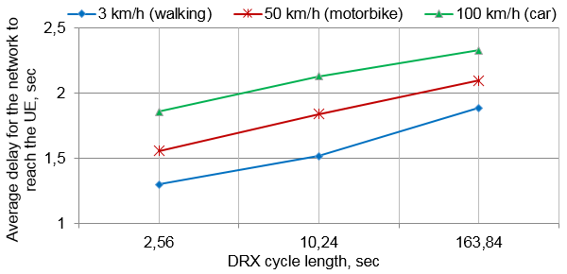

Fig. 11. Average delay for the network to reach the UEs at SFN offset of 0 to 511 between cells and 500 m cell radius.

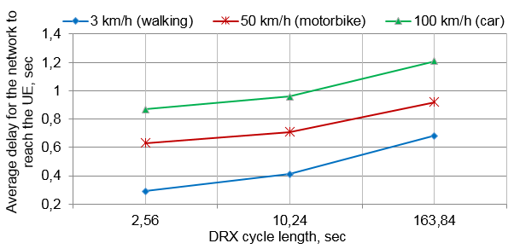

Fig. 12. Average delay for the network to reach the UEs at SFN offset of 0 to 255 between cells and 500 m cell radius.

# ANALYSIS OF POTENTIAL SOLUTIONS FOR UE ENERGY AND REACHABILITY ISSUES

We propose solutions based on analytical study to prevent UE from receiving duplicate paging messages and reduce the probability of UE missing its PO, which in turn reduces average delay and increase UE reachability for the network.

## *Preventing UE from Receiving Duplicate Paging Messages*

In order to prevent UE from answering the duplicate paging messages from eNB, paging messages can be tagged with a unique tag-id. Once the UE successfully receives and responds to the paging message, it can store the respective tag-id and compare it with the tag-id of the successive ‘*n’* received paging messages. If the UE finds a matching tag-id, it ignores the paging message. By doing so, UE can save battery energy, reduce the number of signaling messages/load on eNB and hence radio resources. Here, we assume that the energy consumed by the UE to store and compare the tag-id is negligible compared to total energy consumed by the device to respond to the duplicate paging messages.

# *Increase UE Reachability*

In order to reduce the probability of UE missing a PO due to eDRX and increase reachability for the network, we analyze the proposal in [9], where authors have proposed a solution to improve the eDRX scheme or overcome longer delays in eDRX using windowing mechanism. The windowing mechanism proposed in [6] can be used within the eDRX cycle length where a UE monitors the POs based on legacy paging DRX cycle lengths [8][6]. Let this window be called as Paging Transmission Window (PTW). The length of both the PTW and the legacy DRX cycle within the PTW are configured by the network, based on the requirement for UE reachability and SFN misalignment between the cells. The PTW, containing POs based on legacy DRX cycle lengths, is introduced in the beginning of the eDRX cycle, as shown in Fig. 13. When the PTW expires, UE goes to deep sleep until the next eDRX PO for the UE.

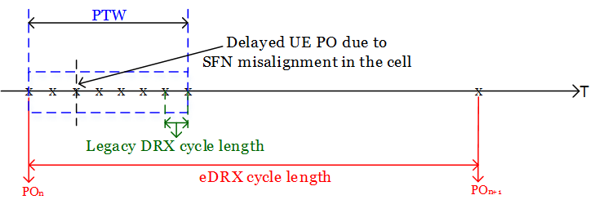

Fig. 13. Illustration of PTW within eDRX cycle.

The purpose of introducing a PTW in the beginning of eDRX cycle is two folds: to compensate for the SFN misalignment between eNB in the cells and to increase the probability that a network can reach the UE within a reasonable time frame even if the UE misses its PO in the new cell. For example, if the UE misses its eDRX POn in the new cell, it could still be made reachable via a legacy DRX POs within the PTW instead of UE’s next eDRX PO, i.e., POn+1.

# CONCLUSIONS

This paper addressed the impact on UE energy consumption and reachability due to eDRX cycles and SFN misalignment between cells. The UE experiences increased number of events of either receiving the duplicate paging message multiple times and/or missing a PO when it’s moving faster across the cells. The number of events is relative to cell sizes. By extending the DRX cycle length, we can save UE energy due to extended sleep periods. By extending the cycle length beyond 10.24 sec’s we can save 90 % more energy as compared to cycle length of 0.32 sec’s.

When UE is configured with eDRX of 163.84 sec and moving across cells of radius of 500 m, UE receives 1.9, 2.6 and 3.1 percent of paging messages as duplicate paging messages at UE speed of 3 km/h, 50 km/h and 100 km/h respectively. This duplicate paging reception increase UE energy consumption by 13.79, 31.11 and 66 percent of the total energy units. The effect of missing a PO and thus receiving a delayed paging message reduces UE reachability for the network. Similarly, for UE configured with eDRX of 163.84 sec, moving across cells of radius 500 m, the percentage of PO misses are 6.6, 7.3 and 9 percent of the total POs at UE speed 3 km/h, 50 km/h and 100 km/h respectively.

Extending the DRX cycle length when UE is at higher speed, forces the UE to experience missing their POs in succession. Further, for the network, a missed PO adds delay, in addition to UE DRX cycle length, for the network to reach the respective UE. Therefore, the subsequent paging receptions, after missing the PO, adds delay in communicating necessary information to the UEs, even critical information at times, resulting in reduced UE reachability. For example, when the SFN misalignment is at 0 to 1023 between eNBs, the average delay for the network to reach the UE are 2.63, 3.15 and 3.92 sec’s, which are measured at DRX cycle lengths of 163.84 sec for UE moving across cells of radius 500 m with 3 km/h, 50 km/h and 100 km/h speeds respectively. By reducing the duration of SFN misalignment between eNBs we can reduce the delay for network to reach the UE and hence increase UE reachability.

# REFERENCES

1. Fowler, S.; "Study on Power Saving Based on Radio Frame in LTE wireless Communication System using DRX", GLOBECOM Workshops, IEEE, Dec. 2011, pp.1062-1066.
2. Arthur, Charles.; “How the Smartphone is Killing the PC”. http://www.theguardian.com/technology/2011/jun/05/smartphones-killing-pc [Accessed on Apr.20,2017].
3. 3GPP TR 23.887, “Study on Machine-Type Communication (MTC) and other Mobile Data Applications Communications Enhancements”, Rel. 12, V. 12.0.0, Dec. 2013.
4. Alcatel-Lucent S.A., “The Impact of Small Cells on MME Signaling: Methods to Reduce and Optimize MME Core Signaling caused by Small Cells”, Application Note, Oct. 2013.
5. MATLAB. https://www.mathworks.com/products/matlab.html [Accessed on Apr.20,2017].
6. 3GPP TS 36.304, “E-UTRA: User Equipment Procedures in Idle Mode”, Rel. 12, V. 12.2.0, Sep. 2014.
7. Qiu, Tao.; Xu, Haibo.; Zhou, Hua.; "Power Efficient Mechanism for MTC UEs in LTE-A Networks", Wireless Communications and Mobile Computing Conference, IEEE, Aug.2014, pp.751 - 755.
8. 3GPP TS 36.331, “E-UTRA: Radio Resource Control Protocol Specification”, Rel. 12, V. 12.3.0, Sep. 2014.
9. R2-157167, “Introducing extended DRX”, Qualcomm Incorporated, 3GPP TSG-RAN WG2 Meeting #92, CR 1988, Anaheim, USA, 16-20 Nov.2015.