**Mini Project Report - 01**

Master of Computer Application – Data Science

Semester – I

**Sub: Frontend Framework and Technologies**

**Topic: RESUME**   
By  
**Name:** DECHAMMA KP  
**Reg no.:** PROV/ASAC/MCA/7/25/040

**Faculty Name:** VEERA RAGHAV K

**Faculty Signature: _______________**

**Department of Computer Application  
Alliance University  
Chandapura - Anekal Main Road, Anekal  
Bengaluru - 562 106**

**September 2025**

**INDEX**

1. Introduction to HTML and CSS
2. Input code
3. Output
4. Conclusion

**INTRODUCTION**

**Introduction to HTML**

HTML (HyperText Markup Language) is the backbone of all

websites. It is used to structure and organize content on the

web so that browsers can display text, images, videos, and links

in a readable way. Instead of running calculations like a

programming language, HTML works by marking up content

with different tags to tell the browserwhat each part of the

page means.

For example, you can use headings to make titles stand out,

paragraphs for text, images for visuals, and links to connect one

page to another. HTML works together with **CSS** (for styling and

design) and **JavaScript** (for interactivity) to create complete and

dynamic websites.

Some of the most important HTML tags are:

• <html> → The container that wraps the entire webpage.

• <head> → Holds meta information, links to CSS/JS, and

the page title.

• <title> → Sets the title shown in the browser tab.

• <body> → Holds the visible content like headings, text,

images, and links.

**Introduction to CSS**

CSS (Cascading Style Sheets) is the language that makes websites

visually attractive and user-friendly. While HTML provides the

structure of a webpage, CSS is responsible for its design—controlling

colors, fonts, spacing, layouts, and even animations. With CSS, the

same HTML content can be presented in completely different styles,giving web designers full creative control over how a site looks and feels.

In CSS:

• **Selector** → Targets the HTML element you want to style (e.g.,

h1).

• **Property** → Specifies the aspect to change (e.g., color, font-size).

• **Value** → Defines the exact style setting (e.g., blue, 20px).

**INPUT CODE:**

<!DOCTYPE html>

<html lang="en">

<head>

<meta charset="UTF-8">

<meta name="viewport" content="width=device-width, initial-scale=1.0">

<title>Document</title>

<style>

h1{

text-align: center;

}

div{

border:1px solid black ;

}

h3{

padding-left: 10px;

}

h2{

padding-left: 10px;

}

p{

padding-left: 10px;

}

span{

color: blue;

}

li{

padding-bottom: 5px;

}

</style>

</head>

<body>

<div><h1>Resume</h1><hr>

<h3>name : <span>Akash srivastva </span></h3>

<H3>EMAIL : <span>akashsrivastva29@gmail.coms</span></H3>

<h3>phone : <span>7061293497</span></h3><hr>

<h2><u>about me:</u></h2>

<p>Lorem ipsum dolor sit amet consectetur adipisicing elit. Et praesentium distinctio

deleniti dolores esse eaque fuga? Incidunt quis eaque asperiores voluptatem! A

obcaecati quidem deserunt rerum eum iusto sint labore assumenda temporibus? Atque

necessitatibus, nisi obcaecati iusto consequuntur veritatis cum tenetur, consequatur,

minus sapiente optio! Sed aspernatur reprehenderit aut praesentium?</p> <hr>

<h2><u>Educational qualification </u>

</h2>

<p>BCA(Alliance university) 2025</p>

<p>intermidiate(jac board) 2022</p>

<p>10th(cambrian public school) 2020</p><hr>

<h2><U>Technical skills </U></h2>

<UL>

<li>python</li>

<li>java</li>

<li>css</li>

<li>java script</li>

</UL><hr>

<h2><u>Projects</u></h2>

<p>Lorem ipsum dolor sit amet consectetur, adipisicing elit. Esse molestias nulla

beatae veritatis quas magnam natus? Voluptatibus sapiente beatae quas explicabo

incidunt tempore blanditiis ea cumque magni nesciunt quidem, molestiae, consectetur

dolorem consequuntur ratione soluta eius. Perspiciatis, laudantium itaque. Ut eligendi

doloribus illum temporibus! Excepturi at, est veritatis autem tempora impedit

repellendus aspernatur error ut corrupti minima rerum expedita eius nemo quas

repudiandae numquam, quo illum. Omnis soluta qui corrupti?</p><hr>

<h2><u>Certifications:</u></h2>

<p>Lorem ipsum dolor sit amet consectetur adipisicing elit. Neque explicabo quidem,

maiores repudiandae doloremque voluptates iusto? Quis quisquam ad, dolore tenetur,

delectus ex nemo tempore impedit quidem facere perspiciatis nostrum ullam laboriosam

fugiat reprehenderit, quas sint optio vero repudiandae? Accusamus voluptas veniam

nobis cupiditate quas perspiciatis doloremque eligendi temporibus laboriosam, velit fuga

fugit cum non beatae eum illum nam officia iure nostrum, exercitationem quisquam!

Rem perferendis mollitia blanditiis sunt quae</p><hr>

<p>Date: _______</p>

<p>place: _______</p>

</div>

</body>

</html>

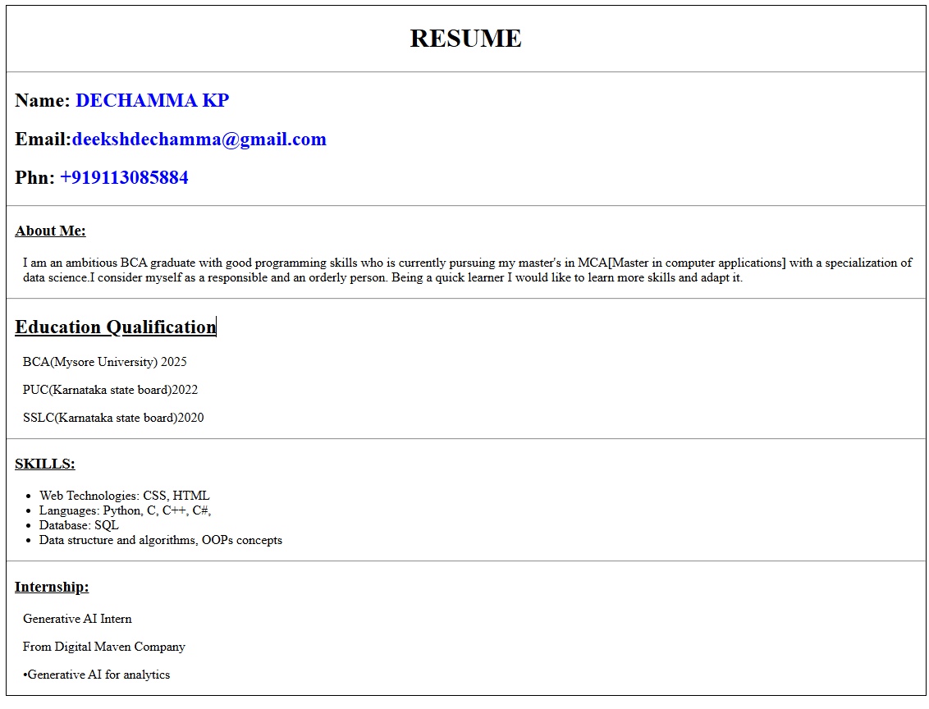

**CONCLUSION:**

This mini project highlights how combining HTML and CSS can

transform plain content into a well-structured and visually appealing

resume webpage. Through this project, I gained hands-on experience

in organizing content with HTML and enhancing its design with CSS.

While the design is simple, it demonstrates the practical use of web

technologies in creating professional and presentable documents,

laying a solid foundation for building more advanced web projects in

the future.