FIVE-DAY SALES DATA ANALYSIS PROJECT REPORT

Overview
This report explains a five-day mini project that demonstrates how sales data can be analyzed using Python and the pandas library. The project covers loading data, exploring its structure, cleaning inconsistencies, analyzing sales performance, and generating insights.

Day 1: Setup & Load Data
On the first day, the pandas library was installed and the CSV sales data file was loaded into the Python environment using PyCharm. The dataset was read using the read_csv() function and previewed to understand its structure.
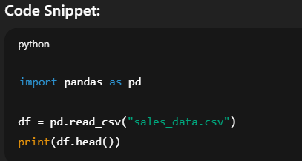

Day 2: Explore Data
On the second day, the dataset was explored to understand its size, columns, and data types. This helped identify how the data is structured and what kind of cleaning might be required.
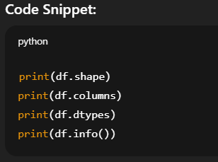

Day 3: Clean Data
Day three focused on cleaning the data. Missing values were handled and duplicate rows were removed to ensure data accuracy and consistency before analysis.
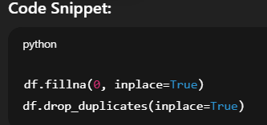

Day 4: Analyze Sales
On the fourth day, sales performance was analyzed. A new column called Revenue was created, and total revenue along with the best-performing product was identified.
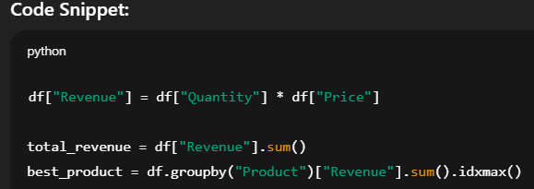

Day 5: Create Report
The final day focused on generating a clean, readable report summarizing key findings and insights from the analysis.

Conclusion
This five-day project demonstrated a complete data analysis workflow using Python and pandas. It showed how raw CSV data can be transformed into meaningful business insights through structured analysis and reporting.

