Jenkins Job Creation:

Implementing Version Control in Your CI/CD Pipeline

STEP 1: Set Up Git Bash
- Open Git Bash and configure your Git username and email: git config --global user.name "Syed Sadath Khadri"
git config --global user.email "sadaths640@gmail.com"

STEP 2: Initialize a Git Repository
- Navigate to your project directory: cd tharun5589
- Initialize the Git repository: git init

STEP 3: Add Files to Git
- Add all files to the staging area: git add tarun

STEP 4: Commit the Files
- Commit the files with a message: git commit -m "Initial commit"

STEP 5: Add GitHub Repository as Remote
- Add the GitHub repository as a remote origin: git remote add origin https://github.com/Sadath08/pingpong-game.git

STEP 6: Push the Project to GitHub
- Push the local project to the GitHub repository: git push -u origin ma

STEP 7: Install Jenkins Plugins (if not already installed):
- Go to Jenkins Dashboard → Manage Jenkins → Manage Plugins.
- In the Available tab, search for and install:
- Pipeline, Git (if using Git as your version control system)

STEP 8: Create a Pipeline Job:
- In Jenkins, click on New Item in the Jenkins dashboard.
- Enter a name for your job, select Pipeline as the project type, and click OK.
- Under the Pipeline section, choose Pipeline script.

STEP 9: Write the Jenkins Pipeline Script:

pipeline { agent any
stages {
stage('Checkout') { steps {
// Checkout code from Git
git url: 'https://github.com/your-repo.git', branch: 'main'
}
}
stage('Build') { steps {
echo 'Building the application...'
// Add your build commands here (e.g., Maven, Gradle, npm, etc.)
// sh 'mvn clean package' or sh './gradlew build'
}
}
stage('Test') { steps {
echo 'Running tests...'
// Add your test commands here (e.g., unit tests, integration tests)
// sh 'mvn test' or sh './gradlew test'
}
}
stage('Deploy') { steps {
echo 'Deploying the application...'
// Add your deploy commands (e.g., deployment scripts, Docker, etc.)

// sh 'docker-compose up -d' or sh 'kubectl apply -f deployment.yaml'
}
}
}
post {
success {
echo 'Pipeline succeeded!'
}
failure {
echo 'Pipeline failed!'
}
}
}

STEP 10: Configure Git Repository:
Replace the placeholder Git repository URL
(https://github.com/Tharungowda26/tharun5589) with your actual repository URL.

STEP 11: Save the Pipeline: After writing the script, click Save. STEP 12: Run the Pipeline:
- Go back to the Jenkins dashboard and select your newly created pipeline job.
- Click Build Now to trigger the pipeline.
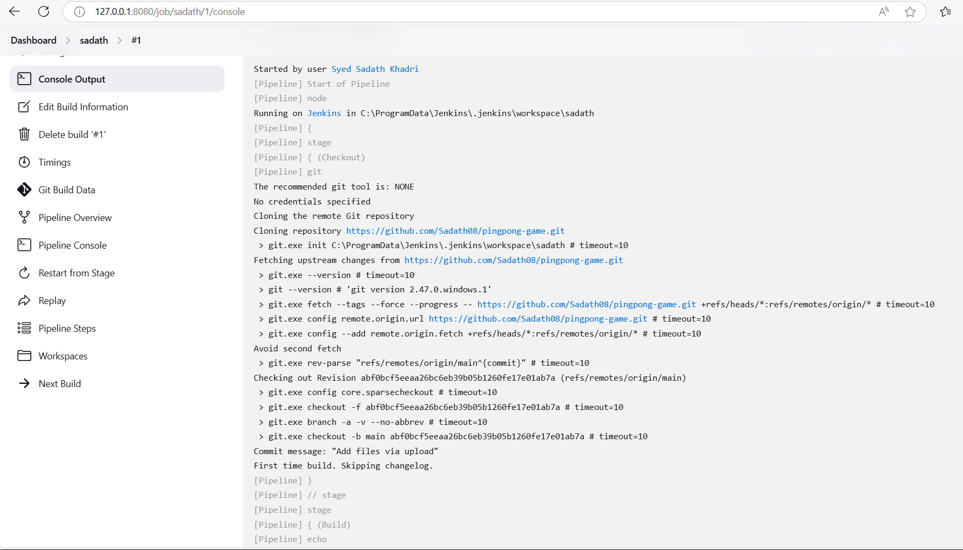

STEP 15: Check Pipeline Execution:
  - As the pipeline runs, you’ll be able to see each stage (Checkout, Build, Test, Deploy) being executed.
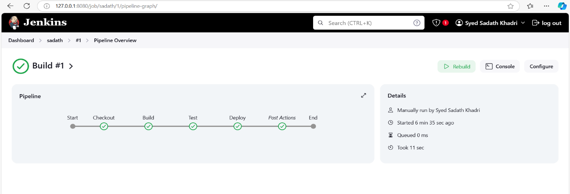
  - You can view the progress by clicking on the Build Number in the build history and selecting Console Output.

