SIMATS ENGINEERING (SAVEETHA SCHOOL OF ENGINEERING)
Department of Computer Science and Engineering
CO1 ASSESSMENT TOOL 1 – Case Study Analysis
Course Code: | CSA10 / CSA1063 | Course Title: | Software Engineering
CO Assessed: | CO1 | Assessment: | Assessment Tool 1 – Case Study Analysis
Weightage: | 20% | Total Marks: | 25
CO1 Statement: | Al-Based Predictive Modelling for Early Forecasting of Bovine Mastitis in Indian Dairy Farms
Student Name: | T. Deekshith | Reg. No.: | 192425145
Date: | 3-10-2026 | Duration: | 60 minutes

Code of Conduct
I T. Deekshith (192425145) certify that this submission is my original work and that I have adhered to the guidelines specified for this assessment. I understand that any violation of academic integrity rules will result in disciplinary action.
Signature of the Student: __deekshith____________
Annexure A – Case Study Analysis
Instructions to Students:
Each student will be allotted one problem statement. Analyze the assigned problem systematically by following the steps given below. Your report should demonstrate your understanding of software engineering concepts and your ability to design an appropriate software solution.
Based on your allotted problem statement, prepare a report by answering the following questions:
1. Understand the Problem Statement
- Explain the problem in your own words.
- Identify the objectives of the proposed system.
- State the scope of the problem.
2. Identify Key Stakeholders and Challenges
- Identify all the stakeholders involved in the system.
- Explain the roles and responsibilities of each stakeholder.
- Discuss the major challenges and issues faced by the stakeholders.
3. Analyze the Current Approach
- Describe the existing system or current process.
- Identify its strengths and limitations.
- Analyze the problems or gaps that need to be addressed.
4. Propose a Suitable Solution Using Software Engineering Principles
- Design a software-based solution for the given problem.
- Describe the major functional modules of the proposed system.
- Identify the functional and non-functional requirements.
- Explain how software engineering principles such as modularity, scalability, maintainability, reliability, usability, and security are incorporated into your solution.
5. Justify the Chosen Methodology/Framework
- Select an appropriate Software Development Life Cycle (SDLC) model or software development framework (e.g., Agile, Scrum, Waterfall, Spiral, DevOps).
- Justify why the selected methodology/framework is suitable for the proposed system.
- Explain how it supports successful project development and maintenance.
6. Discuss Expected Outcomes and Limitations
- Describe the expected benefits of the proposed solution.
- Explain how the solution addresses the identified challenges.
- Discuss potential risks, implementation challenges, and limitations.
- Suggest possible future enhancements.
AI-Based Predictive Modelling for Early Forecasting of Bovine Mastitis in Indian Dairy Farms

1. Understand the Problem Statement

1.1 Explain the problem in your own words.
Bovine mastitis is an inflammation of the udder that affects the health of dairy cattle, the quality of milk and the amount of milk produced. In many Indian dairy farms, it is detected mainly through routine observation, milking records, clinical examination and diagnostic tests. Cases without obvious visible signs, called sub-clinical mastitis, are especially difficult to identify early, and by the time clear signs appear the animal may already have suffered milk loss and need longer treatment.
Farms in India also differ widely in herd size, breeds, housing, milking practices, record keeping, internet connectivity and access to veterinary support. The proposed system aims to use AI-based predictive modelling on animal, milk and farm data to estimate the risk of mastitis before clear clinical signs are observed, so that farmers and veterinarians can give early attention to animals that need it. The system supports veterinary decision-making and does not replace clinical diagnosis or treatment.

1.2 Identify the Objectives of the proposed system
- Provide a digital platform for collecting animal, milk and farm-management records.
- Use AI-based predictive modelling to estimate mastitis risk within a defined forecast period.
- Help farmers and veterinarians identify animals that need closer observation.
- Store animal history and prediction results digitally for easy comparison.
- Provide risk alerts and dashboards in a simple, easy-to-understand format.
- Record veterinary follow-up and confirmed outcomes for evaluation.
- Reduce dependence on fragmented paper-based record keeping.
- Support future improvement of the prediction model using validated farm data.

1.3 State the Scope of the problem
- User registration, farm registration and animal registration.
- Collection and validation of milk, health and management data.
- Secure storage of animal history and prediction results.
- AI-based mastitis risk prediction for a defined forecast period.
- Risk dashboards, alerts, follow-up records and reports.
- Use by farmers, caretakers, veterinarians, farm managers and authorized administrators.
- The system supports, but does not replace, physical examination and diagnostic testing.
- Can be extended to more farms, sensors and data sources in the future.

2. Identify Key Stakeholders and Challenges

2.1 Explain the Key Stakeholders involved in the system
Identify All the Stakeholders Involved in the System
The main stakeholders involved in the "AI-Based Predictive Modelling for Early Forecasting of Bovine Mastitis in Indian Dairy Farms" system are:
- Farmers and Animal Caretakers
- Veterinarians and Para-Veterinary Workers
- Farm Owners and Managers
- Milking and Data-Entry Staff
- Data Scientists and Developers
- System Administrator
- Researchers and Veterinary Institutions

2.2 Explain the Roles and Responsibilities of Each Stakeholder
Stakeholder | Roles and Responsibilities
Farmers and Animal Caretakers | Record animal observations, maintain animal information, review risk alerts and arrange veterinary follow-up.
Veterinarians and Para-Veterinary Workers | Examine flagged animals, conduct or recommend diagnostic tests, confirm outcomes and advise the farm.
Farm Owners and Managers | Monitor herd health, milk production, resources and overall use of the system.
Milking and Data-Entry Staff | Enter milk records, animal observations and other routine information accurately and on time.
Data Scientists and Developers | Develop the data pipeline, predictive model, application and monitoring components.
System Administrator | Manage users, roles, security, backups and system settings.
Researchers and Veterinary Institutions | Support validation, study design, data governance and evaluation of the model.

2.3 Major Challenges and issues faced by the stakeholders
- Manual work takes time and may result in inconsistent records.
- Large numbers of animals make individual monitoring difficult.
- Mastitis may not show obvious signs at an early stage.
- Missing or noisy sensor and farm data can affect predictions.
- Internet and device limitations can affect data collection.
- Animal and farm information must be protected.
- False alerts create extra work, while missed cases delay attention.
- The model must be validated because performance may differ between farms, breeds and management systems.

3. Analyze the Current Approach

3.1 Describe the existing system or current process.
Currently, farm workers observe cattle during routine activities, monitor milk production and other available indicators, and identify animals with possible problems. When necessary, they request veterinary examination. The veterinarian performs clinical assessment and diagnostic tests, after which the result is recorded. Where records are maintained mainly on paper or in separate files, it becomes difficult to review long-term trends across a large herd.

3.2 Identify its strengths and limitations.
Strengths
- Farm workers have direct knowledge of the animals and their normal behaviour.
- Veterinarians can directly examine animals when required.
- Existing farm records can provide useful historical information.
- Physical examination and diagnostic testing can support confirmation.
Limitations
- Early changes are difficult to identify through observation alone.
- Paperwork and separate records are harder to search and maintain.
- Manual monitoring becomes more difficult as herd size increases.
- There is no consistent method for combining several indicators.

3.3 Analyze the problems or gaps that need to be addressed.
The major gap is the absence of one integrated software system that combines animal records, predictive risk estimation, alerts and follow-up. For "AI-Based Predictive Modelling for Early Forecasting of Bovine Mastitis in Indian Dairy Farms", the following problems and gaps need to be addressed:
1. Late Detection – Sub-clinical cases may go unnoticed until clinical signs appear.
2. Fragmented Records – Paper or separate files make it hard to compare an animal's current condition with its history.
3. No Consistent Early-Risk Indicator – Users cannot easily combine milk, health and management information for each animal.
4. Monitoring Effort in Large Herds – Manual checking of many animals is time-consuming and inconsistent.
5. Unavailable Old Records – Previous history is not readily available when an animal needs review.
6. Different Data Formats – Data from different farms and devices follow different practices and formats.

4. Propose a Suitable Solution Using Software Engineering Principles

4.1 Design a software-based solution for the given problem.
An AI-Based Mastitis Risk Prediction System can be developed as a single digital platform where farm users register animals and enter relevant records. The system validates and stores the information, prepares features for the predictive model and generates a mastitis risk estimate for a defined forecast period.
The system can estimate risk using factors such as:
Animal Details + Milk Records + Health History + Management Data + Sensor Readings → Mastitis Risk Score
The results are then displayed through risk dashboards, alerts and reports, and farmers and veterinarians can record follow-up outcomes. The architecture below shows the main flow between farm data, the predictive model, users, alerts and system administration.
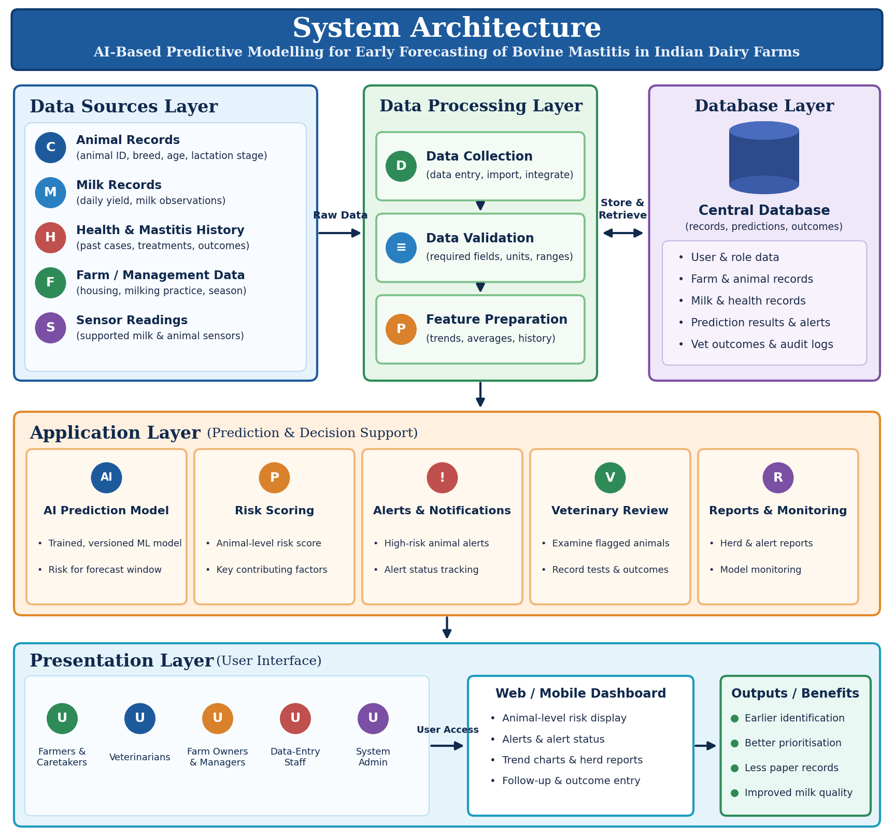
Figure 1. Proposed system architecture for early forecasting of bovine mastitis.

4.2 Describe the major functional modules of the proposed system.
1. User and Farm Management Module
- Secure registration and login with role-based access (Farmer, Veterinarian, Administrator).
- Register farm details and animal details such as animal ID, breed, age and lactation information.
2. Data Collection Module
- Record milk yield and milk-related observations.
- Record previous mastitis history and clinical observations.
- Record environmental or management information and supported sensor readings.
3. Data Validation and Storage Module
- Check required fields, animal IDs, dates, units and value ranges.
- Store validated records securely and prepare features for the model.
4. Predictive Modelling Module
- Supply prepared data to a trained and versioned machine-learning model.
- Estimate mastitis risk within a specified forecast window.
- Keep model version and monitoring records.
5. Risk Dashboard and Alerts Module
- Display animal-level risk, trends and alert status.
- Show the relevant factors behind each alert in a simple format.
6. Veterinary Review and Reports Module
- Allow veterinarians to review flagged animals and record examination, test results and confirmed outcomes.
- Generate herd summaries, alert history and outcome reports.
- Support user management, audit records and system settings.

4.3 Identify the functional and non-functional requirements.
Functional Requirements
- Users should be able to register and log in securely.
- System should register farms and animals.
- System should store animal, milk and management records.
- System should validate data and report errors.
- System should generate mastitis risk for a defined forecast period.
- System should display risk dashboards and generate alerts.
- Veterinarians should be able to record review results and outcomes.
- System should generate digital records and reports.
- Administrator should be able to manage users, roles and model versions.
Non-Functional Requirements
- Security: Only authorized users should access protected information.
- Usability: Screens should be simple and easy to understand.
- Reliability: Important records should be stored safely and be recoverable.
- Performance: Common actions and predictions should respond within practical time.
- Scalability: System should support more farms, users and animals as it grows.
- Maintainability: Application and model components should be easy to update and test.
- Availability: Service should normally be available when users need it.
- Data Quality: System should detect incomplete, inconsistent or invalid records.

4.4 Explain how software engineering principles such as modularity, scalability, maintainability, reliability, usability, and security are incorporated into your solution.
Modularity → The system is divided into independent modules for user management, data collection, storage, prediction, alerts, reporting and administration.
Scalability → Additional farms, animals and data sources can be added later.
Maintainability → Organized modules, documentation, version control and testing allow changes without affecting the whole system.
Reliability → Validation, backups, error handling and monitoring improve the reliability of records and predictions.
Usability → Simple screens and clear risk information make the system easy for farm users.
Security → Authentication, role-based access, controlled permissions and audit records protect farm and animal data.

5. Justify the Chosen Methodology / Framework

5.1 Select an appropriate Software Development Life Cycle (SDLC) model or software development framework (e.g., Agile, Scrum, Waterfall, Spiral, DevOps).
Selected SDLC Model: Agile
The Agile software development methodology is suitable for this system because it can be developed in small parts instead of waiting until the entire system is completed. Requirements, farm data and model performance may change during development, and feedback from farmers and veterinarians can be incorporated at each stage.

5.2 Justify why the selected methodology/framework is suitable for the proposed system.
- Development can be divided into small sprints.
- Individual modules can be developed and tested separately.
- Feedback can be collected from farmers, veterinarians and other users.
- Changes in requirements can be incorporated easily.
- The prediction model and dashboards can be improved continuously.
- Data and usability problems can be found early through regular testing.

5.3 Explain how it supports successful project development and maintenance.
- Sprint 1 – Login, user roles and farm registration.
- Sprint 2 – Animal registration and basic record entry.
- Sprint 3 – Data validation, storage and preprocessing.
- Sprint 4 – Predictive model and risk calculation.
- Sprint 5 – Dashboard, alerts and veterinary review.
- Sprint 6 – Reports, testing, security and pilot deployment.
Requirement Analysis
↓
Sprint Planning
↓
Data Collection & Model Design
↓
Incremental Development
↓
Testing & Validation
↓
User Feedback
↓
Improvement
↓
Deployment & Maintenance

6. Discuss Expected Outcomes and Limitations

6.1 Describe the expected benefits of the proposed solution.
The proposed system is expected to:
- Identify animals that may need closer observation earlier, if the model performs well in local validation.
- Reduce dependence on fragmented paper or separate records.
- Give easy access to animal history and previous alerts.
- Help prioritize animals for veterinary review.
- Improve monitoring through dashboards and reports.
- Keep a digital record of predictions, follow-up and outcomes.
- Provide a modular platform that can be extended to additional farms.

6.2 Explain how the solution addresses the identified challenges.
Challenge | Proposed Solution
Late detection of mastitis | AI-based risk prediction before clear clinical signs
Manual, inconsistent records | Digital data entry with validation and secure storage
Difficult monitoring of large herds | Risk dashboard and alerts that prioritize animals
No access to animal history | Centralized animal records and previous alerts
Missing or noisy data | Data validation and quality checks
False or missed alerts | Veterinary review, outcome records and model monitoring
Different farms and conditions | Local validation and controlled model updates

6.3 Discuss potential risks, implementation challenges, and limitations.
- Internet problems may affect online access or synchronization.
- Security risks must be handled carefully.
- Some users may need basic training.
- Server or software problems may temporarily affect the service.
- Incorrect or missing user-entered information must be checked.
- The model may produce false positive or false negative predictions.
- Performance may change when the system is used on different farms or data conditions.
Limitations
- The system depends on the availability and quality of farm data.
- Predictive modelling cannot completely replace veterinary diagnosis.
- Physical examination and diagnostic testing may still be required.
- Regular software and model maintenance is required.
- Initial development, data collection and validation require time and resources.

6.4 Suggest possible future enhancements.
- Mobile application for easier farm access.
- SMS or mobile notifications for important risk alerts.
- Offline data entry with later synchronization.
- Integration with additional validated milk and animal sensors.
- Multilingual interface for wider usability.
- Automatic reminders for follow-up examinations.
- More detailed herd reports and trend charts.
- Integration with veterinary and dairy-management systems.
- Continuous model monitoring and controlled retraining after sufficient validated data are available.

Rubrics for Calculation
Criteria | Excellent (5 Marks) | Good (3 Marks) | Satisfactory (2 Marks) | Needs Improvement (1 Mark)
Problem Understanding (30%) | Clearly explains the problem, objectives, and scope with complete understanding. | Explains the problem with minor omissions. | Basic understanding with limited explanation. | Poor understanding; objectives and scope are unclear or missing.
Stakeholder & Challenge Analysis (25%) | Identifies all stakeholders, their roles, and challenges with clear analysis. | Identifies most stakeholders and challenges with adequate analysis. | Identifies only a few stakeholders or challenges. | Stakeholders and system analysis are incomplete or inaccurate.
Current System Analysis (20%) | Thoroughly analyzes the existing system, strengths, weaknesses, and identifies all gaps. | Good analysis with most strengths and weaknesses identified. | Limited analysis with partial identification of issues. | Proposed solution is unclear or inappropriate; requirements are largely missing.
Proposed Software Solution & Software Engineering Principles (15%) | Proposes an innovative, feasible solution applying appropriate software engineering principles (modularity, scalability, maintainability, security, etc.). | Suitable solution with good application of software engineering principles. | Basic solution with limited application of software engineering principles. | Methodology is inappropriate, poorly justified, or not discussed.
Methodology/ Framework Justification (10%) | Selects the most suitable SDLC/model/framework and provides strong technical justification. | Suitable methodology selected with adequate justification. | Methodology selected but justification is weak. | Outcomes, limitations, or future enhancements are missing; report lacks organization and clarity.

Criteria | Mark
Problem Understanding (30%) | /5
Stakeholder & Challenge Analysis (25%) | /5
Current System Analysis (20%) | /5
Proposed Software Solution & Software Engineering Principles (15%) | /5
Methodology/ Framework Justification (10%) | /5
TOTAL | /25

