Splunk Distributed Search Troubleshooting

1. What Is This Error?
In a Splunk distributed-search setup, the Search Head (SH) does not store data itself — it sends every search out to its indexer (the "search peer") and merges the results that come back. All of this communication happens over the indexer's management port 8089. This error occurs when the SH tries to reach the indexer on 8089 but cannot, so it marks the peer as Down and reports:
“Unable to distribute to peer named 192.168.152.134:8089 … because peer has status=Down. Verify uri-scheme, connectivity to the search peer, that the search peer is up …”
When the peer is Down, searches can no longer be distributed to it, so results become incomplete. The important thing to understand is that this same "status=Down" message appears for more than one root cause — the indexer's Splunk process being stopped, or a firewall blocking the port. The Splunk UI only tells you that the peer is unreachable, not why. This document reproduces the two main causes, shows how to tell them apart at the network level, and gives the fix for each.
The error shows up in two ways, covered below as (a) Connection Refused and (b) Connection Timed Out.
2. Error (a) — Connection Refused (Indexer splunkd Stopped)
How this happens. The Splunk process (splunkd) on the indexer is stopped, but the host OS is still running. So when the SH's connection request arrives on 8089, the OS finds nothing listening there and immediately answers with a TCP RST — an active rejection meaning "nobody is listening here." The result is a fast Connection Refused. Waiting longer never turns this into a timeout — the host keeps answering with RST every time.
Reproduce: stop splunkd on the indexer
$SPLUNK_HOME/bin/splunk stop
$SPLUNK_HOME/bin/splunk status # splunkd is not running
netstat -tulnp | grep 8089 # returns nothing
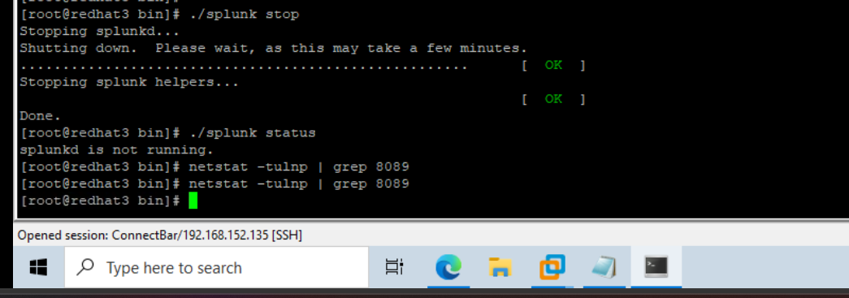
Figure 1 — splunkd stopped on the indexer (redhat3/134). The host stays up; only the Splunk process is down.
Symptom in the Splunk UI & logs
On the SH, running index="_internal" shows the distributed-search error and the DistributedPeerManager WARN in splunkd.log.
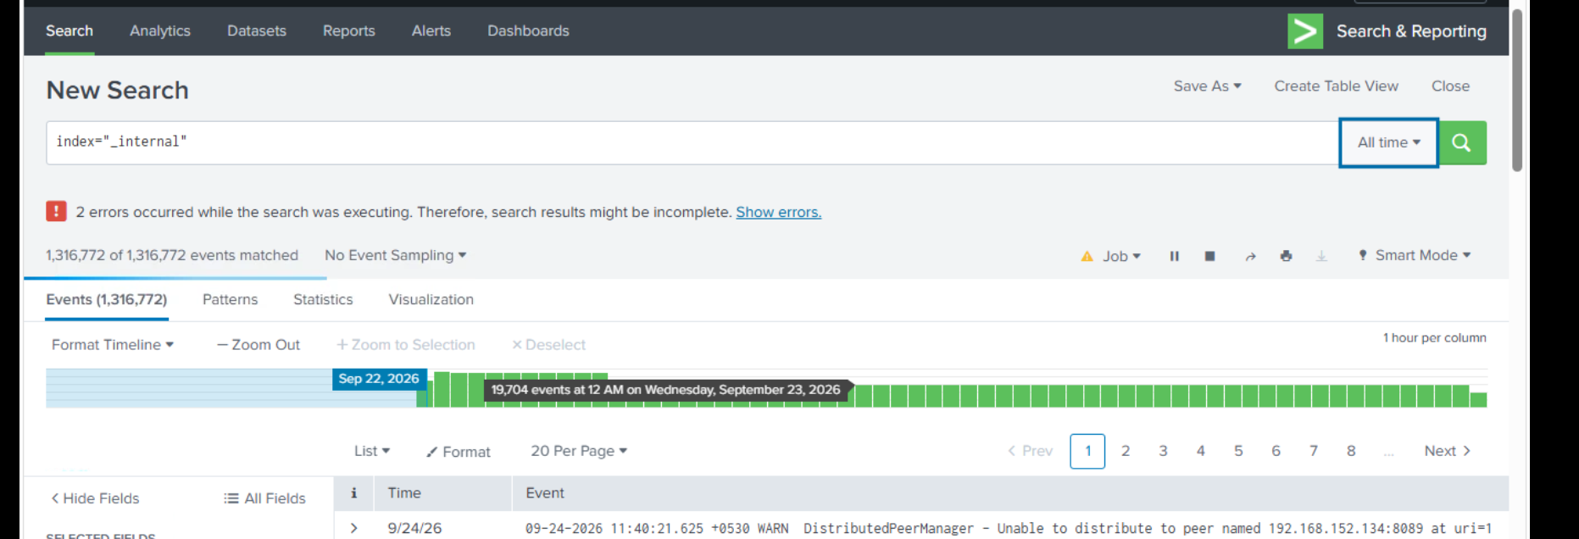
Figure 2 — SH search bar warning: "Unable to distribute to peer … status=Down".
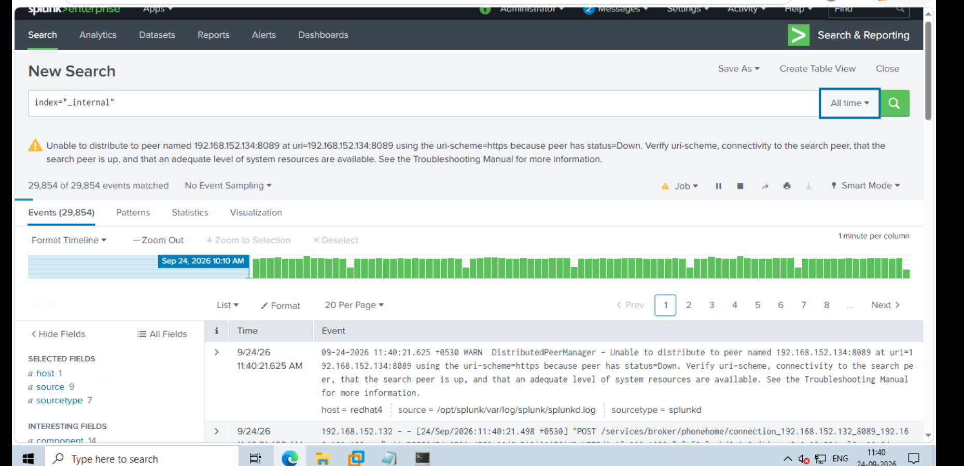
Figure 3 — The DistributedPeerManager WARN event in splunkd.log (host = redhat4, the SH).
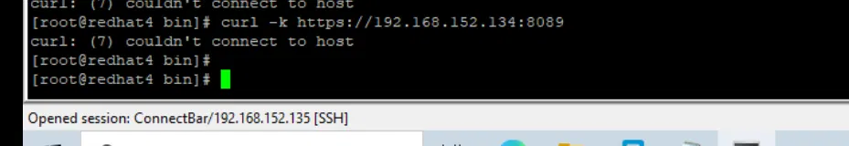
Figure 4 — curl to the indexer without the port (hits 443, not 8089) — an early mistake; the port must be included.
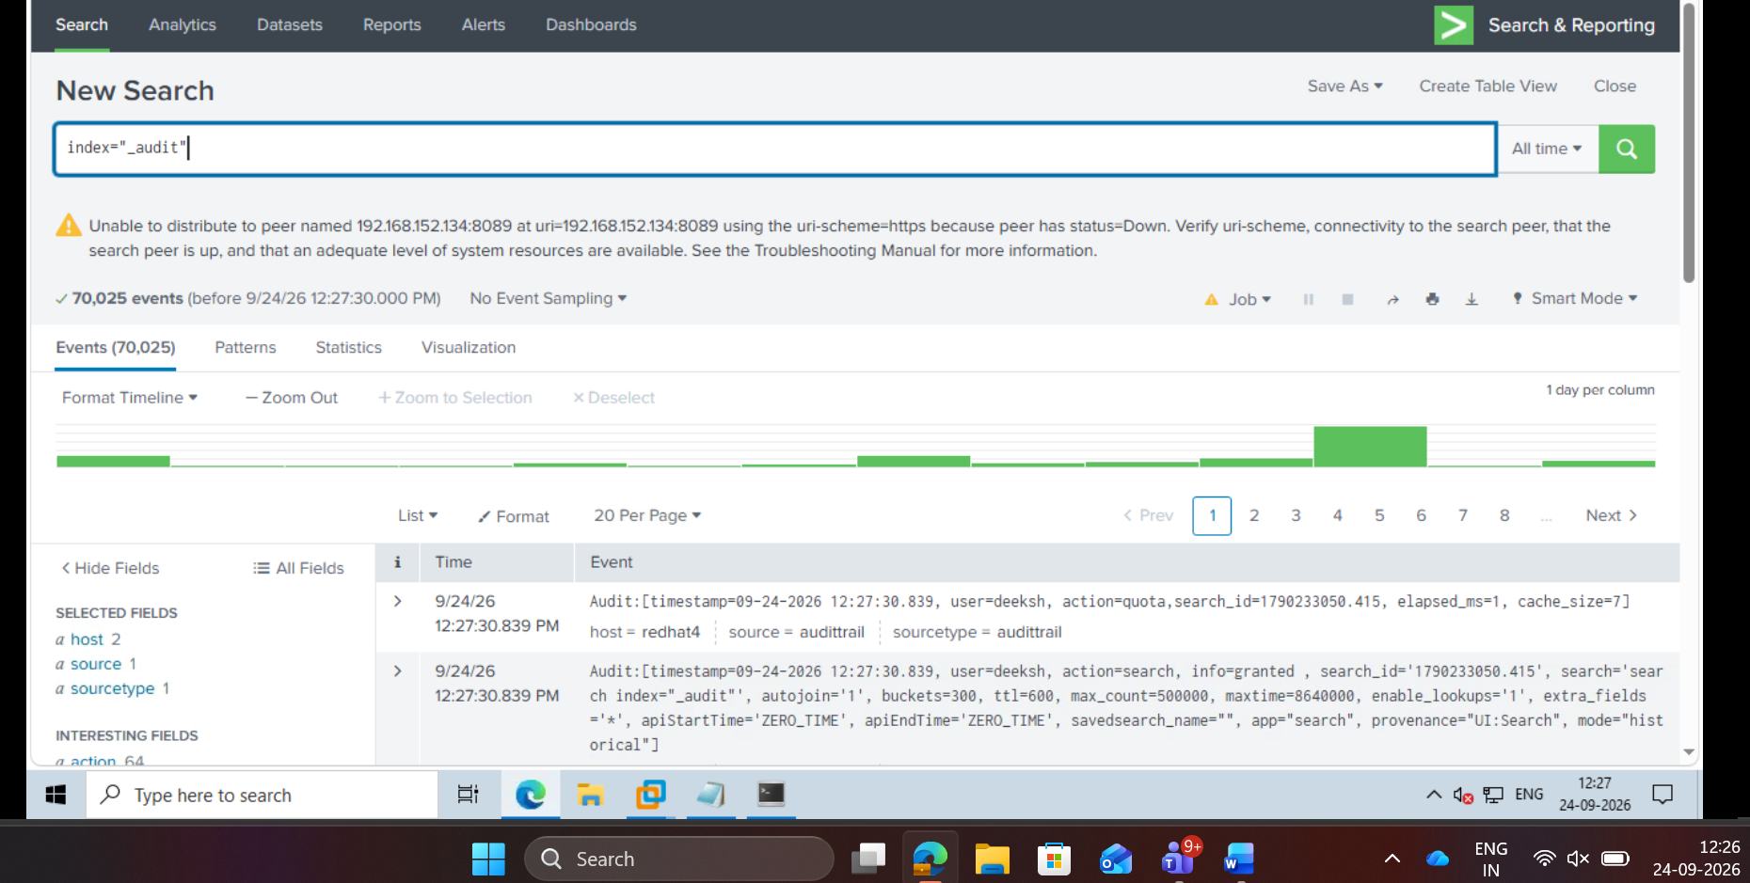
Figure 5 — The same failure visible in the _audit index.
Prove it at the TCP layer with curl -v
With splunkd stopped, curl from the SH. The -v flag does not change the result — it prints the intermediate steps, exposing the real reason behind curl's generic summary line.
curl -v -k https://192.168.152.134:8089
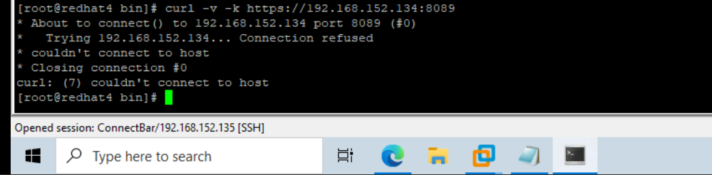
Figure 6 — "Trying 192.168.152.134… Connection refused". The RST arrives immediately — this is the refused signal.
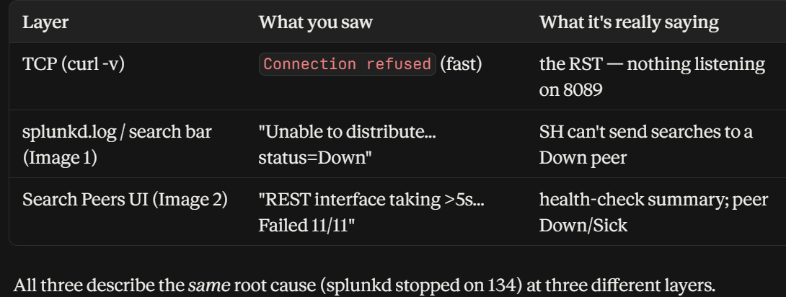
Figure 7 — The same root cause seen at three layers: TCP (curl → refused), splunkd.log (status=Down), and the Search Peers UI (generic health wording). All point to splunkd stopped on 134.
Solution — start splunkd
Start the Splunk process back up on the indexer so port 8089 is listening again:
# on the indexer (134):
$SPLUNK_HOME/bin/splunk start
netstat -tulnp | grep 8089 # confirm *:8089 is now listening
While splunkd was down, the Search Peers page showed the peer as Down / Sick. After starting splunkd it returns to Up.
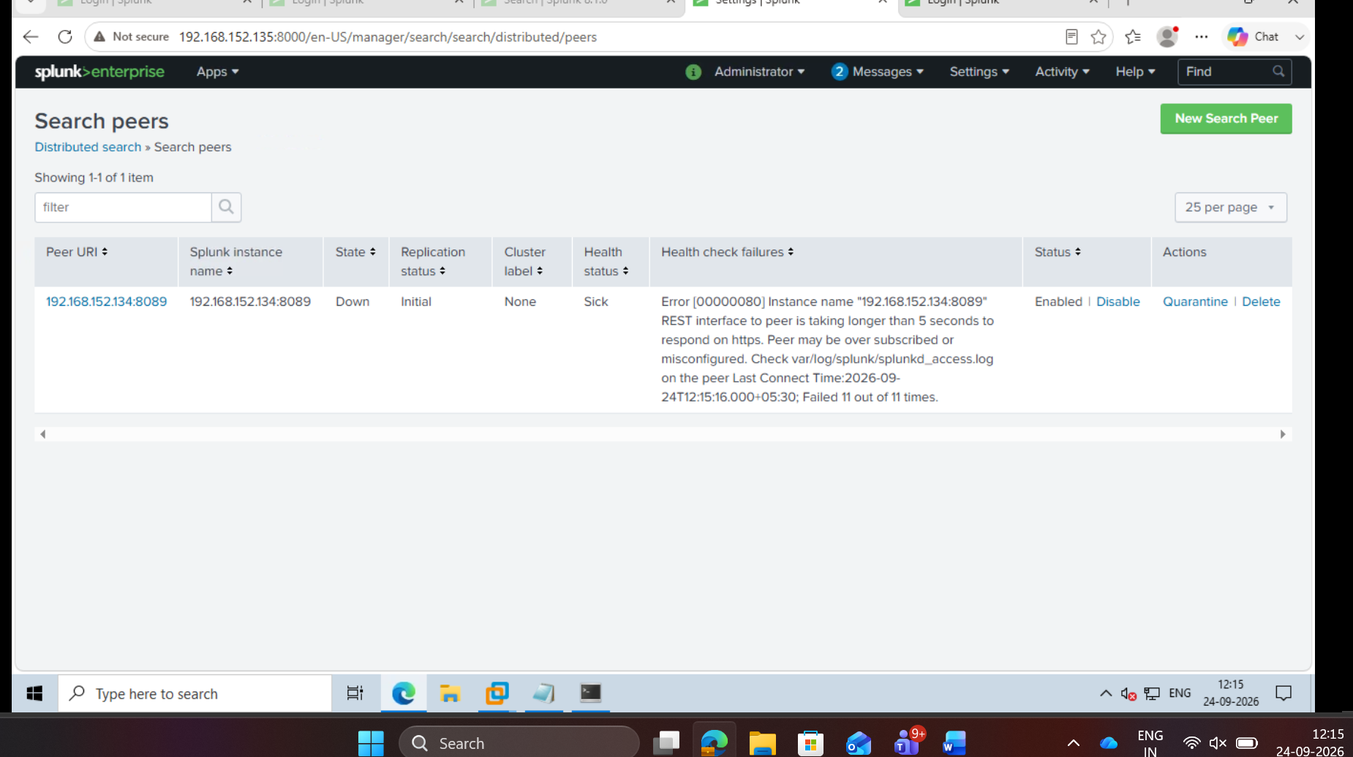
Figure 8 — Search Peers page during the failure: State = Down, Health = Sick. After splunkd is started, this returns to Up.

3. Error (b) — Connection Timed Out (Firewall DROP)
How this happens. This time splunkd is running, but a firewall rule on the indexer DROPs port 8089. The SH's connection request is silently swallowed — no RST, no reply — so the SH waits, retransmits, and eventually reports Connection Timed Out. Same peer "Down" in the UI, but the opposite underlying signal: silence instead of a refusal.
Real-world analogy
This is exactly what happens in a browser: a firewall-blocked site does not fail fast with "refused" — it hangs ("Connecting…") and finally says "took too long to respond". The request is swallowed, so you wait on silence.
Reproduce: splunkd running, then add a DROP rule on 8089
$SPLUNK_HOME/bin/splunk start
iptables -I INPUT -p tcp --dport 8089 -j DROP
iptables -L -n | grep 8089 # confirm the DROP rule is present
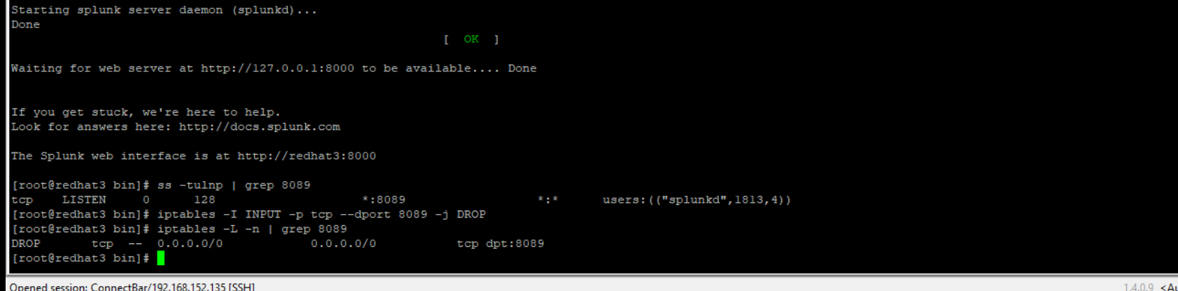
Figure 9 — splunkd started (ss shows *:8089 listening), then the DROP rule on 8089 is added and confirmed. splunkd is up — only the firewall now blocks the port.
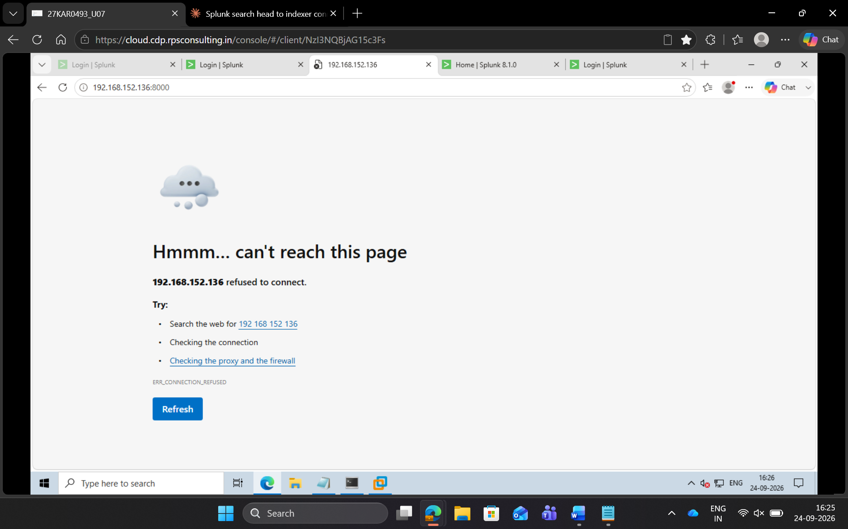
Figure 10 — In a browser, a blocked port does not fail fast — it eventually shows "can't reach this page / refused to connect". The request is swallowed rather than answered.
Symptom: curl from the SH hangs, then times out
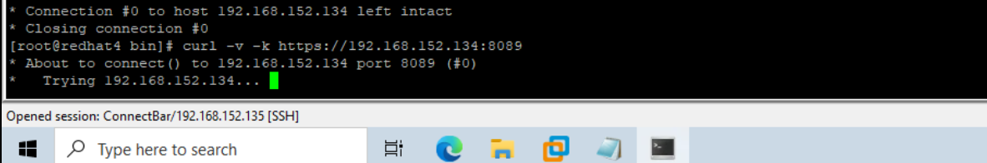
Figure 11 — curl stalls on "Trying 192.168.152.134…" (no immediate reply — the SYN was swallowed by the firewall).
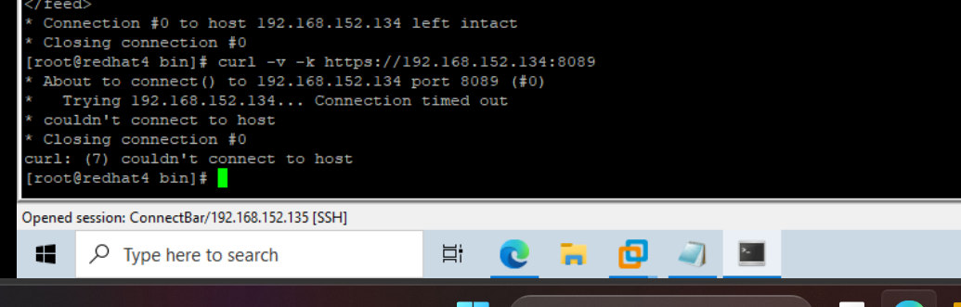
Figure 12 — curl finally reports "Connection timed out". Slow failure = firewall DROP, in clear contrast to the fast "refused" of (a).
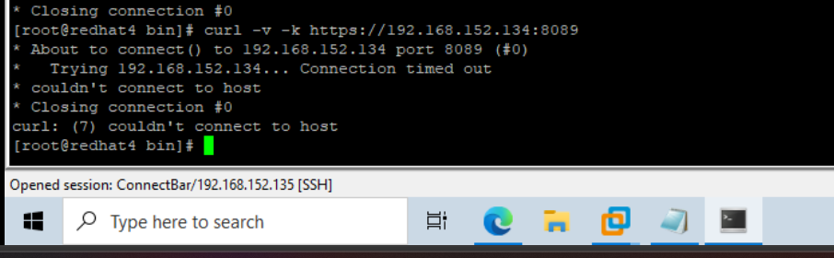
Figure 13 — The same "Connection timed out" result confirmed from the SH.
Solution — remove the firewall block
Delete the DROP rule so the SYN can reach splunkd on 8089 again:
# on the indexer (134):
iptables -D INPUT -p tcp --dport 8089 -j DROP # remove the block
iptables -L -n | grep 8089 # confirm it is gone
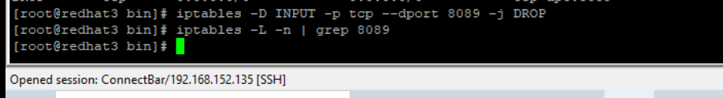
Figure 14 — Removing the DROP rule with iptables -D, then confirming it is gone.
Verify from the SH — curl now completes the handshake and returns the XML feed.
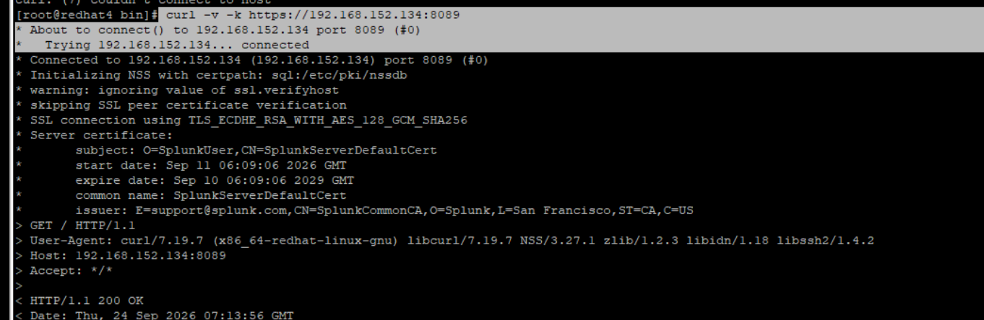
Figure 15 — curl now shows "connected", TLS handshake, and HTTP/1.1 200 OK — connectivity restored.
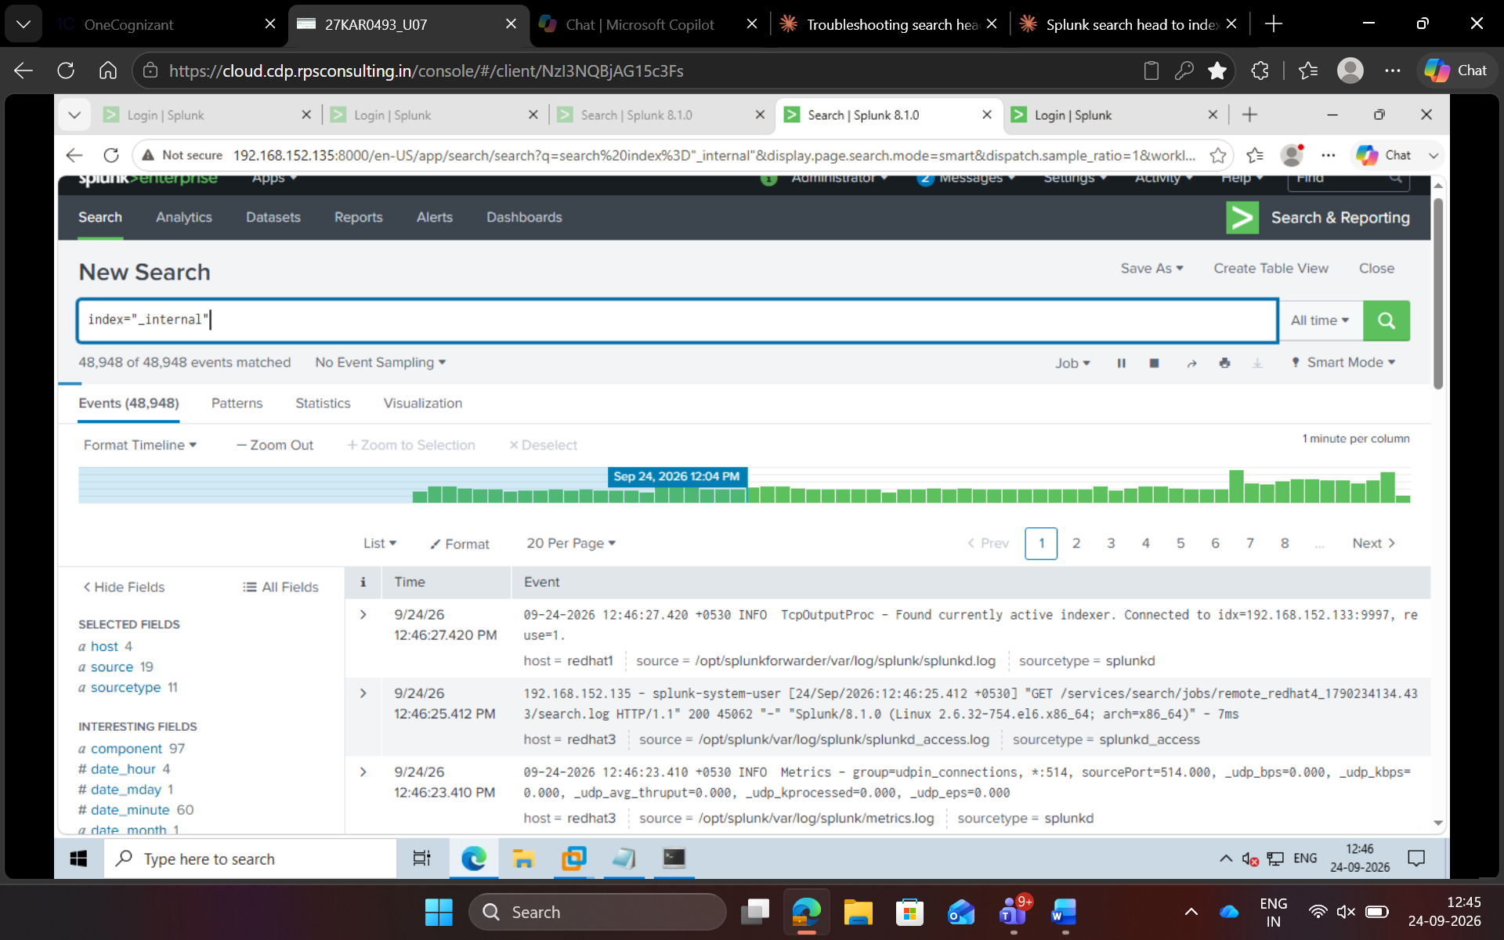
Figure 16 — Distributed search runs clean; the SH pulls remote results from the indexer (remote_redhat4 job) with no peer warning.
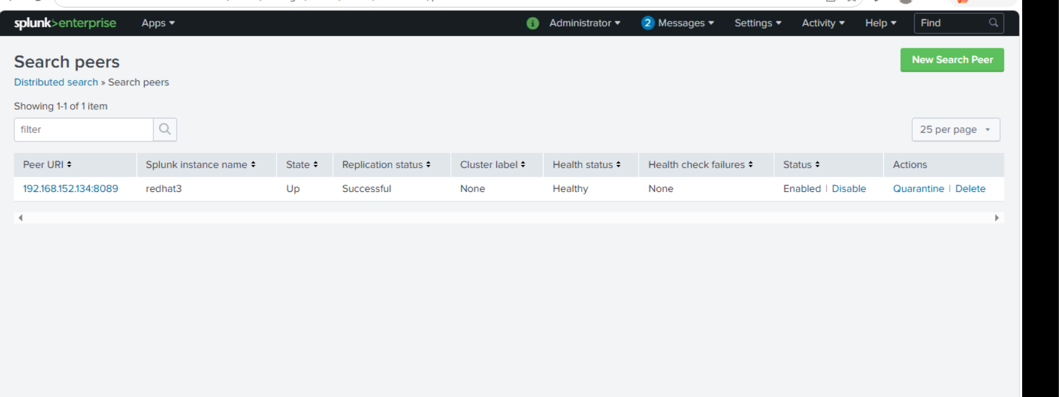
Figure 17 — Search Peers page: peer back to State = Up, Replication = Successful, Health = Healthy.

4. Three-State Summary
The entire diagnosis comes down to what happens to the SH's first SYN packet:
State | splunkd | Firewall | curl -v behaviour | UI / Fix
Healthy | running | open | Returns XML feed | Up / —
(a) Refused | stopped | open | Connection refused (fast) | Down / start splunkd
(b) Timeout | running | DROP 8089 | Connection timed out (slow) | Down / remove DROP rule
5. Key Takeaways
- Same UI message, two causes: "peer has status=Down" appears for both refused and timeout. The Splunk log tells you that the peer is down — not why.
- curl -v is the real diagnostic: it reveals refused (fast) vs timed out (slow) at the TCP layer, which the UI cannot distinguish.
- (a) Refused = process problem: host is up, nothing on 8089 → start splunkd.
- (b) Timeout = network problem: firewall swallowing the packet → open port 8089 / remove the DROP rule.
- -v changes visibility, not behaviour: the "Connection refused" line was always there; -v just prints it instead of the generic "couldn't connect to host".

