---------------------------------------------------------------------------------------------------------------------------------------

#Question-1- Visualize the daily temperature changes over time in a city and give your conclusion

Input: days = list(range(1, 32))

temperature = [65, 68, 70, 72, 75, 76, 78, 80, 81, 79, 75, 72, 70, 68, 67, 69, 70, 73, 75, 76, 78, 80, 81, 82, 83, 82, 80, 78, 76, 74, 71]

import matplotlib.pyplot as plt #importing matplotlib

days = list(range(1, 32)) #creating a list of days

temperature =[65,68,70,72,75,76,78,80,81,79,75,72

,70,68,67,69,70,73,75,76,78,80,81,82,83,82,80,78,76,74,71] #temp data for each day

plt.plot(days,temperature,marker='o',color='blue',linestyle='-') #plotting temp data

plt.title('Daily Temperature Changes',fontsize=20) #adding title

plt.xlabel('Days',fontsize=15) #adding label for x-axis

plt.ylabel('Temperature (°F)',fontsize=15) #adding label for y-axis

plt.show() #displaying the plot

OUTPUT:

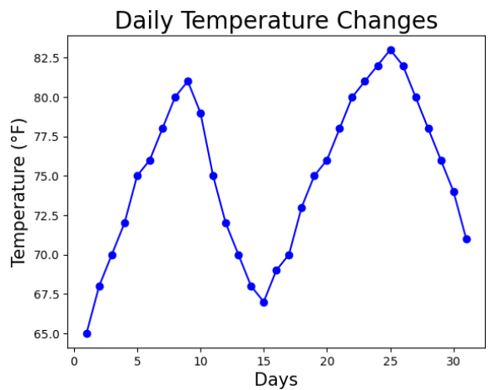

---------------------------------------------------------------------------------------------------------------------------------------#Question-2-Create a line plot to visualize the daily closing prices of a stock over a year and give your conclusion. Input: days = list(range(1, 78))

stock_prices = [100, 105, 110, 115, 112, 120, 118, 125, 128, 130, 132, 135, 138, 140, 142, 144, 145, 148, 150, 155, 160, 158, 162, 165, 170, 172, 175, 178, 180, 182, 185, 188, 190, 192, 195, 198,200, 198, 195, 193, 190, 188, 185, 182, 180, 178, 175, 172, 170, 168, 165, 162, 160, 158, 155, 152, 150, 148, 145, 143, 140, 138, 135, 132, 130, 128, 125, 123, 120, 118, 115, 112, 110, 108, 105, 103, 100]

--------------------------------------------------------------------------------------------------------------------------------------

import matplotlib.pyplot as plt #importing matplotlib

days = list(range(1, 78)) #creating a list of days

stock_prices = [100,105,110,115,112,120,118,125,128,130,

132,135,138, 140,142,144,145,148,150,155,160,158,162,165

,170,172,175,178,180, 182,185,188,190,192,195,198,200

,198,195,193,190,188,185,182,180,178,175,172,170,168,

165,162,160,158,155,152,150,148,145,143,140 ,138,135,

132,130,128,125,123,120,118,115,112,110,108,105,103,100] #stock prices over a year

plt.plot(days, stock_prices, marker='o', linestyle='-') #plotting stock data

plt.xlabel('Days') #adding label to x-axis

plt.ylabel('Stock Price ($)') #adding label to y-axis

plt.title('Daily Closing Prices of a Stock Over a Year') #adding title

plt.show() #displaying plot

OUTPUT:

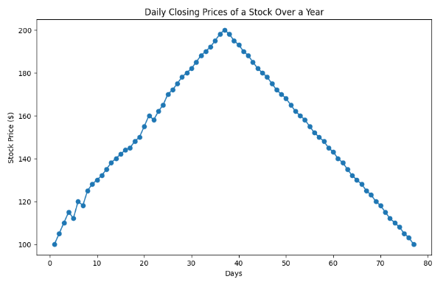

#Question-3-Create a bar chart to represent monthly expenses in different spending categories and give your conclusion. Input: categories = ['Rent', 'Groceries', 'Utilities', 'Entertainment', 'Transportation'] expenses = [1200, 400, 200, 150, 250]

import matplotlib.pyplot as plt #importing matplotlib

categories = ['Rent','Groceries','Utilities','Entertainment','Transportation'] #list of categories

expenses = [1200, 400, 200, 150, 250] #list of expenses

plt.bar(categories, expenses, color='skyblue') #creating bar plot

plt.xlabel('Spending Categories',fontsize=15) #adding label to x-axis

plt.ylabel('Monthly Expenses ($)',fontsize=15) #adding label to y-axis

plt.title('Monthly Expenses in Different Spending

Categories',fontsize=20) #adding title

plt.show() #displaying plot

print("Monthly expenses are primarily dominated by rent,

groceries, and transportation, while utilities and

entertainment make up smaller portions.") #conclusion

OUTPUT:

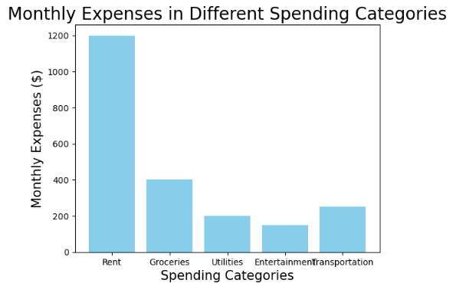

Monthly expenses are primarily dominated by rent, groceries, and transportation, while utilities and entertainment make up smaller portions.

#Question-4-Create a histogram to represent the distribution of product prices in a retail store and give your conclusion. Input: product_prices = [24.99, 34.99, 49.99, 64.99, 39.99, 54.99, 79.99, 99.99, 29.99, 44.99, 59.99, 69.99, 84.99, 109.99, 119.99, 89.99, 74.99, 124.99, 69.99, 54.99]

import matplotlib.pyplot as plt #importing matplotlib

product_prices = [24.99, 34.99, 49.99, 64.99, 39.99,

54.99,79.99, 99.99, 29.99, 44.99, 59.99, 69.99, 84.99,

109.99, 119.99, 89.99, 74.99, 124.99, 69.99, 54.99] #list of product prices

plt.hist(product_prices, bins=5, color='skyblue', edgecolor='black') #creating histogram

plt.xlabel('Product Prices ($)',fontsize=15) #adding label to x-axis

plt.ylabel('Frequency',fontsize=15) #adding label to y-axis

plt.title('Distribution of Product Prices in Retail Store',fontsize=20) #adding title

plt.show() #displaying plot

print("The majority of products in the retail store are

priced between $25 to $50, with fewer products in higher price ranges.") #conclusion

OUTPUT:

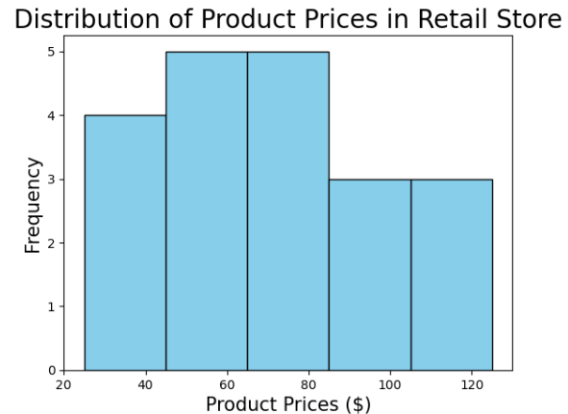

The majority of products in the retail store are priced between $25-$50,with fewer products in higher price ranges.