#Question-1-Analyze the relationship between the size of houses (measured in square footage) and their selling prices in a particular neighborhood. You have collected data on various houses in that neighborhood.Create a scatter plot using the below data and share your conclusion/analysis.

Input:

square_footage = np.array([1200, 1400, 1600, 1800, 2000, 2200, 2400, 2600, 2800, 3000])

selling_prices = np.array([250, 290, 315, 380, 410, 450, 500, 525, 570, 610])

import numpy as np #importing numpy library

import matplotlib.pyplot as plt #importing matplotlib

square_footage = np.array([1200,1400,1600,1800,2000,

2200,2400,2600,2800,3000]) #list of square foot

selling_prices = np.array([250, 290, 315, 380, 410,

450, 500, 525, 570, 610]) #list of selling prices

plt.scatter(square_footage, selling_prices, color='black') #creating scatter plot

plt.xlabel('Square Footage', fontsize=15) #adding label to x-axis

plt.ylabel('Selling Price ($)', fontsize=15) #adding label to y-axis

plt.title('Relationship between Square

Footage and Selling Price', fontsize=18) #adding title

plt.show() #displaying plot

OUTPUT:

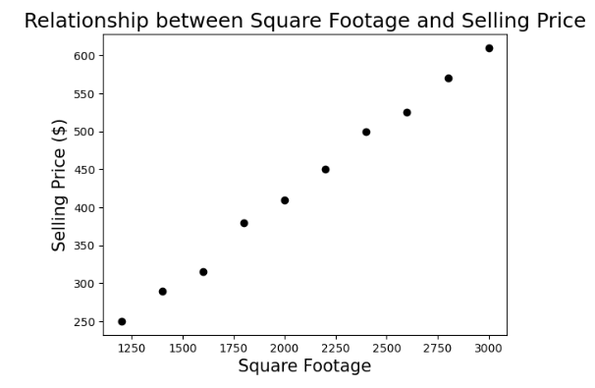

#Question-2-Create a pie chart to visualize the distribution of your monthly income by source. You have collected data on the various sources of your income, such as salary, freelance work, investments, and rental income. Share your conclusion/analysis.

Input: income_sources = ['Salary', 'Freelance', 'Investments', 'Rental', 'Other'] monthly_income = [5000, 1500, 1000, 600, 400]

import matplotlib.pyplot as plt #importing matplotlib

income_sources=['Salary','Freelance','Investments','Rental','Other'] #list of income sources

monthly_income=[5000, 1500, 1000, 600, 400] #list of monthly income

plt.pie(monthly_income,labels=income_sources, #creating piechart

autopct='%1.1f%%',startangle=140,

colors=['skyblue','pink','lightgreen', 'y', 'blue'])

plt.title('Distribution of Monthly Income by Source', fontsize=16) #adding title

plt.show() #displaying plot

OUTPUT:

