LTE CARRIER AGGREGATION USING MATLAB
1. MATLAB Program
clc;
clear;
close all;
BW = 20;
SE = 4;
CC = [1 2 3];
AggBW = BW.*CC;
Throughput = AggBW.*SE;
disp([CC' AggBW' Throughput']);
bar(CC, Throughput);
xlabel('Number of Carriers');
ylabel('Throughput (Mbps)');
title('LTE Carrier Aggregation');
grid on;
2. Expected Command Window Output
Number of Carriers | Aggregated Bandwidth (MHz) | Throughput (Mbps)
1 | 20 | 80
2 | 40 | 160
3 | 60 | 240
3. Result
The MATLAB program calculates the aggregated bandwidth and throughput for 1, 2, and 3 component carriers. The throughput increases from 80 Mbps to 240 Mbps as the number of carriers increases, demonstrating the benefit of LTE Carrier Aggregation.
4. MATLAB Simulation Screenshot
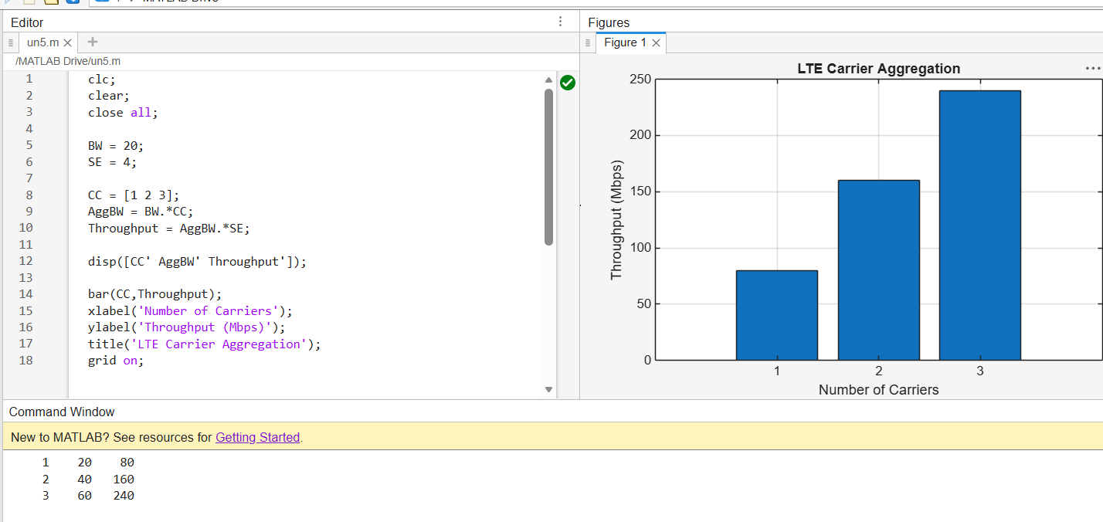
Figure 1: MATLAB code, command-window output, and LTE Carrier Aggregation throughput graph.

