MATLAB SIMULATION EXPERIMENTS
EXPERIMENT 1: SISO AND MIMO BIT ERROR RATE (BER)
MATLAB Code (visible portion)
clc;
clear;
close all;
SNR = 0:2:20;
BER1 = zeros(size(SNR));
BER2 = zeros(size(SNR));
N = 10000;
for k=1:length(SNR)
bits = randi([0 1],N,1);
tx = 2*bits-1;
snr = 10^(SNR(k)/10);
rx = tx + randn(N,1)/sqrt(2*snr);
BER1(k) = mean((real(rx)>0)~=bits);
% The remaining lines of the program are not visible in the supplied screenshot.
Output / Observation
The graph compares the Bit Error Rate (BER) of SISO and MIMO systems at different SNR values. BER decreases as SNR increases. The plotted MIMO curve is lower than the SISO curve at the displayed SNR points, indicating better error performance.
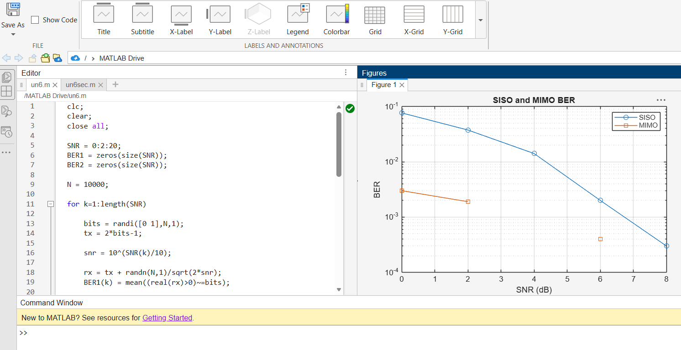
Figure 1: MATLAB editor and SISO–MIMO BER comparison graph.

EXPERIMENT 2: BEAMFORMING GAIN
MATLAB Code (visible portion)
clc;
clear;
close all;
N = 8;
angle = -90:90;
steer = 30;
gain = zeros(size(angle));
for k=1:length(angle)
a = exp(1i*pi*(0:N-1)'*sind(angle(k)));
w = exp(1i*pi*(0:N-1)'*sind(steer));
gain(k) = abs(w'*a/N)^2;
end
plot(angle,10*log10(gain+eps));
xlabel('Steering Angle');
ylabel('Gain (dB)');
title('Beamforming Gain');
Output / Observation
The graph shows the beamforming gain of an 8-element antenna array for steering angles from −90° to +90°. The main beam is directed toward the specified steering angle of 30°, while lower values at other angles represent reduced gain.
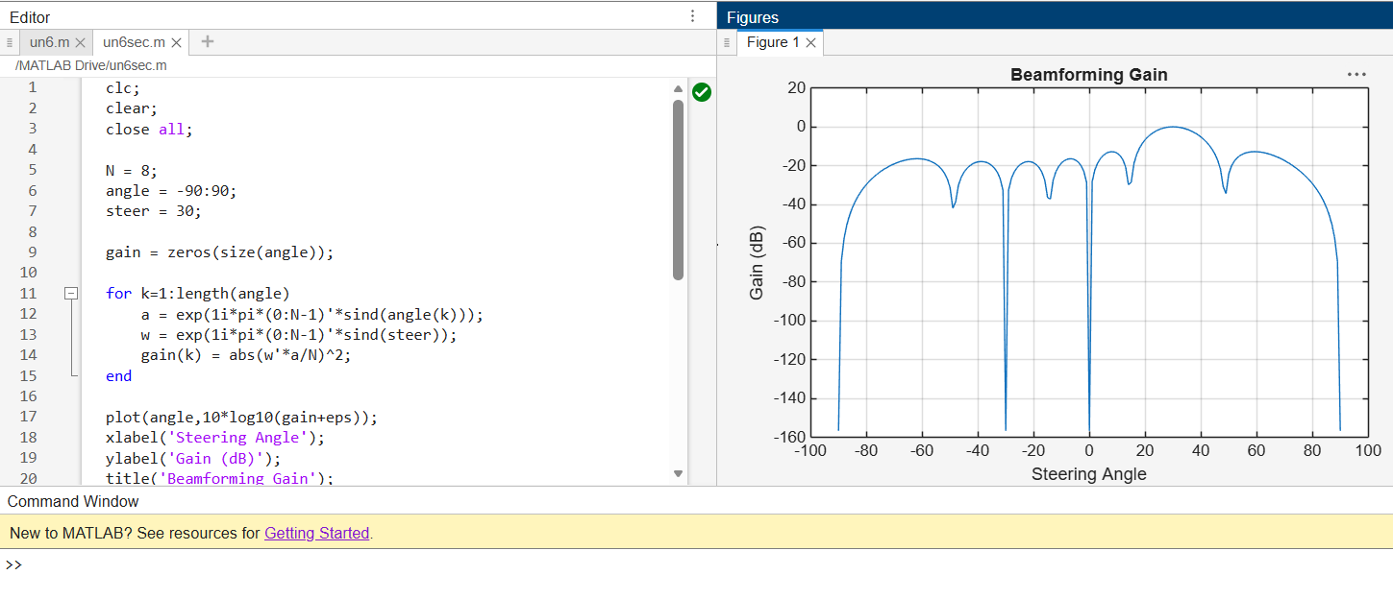
Figure 2: MATLAB code and beamforming gain radiation pattern.
RESULT
The MATLAB simulations illustrate that MIMO provides improved BER performance compared with the displayed SISO result, and that beamforming focuses antenna-array gain in the selected steering direction.

