Experiment 1 – Expected MATLAB Output
Graph 1: FDMA, TDMA and CDMA Capacity Comparison
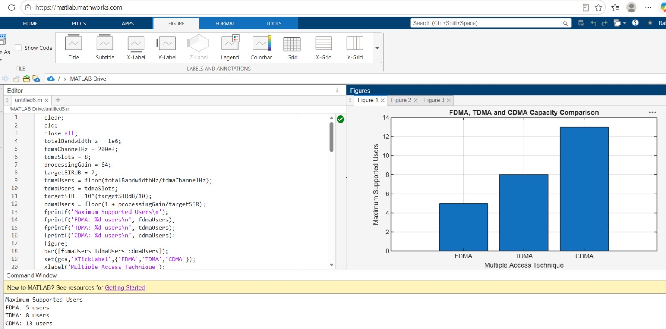

Graph 2: CDMA SIR versus Number of Users
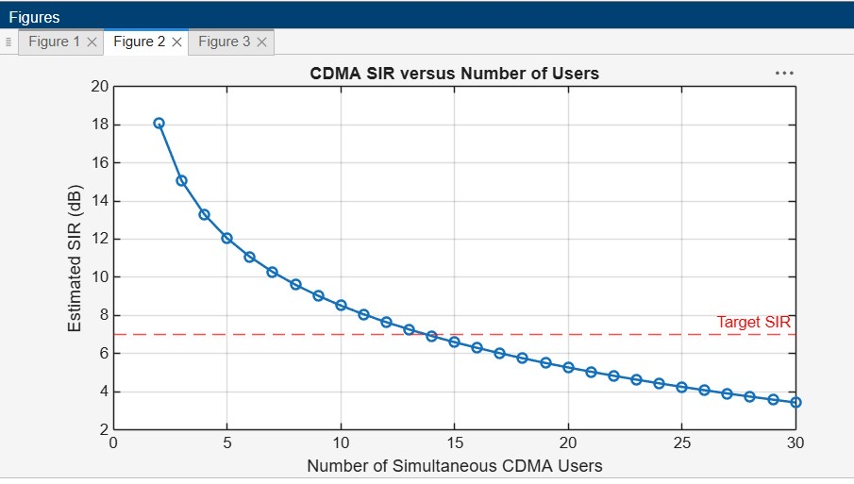

Graph 3: Conceptual Resource Allocation
