Exp 10 Digital Speech Processing and Noise Reduction
10.1 Implementation of Spectral Subtraction for Speech Noise Reduction
Objectives:
1 To generate a noisy speech signal by adding noise to a clean speech signal.
2 To estimate the noise spectrum and implement the Spectral Subtraction algorithm.
3 To obtain and analyze the magnitude spectra of the noisy and enhanced speech signals.
4 To evaluate the performance of spectral subtraction in speech enhancement.
Code:
clc; clear; close all;
Fs=8000; t=0:1/Fs:3;
x=sin(2*pi*200*t)+0.5*sin(2*pi*400*t); % Clean signal
xn=x+0.3*randn(size(x)); % Noisy signal
Y=fft(xn);
N=fft(0.3*randn(size(x)));
xe=real(ifft(max(abs(Y)-abs(N),0).*exp(1j*angle(Y))));
% Signals
figure;
subplot(311),plot(t,x),title('Clean Speech')
subplot(312),plot(t,xn),title('Noisy Speech')
subplot(313),plot(t,xe),title('Enhanced Speech')
% Spectrograms
figure;
subplot(311),spectrogram(x),title('Clean Spectrogram')
subplot(312),spectrogram(xn),title('Noisy Spectrogram')
subplot(313),spectrogram(xe),title('Enhanced Spectrogram')
% Magnitude Spectra
figure;
subplot(311),plot(abs(fft(x))),title('Clean Spectrum')
subplot(312),plot(abs(fft(xn))),title('Noisy Spectrum')
subplot(313),plot(abs(fft(xe))),title('Enhanced Spectrum')
Output:
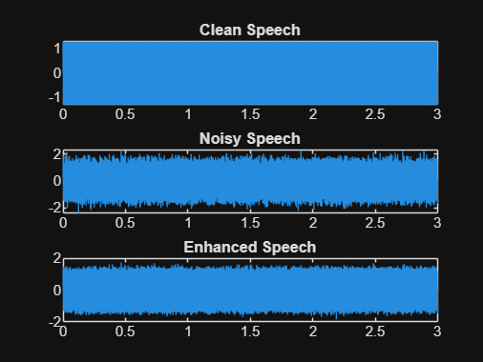
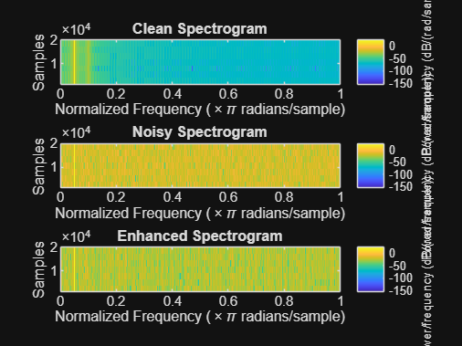
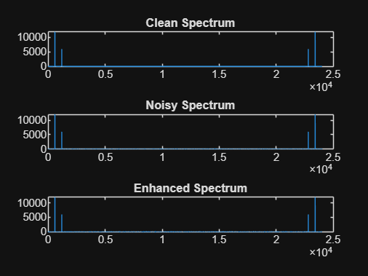
Warning: An error occurred while drawing the scene: Could not find node in node tree during replaceChild
Result:
1. A noisy speech signal was successfully generated by adding noise to the clean speech signal.
2. The noise spectrum was estimated and the Spectral Subtraction algorithm was successfully implemented.
3. The magnitude spectra of the noisy and enhanced speech signals were obtained and analyzed, showing a reduction in noise components after enhancement.
4. The performance of spectral subtraction was evaluated, and the enhanced speech signal exhibited improved speech quality and intelligibility compared to the noisy speech signal.

