5. Design of High Pass Filter using Windowing Techniques
5.1 Generate the coefficients of an FIR High-Pass filter using rectangular windowing techniques.
Objectives
1. To design an FIR High-Pass Filter using the Rectangular Window technique for the given cutoff frequency, sampling frequency, and filter order specifications.
2. To generate the FIR filter coefficients using the Rectangular Window method in MATLAB and implement the designed filter.
3. To obtain and analyze the magnitude response and phase response of the FIR High-Pass Filter designed using the Rectangular Window.
Code:
clc; clear; close all;
%% --- Input Parameters ---
fp = 1000; % High-pass cutoff frequency (Hz)
fs = 8000; % Sampling frequency (Hz)
N = 50; % Filter order
wc = fp/(fs/2); % Normalized cutoff (0–1)
%% --- 1. FIR High Pass using Rectangular Window ---
b_rect = fir1(N, wc, 'high', rectwin(N+1));
disp('--- High-Pass Coefficients (Rectangular Window) ---');
disp(b_rect');
%% --- 2. FIR High Pass using Hamming Window ---
b_hamm = fir1(N, wc, 'high', hamming(N+1));
disp('--- High-Pass Coefficients (Hamming Window) ---');
disp(b_hamm');
%% --- 3. FIR High Pass using Hanning Window ---
b_hann = fir1(N, wc, 'high', hanning(N+1));
disp('--- High-Pass Coefficients (Hanning Window) ---');
disp(b_hann');
%% --- Frequency Response Plots ---
figure;
freqz(b_rect,1);
title('High-pass FIR using Rectangular Window');
figure;
freqz(b_hamm,1);
title('High-pass FIR using Hamming Window');
figure;
freqz(b_hann,1);
title('High-pass FIR using Hanning Window');
Output:
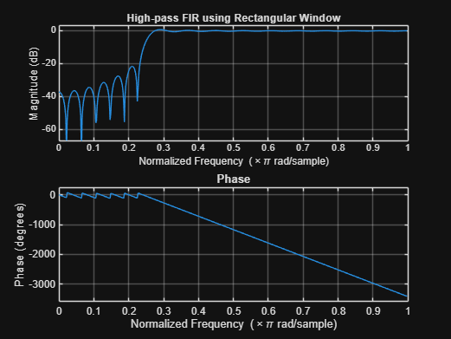

5.2. Generate the coefficients of an FIR High-Pass filter using Hamming windowing techniques
OBJECTIVE:
1. To design an FIR High-Pass Filter using the Hamming Window technique for the given cutoff frequency, sampling frequency, and filter order specifications.
2. To generate the FIR filter coefficients using the Hamming Window method in MATLAB and implement the designed filter.
3. To obtain and analyze the magnitude response and phase response of the FIR High-Pass Filter designed using the Hamming Window.
CODE:
clc; clear; close all;
%% --- Input Parameters ---
fp = 1000; % High-pass cutoff frequency (Hz)
fs = 8000; % Sampling frequency (Hz)
N = 50; % Filter order
wc = fp/(fs/2); % Normalized cutoff (0–1)
%% --- FIR High Pass using Hamming Window ---
b_hamm = fir1(N, wc, 'high', hamming(N+1));
disp('--- High-Pass Coefficients (Hamming Window) ---');
disp(b_hamm');
%% --- Frequency Response Plots ---
figure;
freqz(b_hamm,1);
title('High-pass FIR using Hamming Window');
title('High-pass FIR using Hanning Window');
OUTPUT:
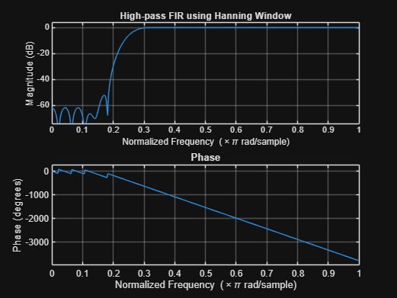
5.3. Generate the coefficients of an FIR High-Pass filter using Hanning windowing techniques
OBJECTIVES:
1. To design an FIR High-Pass Filter using the Hanning Window technique for the given cutoff frequency, sampling frequency, and filter order specifications.
2. To generate the FIR filter coefficients using the Hanning Window method in MATLAB and implement the designed filter.
3. To obtain and analyze the magnitude response and phase response of the FIR High-Pass Filter designed using the Hanning Window.
CODE:
clc; clear; close all;
%% --- Input Parameters ---
fp = 1000; % High-pass cutoff frequency (Hz)
fs = 8000; % Sampling frequency (Hz)
N = 50; % Filter order
wc = fp/(fs/2); % Normalized cutoff (0–1)
%% --- FIR High Pass using Hanning Window ---
b_hann = fir1(N, wc, 'high', hanning(N+1));
disp('--- High-Pass Coefficients (Hanning Window) ---');
disp(b_hann');
%% --- Frequency Response Plots ---
figure;
freqz(b_hann,1);
title('High-pass FIR using Hanning Window');
OUTPUT:
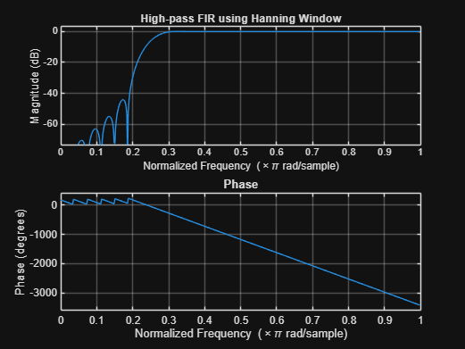
RESULT:The FIR High-Pass Filter was successfully designed using the Hanning Window technique for the specified cutoff frequency, sampling frequency, and filter order.

